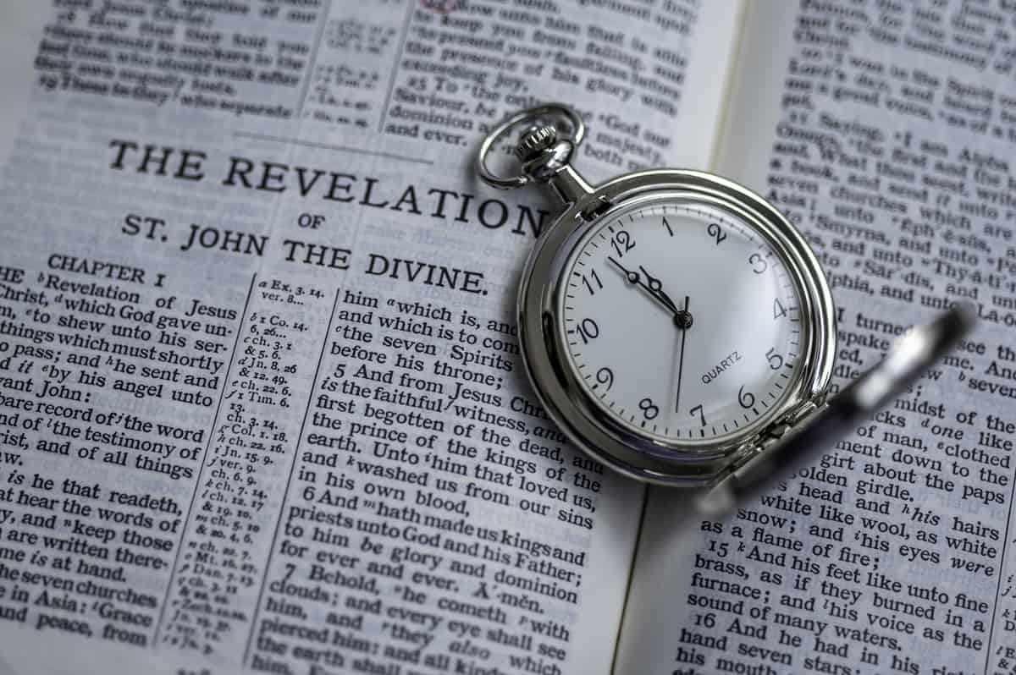Revelation – Chapter 14

It’s Harvest Time

5/6/2025

Presented by Clifford Phipps

1 Then I looked, and behold, the Lamb was standing on Mount Zion, and with Him one hundred and forty-four thousand, having His name and the name of His Father written on their foreheads.

________________________________________________________________________________________________________________________

(Joel 2:30-32, Rev 6:16)

________________________________________________________________________________________________________________________

2 And I heard a voice from heaven, like the sound of many waters and like the sound of loud thunder, and the voice which I heard was like the sound of harpists playing on their harps.

3 And they sang a new song before the throne and before the four living creatures and the elders; and no one could learn the song except the one hundred and forty-four thousand who had been purchased from the earth.

________________________________________________________________________________________________________________________

(Ex 6:6)

4 These are the ones who have not been defiled with women, for they have kept themselves chaste. These are the ones who follow the Lamb wherever He goes. These have been purchased from among men as first fruits to God and to the Lamb.

5 And no lie was found in their mouth; they are blameless.

________________________________________________________________________________________________________________________

6 And I saw another angel flying in midheaven, having an eternal gospel to preach to those who live on the earth, and to every nation and tribe and tongue and people;

Matt 24:14

14 "This gospel of the kingdom shall be preached in the whole world as a testimony to all the nations, and then the end will come. NASU

____________________________________________________________________________________________________________________________________________________________________________________

7 and he said with a loud voice, "Fear God, and give Him glory, because the hour of His judgment has come; worship Him who made the heaven and the earth and sea and springs of waters."

________________________________________________________________________________________________________________________

8 And another angel, a second one, followed, saying, "Fallen, fallen is Babylon the great, she who has made all the nations drink of the wine of the passion of her immorality."

________________________________________________________________________________________________________________________

9 Then another angel, a third one, followed them, saying with a loud voice, "If anyone worships the beast and his image, and receives a mark on his forehead or on his hand,

10 he also will drink of the wine of the wrath of God, which is mixed in full strength in the cup of His anger; and he will be tormented with fire and brimstone in the presence of the holy angels and in the presence of the Lamb.

________________________________________________________________________________________________________________________

11 "And the smoke of their torment goes up forever and ever; they have no rest day and night, those who worship the beast and his image, and whoever receives the mark of his name."

(Rev. 14:13)

12 Here is the perseverance of the saints who keep the commandments of God and their faith in Jesus.

____________________________________________________________________________________________________________________________________________________________________________________

13 And I heard a voice from heaven, saying, "Write, 'Blessed are the dead who die in the Lord from now on!'" "Yes," says the Spirit, "so that they may rest from their labors, for their deeds follow with them."

(Rev 7:15-17, Phil 3:20-21)

____________________________________________________________________________________________________________________________________________________________________________________

**Step One**.

Satan is going to kill the Jews that were not protected by God in the wilderness.

(Rev 12:17)

**Step Two**

Since Satan can’t touch the Jews that are protected by God in the wilderness, Satan is going to send people into the wilderness to deceive the Jews to keep them from recognizing Jesus as their true Messiah.

Since Satan can’t personally do this, who will he use to accomplish his dirty work?

The Antichrist.

**Step Three**

Satan is going to use the Antichrist to gather together an army that can storm the wilderness and kill those Jews that God has been protecting once and for all.

14 Then I looked, and behold, a white cloud, and sitting on the cloud was one like a son of man, having a golden crown on His head and a sharp sickle in His hand.

15 And another angel came out of the temple, crying out with a loud voice to Him who sat on the cloud, "Put in your sickle and reap, for the hour to reap has come, because the harvest of the earth is ripe."

16 Then He who sat on the cloud swung His sickle over the earth, and the earth was reaped.

________________________________________________________________________________________________________________________

Matt 13:24-30

24 Jesus presented another parable to them, saying, "The kingdom of heaven may be compared to a man who sowed good seed in his field.

25 "But while his men were sleeping, his enemy came and sowed tares among the wheat, and went away.

26 "But when the wheat sprouted and bore grain, then the tares became evident also.

27 "The slaves of the landowner came and said to him, 'Sir, did you not sow good seed in your field? How then does it have tares?'

28 "And he said to them, 'An enemy has done this!' The slaves said to him, 'Do you want us, then, to go and gather them up?'

29 "But he said, 'No; for while you are gathering up the tares, you may uproot the wheat with them.

30 'Allow both to grow together until the harvest; and in the time of the harvest I will say to the reapers, "First gather up the tares and bind them in bundles to burn them up; but gather the wheat into my barn."'" NASU

Matt 13:36-43

36 Then He left the crowds and went into the house. And His disciples came to Him and said, "Explain to us the parable of the tares of the field."

37 And He said, "The one who sows the good seed is the Son of Man,

38 and the field is the world; and as for the good seed, these are the sons of the kingdom; and the **tares are the sons of the evil one**;

39 **and the enemy who sowed them is the devil, and the harvest is the end of the age; and the reapers are angels**.

40 "So just as the tares are gathered up and burned with fire, so shall it be at the end of the age.

41 **"The Son of Man will send forth His angels, and they will gather out of His kingdom all stumbling blocks**, and those who commit lawlessness,

42 and will throw them into the furnace of fire; in that place there will be weeping and gnashing of teeth. NASU

____________________________________________________________________________________________________________________________________________________________________________________

Rev 16:13-14,16

13 And I saw coming out of the mouth of the dragon and out of the mouth of the beast and out of the mouth of the false prophet, three unclean spirits like frogs;

14 for they are spirits of demons, performing signs, which go out to the kings of the whole world, to gather them together for the war of the great day of God, the Almighty.

16 And they gathered them together to the place which in Hebrew is called Har-Magedon.

____________________________________________________________________________________________________________________________________________________________________________________

17 And another angel came out of the temple which is in heaven, and he also had a sharp sickle.

18 Then another angel, the one who has power over fire, came out from the altar; and he called with a loud voice to him who had the sharp sickle, saying, "Put in your sharp sickle and gather the clusters from the vine of the earth, because her grapes are ripe."

19 So the angel swung his sickle to the earth and gathered the clusters from the vine of the earth, and threw them into the great wine press of the wrath of God.

20 And the wine press was trodden outside the city, and blood came out from the wine press, up to the horses' bridles, for a distance of two hundred miles. NASU

________________________________________________________________________________________________________________________

Rev 19:11-21

11 And I saw heaven opened, and behold, a white horse, and He who sat on it is called Faithful and True, and in righteousness He judges and wages war.

12 His eyes are a flame of fire, and on His head are many diadems; and He has a name written on Him which no one knows except Himself.

13 He is clothed with a robe dipped in blood, and His name is called The Word of God.

14 And the armies which are in heaven, clothed in fine linen, white and clean, were following Him on white horses.

15 From His mouth comes a sharp sword, so that with it He may strike down the nations, and He will rule them with a rod of iron; and He treads the wine press of the fierce wrath of God, the Almighty.

16 And on His robe and on His thigh He has a name written, "KING OF KINGS, AND LORD OF LORDS."

17 Then I saw an angel standing in the sun, and he cried out with a loud voice, saying to all the birds which fly in midheaven, "Come, assemble for the great supper of God,

18 so that you may eat the flesh of kings and the flesh of commanders and the flesh of mighty men and the flesh of horses and of those who sit on them and the flesh of all men, both free men and slaves, and small and great."

19 And I saw the beast and the kings of the earth and their armies assembled to make war against Him who sat on the horse and against His army.

20 And the beast was seized, and with him the false prophet who performed the signs in his presence, by which he deceived those who had received the mark of the beast and those who worshiped his image; these two were thrown alive into the lake of fire which burns with brimstone.

21 And the rest were killed with the sword which came from the mouth of Him who sat on the horse, and all the birds were filled with their flesh. NASU

____________________________________________________________________________________________________________________________________________________________________________________

Isa 63:1-6

1 Who is this who comes from Edom,

With garments of glowing colors from Bozrah,

This One who is majestic in His apparel,

Marching in the greatness of His strength?

"It is I who speak in righteousness, mighty to save."

2 Why is Your apparel red,

And Your garments like the one who treads in the wine press?

3 "I have trodden the wine trough alone,

And from the peoples there was no man with Me.

I also trod them in My anger

And trampled them in My wrath;

And their lifeblood is sprinkled on My garments,

And I stained all My raiment.

4 "For the day of vengeance was in My heart,

And My year of redemption has come.

5 "I looked, and there was no one to help,

And I was astonished and there was no one to uphold;

So My own arm brought salvation to Me,

And My wrath upheld Me.

6 "I trod down the peoples in My anger

And made them drunk in My wrath,

And I poured out their lifeblood on the earth." NASU

(Joel 3:12-16)

Perspectives from Revelation Chapter 14

1. There is a dramatic increase in the focus on Israel beginning with Revelation chapter 10.

* Chapter 1 Jesus tells John to send the book of Revelation to the churches
* Chapters 2 – 3 are the 7 letters to the 7 churches
* Chapter 4 – 5 describe the Rapture of the church and describes the taking of the scroll from the hand of God by Jesus, an event that the church will witness
* Chapter 6 The opening of the 6 seals. Still no mention of Israel
* Chapter 7 The sealing of the 144,000 and discussion of the Tribulation Saints that came out of the Great Tribulation.
* Chapter 8 & 9 The sounding of the Trumpets.

Very little mention of the Nation of Israel in any of these chapters. But once we get to Revelation chapter 10 Israel becomes the primary focus.

Chapter 10 The “little book”

Chapter 11 John measures the Temple and The Two Witnesses

Chapter 12 Background on “The Woman” (Israel) and her interaction with Satan (tried to kill the male child and tried to kill the Woman as she had to flee into the wilderness)

Chapter 13 Describes the Antichrist and False Prophet

Chapter 14 God’s warning through 3 angels. 1) Receive the gospel and give God glory, 2) Babylon is fallen, 3) Don’t take the Mark of the Antichrist. God’s purification (removing the tares among the wheat and the crushing of the Antichrist’s army)

Chapters 15 – 18 will continue to focus on the Nation of Israel.

Always remember that the 70th Seven of Daniel (or the Tribulation Period) is a Jewish Era. God has turned His attention back to the Nation of Israel and is doing amazing things for her to aid her to recognize that Jesus is her true Messiah.

1. Why does God need an angel to preach the eternal gospel?

There won’t be many left to witness at this time.

* + The 2 Witnesses have been killed
  + Many of the Tribulation Saints have been killed by the Antichrist
  + Since the Tribulation Saints won’t take the Mark of the Beast they can’t buy, sell or trade and may not be able to survive without food
  + Those Tribulation Saints that do survive may have to go underground to avoid death
  + There won’t be many witnessing at this time that the Antichrist hasn’t killed.
  + This angel can’t be killed or stopped.
  + The Antichrist is powerless to stop this angel