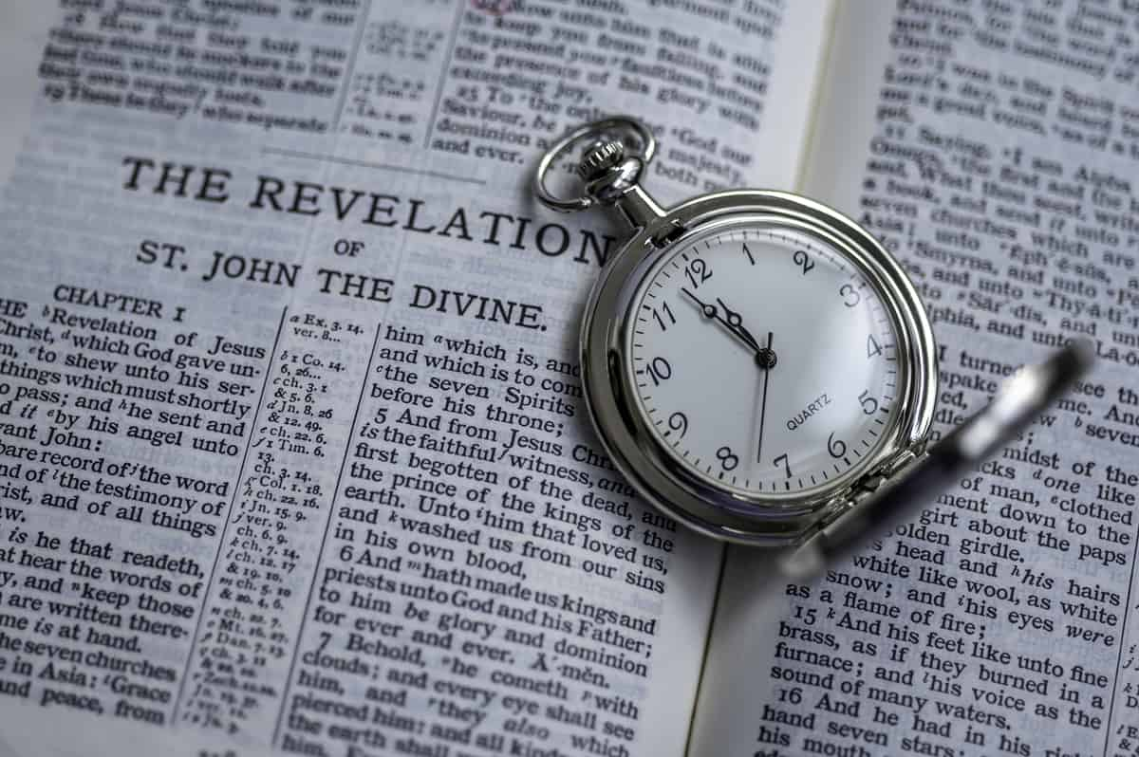

Laodicea & 7 Church Summary
Revelation 3:14-22 – 2/25/25
Presented by Gene Dahler

Review notes: ___________________________________________
_____________________________________________________________________________________________________________________________________________________________________

To the Church at Laodicea

"Rule of the people"

Title: Rev 3:14 "To the angel of the church in Laodicea write: The Amen, the faithful and true Witness, the Beginning of the creation of God,

Commendations:

Criticism: says this: 15' I know your deeds, that you are neither cold nor hot; I wish that you were cold or hot.
16 'So because you are lukewarm, and neither hot nor cold, I will spit you out of My mouth.
_____________________________________________________________________________________________________________________________________________________________________

17 'Because you say, " I am rich, and have become wealthy, and have need of nothing," and you do not know that you are wretched and miserable and poor and blind and naked,
_____________________________________________________________________________________________________________________________________________________________________

18 I advise you to buy from Me gold refined by fire so that you may become rich, and white garments so that you may clothe yourself, and that the shame of your nakedness will not be revealed; and eye salve to anoint your eyes so that you may see.
_____________________________________________________________________________________________________________________________________________________________________

Exhortation: 19' Those whom I love, I reprove and discipline; therefore be zealous and repent.
20' Behold, I stand at the door and knock; if anyone hears My voice and opens the door, I will come in to him and will dine with him, and he with Me.
_____________________________________________________________________________________________________________________________________________________________________

REPORT CARD SUMMARY -

- you are neither hot nor cold, you are lukewarm
- you are wretched
- you are miserable
- you are poor
- you are blind
- you are naked
_____________________________________________________________________________________________________________________________________________________________________

Promise to the Overcomer: 21' He who overcomes, I will grant to him to sit down with Me on My throne, as I also overcame and sat down with My Father on His throne.
____________________________________________________________________________________________________________________________________________________________________________________________________________________________

Closure: 22' He who has an ear, let him hear what the Spirit says to the churches.'" NASU

KEY POINT FOR TODAY: Jesus stands at the door and knocks; if anyone hears His voice and opens the door, He will come in.
_____________________________________________________________________________________________________________________________________________________________________

SUMMARY

We are living here on earth near the end of the age and have churches with the predefined issues described in Rev 2 & 3 for church situational awareness.
_____________________________________________________________________________________________________________________________________________________________________

What have we learned in studying these seven churches? Some churches are safer places than others.

Church summary:
Ephesus – lost first love, near losing its lamp stand
Smyrna – about to be tested
Pergamum – false teaching - Balaam
Thyatira – false teaching – Jezebel
Sardis – wake up, remember what you have received
Philadelphia – warning, hold fast
Laodicea – Jesus is knocking at their door

Five of the seven are churches with concerning characteristics. Smyrna and Philadelphia had no criticism. Remember it is only 30 years after Paul & Peter.

The members of the churches were told what they needed to do to become overcomers. Here are the key statements:

- Test those who call themselves apostles/teachers/pastors (Ephesus)
- Keep My word (Philadelphia)
- Do not deny My name (Philadelphia)
- Hold fast what you have – truth (Thyatira)
- Be faithful until death (Smyrna)

What does the safest church for believers do? It teaches God’s Word.

Rev 3:8 (Philadelphia)
8 'I know your deeds. Behold, I have put before you an open door which no one can shut, because you have a little power, and have kept My word, and have not denied My name. NASU

How does a church keep God’s Word? It has to:
- Have it
- Know it is significant and true
- Preach/teach God’s Word in context
- Focus on the truth
- Avoid teaching other subjects

However, 5 of our 7 churches are evidently into churchianity.

The key question – can people retain their salvation, even in a less safe church. YES However, there may not be many.

Rev 3:4-5 (Church at Sardis)
4 'But you have a few people in Sardis who have not soiled their garments; and they will walk with Me in white, for they are worthy.
5 'He who overcomes will thus be clothed in white garments; and I will not erase his name from the book of life, and I will confess his name before My Father and before His angels NASU

Situational awareness for today.

We don’t have a Peter or Paul to keep the churches and us on track today. Jesus hasn’t sent any new apostles. So, that could only mean that everything we need to know is right here in the Bible.

Key Point – Exercise Discernment

Since today there exists more false teaching than truth, discernment confirming the truth is the key thing that will strengthen us to insure we will become overcomers.

What are preachers saying in a churchianity church?

- There are good Christians on both sides of this topic
- We have agreed to disagree agreeably for the sake of unity
- Says or implies that transliterations or paraphrases are scripture
- Claims Bible prophecy cannot be understood or is not important
- Have the perspective that the church has permanently replaced Israel.
- Does not teach the blessed hope, the rapture of the church
- You are saved by saying a prayer
- When a believer dies, they go to heaven and stay for all eternity
- The judgment of the nations applies to us (Mt 25)
- Our goal is to hear “well done, good and faithful servant”. (Mt 25)
- The churches mission is to reach the world with the good news so Jesus can return (Mt 24:14) (Rev 14:6-7)
_____________________________________________________________________________________________________________________________________________________________________

What, most likely, are the people saying that attend a churchianity church?
- I love my pastor
- I love the worship
- My kids love the youth program
- The people there are friendly
- My kids went to college and graduated atheist!!
- I’m concerned that some (maybe me) started out on fire, but the fire dwindled and perhaps went out.

How does that happen? It can only happen if that saved person does not know Jesus and does not know of God’s plans for them. Were they really saved?

Question - Should we be concerned if a person claiming to be a Christian is really saved? Answer – YES.

Question – How do we know if a person is saved?

Observable criteria -
- They have a desire to know and understand God’s Word. (Jn 16:13)
- They have a sincere concern for the unsaved
- They have a sincere concern for the immature Christians

What are we to be doing? We are to hear what the Spirit says to the churches! Seven times we were told to hear what the Spirit says.

What does the Spirit say?

John 16:13
13 "But when He, the Spirit of truth, comes, He will guide you into all the truth; for He will not speak on His own initiative, but whatever He hears, He will speak; and He will disclose to you what is to come. NASU
_____________________________________________________________________________________________________________________________________________________________________

What are we to be doing?

2 Cor 10:3-5
3 For though we walk in the flesh, we do not war according to the flesh,
4 for the weapons of our warfare are not of the flesh, but divinely powerful for the destruction of fortresses.
5 We are destroying speculations and every lofty thing raised up against the knowledge of God, NASU

The church at Philadelphia is a church that knew the Word, it has the best report card and a majority of its members are overcomers. Jesus confirmed the door was open for them.

That is the kind of church we all desire to be part of.

Here are some things that we can do today to help insure we receive everything God has for us.

1. Check all verses that you see or hear that are from a transliteration or a paraphrase with a real Bible translation (NASU, NKJV). There is power in the Word of God, but only if it is His Word.
______________________________________________________________________________________________________________

2. If the messages you are hearing are topical using verses from many different books, check the context by confirming:
- Who is speaking/writing
- Who is being spoken/written to
- Who or what it is about
- When it applies
Never consider believing what appears to be the meaning of a single verse until you have checked the context.
______________________________________________________________________________________________________________

3. Join a verse-by-verse Bible study where you can fellowship with others that are interested in knowing the truth and ask questions.
______________________________________________________________________________________________________________

Finally, today there is one significant thing different than the church situation in 95 AD when these letters were written. Remember:
“To the angel of the church in Laodicea”

What does that mean? Today we have a perfectly valid church option that the seven first century church members that Jesus wrote to evidently didn’t have. We can easily and conveniently change churches.

If you decide to consider changing churches with the goal to attend a church where you can learn more Biblical truth, ask the following questions to a leader in the church you are considering.

- What does a person have to do to be saved?
- Answer – Believe the gospel
- When did the old covenant end and the new covenant begin?
- Answer – OC end - Triumphal entry. NC began - Pentecost
- Is it possible for a saved person to become unsaved?
- Answer - Yes
- What future prophecy perspective does this church teach?
- Answer – Pre-tribulation rapture

Confirm the theology of a church before you consider becoming a member. If you have multiples to pick from, then consider the pastor, worship, friendliness, convenience, etc.

KEY POINT – It is OK to leave a church. It is NOT OK to leave the church.

Holy Spirit promises for all those that overcome

I will eat of the tree of life in the Paradise of God (Rev 2:7)

He will give me the crown of life (Rev 2:10)

I will not be hurt by the second death (Rev 2:11)

He will give me some of the hidden manna (Rev 2:17)

He will give me a white stone with a new name written on it that no one knows but me (Rev 2:17)

He will give me authority over the nations (Rev 2:26)

He will give me the Morning Star (Jesus) (Rev 2:28)

I will be clothed in white garments (righteousness) (Rev 3:5)

He will not erase my name from the book of life and will confess my name before His Father and before His angels (advocate) (Rev 3:5)

He will make me a pillar in the temple of God (Rev 3:12)

He will write on me the name of His God, the name of the city of His God, the New Jerusalem, and His new name (Rev 3:12)

He will grant to me to sit down with Him on His throne, as He also overcame and sat down with His Father on His throne. (Rev 3:21)
___________________________________________________________________________________________________________________________________________________________________________________________________________________________________________________________________________________

