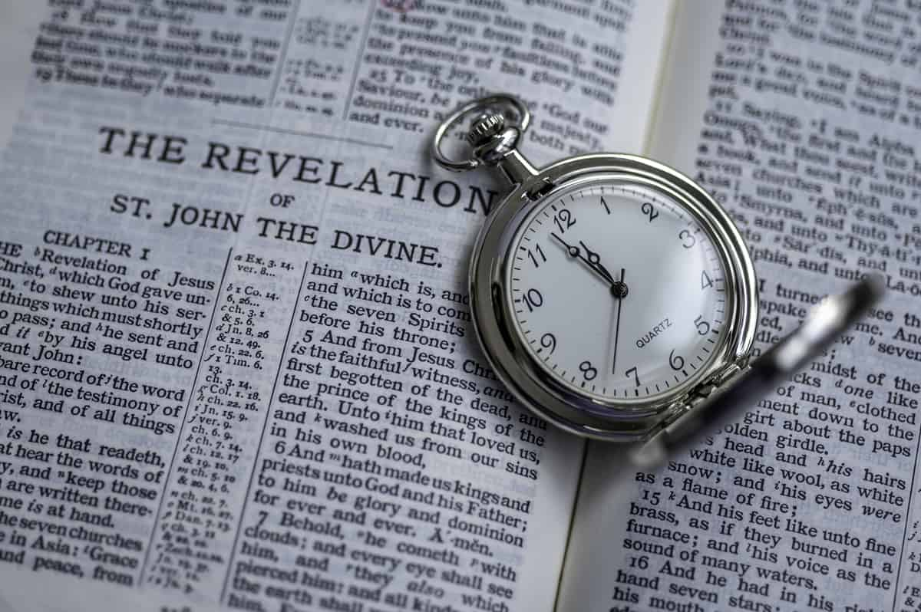Revelation – Chapter 12

Satan Vs Israel
4/15/2025
Presented by Clifford Phipps
Rev 12
1 A great sign appeared in heaven: a woman clothed with the sun, and the moon under her feet, and on her head a crown of twelve stars;
2 and she was with child; and she cried out, being in labor and in pain to give birth.
3 Then another sign appeared in heaven: and behold, a great red dragon having seven heads and ten horns, and on his heads were seven diadems.
4 And his tail swept away a third of the stars of heaven and threw them to the earth. And the dragon stood before the woman who was about to give birth, so that when she gave birth he might devour her child.
5 And she gave birth to a son, a male child, who is to rule all the nations with a rod of iron; and her child was caught up to God and to His throne.
6 Then the woman fled into the wilderness where she had a place prepared by God, so that there she would be nourished for one thousand two hundred and sixty days.
____________________________________________________________________________________________________________________________________________________________________________________

Gen 37:9-11
9 Now he had still another dream, and related it to his brothers, and said, "Lo, I have had still another dream; and behold, the sun and the moon and eleven stars were bowing down to me." 10 He related it to his father and to his brothers; and his father rebuked him and said to him, "What is this dream that you have had? Shall I and your mother and your brothers actually come to bow ourselves down before you to the ground?" 11 His brothers were jealous of him, but his father kept the saying in mind. NASU
____________________________________________________________________________________________________________________________________________________________________________________

The woman of Revelation chapter 12 is best described as the Nation of Israel.
____________________________________________________________________________________________________________________________________________________________________________________

(Rev 19:15-16, Psalm 2:9 and Rev. 2:27)
________________________________________________________________________________________________________________________________________________________________________________________________________________________________________________

Rev. 12:9
And the great dragon was thrown down, the serpent of old who is called the devil and Satan,
________________________________________________________________________________________________________________________

Rev 12:17
17 So the dragon was enraged with the woman, and went off to make war with the rest of her children

(John 8:44b, Rev 1:20)

Is there anywhere else in the bible that tells us more about the background of Satan’s fall?

Isa 14:12-16
12 "How you have fallen from heaven,
O star of the morning, son of the dawn!
You have been cut down to the earth,
You who have weakened the nations!
13 "But you said in your heart,
'I will ascend to heaven;
I will raise my throne above the stars of God,
And I will sit on the mount of assembly
In the recesses of the north.
14 'I will ascend above the heights of the clouds;
I will make myself like the Most High.'
15 "Nevertheless you will be thrust down to Sheol,
To the recesses of the pit. NASU

Ezek 28:12-15
12 'Thus says the Lord God,
"You had the seal of perfection,
Full of wisdom and perfect in beauty.
13 "You were in Eden, the garden of God;
Every precious stone was your covering:
The ruby, the topaz and the diamond;
The beryl, the onyx and the jasper;
The lapis lazuli, the turquoise and the emerald;
And the gold, the workmanship of your settings and sockets,
Was in you.
On the day that you were created
They were prepared.
14 "You were the anointed cherub who covers,
And I placed you there.
You were on the holy mountain of God;
You walked in the midst of the stones of fire.
15 "You were blameless in your ways
From the day you were created
Until unrighteousness was found in you. NASU
Rev 12:4 And his tail swept away a third of the stars of heaven and threw them to the earth. And the dragon stood before the woman who was about to give birth, so that when she gave birth he might devour her child.

Since Genesis 3:15 Satan has been trying to unravel God’s promise that the Messiah would crush his head.

Gen 3:13-14
13 Then the Lord God said to the woman, "What is this you have done?" And the woman said, "The serpent deceived me, and I ate." 14 The Lord God said to the serpent,
"Because you have done this,
Cursed are you more than all cattle,
And more than every beast of the field;
On your belly you will go,
And dust you will eat
All the days of your life;

Gen. 3:15
And I will put enmity
Between you and the woman,
And between your seed and her seed;
He shall bruise you on the head,
And you shall bruise him on the heel." NASU
____________________________________________________________________________________________________________________________________________________________________________________

(1 Cor 15:3-4, Luke 24:25-27)

In an effort to keep from being killed by the Messiah and in an effort to undo God’s plan of redemption of the earth and man; Satan has developed 4 strategies.

- He tried to keep the Seed of the Woman from coming. He attempted to disrupt the genetic line that would lead to the birth of the Messiah.
- Tried to disrupt God’s Redemptive plan
- Tried and is still trying to destroy Israel (the woman)
- Try to kill Jesus

Satan Tried to Keep the Seed of the Woman from Coming

  - Satan was behind the death of Abel.

(1 John 3:11-12, Gen 4:25)

  - We see Satan at work again in Genesis chapter 6. Fallen angels were able to breed with human women and a genetic aberration was created called the Nephilim. It appeared that the human race had become infected with this genetic problem and the entire human race became so evil that the bible quotes God as saying that He wished that He had never made man. God decided to wipe out the entire human race. But the Seed of the Woman was preserved through Noah.

(Gen 6:9-10)

In Genesis 22 God required Abraham to take and sacrifice his son Isaac. Abraham obeyed God and as a result of his obedience God made Abraham a promise.

(Gen 22:18-19)

God promised to bless the nations through the coming of the Messiah. The seed of the Woman would now come through Abraham, through Isaac and then through Jacob.

Satan was paying attention.

  - As we continue in Genesis, we see that Esau desired to kill Jacob because of a dispute over his birth-right. Jacob had to flee from his brother.
(Gen 27:41-42)

  - Moses is born and would eventually lead the Nation of Israel out of Egypt
  - In 2 Chronicles chapters 21-22 we read that the entire royal seed of Israel was completely wiped out except for one, Joash, who was hidden for 6 years. All Messianic hope was one baby away from complete obliteration! But God preserved the seed.
  - Mortecai and Haman.

Satan tried and failed to keep the Seed of the Woman, or the Messiah from coming. Jesus was born in Bethlehem to a Virgin.

Satan wasn’t done. In a last-ditch effort to kill the Messiah, Satan put it in the heart of King Herod to have all the children two years and younger killed to keep the Messiah from coming

Satan failed to keep the Messiah from coming and now has to change his strategy.

Since God sent Jesus to redeem the earth and man back to God, we now see Satan trying to interrupt God’s plan of redemption.

(Matt 4:8-11, John 12:27, Matt 16:21-23)

Satan was not successful at

- Preventing the Seed of the Woman from coming to the earth.
- Interrupting God’s plan for the redemption of man and the redemption of the earth.
We now see that Satan has a third strategy.

Satan’s third strategy is to destroy the entire nation of Israel.

Satan has been trying to wipe out the Jews.

Why?

Matt 23:39
"For I say to you, from now on you will not see Me until you say, 'BLESSED IS HE WHO COMES IN THE NAME OF THE LORD!'" NASU
________________________________________________________________________________________________________________________________________________________________________________________________________________________________________________________________________

Satan will try to kill the Messiah.

Rev 20:7-11
7 When the thousand years are completed, Satan will be released from his prison, 8 and will come out to deceive the nations which are in the four corners of the earth, Gog and Magog, to gather them together for the war; the number of them is like the sand of the seashore. 9 And they came up on the broad plain of the earth and surrounded the camp of the saints and the beloved city, and fire came down from heaven and devoured them. 10 And the devil who deceived them was thrown into the lake of fire and brimstone, where the beast and the false prophet are also; and they will be tormented day and night forever and ever. NASU

Knowing that his ultimate resting place is the Lake of Fire, Satan has used four strategies to attempt to undo God’s plan.

1) Tried to keep the Messiah from coming
2) Tried to interrupt the redemptive plan of God
3) Now trying to destroy Israel.
4) Satan will attempt to kill the Messiah

6 Then the woman fled into the wilderness where she had a place prepared by God, so that there she would be nourished for one thousand two hundred and sixty days.
________________________________________________________________________________________________________________________
7 And there was war in heaven, Michael and his angels waging war with the dragon. The dragon and his angels waged war,
8 and they were not strong enough, and there was no longer a place found for them in heaven.
9 And the great dragon was thrown down, the serpent of old who is called the devil and Satan, who deceives the whole world; he was thrown down to the earth, and his angels were thrown down with him.
10 Then I heard a loud voice in heaven, saying,
"Now the salvation, and the power, and the kingdom of our God and the authority of His Christ have come, for the accuser of our brethren has been thrown down, he who accuses them before our God day and night.
____________________________________________________________________________________________________________________________________________________________________________________

11 "And they overcame him because of the blood of the Lamb and because of the word of their testimony, and they did not love their life even when faced with death.

1 John 5:9-12
9 If we receive the testimony of men, the testimony of God is greater; for the testimony of God is this, that He has testified concerning His Son.
10 The one who believes in the Son of God has the testimony in himself; the one who does not believe God has made Him a liar, because he has not believed in the testimony that God has given concerning His Son.
11 And the testimony is this, that God has given us eternal life, and this life is in His Son.
12 He who has the Son has the life; he who does not have the Son of God does not have the life. NASU
____________________________________________________________________________________________________________________________________________________________________________________

12 "For this reason, rejoice, O heavens and you who dwell in them. Woe to the earth and the sea, because the devil has come down to you, having great wrath, knowing that he has only a short time."
________________________________________________________________________________________________________________________
13 And when the dragon saw that he was thrown down to the earth, he persecuted the woman who gave birth to the male child.
14 But the two wings of the great eagle were given to the woman, so that she could fly into the wilderness to her place, where she was nourished for a time and times and half a time, from the presence of the serpent.
________________________________________________________________________________________________________________________

15 And the serpent poured water like a river out of his mouth after the woman, so that he might cause her to be swept away with the flood.
16 But the earth helped the woman, and the earth opened its mouth and drank up the river which the dragon poured out of his mouth.
________________________________________________________________________________________________________________________

17 So the dragon was enraged with the woman, and went off to make war with the rest of her children, who keep the commandments of God and hold to the testimony of Jesus. NASU
____________________________________________________________________________________________________________________________________________________________________________________

Perspectives

Rev 12:1-6
1 A great sign appeared in heaven: a woman clothed with the sun, and the moon under her feet, and on her head a crown of twelve stars;

Time frame – 1800 B.C. Takes us back to Jacob. God changed his name to Israel.

2 and she was with child; and she cried out, being in labor and in pain to give birth.

Time frame - Takes us to the birth of Christ, 1 A.D.

3 Then another sign appeared in heaven: and behold, a great red dragon having seven heads and ten horns, and on his heads were seven diadems.
4 And his tail swept away a third of the stars of heaven and threw them to the earth.

Time Frame – before we meet Satan in the Garden of Eden

And the dragon stood before the woman who was about to give birth, so that when she gave birth he might devour her child.
5 And she gave birth to a son, a male child,

Time Frame – Back to the birth of Christ, 1 A.D.

Verse 5 continues…….who is to rule all the nations with a rod of iron;

Time Frame - Millenium

and her child was caught up to God and to His throne.

Time frame – the Ascension in 32 A.D.

6 Then the woman fled into the wilderness where she had a place prepared by God, so that there she would be nourished for one thousand two hundred and sixty days.

Time Frame – Midpoint of the Tribulation

What’s missing here?

In verse 5 the child is caught up to God and His throne. That’s the Ascension.

Then in verse 6, John sees the woman, or Israel, fleeing into the wilderness.

This happens at the midpoint of the Tribulation, (when the Antichrist desecrates the Temple and demands to be worshipped as God. That’s when Jesus tells the Jews, in Matthew 24 to flee into the mountains).
We’ve gone forward in time from the Ascension of Jesus to the midpoint of the Tribulation period.

What’s missing?

The entire Church Era. John just skips right past the entire Church Era.

Why? This is about the Jews. Since the beginning of the 70th 7, God has His attention back on His chosen people.

The word “Law” is missing from the entire book of Revelation.

The law was given to the Nation of Israel by God when they entered the “promised land”. Paul tells us in Galatians chapter 3 that the Law was given because of transgressions. The law showed the Israelites where they had failed God and how to resolve that failure through animal sacrifices to re-establish their relationship with God.

Paul goes on to tell us that the law served as a tutor to lead the Nation of Israel to their Savior or Messiah.

The problem for Israel is that they focused so intensely on the Law that they missed Jesus as their Messiah and rejected Him at the Triumphal Entry.

In the gospels, Jesus actually fulfilled the Law to perfection.

In the books of…..
Acts
Romans
1 Corinthians
Galatians
1 Timothy
Titus
Hebrews
James…….clarify that no-one is saved by following the Law. Justification comes through faith in Jesus and salvation only comes through belief in the gospel. Complete forgiveness is available and our relationship with the Father is made perfect by the shed blood of Jesus

In the Book of Revelation – even though the Anti-Christ has helped Israel to rebuild their temple, never once is there the mention of the “law’.

Why? Because the law will not save anyone. The only way to be saved is to receive and believe in Jesus.

The focus of the Book of Revelation is on Israel finally recognizing that Jesus was their true Messiah all along and how to get them to finally receive Him.

God has provided the Nation of Israel……….

- Two witnesses that can’t be killed that prophecy about Jesus for 3 ½ years
- The witness of the Tribulation Saints that have received Jesus and have been beheaded by the antichrist because of their testimony
- The possible witness of the 144,000 Jews that were sealed and protected by God
- We are going to hear about an angel that will fly through the heavens preaching the gospel so that every tribe, nation and tongue will have finally heard the gospel.
- There will be another angel that will fly through the heavens warning to not take the Mark of the Beast

The word “Law” is missing from the entire Book of Revelation because God’s desire is for the Nation of Israel to willingly say, “Blessed is He who comes in the name of the Lord”.

Once the Nation of Israel does that, God will finally bring His kingdom to this earth.

His kingdom will come and His will finally will be done on earth as it is in heaven.

Satan is not out to kill you as a Church Age Gentile.

If he kills you as a Gentile believer, he adds one more number to the “fullness of the Gentiles” and brings the Rapture of the Church that much quicker.

He would love to tear you away from your faith and get you to stop believing in the gospel. But he is not necessarily out to kill you.

Satan is out to kill the Jews. Why? He has to keep them from saying “Blessed is He who comes in the name of the Lord”.

Satan has no problem killing Tribulation Saints. They know that the Anti-Christ is not the true Messiah and they have the testimony of Jesus. They pose a threat to exposing the truth about the Anti-Christ and Satan has no problem killing them to silence them.

