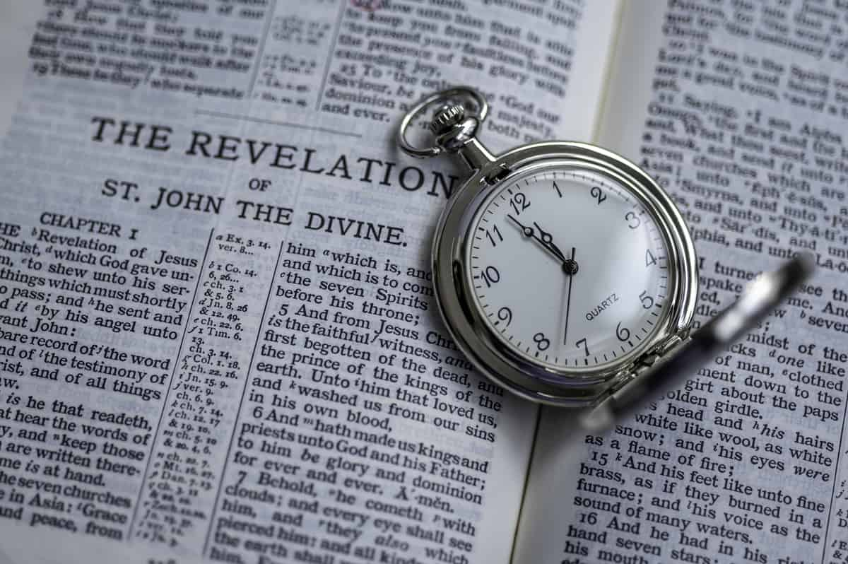

The Awesome Closing Message Revelation 22
Gene Dahler – 6/24/2025

Review:
___________________________________________________________________________________________________________________________________________________________________________________________________________________________________________________________________________________

Revelation 22:1-21
1 Then he showed me a river of the water of life, clear as crystal, coming from the throne of God and of the Lamb,
2 in the middle of its street. On either side of the river was the tree of life, bearing twelve kinds of fruit, yielding its fruit every month; and the leaves of the tree were for the healing of the nations.
____________________________________________________________________________________________________________________________________________________________________________________________________________________________

3 There will no longer be any curse; and the throne of God and of the Lamb will be in it, and His bond-servants will serve Him;
4 they will see His face, and His name will be on their foreheads.
5 And there will no longer be any night; and they will not have need of the light of a lamp nor the light of the sun, because the Lord God will illumine them; and they will reign forever and ever.
____________________________________________________________________________________________________________________________________________________________________________________________________________________________

6 And he said to me, "These words are faithful and true"; and the Lord, the God of the spirits of the prophets, sent His angel to show to His bond-servants the things which must soon take place.
____________________________________________________________________________________________________________________________________________________________________________________________________________________________

7 "And behold, I am coming quickly. Blessed is he who heeds the words of the prophecy of this book."
_____________________________________________________________________________________________________________________________________________________________________
_______________________________________________________

Steps to heeding the words of this prophecy.
- Know what it says
- __________ it is true
- Realize the _________ of knowing it is true.
- Recognize _____________, ____________, ___________ and __________ teaching

It is a breakthrough moment when we realize that what we ________ is significantly more important than what we __________.

8 I, John, am the one who heard and saw these things. And when I heard and saw, I fell down to worship at the feet of the angel who showed me these things.
9 But he said to me, "Do not do that. I am a fellow servant of yours and of your brethren the prophets and of those who heed the words of this book. Worship God."
______________________________________________________________________________________________________________

:9 - Who is the angel a fellow servant of?
1. The apostle John
2. The prophets
3. “Those who heed the words of this book”

10 And he said to me, "Do not seal up the words of the prophecy of this book, for the time is near.
_____________________________________________________________________________________________________________________________________________________________________

11 "Let the one who does wrong, still do wrong; and the one who is filthy, still be filthy; and let the one who is righteous, still practice righteousness; and the one who is holy, still keep himself holy."
12 "Behold, I am coming quickly, and My reward is with Me, to render to every man according to what he has done.

:12 We will all receive a reward, the crown of righteousness.

2 Tim 4:8 in the future there is laid up for me the crown of righteousness, which the Lord, the righteous Judge, will award to me on that day; and not only to me, but also to all who have loved His appearing.
__________________________________________________________________________________________________________________________

13 "I am the Alpha and the Omega, the first and the last, the beginning and the end."
14 Blessed are those who wash their robes, so that they may have the right to the tree of life, and may enter by the gates into the city.
15 Outside are the dogs and the sorcerers and the immoral persons and the murderers and the idolaters, and everyone who loves and practices lying.
______________________________________________________________________________________________________________

16 "I, Jesus, have sent My angel to testify to you these things for the churches. I am the root and the descendant of David, the bright morning star."
______________________________________________________________________________________________________________

17 The Spirit and the bride say, "Come." And let the one who hears say, "Come." And let the one who is thirsty come; let the one who wishes take the water of life without cost.
______________________________________________________________________________________________________________

18 I testify to everyone who hears the words of the prophecy of this book: if anyone adds to them, God will add to him the plagues which are written in this book;
19 and if anyone takes away from the words of the book of this prophecy, God shall take away his part from the Book of Life, from the holy city, and from the things which are written in this book.
_____________________________________________________________________________________________________________________________________________________________________

20 He who testifies to these things says, "Yes, I am coming quickly." Amen. Come, Lord Jesus.
__________________________________________________________________________________________________________________________

21 The grace of the Lord Jesus be with all. Amen. NASU/NKJV

SUMMARY PERSPECTIVE -

What do the words we have been asked to heed reveal to us?
- History now makes sense
- The previous 65 books now make sense
- The conditions of the church today (Rev 2 & 3)
- The next time God directly intervenes on earth (rapture).
- What we will be experiencing and doing in heaven
- Where we are going next (Earth)
- What we will do when we get there (Kingdom of Priests)
- How long will we be there (1,000 years)
- Where we are going after that (New Jerusalem)
- What it will be like there
- How long we will be there (For eternity)
- Who will be with us on our journey (Jesus)
- Who will be with us at our destination (Our heavenly Father and His Son)

No other book reveals this to us. It really is a Revelation.
______________________________________________________________________________________________________________

What are the blessings of knowing this book while still here on earth?
- Comfort
- Angelic fellow servants
- Truth based perspective for life
- Knowing who God is, who you are, where you are in time and what’s the plan
- Living it (peace, rest, freedom & power)
- Knowing we will not experience the tribulation period
- Understanding we are literally living this book of truth
______________________________________________________________________________________________________________

file: 250624 – HO Rev-22 rev g.doc

