Today In Prophecy – July 21, 2020

Presented by Gene Dahler

Today, with all that’s going on in the world, it is of great advantage to be a Bible-based Christian. For we are the only ones that really understand where we are in time. Biblical prophecy of the end of the church age and current events are merging together as one. We are living in the time of the signs. The world may be in turmoil, but we know that everything is simply falling into place. The important thing is that we should never forget who we are or where we are in time. Have a look at the time line below.

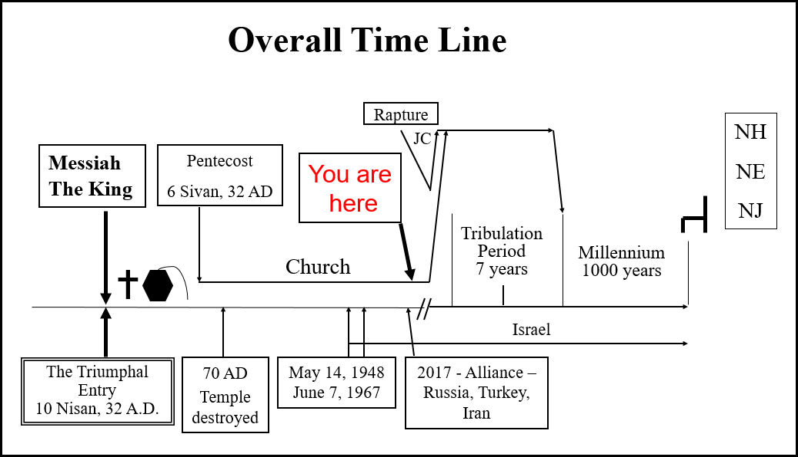

You have seen this timeline many times if you have attended the Verse-by-Verse Bible Study. It is essential that we understand where we are in time. We can be confident we know where we are because of the details we have of God’s plan and the signs that have occurred.

In preparation for the coming church era, Jesus had this lesson for the apostles who relayed it to us.

Luke 21:28-33

28 "But when these things begin to take place, straighten up and lift up your heads, because your redemption is drawing near."

29 Then He told them a parable: "Behold the fig tree and all the trees;

30 as soon as they put forth leaves, you see it and know for yourselves that summer is now near.

31 "So you also, when you see these things happening, recognize that the kingdom of God is near.

32 "Truly I say to you, this generation will not pass away until all things take place.

33 "Heaven and earth will pass away, but My words will not pass away.

NASU

He said that we should be watching because when we see some of “these things” start to appear that our redemption is drawing near.

And then He said no less than 10 times to **be watching for My return**. Here are just a few of those verses.

Mt 24:42 "Therefore be on the alert (watch), for you do not know which day your Lord is coming.

Mk 13:37 "What I say to you I say to all, 'Be on the alert (watch)!'"

Lk 21:34 "Be on guard, so that your hearts will not be weighted down with dissipation and drunkenness and the worries of life, and that day will not come on you suddenly like a trap;

Lk 21:35 for it will come upon all those who dwell on the face of all the earth.

Lk 21:36 "But keep on the alert (watch) at all times, praying that you may have strength to escape all these things that are about to take place, and to stand before the Son of Man."

So, you may be thinking, what are some of the “these things” we have already seen? Here are examples of things that have recently (last 20 years) happened.

**Pestilence / Plague**

Chinese communist virus (Covid-19) is a good example. We are told in the tribulation period, there will be plagues and pestilence (Lk 21:11; Rev 6:8). Now we have one in the church era. Were we told in advance that there would be a virus specifically. No. But we were told that we would see the beginning of the things of the tribulation period which include plagues and pestilence. The Chinese Communist virus is most likely nothing more than a preview of what is to come on earth in the tribulation period.

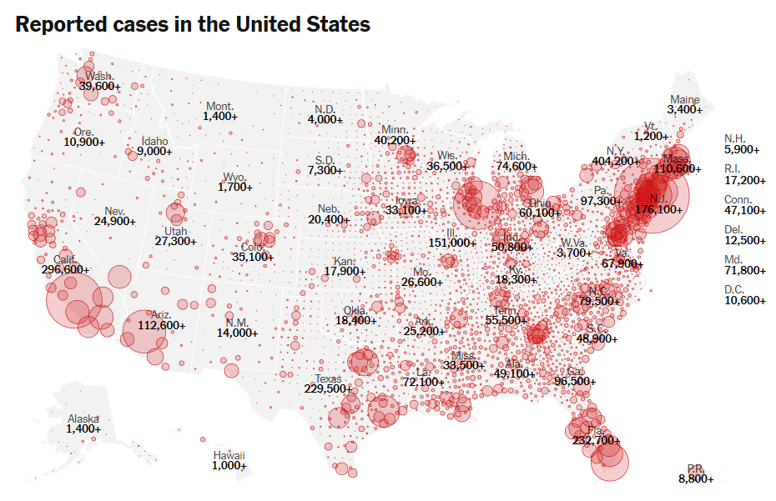

**Homosexuality**

The acceptance of homosexuality and same sex marriage is another sign. In the year 2000, there was not a single country on Earth that had legalized same sex marriage. Today, in only 20 years, every nation on Earth has either legalize same sex marriage or accepts same sex marriage. The exception is the Muslim nations. The acceptance of same sex marriage spread throughout the world without anyone appearing to be leading the cause, but spread absolutely everywhere. Jesus specifically warned of this happening;

Luke 17:28-30

28 "It was the same as happened in the days of Lot: they were eating, they were drinking, they were buying, they were selling, they were planting, they were building;

29 but on the day that Lot went out from Sodom it rained fire and brimstone from heaven and destroyed them all.

30 "It will be just the same on the day that the Son of Man is revealed. NASU

On that day, perhaps very soon, when the Son of Man (Jesus) is revealed, the acceptance of the homosexuality of Sodom will be on the earth. Today perfectly qualifies for such a day.

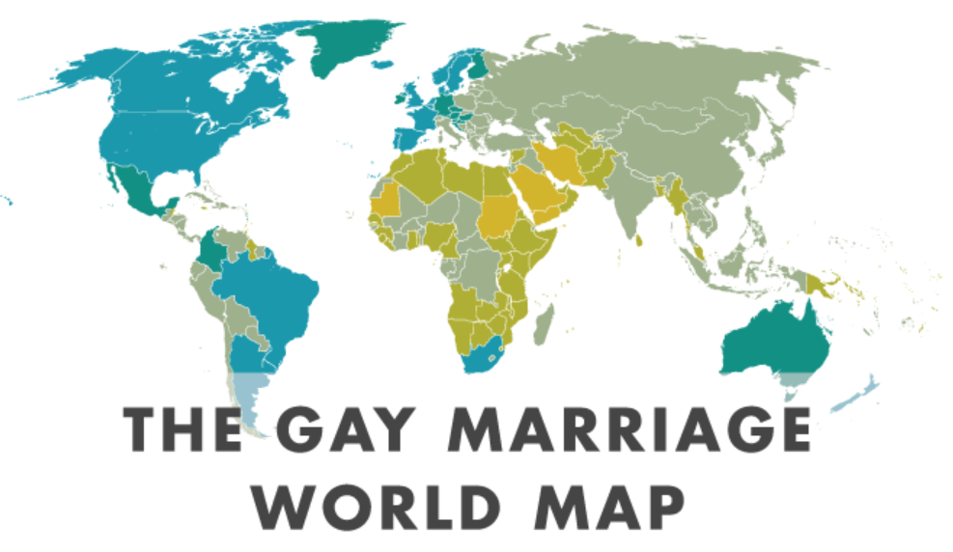

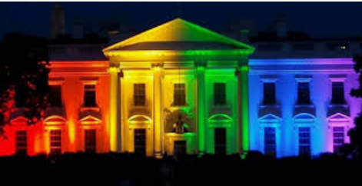

Jan 20, 2017. Obama’s last day in office.

**Ezekiel 38-39**

Ezekiel 38-39 speaks of a combination of nations that will organize an attack of Israel. The three most powerful nations today of the group are Russia, Turkey and Iran. Historians claim that an alliance of these nations has not occurred in all of recorded history, but it did happen in 2017. The battle with ISIS enabled Russia and Iran to develop a military presence in Syria on the northern border of Israel. This could be the setting of the stage of the fulfillment of the battle with Israel described in Ezekiel. Note: this alliance is on the time line.

Putin scores victory, will hold power until 2036

July, 2020 - 77.6% of Russian voters approve changes to the constitution that will allow Putin to potentially hold power until 2036.

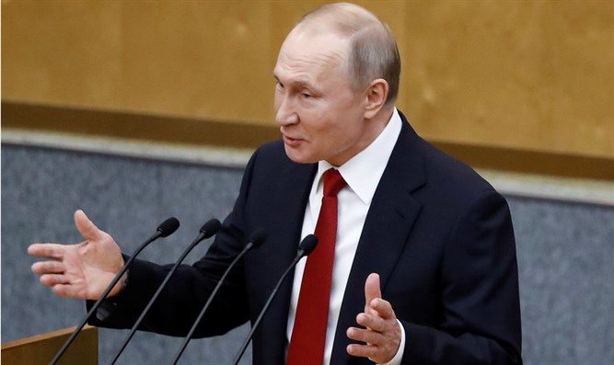

Vladimir Putin

Russian voters on Wednesday approved changes to the constitution that will allow President Vladimir Putin to potentially hold power until 2036, but the weeklong plebiscite was tarnished by widespread reports of pressure on voters and other irregularities, The Associated Press reported.

This pretty much assures, that if he lives, he will be Gog of the land of Magog (Russia). Ezek 38:2

**TECHNOLOGY**

Rev 13:16-17

16 And he causes all, the small and the great, and the rich and the poor, and the free men and the slaves, to be given a mark on their right hand or on their forehead,

17 and he provides that no one will be able to buy or to sell, except the one who has the mark, either the name of the beast or the number of his name. NASU

Rev 11:3-13

3 "And I will grant authority to my two witnesses, and they will prophesy for twelve hundred and sixty days, clothed in sackcloth."

9 Those from the peoples and tribes and tongues and nations will look at their dead bodies for three and a half days, and will not permit their dead bodies to be laid in a tomb. 10 And those who dwell on the earth will rejoice over them and celebrate; and they will send gifts to one another, because these two prophets tormented those who dwell on the earth. NASU

**Elon Musk And SpaceX Launched 58 Starlink Satellites And Three Planet SkySats Into Orbit On June 13 To Begin Circling The Planet With Internet**

'Once fully deployed, the SpaceX system will pass over virtually all parts of the Earth's surface and therefore, in principle, have the ability to provide ubiquitous global service,' the firm said. 'Every point on the Earth's surface will see, at all times, a SpaceX Starlink satellite.



June 16, 2020

# SpaceX has permission from the US government to launch up to 42,000 StarLink satellites into orbit around the Earth, creating an internet web circling the world.



**WAR**

Matt 24:6-7

6 "You will be hearing of wars and rumors of wars. See that you are not frightened, for those things must take place, but that is not yet the end.

7 "For nation will rise against nation, and kingdom against kingdom, and in various places there will be famines and earthquakes. NASU

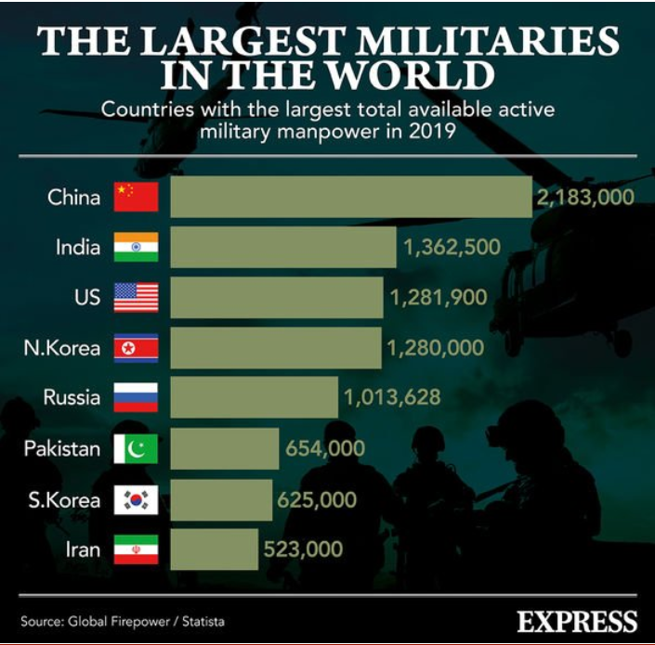

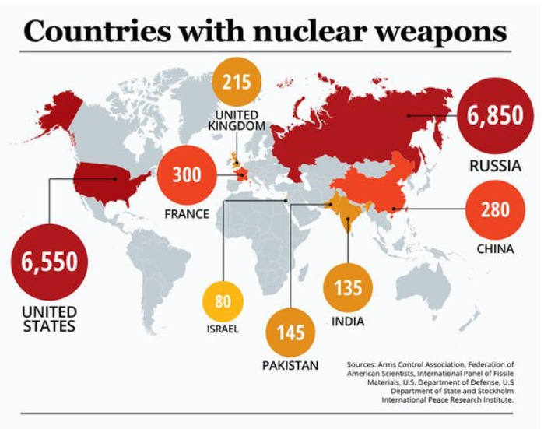

# 

# Iran prepares to confront Israel in Syria via Hezbollah

JUNE 7, 2020 20:46

Iran may be preparing for conflict with Israel in Syria and no longer will accept [Israeli](https://www.jpost.com/israel-news/netanyahu-coronavirus-wont-diminish-our-determination-to-stop-iran-630602) airstrikes on its warehouses without a response, a report over the weekend suggested.

# Israel announces successful launch of new spy satellite

Associated Press, 07.06.20 , 08:40

Israel successfully launched a new spy satellite early on Monday, the Defense Ministry confirmed.

It said the "Ofek 16" reconnaissance satellite was launched at 4am from central Israel into space. It described the Ofek as an "electro-optical reconnaissance satellite with advanced capabilities."

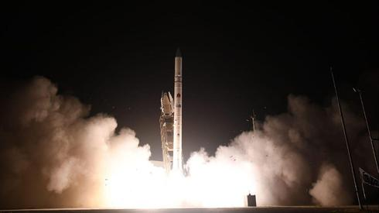

The launch of Ofek 16 (Photo: The Defense Ministry)

Shortly after the launch, it said the Ofek already was transmitting data and beginning to orbit around the Earth.

Iron Dome defense operations continue in Israel

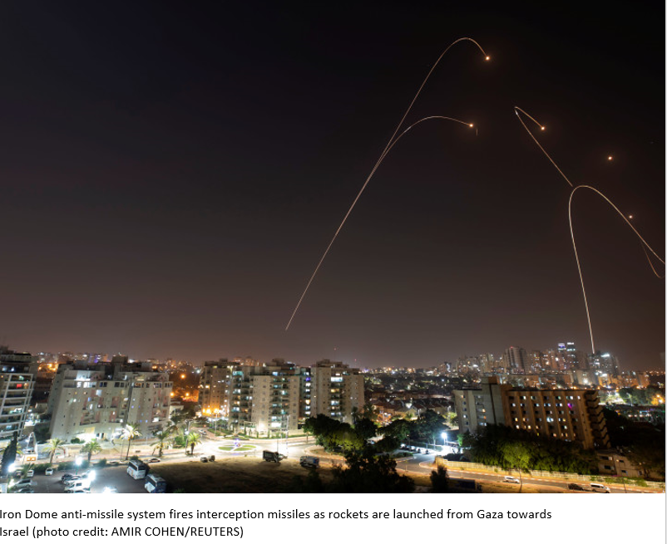

**Israel - Aliyah**

Ezek 36:24

24 "For I will take you from the nations, gather you from all the lands and bring you into your own land. NASU

# Amid Global Uncertainty, Record Numbers of Jews Return 'Home!



June 09, 2020

In a time of darkness, a time of pandemic, pandemonium and power struggles, a thin ray of light can be seen in the Jewish world.

In May, the number of North Americans applying to make aliyah was double what it was last year at this time (814 vs. 424). In fact, last month was the biggest ever in the 19-year history of Nefesh B'Nefesh, the nonprofit that with the help of Israel's government and the Jewish Agency for Israel has already shepherded some 60,000 North American Jews to new homes in Israel.

**AMERICA - War**

Two Russian Su-35 aircraft unsafely intercept a P-8A Poseidon patrol aircraft assigned to U.S. 6th Fleet over the Mediterranean Sea May 26, 2020. The intercept was determined to be unsafe and unprofessional due to the Russian pilots taking close station.

[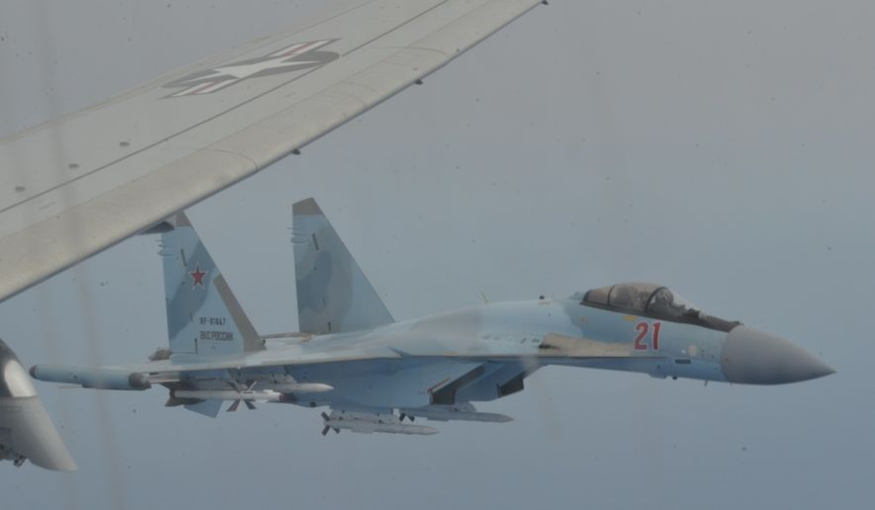](https://www.washingtontimes.com/multimedia/image/17_russiajpg/)

**American Military News – 6/10/20**

# US fighter jets intercept 8 Russian warplanes 30 miles from Alaska

NORAD F-22s, CF-18s, supported by KC-135 Stratotanker and E-3 Sentry AWACS aircraft, intercepted two Russian Tu-142 maritime reconnaissance aircraft entering the Alaskan Air Defense Identification Zone on Monday, March 9th. (NORAD photo/Released)

June 10, 2020

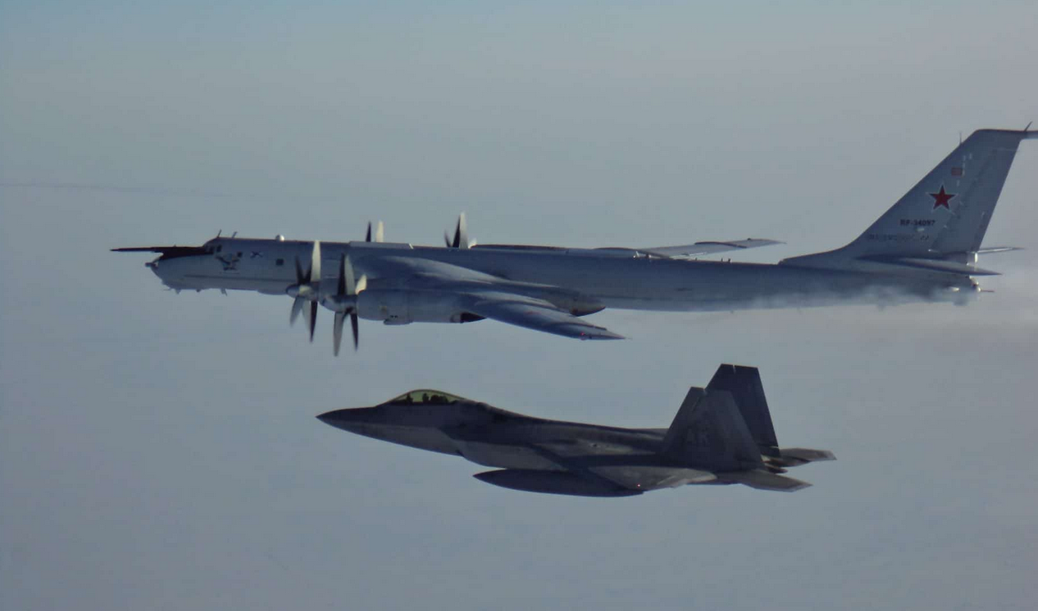

U.S. F-22 Raptor fighter jets intercepted two Russian bomber formations, comprised of Russian Tu-95 bombers, Su-35 fighter jets, and A-50 airborne early warning and control aircraft, just 30 miles from Alaska.

**China moving military ships near Taiwanese coast may spark US confrontation**



May 26, 2020 China's aircraft carrier, the Liaoning AFP

The Chinese Communist Party is readying two new aircraft carriers for deployment off the coast of Taiwan that could lead to a [military confrontation with the US](https://nypost.com/2020/05/25/china-says-us-pushing-relationship-to-brink-of-new-cold-war/) ships in the region, as the relationship between the two global powers has become strained by trade issues and the coronavirus pandemic, according to a report.

“The United States is also at risk of being drawn into a military conflict with China in this region as a result of U.S. defense treaty obligations to at least one of the claimants to the contested territory, the Philippines,” the council said.

# Iran builds fake US aircraft carrier to practice blowing it up

June 09, 2020

A mockup of a U.S. Nimitz-class aircraft carrier has appeared in the waters off the Iranian port city of Bandar Abbas, as tensions with U.S. Navy warships near the Persian Gulf have risen in recent weeks.

Satellite images [obtained by](https://apnews.com/8c0447c55b9db116e9472d1714597f4b) The Associated Press Tuesday show the model of the U.S. style aircraft carrier, complete with 16 mock up fighter jets on the deck.

As tensions remain high between Iran and the U.S., the Islamic Republic appears to have constructed a new mock-up of an aircraft carrier off its southern coast for potential live-fire drills.

[[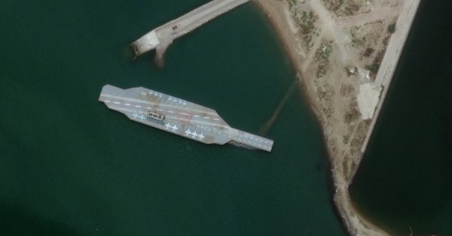](https://t.co/lio6w18Qpp)](https://t.co/lio6w18Qpp)

In April, 11 Iranian speedboats swarmed around six U.S. warships,

forcing the U.S. ships to maneuver to avoid collisions. A week after the incident, President Donald Trump threatened the U.S. would destroy any Iranian vessels sent to harass U.S. warships.

I have instructed the United States Navy to shoot down and destroy any and all Iranian gunboats if they harass our ships at sea.

Iran has been increasingly carrying out seaborn target practice following the exchange between U.S. and Iranian ships as well as Trump’s threatening remarks.

**AMERICA – LAWLESSNESS**

Gen 6:5

5 Then the Lord saw that the wickedness of man was great on the earth, and that every intent of the thoughts of his heart was only evil continually. NASU

Mt 24:12 "Because lawlessness is increased, most people's love will grow cold. NASU

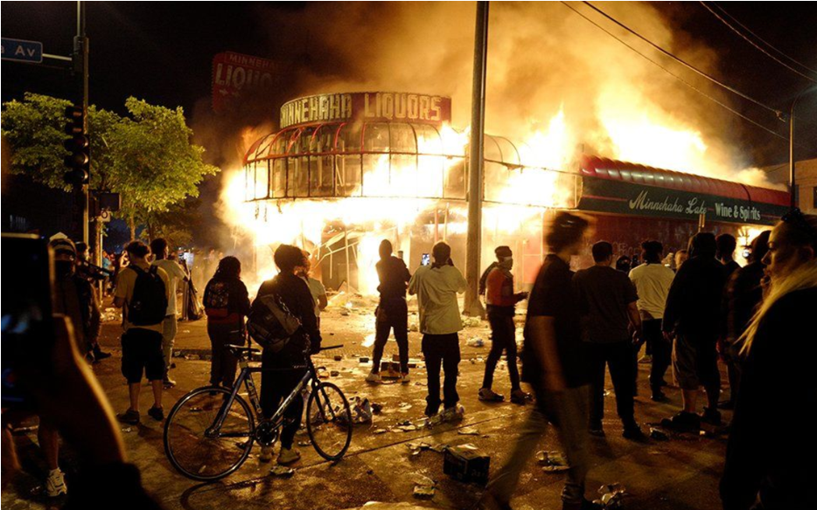

What do these people want? What are the goals of Black Lives Matter? Finally, a clear concise statement by a leader, Jaiden Grayson.

<https://www.facebook.com/watch/?v=665021610894791>

## **NYPD to disband 600-strong plainclothes anti-crimes unit in a move toward community-focused ’21st century policing’**

**The move will impact** some 600 plainclothes officers, who will be transitioned into other assignments like neighborhood policing and detective work. In the past, they’ve worked out of the department’s 77 precincts, targeting violent crime, [The New York Times reported](https://www.nytimes.com/2020/06/15/nyregion/nypd-plainclothes-cops.html).

IN THE NEWS – VARIOUS CITIES ARE DISCUSSING DEFUNDING POLICE DEPARTMENTS.

# Poll: 79% of truckers say they won’t deliver to cities that defund police

A recent poll of commercial truck drivers indicates nearly eight in 10 drivers would refuse to drive shipments to cities that have either defunded or disbanded their police departments.

Protests have formed against police agencies across the country after a black man, George Floyd, was killed while in Minneapolis police custody. On Friday, the Minneapolis City Council voted unanimously to conduct a year-long study of ways to [replace the city’s police department](https://americanmilitarynews.com/2020/06/minneapolis-approves-plan-to-create-community-alternative-to-police-department/).

# What are the people doing?

# FBI gun background checks set new record in June amid coronavirus, rioting fears

[](https://www.washingtontimes.com/multimedia/image/ap_virus_outbreak_pennsylvania_68706jpg/)

Background checks for gun sales surged again in June, smashing the record for the highest number of background checks in a single month, according to [FBI](https://www.washingtontimes.com/topics/federal-bureau-of-investigation/) data released Wednesday.

The [FBI](https://www.washingtontimes.com/topics/federal-bureau-of-investigation/) said it conducted 3.9 million checks in the National Instant Criminal Background Check System (NICS), shattering the previous record of 3.7 million checks in March.

And the number of checks represents a 70 percent increase over June 2019.

America

What should we expect as we approach the end of the church age?

What is the first two things that happen after the rapture of the church?

________________________________________________________________________________________________________________________

We need to have situational awareness in regard to the second thing.

* We have never been this far down this road before
* No one has ever been this far down this road before

We know that scripture says that there is going to be a one world government brought in by the Anti-Christ. We are now seeing throughout the world the acceptance of the concept of a one world government or as most call it the New World Order (NWO). Here in America we have seen the past 4 presidents; George H. W. Bush, Bill Clinton, George W. Bush and Barack Obama all referring to the global concept of the NWO. The USA presidential election of 2016 was evidently to be the final step for initiating the NWO as Hilary Clinton was to submit our country to membership. But since Clinton did not win, almost everything that is happening now is because the left’s plans to remake the United States from a Constitutional republic into borderless global state were thwarted by the people electing Donald J. Trump for president.  As a result, the left not only hates Trump for beating their savior Hillary Clinton, it also loathes the citizens who voted for him. Just try having a calm, rational political discussion with a democrat. Donald Trump is a nationalist president of the most powerful nation on earth and opposed to our involvement in the NWO movement. The election of 2016 didn’t just influence the governance of America, but the entire world. As a result, we see the political organizations of the world and those NWO backers in our own government doing their best to destroy our president.

Accurate situational perspective -

* + America is under attack by every NWO organization
  + The rate of worldly change is increasing
  + The only valid applicable advice available is in the Bible

The new world order (NOW) is not a new idea.

[Henry Kissinger](https://en.wikipedia.org/wiki/Henry_Kissinger) stated in 1994: "The New World Order cannot happen without U.S. participation, as we are the most significant single component. Yes, there will be a New World Order, and it will force the United States to change its perceptions".[[52]](https://en.wikipedia.org/wiki/New_world_order_(politics)#cite_note-53) Then on January 5, 2009, when asked on television by CNBC anchors about what he suggests [Barack Obama](https://en.wikipedia.org/wiki/Barack_Obama) focus on during the current Israeli crises he replied that it is a time to reevaluate American foreign policy and that "he can give new impetus to American foreign policy. [...] I think that his task will be to develop an overall strategy for America in this period, when really a 'new world order' can be created. It's a great opportunity. It isn't such a crisis".

The American Election and the NWO

This is not just an election of a president, it is an election that will determine how the world will be managed starting Jan 20, 2021.

Here is some recent history.



6/22/18

George Soros had this to say a couple of years after the 2016 election: “Trump is Winning, He’s Destroying the New World Order. “

George Soros recently expressed his frustration that “everything that could go wrong has gone wrong" referring to the rapid dismantling of the New World Order spearheaded by President Donald Trump. The billionaire globalist who financed countless Color Revolutions all across the world told the Washington Post that he was “living in [his] own bubble” due to failing to foresee Trump’s meteoric rise. Soros expressed fears that Trump “is willing to destroy the world" and vowed to “redouble [his] efforts” by pouring millions of dollars into opposing everything that the President stands for all across the world.

While the Hungarian-American (Soros) might come off as full of doom and gloom in his interview, he actually has a reason to feel that way because Trump has single-handedly presided over the dismantlement of the Liberal-Globalist world order that Soros has worked for decades to build. From Soros’ perspective, Trump is indeed destroying the world, albeit not in the apocalyptic sense like he’s implying but in the ideological one of pioneering a completely new level of national freedom rather than advancing towards the new world order that the President inherited from Obama.



The Obama-Soros vision was to have the media attack all of their opponents as “racist, fascist, white supremacists” for daring to think that the future might be different.

**July 6, 2020 - George Soros Launders $40,000,000 Into Anti-Trump Super PAC From Various NGO Front Groups, More Than Twice What He Spent Last Year Buying Votes**

George Soros has directly provided $5.5 million to his super PAC. Another $35 million came from his Fund for Policy Reform, a nonprofit in his Open Society Foundations network that reported having $750 million in the bank on its most recent tax forms. This arrangement allows Soros to keep his name from the top of lists highlighting the biggest donors to political committees while he gives tens of millions indirectly. Factoring in the money from the nonprofit, Soros's election spending eclipses that of any right-leaning donor this cycle.

**2020 is not** like 2016, the stakes are much higher, and the enemies of Trump are highly energized and extremely organized. Last time, they took for granted that Hillary would win, when she didn’t they had a mental breakdown. Now they stand ready to throw everything at Trump,

# What else is happening in regard to the election?

**Ted Cruz Questions Robert Epstein About Big Tech Election Interference – September 2, 2019**



Robert Epstein

The former Editor in Chief of Psychology Today responds to Sen. Cruz on big tech's manipulation of the voting process.

<https://www.c-span.org/video/?c4814811/user-clip-ted-cruz-questions-robert-epstein-big-tech-election-interference>

Who would have thought that in our lifetime we would see the whole world turn in favor of the NWO and witness one man standing strong in opposition, President Donald Trump.

We are in for an exciting 4 months.

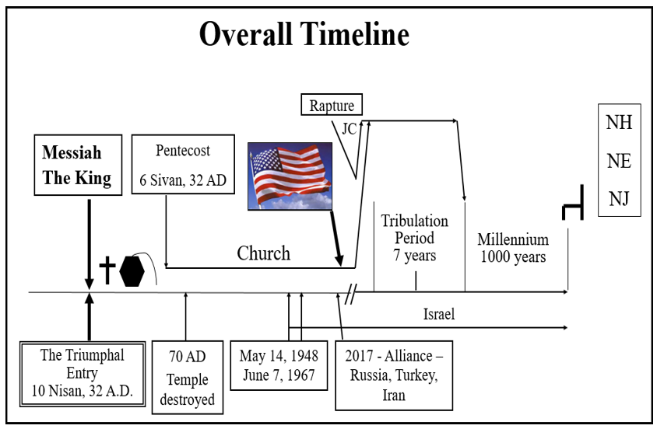

Remember – We have never been this far down this road before.

So what do we do now, since we have never been this far down this road before and we know there is a lot at stake? This is not another republican vs. democrat election like those of the past. This is nation freedom vs. socialistic NWO control for the country and NWO control of the world.

The Apostle Paul said a couple of things that would be very applicable to today.  Regardless of our situation, remember:

Phil 4:6-7

6 Be anxious for nothing (that would include the year 2020), but in everything by prayer and supplication with thanksgiving let your requests be made known to God.

7 And the peace of God, which surpasses all comprehension, will guard your hearts and your minds in Christ Jesus. NASU

Paul can live this way being anxious for nothing and able to get along regardless of his personal circumstances because he has faith in God’s plans. He knows, as a child of God, in the end he has an awesome inheritance to look forward to. We can have this same way of life today.

The apostle Paul wrote this to the church at Thessalonica.

1 Thess 4:16-18

16 For the Lord Himself will descend from heaven with a shout, with the voice of the archangel and with the trumpet of God, and the dead in Christ will rise first.

17 Then we who are alive and remain will be caught up together with them in the clouds to meet the Lord in the air, and so we shall always be with the Lord.

18 Therefore comfort one another with these words. NASU

Today many professing Christians are anxious and disturbed about current events. In this last prophecy that we will consider, Jesus tells us why. Jesus said the following about the people that would be living at this time. Here are the verses:

Mt 24:37-39 "For the coming of the Son of Man will be just like the days of Noah. For as in those days before the flood they were eating and drinking, marrying and giving in marriage, until the day that Noah entered the ark, and they did not understand until the flood came and took them all away; so will the coming of the Son of Man be.

Jesus says that at the end of the church era, the people will not know what is coming on earth. If we are close to the end, today would certainly be a fulfillment of that prophecy.

So, what is it that is coming on earth that the people don’t know is coming? Jesus described it this way.

Matt 24:21-22

21 "For then there will be a great tribulation, such as has not occurred since the beginning of the world until now, nor ever will.

22 "Unless those days had been cut short, no life would have been saved; but for the sake of the elect those days will be cut short. NASU

Jesus’ description of the coming tribulation period says it will be greater than anything that has happened so far. That would include the flood of Noah! (Tribulation period - Rev 6-19).

You already know if you watch many network news programs, you will not hear of this perspective from the major news media. They evidently do not know of God's preordained plan for earth for this period of time or the coming tribulation period. Therefore, their perspective on the issues is incomplete from a big picture standpoint.

What else is coming?

The departure of all believers in the Gospel is the next thing to come. In fact, it happens before the tribulation period starts. That is really good news. It is a blessing to know that we are not destined for the devastating period that is coming on earth called the tribulation period. Jesus promised this:

John 14:1-3

1 "Do not let your heart be troubled; believe in God, believe also in Me.

2 "In My Father's house are many dwelling places; if it were not so, I would have told you; for I go to prepare a place for you.

3 "If I go and prepare a place for you, I will come again and receive you to Myself, that where I am, there you may be also. NASU

Jesus said, “Do not let your hearts be troubled”. He promised He would appear coming for us before the devastating seven-year tribulation period starts (this is on the time line). Faith in our blessed hope gives us the ability to live like the Apostle Paul, “anxious for nothing”.

This “not knowing” prophecy (Mt 24:37-39), when I first discovered it, I thought would only apply to non-Christians. But, I have discovered it also applies to what must be at least 90% of the professing Christians in the United States of America. That is a perplexing perspective when, according to several polls, Americans have on the average of 2.5 to 4 Bibles in every household. This is the most concerning aspect of Jesus’ prophecy that those claiming to be God’s children do not know His message.

At this time, during the church era, we are apparently seeing the very beginning of the disastrous events of the tribulation to come. All this confirms that God's plan is unfolding just as Jesus said it would. We should be completely reassured that when we have found this information in God's Word that we have found the truth, that we are on the right track and that we have an incredible future.

So, there is one more thing we should be doing. That is to share this with all of your friends and relatives, especially those that are professing Christians, but don’t understand who they are or where they are in time. We need to do that now. Time is not on our side.

I pray this is helpful and perhaps has served as a bit of a reminder as to who we are and where we are in time. Be looking for our blessed hope, the return of Lord and Savior, Jesus Christ. Remember, the Lord knows who we are, where we are, what is happening and He will keep all of His promises.

Prophetic Perspective News Sources

Rapture Ready News - <http://www.raptureready.com/rapnews_db.php>

Koenig World Watch Daily - <http://www.watch.org/>

His Channel – World News Briefing & Breaking News - <http://www.hischannel.com/>

Israeli Middle East Conflict News - <https://www.debka.com/>