Today In Prophecy – August 17, 2021

Presented by Gene Dahler

**SITUATIONAL AWARENESS**

Today, with all that’s going on in the world, it is of great advantage to be a Bible-based born again Spirit filled pre-tribulation rapture Christian. For we are the only ones that really understand where we are in time. Biblical prophecy of the end of the church age and current events are merging together as one. We are living in the time of the signs. The world may be in turmoil, but we know that everything is simply falling into place. The important thing is that we should never forget who we are or where we are in time.

\_\_\_\_\_\_\_\_\_\_\_\_\_\_\_\_\_\_\_\_\_\_\_\_\_\_\_\_\_\_\_\_\_\_\_\_\_\_\_\_\_\_\_\_\_\_\_\_\_\_\_\_\_\_\_\_\_\_\_\_\_\_\_\_\_\_\_\_\_\_\_\_\_\_\_\_\_\_\_\_\_\_\_\_\_\_\_\_\_\_\_\_\_\_\_\_\_\_\_\_\_\_\_\_\_\_\_\_\_\_\_\_\_\_\_\_\_\_\_\_\_\_\_\_\_\_\_\_\_\_\_\_\_\_\_\_\_\_\_\_\_\_\_\_\_\_\_\_\_\_\_\_\_\_\_\_\_\_\_\_\_\_\_\_\_\_\_\_\_\_\_\_\_\_\_\_\_\_\_\_

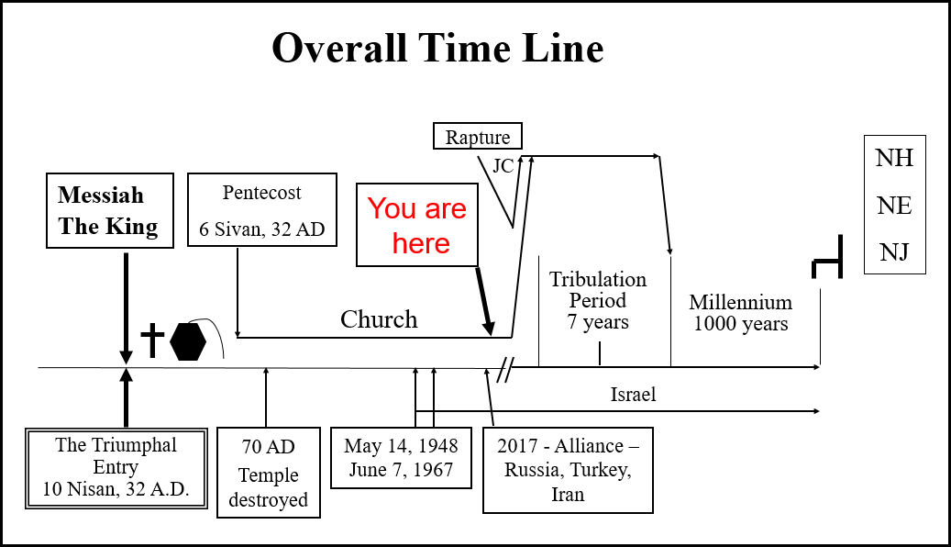

You have seen this timeline many times if you have attended the Verse-by-Verse Bible Study. It is essential that we understand where we are in time. We can be confident we know where we are because of the details we have of God’s plan and the signs that have occurred.

In preparation for the end of the coming church era, Jesus had this lesson for the apostles who relayed it to us.

Luke 21:28-33

28 "But when **these things** **begin** to take place, straighten up and lift up your heads, because your redemption is drawing near."

29 Then He told them a parable: "Behold the fig tree and all the trees;

30 as soon as they put forth leaves, you see it and know for yourselves that summer is now near.

31 "So you also, when you see **these things** happening, recognize that the kingdom of God is near.

32 "Truly I say to you, this generation will not pass away until all things take place.

33 "Heaven and earth will pass away, but My words will not pass away.

NASU

:28 He said that we should be watching because when we see “these things” begin to appear that our redemption is drawing near.

:32 – This generation will not pass away. The time could be as short as 7-10 years

And then He said no less than 10 times to **be watching for His return**. Here are just a few of those verses.

Mt 24:42 "Therefore be on the alert (watch), for you do not know which day your Lord is coming.

Mk 13:33 "Take heed, keep on the alert (watch); for you do not know when the appointed time will come.

Mk 13:37 "What I say to you I say to all, 'Be on the alert (watch)!'"

Lk 21:34 "Be on guard, so that your hearts will not be weighted down with dissipation and drunkenness and the worries of life, and that day will not come on you suddenly like a trap;

Lk 21:35 for it will come upon all those who dwell on the face of all the earth.

Lk 21:36 "But keep on the alert (watch) at all times, praying that you may have strength to escape all these things that are about to take place, and to stand before the Son of Man."

:36 Our promise and our prayer

So, you may be thinking, what are some of the “these things” (Lk 21:28) we are seeing today? We are starting with the two things most on the minds of Americans today.

We will start off by looking at six key major news “things” happening today.

**PESTILENCE / PLAGUE – Covid-19**

Chinese Communist Party virus (Covid-19) pandemic is the number 1 item for today’s world. We are told in the tribulation period, there will be plagues and pestilence (Lk 21:11; Rev 6:8). Now we have one in the church era. Were we told in advance that there would be a virus specifically. No. But we were told that we would see the beginning of the things of the tribulation period which include plagues and pestilence. The Chinese Communist Party virus pandemic is most likely nothing more than a light preview of what is to come on earth in the tribulation period.

**What do we know about the Covid-19 virus? Some fundamentals -**

Why is it called Covid-19?

'CO' stands for 'corona,' 'VI' for 'virus’, ‘D' for ‘disease’ and ‘19’ is for the year it was discovered. The virus that causes COVID-19, SARS-CoV-2, is a coronavirus.

Where is Covid-19 reported to exist?

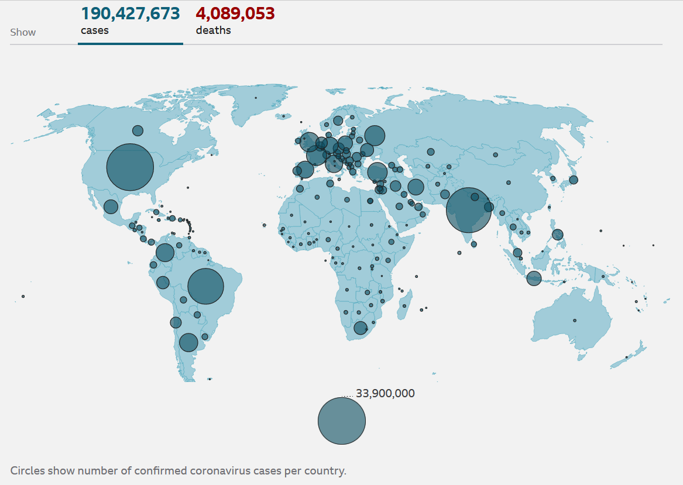



Why is America #1? We have done 150% PCR testing.

**What is a pandemic?**

Merriam-Webster - Definition of pandemic

An outbreak of a disease that occurs over a wide geographic area (such as multiple countries or continents) and typically affects a significant proportion of the population. A global pandemic seems to strike every few decades and kills by the million— perhaps 100m in the "Spanish" flu of 1918-19.

**What is Covid-19**

Wikipedia - The [ongoing pandemic](https://en.wikipedia.org/wiki/COVID-19_pandemic) of [COVID-19](https://en.wikipedia.org/wiki/COVID-19), which began in 2019 and is caused by [Severe acute respiratory syndrome coronavirus 2](https://en.wikipedia.org/wiki/Severe_acute_respiratory_syndrome_coronavirus_2), is the deadliest pandemic since Spanish flu due to its spread worldwide and high death toll.[[16]](https://en.wikipedia.org/wiki/Spanish_flu#cite_note-16)

**The last pandemic – The Spanish flu. Let’s check it out.**

Wikipedia - The **Spanish flu** was an unusually deadly [influenza pandemic](https://en.wikipedia.org/wiki/Influenza_pandemic) caused by the [H1N1 influenza A virus](https://en.wikipedia.org/wiki/Influenza_A_virus_subtype_H1N1). Lasting from February 1918 to April 1920, it infected 500 million people – about a third of the world's population at the time – in four successive waves. The death toll is typically estimated to have been somewhere between 20 million and 50 million, although estimates range from a conservative 17 million to a possible high of 100 million, making it one of the [deadliest pandemics](https://en.wikipedia.org/wiki/List_of_epidemics) in human history.[[3]](https://en.wikipedia.org/wiki/Spanish_flu#cite_note-:17-3)[[4]](https://en.wikipedia.org/wiki/Spanish_flu#cite_note-pmid30202996-4)[[5]](https://en.wikipedia.org/wiki/Spanish_flu#cite_note-5)

SUMMARY – SPANISH FLU PANDEMIC

Cases – 500 million – 33% of the world population

Time – Feb 1918 – Apr 1920 (26 months)

Deaths – 17 – 100 million. At 50 million deaths = 10% of the cases, 3% of the population (3 of 100)

**Death rate = 23 million/year (153 out of 10,000/year)**

Methods –

SUMMARY - Covid-19

Worldometers.info – 8/11/2021

Cases = 205 million – World population 7.8 billion – 2.6%

Time – Jan 2020 – August 2021 (20 months)

Deaths = 4.3M - .06% of population (6 of 10,000)

**Death rate – 2.6 million/year (3 out of 10,000)**

Methods –

# \_\_\_\_\_\_\_\_\_\_\_\_\_\_\_\_\_\_\_\_\_\_\_\_\_\_\_\_\_\_\_\_\_\_\_\_\_\_\_\_\_\_\_\_\_\_\_\_\_\_\_\_\_\_\_\_\_\_\_\_\_\_\_\_\_\_\_\_\_\_\_\_\_\_\_\_\_\_\_\_\_\_\_\_\_\_\_\_\_\_\_\_\_\_\_\_\_\_\_\_\_\_\_\_\_\_\_\_\_\_\_\_\_\_\_\_\_\_\_\_\_\_\_\_\_\_\_\_\_\_\_\_\_\_\_\_\_\_\_\_\_\_\_\_\_\_\_\_\_\_\_\_\_\_\_\_\_\_\_\_\_\_\_\_\_\_\_\_\_\_\_\_\_\_\_\_\_\_\_\_\_\_\_\_\_\_\_\_\_\_\_\_\_\_\_\_\_\_\_\_\_\_\_\_\_\_\_\_\_\_\_\_\_\_\_\_\_\_\_\_\_\_\_\_\_\_\_\_\_\_\_\_\_\_\_\_\_\_\_\_

CONCLUSION – the Covid-19 virus exists. However, the good news is the Covid-19 pandemic does not!!!! It does not impact a significant portion of the world population.

**VACCINE**

Merriam-Webster - Definition of vaccine

**A** preparation that is administered (as by injection) to stimulate the body's [immune response](https://www.merriam-webster.com/dictionary/immune%20response) against a specific infectious agent or disease: such as an antigenic preparation of a typically inactivated or attenuated pathogenic agent or one of its components or products. Many vaccines are made from the virus itself, either weakened or killed, which will induce antibodies to bind and kill a live virus. Measles vaccines are just that, weakened measles viruses.

Today’s Covid-19 vaccine is an experimental gene therapy shot.

Never tried before on humans.

6/21 - Shock: European Union Reports 1.5 Million Vaccine Injuries, 15,472 Deaths

The European database of suspected drug reaction reports is *[EudraVigilance,](http://www.adrreports.eu/en/index.html" \t "_blank)* which also tracks reports of injuries and deaths following the experimental COVID-19 “vaccines.”

SINGAPORE, July 23 (Reuters) - Vaccinated individuals accounted for three-quarters of Singapore's COVID-19 infections in the last four weeks, but they were not falling seriously ill, government data showed, as a rapid ramp-up in inoculations leaves fewer people unvaccinated.

**CDC just admitted that 74% of those infected in Massachusetts Covid outbreak were “fully vaccinated”**

Tuesday, August 03, 2021

# 8/8/21 – naturalnews.com

# “Fully vaccinated” Gibraltar sees 2,500 percent increase in “Covid” cases, prompting new lockdowns

# By June 1st, over 99% of Gibraltar's population was fully vaccinated. Since that time, new COVID cases per day have increased more than 2500%

Conclusion –

The more people that get “the shot”, the higher the percentage of new cases that have received it.

Perspective -

Red cross blood donations – 6/21 – 20% antibodies

Vaccinated new cases – 7/21 – 66% to 75%

\_\_\_\_\_\_\_\_\_\_\_\_\_\_\_\_\_\_\_\_\_\_\_\_\_\_\_\_\_\_\_\_\_\_\_\_\_\_\_\_\_\_\_\_\_\_\_\_\_\_\_\_\_\_\_\_\_\_\_\_\_\_\_\_\_\_\_\_\_\_\_\_\_\_\_\_\_\_\_\_\_\_\_\_\_\_\_\_\_\_\_\_\_\_\_\_\_\_\_\_\_\_\_\_\_\_\_\_\_\_\_\_\_\_\_\_\_\_\_\_\_\_\_\_\_\_\_\_\_\_\_\_\_\_\_\_\_\_\_\_\_\_\_\_\_\_\_\_\_\_\_\_\_\_\_\_\_\_\_\_\_\_\_\_\_\_\_\_\_\_\_\_\_\_\_\_\_\_\_\_\_\_\_\_\_\_\_\_\_\_\_\_\_\_\_\_\_\_\_\_\_\_\_\_\_\_\_\_\_\_\_\_\_\_\_\_\_\_\_\_\_\_\_\_\_\_\_\_\_\_\_\_\_\_\_\_\_\_\_\_\_\_\_\_\_\_\_\_\_\_\_\_\_\_\_\_\_\_\_\_\_\_\_\_\_\_\_\_\_\_\_\_\_\_\_\_\_\_\_\_\_\_\_\_\_\_\_\_\_\_\_\_\_\_\_\_\_\_\_\_

Covid-19/pseudo vaccine/lockdown/masks

# Mapping coronavirus anti-lockdown protests around the world



2 Feb 2021

Since the start of 2021, a growing number of countries have seen street demonstrations, some of which have turned violent, against government measures implemented to fight COVID-19.

Over the same period, nearly 100 countries have imposed nationwide lockdowns or stay-at-home orders, nearly one year since the World Health Organization declared COVID-19 a global pandemic.

### **Europe**

### \_\_\_\_\_\_\_\_\_\_\_\_\_\_\_\_\_\_\_\_\_\_\_\_\_\_\_\_\_\_\_\_\_\_\_\_\_\_\_\_\_\_\_\_\_\_\_\_\_\_\_\_\_\_\_\_\_\_\_\_\_\_\_\_\_\_\_\_\_\_\_\_\_\_\_\_\_\_\_\_\_\_\_\_\_\_\_\_\_\_\_\_\_\_\_\_\_\_\_\_\_\_\_\_\_\_\_\_\_\_\_\_\_\_\_\_\_\_\_\_\_\_\_\_\_\_\_\_\_\_\_\_\_\_\_\_\_\_\_\_\_\_\_\_\_\_\_\_\_\_\_\_\_\_\_\_\_\_\_\_\_\_\_\_\_\_\_\_\_\_\_\_\_\_\_\_\_\_\_\_

### **Rest of the world**

\_\_\_\_\_\_\_\_\_\_\_\_\_\_\_\_\_\_\_\_\_\_\_\_\_\_\_\_\_\_\_\_\_\_\_\_\_\_\_\_\_\_\_\_\_\_\_\_\_\_\_\_\_\_\_\_\_\_\_\_\_\_\_\_\_\_\_\_\_\_\_\_\_\_\_\_\_\_\_\_\_\_\_\_\_\_\_\_\_\_\_\_\_\_\_\_\_\_\_\_\_\_\_\_\_\_\_\_\_\_\_\_\_\_\_\_\_\_\_\_\_\_\_\_\_\_\_\_\_\_\_\_\_\_\_\_\_\_\_\_\_\_\_\_\_\_\_\_\_\_\_\_\_\_\_\_\_\_\_\_\_\_\_\_\_\_\_\_\_\_\_\_\_\_\_\_\_\_\_\_

Last year, the lawlessness was BLM and Antifa. This year it’s anti-lockdown, quarantine, mask, vaccination, etc. It is all about government action associated with the CCP virus.  
\_\_\_\_\_\_\_\_\_\_\_\_\_\_\_\_\_\_\_\_\_\_\_\_\_\_\_\_\_\_\_\_\_\_\_\_\_\_\_\_\_\_\_\_\_\_\_\_\_\_\_\_\_\_\_\_\_\_\_\_\_\_\_\_\_\_\_\_\_\_\_\_\_\_\_\_\_\_\_\_\_\_\_\_\_\_\_\_\_\_\_\_\_\_\_\_\_\_\_\_\_\_\_\_\_\_\_\_\_\_\_\_\_\_\_\_\_\_\_\_\_\_\_\_\_\_\_\_\_\_\_\_\_\_\_\_\_\_\_\_\_\_\_\_\_\_\_\_\_\_\_\_\_\_\_\_\_\_\_\_\_\_\_\_\_\_\_\_\_\_\_\_\_\_\_\_\_\_\_\_

# Ron DeSantis Is Defending Freedom By 'Getting In The Way' Of COVID Authoritarians

**“There is simply no evidence anywhere in the world that restricting the individual rights of citizens, segregating the unvaccinated from the vaccinated, and forcing people to wear masks all day would have any benefit whatsoever when it comes to stopping a virus.** Virtually every “public health” command and edict has come up empty, and these severely damaging policies have made matters worse across the board.”

**AMERICA – LAWLESSNESS**

Gen 6:5

5 Then the Lord saw that the wickedness of man was great on the earth, and that every intent of the thoughts of his heart was only evil continually.

NASU

Mt 24:12 "Because lawlessness is increased, most people's love will grow cold. NASU

We have covered anti-lockdown lawlessness, but the BLM Antifa activity continues.

# May, 2021 - Portland police declare riot, arrest 5, as marchers break windows on anniversary of George Floyd’s murder

# George Soros Gives $1 Million To Group Trying To "Defund The Police" Amid Surge In Crime. Washington Free Beacon [reported](https://freebeacon.com/democrats/george-soros-funnels-1m-to-defund-the-police-as-violent-crime-surges/) on July 22

**What are the people doing? Same as last year.**

# FBI gun background checks set new record amid BLM, Antifa, coronavirus, illegal aliens, lockdown rioting fears

The Federal Bureau of Investigation processed a record **39.7 million firearm background checks** last year — 40% more than the year before. 2021 background checks will exceed 50 M at the current rate.

\_\_\_\_\_\_\_\_\_\_\_\_\_\_\_\_\_\_\_\_\_\_\_\_\_\_\_\_\_\_\_\_\_\_\_\_\_\_\_\_\_\_\_\_\_\_\_\_\_\_\_\_\_\_\_\_\_\_\_\_\_\_\_\_\_\_\_\_\_\_\_\_\_\_\_\_\_\_\_\_\_\_\_\_\_\_\_\_\_\_\_\_\_\_\_\_\_\_\_\_\_\_\_\_\_\_\_\_\_\_\_\_\_\_\_\_\_\_\_\_\_\_\_\_\_\_\_\_\_\_\_\_\_\_\_\_\_\_\_\_\_\_\_\_\_\_\_\_\_\_\_\_\_\_\_\_\_\_\_\_\_\_\_\_\_\_\_\_\_\_\_\_\_\_\_\_\_\_\_\_\_\_\_\_\_\_\_\_\_\_\_\_\_\_\_\_\_\_\_\_\_\_\_\_\_\_\_\_\_\_\_\_\_\_\_\_\_\_\_\_\_\_\_\_\_\_\_\_\_\_\_\_\_\_\_\_\_\_\_\_

**WARS and RUMORS of WARS**

Matt 24:6-7

6 "You will be hearing of wars and rumors of wars. See that you are not frightened, for those things must take place, but that is not yet the end.

7 "For nation will rise against nation, and kingdom against kingdom, and in various places there will be famines and earthquakes. NASU

**RUSSIA**

**Russia announces successful test of 5,000mph hypersonic missile**

# Russia Producing Two New 'Doomsday Planes' As Mobile Command Centers In Event Of Nuclear War

# Russia’s Gigantic Submarine, Belgorod, Sails For The First Time

# Russia’s new ‘Checkmate’ stealth jet expected to arrive in Mideast

# \_\_\_\_\_\_\_\_\_\_\_\_\_\_\_\_\_\_\_\_\_\_\_\_\_\_\_\_\_\_\_\_\_\_\_\_\_\_\_\_\_\_\_\_\_\_\_\_\_\_\_\_\_\_\_\_\_\_\_\_\_\_\_\_\_\_\_\_\_\_\_\_\_\_\_\_\_\_\_\_\_\_\_\_\_\_\_\_\_\_\_\_\_\_\_\_\_\_\_\_\_\_\_\_\_\_\_\_\_\_\_\_\_\_\_\_\_\_\_\_\_\_\_\_\_\_\_\_\_\_\_\_\_\_\_\_\_\_\_\_\_\_\_\_\_\_\_\_\_\_\_\_\_\_\_\_\_\_\_\_\_\_\_\_\_\_\_\_\_\_\_\_\_\_\_\_\_\_\_\_

**CHINA**

# Researchers find 110 more secret Chinese nuclear missile silos under construction

**US moves 35 fighter jets closer to China for attack drills** americanmilitarynews.com

# UK Defies Chinese Communist Party, Deploys Warships to Disputed South China Sea

**German warship heads for South China Sea amid tension with Beijing** Reuters - August 2, 2021

**RUSSIA & CHINA**

# Russia, China hold joint military exercise for first time hosted on Chinese soil. israel365news.com

# \_\_\_\_\_\_\_\_\_\_\_\_\_\_\_\_\_\_\_\_\_\_\_\_\_\_\_\_\_\_\_\_\_\_\_\_\_\_\_\_\_\_\_\_\_\_\_\_\_\_\_\_\_\_\_\_\_\_\_\_\_\_\_\_\_\_\_\_\_\_\_\_\_\_\_\_\_\_\_\_\_\_\_\_\_\_\_\_\_\_\_\_\_\_\_\_\_\_\_\_\_\_\_\_\_\_\_\_\_\_\_\_\_\_\_\_\_\_\_\_\_\_\_\_\_\_\_\_\_\_\_\_\_\_\_\_\_\_\_\_\_\_\_\_\_\_\_\_\_\_\_\_\_\_\_\_\_\_\_\_\_\_\_\_\_\_\_\_\_\_\_\_\_\_\_\_\_\_\_\_

**ISRAEL**

[**Amid rising tensions, Gantz says Israel is ready to strike in Iran**](https://www.timesofisrael.com/amid-rising-tensions-gantz-says-israel-is-ready-to-strike-in-iran/)**. Iran is 10 weeks from breakout to a nuclear weapon** prophecynewswatch.com

# The Clock Is Ticking - Countdown To Conflict Between Israel And Iran

# prophecynewswatch.com

# IDF requests funding for a potential strike on Iran, reports say

7/15/21 – ynetnews.com

\_\_\_\_\_\_\_\_\_\_\_\_\_\_\_\_\_\_\_\_\_\_\_\_\_\_\_\_\_\_\_\_\_\_\_\_\_\_\_\_\_\_\_\_\_\_\_\_\_\_\_\_\_\_\_\_\_\_\_\_\_\_\_\_\_\_\_\_\_\_\_\_\_\_\_\_\_\_\_\_\_\_\_\_\_\_\_\_\_\_\_\_\_\_\_\_\_\_\_\_\_\_\_\_\_\_\_\_\_\_\_\_\_\_\_\_\_\_\_\_\_\_\_\_\_\_\_\_\_\_\_\_\_\_\_\_\_\_\_\_\_\_\_\_\_\_\_\_\_\_\_\_\_\_\_\_\_\_\_\_\_\_\_\_\_\_\_\_\_\_\_\_\_\_\_\_\_\_\_\_

**USA**

# Top General Pushes Military CRT

The head of the Joint Chiefs of Staff, General Mark Milley. Our service members need to be "open-minded and widely read," especially, he argued, on issues like racism. June 25, 2021 Tony Perkings – Washington Watch

\_\_\_\_\_\_\_\_\_\_\_\_\_\_\_\_\_\_\_\_\_\_\_\_\_\_\_\_\_\_\_\_\_\_\_\_\_\_\_\_\_\_\_\_\_\_\_\_\_\_\_\_\_\_\_\_\_\_\_\_\_\_\_\_\_\_\_\_\_\_\_\_\_\_\_\_\_\_\_\_\_\_\_\_\_\_\_\_\_\_\_\_\_\_\_\_\_\_\_\_\_\_\_\_\_\_\_\_\_\_\_\_\_\_\_\_\_\_\_\_

**CLIMATE CHANGE**

# ‘We didn’t expect a monster like this’: Dixie Fire grows to single largest in Calif. history

# Siberian wildfires dwarf all others on Earth combined

# Smoke from massive wildfires in Russia's Siberia region has reached the geographic [North Pole](https://www.livescience.com/41955-north-pole.html) "for the first time in recorded history," according to NASA — while the forest blazes themselves are bigger than all the other wildfires currently burning in the world combined, one expert said.

# Fires to floods: Extreme weather is occurring worldwide

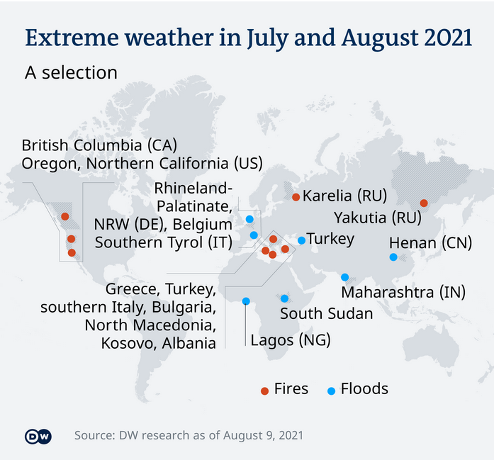

**America as multiple heat domes scorch the Pacific Northwest, Central states, and East Coast.**

**LAKE MEAD 8/11/2021**



**Climate change: Time running out to stop catastrophe.**

**The world is "dangerously close" to running out of time to stop a climate change catastrophe, the UK government's climate chief Alok Sharma has said.**

\_\_\_\_\_\_\_\_\_\_\_\_\_\_\_\_\_\_\_\_\_\_\_\_\_\_\_\_\_\_\_\_\_\_\_\_\_\_\_\_\_\_\_\_\_\_\_\_\_\_\_\_\_\_\_\_\_\_\_\_\_\_\_\_\_\_\_\_\_\_\_\_\_\_\_\_\_\_\_\_\_\_\_\_\_\_\_\_\_\_\_\_\_\_\_\_\_\_\_\_\_\_\_\_\_\_\_\_\_\_\_\_\_\_\_\_\_\_\_\_\_\_\_\_\_\_\_\_\_\_\_\_\_\_\_\_\_\_\_\_\_\_\_\_\_\_\_\_\_\_\_\_\_\_\_\_\_\_\_\_\_\_\_\_\_\_\_\_\_\_\_\_\_\_\_\_\_\_\_\_\_\_\_\_\_\_\_\_\_\_\_\_\_\_\_\_\_\_\_\_\_\_\_\_\_\_\_\_\_\_\_\_\_\_\_\_\_\_\_\_\_\_\_\_\_\_\_\_\_\_\_\_\_\_\_\_\_\_\_\_

**CRITICAL RACE THEORY**

### What is Critical Race Theory?

Critical Race Theory is a perspective on modern life—a worldview—that believes all the events and ideas around us in politics, education, entertainment and the media, the workplace, and beyond must be explained in terms of racial identities.

### Where did it come from?

German academics who wanted to find an authentic form of Marxism after World War I formed the “Frankfurt School” at the University of Frankfurt.

The early theorists combined the Marxist perspective that the world is divided only between oppressors and the oppressed and the postmodern idea that there is no “authentic truth,” only perspectives (called “narratives”).

**UFO**

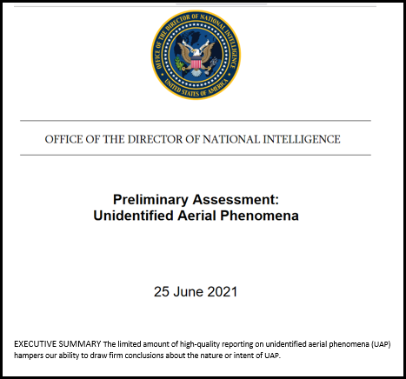

2021 - What are the major news media issues in the world today?

* Covid-19
* Lawlessness
* War
* Global Warming - Climate control
* CRT
* UFO

What do all 6 have in common???

Why might that be of great importance????

What is the only common sense solution to these issues????



What is the first thing to be established in the tribulation period? The reign of the anti-Christ initiating the Israeli peace agreement and the implementation of a one world government, referred to today as the New World Order.

Remember – We have never been this far down this road before. We are witnessing the beginning of the tribulation events and that is apparently influencing the actions of governments and organizations today. Possibly explaining the illogical actions of governments, especially ours. Government leaders attempting to use the experience of the past as their source of wisdom will not be able to make decisions that will produce the results they want today.

So what do we do now, since we have never been this far down this road before and we know there is a lot at stake?

The Apostle Paul said a couple of things that would be very applicable to today.  Regardless of our situation, remember:

Rom 8:18

18 For I consider that the sufferings of this present time are not worthy to be compared with the glory that is to be revealed to us. NASU

Phil 4:6-7

6 Be anxious for nothing (that would include the year 2021), but in everything by prayer and supplication with thanksgiving let your requests be made known to God.

7 And the peace of God, which surpasses all comprehension, will guard your hearts and your minds in Christ Jesus. NASU

Paul can live this way being anxious for nothing and able to get along regardless of his personal circumstances because he has faith in God’s plans. He knows, as a child of God, in the end he has an awesome inheritance to look forward to. We can have this same way of life today.

The apostle Paul wrote this to the church at Thessalonica.

1 Thess 4:16-18

16 For the Lord Himself will descend from heaven with a shout, with the voice of the archangel and with the trumpet of God, and the dead in Christ will rise first.

17 Then we who are alive and remain will be caught up together with them in the clouds to meet the Lord in the air, and so we shall always be with the Lord.

18 Therefore comfort one another with these words. NASU

Today many professing Christians are anxious and disturbed about current events. In the following prophecy, Jesus tells us why. Jesus said the following about the people that would be living at this time. Here are the verses:

Mt 24:37-39 "For the coming of the Son of Man will be just like the days of Noah. For as in those days before the flood they were eating and drinking, marrying and giving in marriage, until the day that Noah entered the ark, and they did not understand until the flood came and took them all away; so will the coming of the Son of Man be.

Jesus says that at the end of the church era, the people will not know what is coming on earth. If we are close to the end, today would certainly be a fulfillment of that prophecy.

So, what is it that is coming on earth that the people don’t know is coming? Jesus described it this way.

First, the beginning of the tribulation period devastation.

Second, the departure of all believers in the Gospel is the next thing to come. It happens before the tribulation period starts. That is really good news. It is a blessing to know that we are not destined for the devastating period that is coming on earth called the tribulation period. Jesus promised this:

John 14:1-3

1 "Do not let your heart be troubled; believe in God, believe also in Me.

2 "In My Father's house are many dwelling places; if it were not so, I would have told you; for I go to prepare a place for you.

3 "If I go and prepare a place for you, I will come again and receive you to Myself, that where I am, there you may be also. NASU

Jesus said, “Do not let your hearts be troubled”. He promised He would appear coming for us before the devastating seven-year tribulation period starts (this is on the time line). Faith in our blessed hope gives us the ability to live like the Apostle Paul, “anxious for nothing”.

At this time, during the church era, we are apparently seeing the very beginning of the disastrous events of the tribulation to come. All this confirms that God's plan is unfolding just as Jesus said it would. We should be completely reassured that when we have found this information in God's Word that we have found the truth, that we are on the right track and that we have an incredible future.

So, there is one thing we should be doing. That is to share this with all of your friends and relatives that are professing Christians, but don’t understand who they are or where they are in time. We need to do that now. Time is not on our side.

I pray this is helpful and perhaps has served as a bit of a reminder as to who we are and where we are in time. Be looking for our blessed hope, the return of Lord and Savior, Jesus Christ. Remember, the Lord knows who we are, where we are, what is happening and He will keep all of His promises.

Prophetic Perspective News Sources

Rapture Ready News - <http://www.raptureready.com/rapnews_db.php>

Koenig World Watch Daily - <http://www.watch.org/>

His Channel – World News Briefing - <http://www.hischannel.com/>

Israeli Middle East Conflict News - <https://www.debka.com/>

Olive Tree Views – Jan Markell – News Headlines and Radio Complete Archives - <https://olivetreeviews.org/>