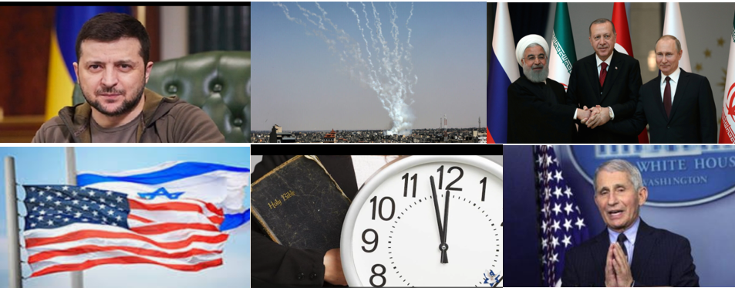
Today In Prophecy – Date 9/13/22
Presented by Gene Dahler
SITUATIONAL AWARENESS

Today, with all that’s going on in the world, it is of great advantage to be a Bible-based born again Spirit filled pre-tribulation rapture Christian. For we are the only ones that really understand where we are in time. Biblical prophecy of the end of the church age and current events are merging together as one. We are living in the time of the signs. The world may be in turmoil, but we know that everything is simply falling into place. The important thing is that we should never forget who we are or where we are in time.

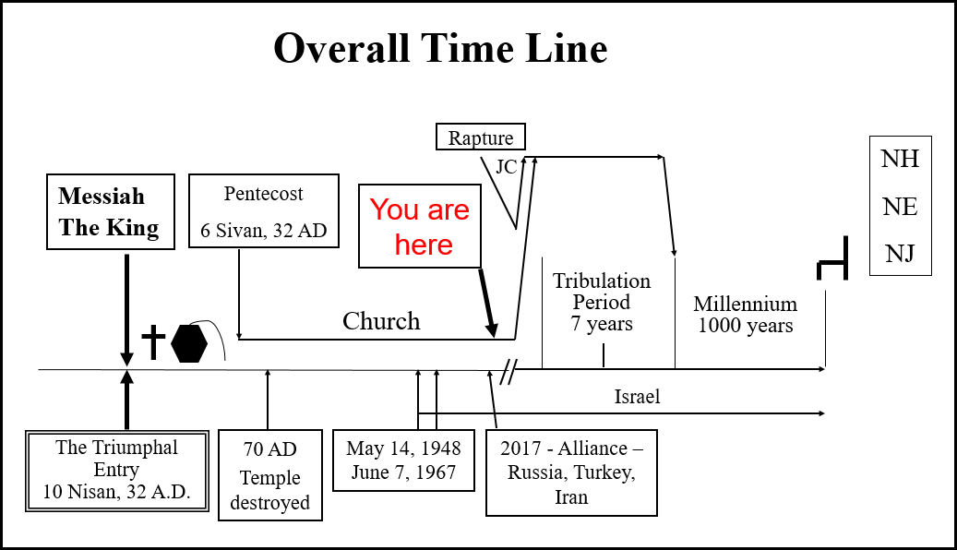
You have seen this timeline many times if you have attended the Verse-by-Verse Bible Study. We use this time line to help believers understand where we are in time. We can be confident we know where we are because of the details we have of God’s plan and the signs that have occurred.
____________________________________________________________________________________________________________________________________________________________________________________

ORDER OF TOPICS FOR THIS EVENING -

- Prophetic events that are specifically defined to happen today
- Events that possibly are the beginning of tribulation events
- Events regarding America
- Anticipated future events
- The most significant prophecy of today

1.Things specifically prophesied to happen before the rapture or in the “last days” that either have happened or are happening today.

Homosexuality - The expansion of the acceptability of homosexuality and same sex marriage is happening. Until 1973, homosexuality was considered a mental illness. In 2020, not a single nation had legalized same sex marriage. Today, practically every nation has either legalized or accepts it except for Muslim nations. (Luke 17:28-30)

False Teaching - False Bible teaching has prevailed as we approach the end of the church era. (1 Tim 4:1-3, 2 Peter 2:1-3, Acts 20:28-30, 2 Tim 4:3-4, 2 Peter 3:13-16)

The Christian Post reported (9/3/22) -
The findings were among several surprising responses as part of a survey conducted earlier this year by the Cultural Research Center at Arizona Christian University.
The American Worldview Inventory 2022 examined more than three dozen beliefs held by pastors. Researchers found that in addition to believing that people can merit salvation based solely on their good works, one-third or more of senior pastors surveyed also believe the Holy Spirit is not a person but rather “a symbol of God’s power." Others said that moral truth is subjective; sexual relations between two unmarried people who love each other is “morally acceptable" and biblical teaching on abortion is “ambiguous.”

Data reported earlier this year found just 37% of Christian pastors have a biblical worldview, the latest CRC report analyzed that research across all major U.S. denominations, and found that a “loss of biblical belief is prevalent among pastors in all denominational groupings.”

https://www.christianpost.com/news/third-of-evangelical-pastors-say-people-can-get-heaven-just-by-being-good.html

Difficult Times - Realize this, that in the “last days” difficult times will come. (Luke 21:11, Rev 6:8)
____________________________________________________________________________________________________________________________________

Mockers – In the “last days” there will be mockers from within and without the church denying the promises of God.
____________________________________________________________________________________________________________________________________

No Understanding – The people including the church will not know what is about to happen. This prophecy is being fulfilled today. This is a significant sign for today since the printed Bible is available everywhere and is on smart phones.

Matt 24:37-39
37 "For the coming of the Son of Man will be just like the days of Noah.
38 "For as in those days before the flood they were eating and drinking, marrying and giving in marriage, until the day that Noah entered the ark,
39 and they did not understand until the flood came and took them all away; so will the coming of the Son of Man be. NASU

For the people in Noah’s day, the flood was coming. For people today, the tribulation period is coming.
________________________________________________________________________________________________________________________

Church era beginning of tribulation period events. - In preparation for those alive at the end of the coming church era, Jesus had this lesson for the gospel writers who relayed it to us.

Luke 21:28-33
28 "But when these things begin to take place, straighten up and lift up your heads, because your redemption is drawing near."
29 Then He told them a parable: "Behold the fig tree and all the trees;
30 as soon as they put forth leaves, you see it and know for yourselves that summer is now near.
31 "So you also, when you see these things happening, recognize that the kingdom of God is near.
32 "Truly I say to you, this generation will not pass away until all things take place. NASU

:28 He said that we should be watching because when we see “these things” begin to appear that our redemption is drawing near.

What are the things? Answer - Things of the tribulation period.

:32 – This generation will not pass away. Those that survive on earth will see it all. The time could be as short as 7-10 years

This prophecy opens a large number of events of today that are likely the beginning of tribulation events that will have full impact in the tribulation period. Those events are the second category of prophecies.

2. There are things defined in the tribulation period that we may see the beginning of while still in the church era. Some have apparently not happened before in all of history.

The focus will now be on identifying and explaining some of the events. The verses are frequently short, but the details of the events are frequently fascinating.

Covid-19 Pandemic – Chinese Communist Party virus (Covid-19) pandemic and the related issues are most likely the number one tribulation end times event we are seeing the beginning of today. We are told in the tribulation period, there will be plagues and pestilence. Now we have one in the church era. Were we told in advance that there would be a virus specifically. No. But we were told that we would see the beginning of the things of the tribulation period which include plagues and pestilence. The Chinese Communist Party virus pandemic is most likely nothing more than a light preview of what is to come on the earth in the tribulation period. The key thing to understand is that there has not been a situation like this in all of history. A quick summary:
- An unelected medical bureaucrat took control of people worldwide
- The medical bureaucracy set up and established a false worldwide pandemic for a mild virus
- The medical bureaucracy prevented the use of safe effective medications for patients
- The medical bureaucracy forced an experimental untested gene therapy product falsely named a “vaccine” on people worldwide. A product that time has proven to be ineffective and dangerous.
- The governments worldwide endorsed the actions of the medical bureaucracy
- Millions have been significantly impacted and hundreds of thousands of people have died unnecessarily due to the restraints placed on medical physicians

Plagues and pestilence (in this case a pandemic) were anticipated for this time. However, no one anywhere was predicting it would not be real, a fraud. Such an event has apparently not happened in all of history.
(Lk 21:16, Rev 6:8)

Lawlessness – The lawlessness we witnessed in numerous countries in the past 2 years is unique because it could have been stopped by city, county, state or federal law enforcement at any time. However, the local governments held back law enforcement and allowed the lawlessness to continue. Supposedly this has not happened in all of history. This action by the governments was obviously to demoralize and destabilize the nations. This even led to several attempts to defund the police in numerous locations.

Today we have restrained lawlessness, but the governments are being careful not to eliminate it. Although lawlessness was anticipated for this time, no one was predicting that when it happened the governments would have the power to stop it, but wouldn’t. (2Thess 2:7, Mt:24:12)

One World Government Foundation - It appears that the foundation for the anti-Christ’s rule on earth is being laid. Globalism is being emphasized wherever and whenever possible, nationalism is being criticized and socialism is being promoted. All of the major issues being publicized (pandemic, war, UFO, environment, racial) have one obvious solution, a one world government. Candidates for the beginning of this today are the World Economic Forum, United Nations and the World Health Organization.

One World Religion - Pope Francis has laid much groundwork for the prophesied one-world religion. He has recruited the Anglican Archbishop, the Orthodox Metropolitan, assured Muslims that Allah and Jehovah are one and the same, pledged a continued relationship with the Jews, and persuaded some evangelical Protestants to agree that "Luther`s protest is over!"
A One World Religion Headquarters is set to open in 2023. The headquarters will be called The Abrahamic Family House and is being built on an island in the middle eastern city of Abu Dhabi. The headquarters is being done in collaboration with Pope Francis and Sunni Muslim leader, Sheikh Ahmen al-Tayeb, after they both signed a global peace covenant called the Document of Human Fraternity for World Peace.
________________________________________________________________________________________________________________________
Children Disobedient to Parents - Children will revolt against their parents. It has now become common practice for school teachers to teach students that it is acceptable for children to disobey and deceive parents, even to the point of not informing parents of an abortion or a program for gender change. This has primarily happened in the last 20 years. (2Tim 3:1-5, Rom 1:28-32)

Delusional Thinking – In the past 10-20 years, people have come to believe they can change genders (there are now 48), commit indecent acts and steal without consequences. Scripture says they have become fools and have depraved minds. (Rom 1:21-32)
________________________________________________________________________________________________________________________

Russia, Turkey & Iran Alliance - Ezekiel 38-39 speaks of a combination of nations that will organize an attack of Israel. The three most powerful nations today of the group are Russia, Turkey and Iran. Historians claim that an alliance of these nations has not occurred in all of recorded history, but it did happen in 2017. The stage appears to be set for the attack to occur.

Rise of Anti-Semitism. Anti-Jewish sentiment has been heating up in many places. It has recently become very bad in certain parts of Europe. It has even begun to rise again in America, where Jews have been relatively safe for since WWII. Some call this “the new normal”.

3. America –

There are things specifically happening in America apparently to bring about the demise of the country. In the New World Order (NWO), there is no room for a country that is attracting people from many other countries. Such a country or location has to be brought in line with the other places. This activity is most likely the planting of the foundation of the one world government of Revelation 13.

The new world order NWO is not a new idea.
Henry Kissinger stated in 1994: "The New World Order cannot happen without U.S. participation, as we are the most significant single component. Yes, there will be a New World Order, and it will force the United States to change its perceptions".^{[52]} Then on January 5, 2009, when asked on television by CNBC anchors about what he suggests Barack Obama focus on during the current Israeli crises he replied that it is a time to reevaluate American foreign policy and that "he can give new impetus to American foreign policy. [...] I think that his task will be to develop an overall strategy for America in this period, when really a 'new world order' can be created. It's a great opportunity. It isn't such a crisis".
The American Election and the NWO
The NOW believed that the 2020 election was not just an election of a president, it is an election that will determine how the world will be managed starting Jan 20, 2021.
Here is some recent history.
6/22/18
George Soros had this to say a couple of years after the 2016 election: “Trump is Winning, He’s Destroying the New World Order.“
George Soros recently expressed his frustration that “everything that could go wrong has gone wrong" referring to the rapid dismantling of the New World Order spearheaded by President Donald Trump. The billionaire globalist who financed countless Color Revolutions all across the world told the Washington Post that he was “living in [his] own bubble” due to failing to foresee Trump’s meteoric rise. Soros expressed fears that Trump “is willing to destroy the world" and vowed to “redouble [his] efforts” by pouring millions of dollars into opposing everything that the President stands for all across the world.
While the Hungarian-American (Soros) might come off as full of doom and gloom in his interview, he actually has a reason to feel that way because Trump has single-handedly presided over the dismantlement of the Liberal-Globalist world order that Soros has worked for decades to build. From Soros’ perspective, Trump is indeed destroying the world, albeit not in the apocalyptic sense like he’s implying but in the ideological one of pioneering a completely new level of national freedom rather than advancing towards the new world order that the President inherited from Obama.
The Obama-Soros vision was to have the media attack all of their opponents as “racist, fascist, white supremacists” for daring to think that the future might be different.
Actions today to advance the decline of America and the significance of the NWO are as follows.

Critical Race Theory (CRT) – This is being taught in public schools and is the perfect tactic for globalist to divide, demoralize and destabilize the citizens of the nation. It is referred to as systemic racism.

Southern Open Border – The current administration will work to keep the border open and to admit more illegal aliens. This is not only a destabilizing action, but if it is allowed to continue, will destroy the prominence of this country in time like a cancer. The NWO, in general, is opposed to borders.

$30T Debt – We have no idea what the consequences of this phenomenal debt may be, but it will most likely be one of the issues to attempt to bring about the decline of the nation.

Fraudulent Presidential Election – The acceptance of a known fraudulent presidential vote process on Jan 7, 2021 has demoralized the entire nation. The actions since Jan 20, 2021 that the current administration has initiated has the nation on the current overall decline and is continuing today.

Federal Corruption – The federal government disregarding the constitution and the law in general in its actions has continued since Jan 2021.

Free Speech - Attacks on free speech in colleges. For the past 10-20 years, presentations by conservative speakers has been shut down by revolting students in many of the large colleges in the nation. Freedom of speech, a constitutional right, is disregarded without opposition.

Censorship – Censorship of valid and important information by the so-called news and social media has deceived many and impacted the outcome of elections.

Education Administration – The public school system is attempting to take control of children from parents. Education administrators are now openly stating that parents have to understand the students are not your children, they are our children.

Increased Use of Drugs - Increasing use of illegal drugs is happening, evidently by the ease of bringing them in across our southern border. It has become easier to get illegal drugs delivered into our country than it is to get legitimate product off a ship to a consumer.

4. Anticipated future trends and events

- World will continue to lack a leader as long as the church is present.

- Sustained attention on viruses and pandemics.

- More emphasis on the environment.

Greenpeace Co-Founder Patrick Moore Says Climate Change Based On False Narratives
Thursday, Sep 08, 2022 - 05:20 PM
Patrick Moore, one of the founders of Greenpeace, said in an email obtained by The Epoch Times that his reasons for leaving Greenpeace were very clear: “Greenpeace was ‘hijacked’ by the political left when they realized there was money and power in the environmental movement. [Left-leaning] political activists in North America and Europe changed Greenpeace from a science-based organization to a political fundraising organization,” Moore said.
Moore left Greenpeace in 1986, 15 years after he co-founded the organization.
“The ‘environmental’ movement has become more of a political movement than an environmental movement,” he said. “They are primarily focused on creating narratives, stories, that are designed to instill fear and guilt into the public so the public will send them money.”
He said they mainly operate behind closed doors with other political operatives at the U.N., World Economic Forum, and so on, all of which are primarily political in nature.
The Intergovernmental Panel on Climate Change [IPCC] is “not a science organization,” he said. “It is a political organization composed of the World Meteorological Organization and the United Nations Environment Program.
“The IPCC hires scientists to provide them with ‘information’ that supports the ‘climate emergency’ narrative.
Their campaigns against fossil fuels, nuclear energy, CO2, plastic, etc., are misguided and designed to make people think the world will come to an end unless we cripple our civilization and destroy our economy. They are now a negative influence on the future of both the environment and human civilization.”
“Many [so-called] ‘environmental’ leaders were now saying that ‘humans are the enemies of the Earth, the enemies of Nature.’
He said the new dominant philosophy is that the world would be better if fewer people existed.
“But the people who said this were not volunteering to be the first to go away. They behave as if they are superior to others.
https://www.zerohedge.com/markets/greenpeace-co-founder-patrick-moore-says-climate-change-based-false-narratives

- Lawlessness around the world will continue

- Renewed focus on UFO’s

- New focus on asteroids coming through our solar system

- Conflicts, invasions and wars will continue.

What do all of these have in common? The solution for all is always the same, a one world government.

- The most significant sign that Jesus is coming soon.

Convergence – We have never had a convergence of events like what we are witnessing now. If a born again Spirit filled pre-tribulation rapture person steps back and considers what is happening, they will become aware of the high probability that we are in the season of the rapture of the church and the start of the tribulation period. It is important to realize this is different. Situational awareness has become very significant for people living today. Check the time line.

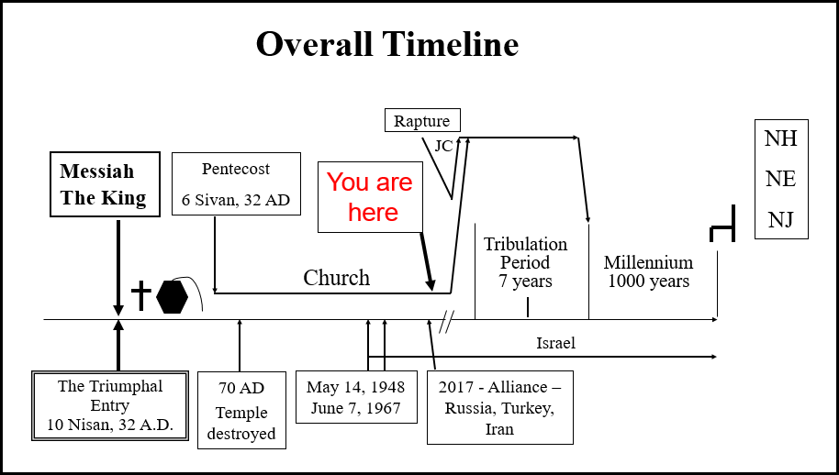

Situational awareness – Note where we are on the time line. Understand no one has ever been here before. Unusual events and strange changes will be happening as tribulation period events begin to influence what is happening on earth now. Today is definitely the time of the signs.

Regardless of how good or bad your personal situation of the past or present, remember always, the truth of the glory of what is going to happen in the future for all those that believe. The Apostle Paul’s perspective on life may be perfect for believers living today.
Phil 3:8-21
8 - - - - - I count all things to be loss in view of the surpassing value of knowing Christ Jesus my Lord, for whom I have suffered the loss of all things, and count them but rubbish so that I may gain Christ,
9 and may be found in Him, not having a righteousness of my own derived from the Law, but that which is through faith in Christ, the righteousness which comes from God on the basis of faith,
10 that I may know Him and the power of His resurrection and the fellowship of His sufferings, being conformed to His death;
11 in order that I may attain to the resurrection from the dead.

So, what does he do?

13 Brethren, I do not regard myself as having laid hold of it yet; but one thing I do: forgetting what lies behind and reaching forward to what lies ahead,
14 I press on toward the goal for the prize of the upward call of God in Christ Jesus.

Why?

20 For our citizenship is in heaven, from which also we eagerly wait for a Savior, the Lord Jesus Christ;
21 who will transform the body of our humble state into conformity with the body of His glory, by the exertion of the power that He has even to subject all things to Himself. NASU

We are actually really going to be like Jesus!!!!!!

Prophetic Perspective News Sources
Rapture Ready News - http://www.raptureready.com/rapnews_db.php
Koenig World Watch Daily - http://www.watch.org/
Olive Tree Views – Jan Markell – News Headlines and Radio Complete Archives - https://olivetreeviews.org/
Washington Watch - https://www.tonyperkins.com/
His Channel – World News Briefing - http://www.hischannel.com/

