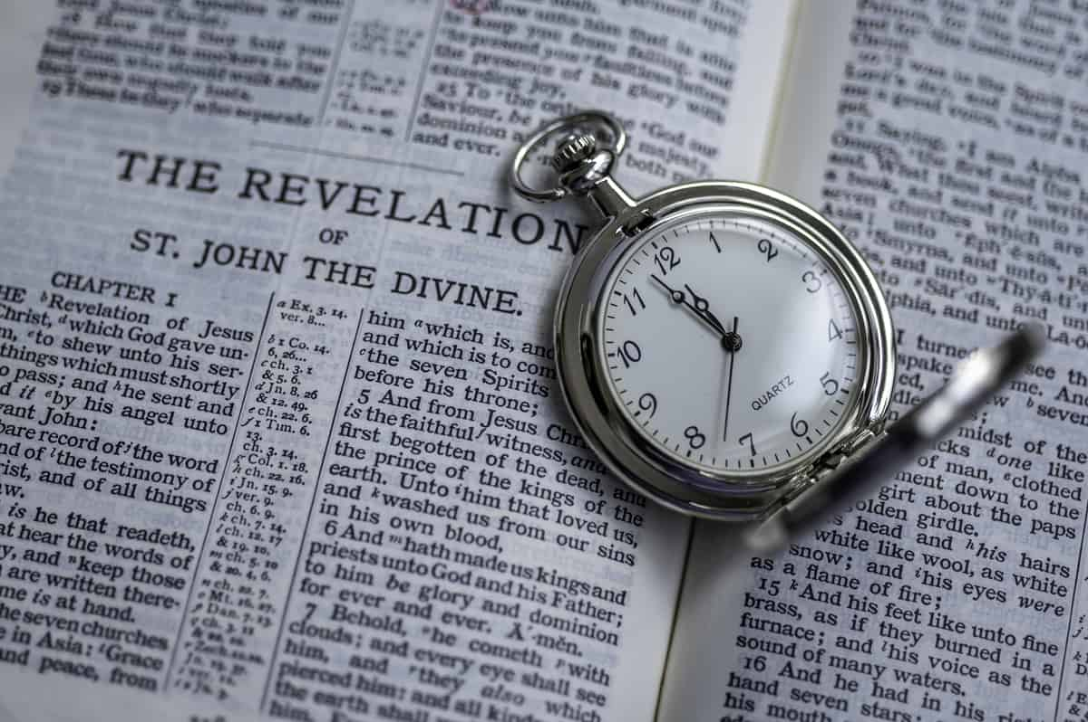
Revelation Introduction
2/11/2025
Presented by Clifford Phipps

2025 Revelation Chapter 2:8-17 Smyrna & Pergamum

Revelation 2:8-11 Smyrna

Church at Smyrna

Rev 2:8-11

8 "And to the angel of the church in Smyrna write:

The first and the last, who was dead, and has come to life, says this:

9 'I know your tribulation and your poverty (but you are rich), and the blasphemy by those who say they are Jews and are not, but are a synagogue of Satan.
10 'Do not fear what you are about to suffer. Behold, the devil is about to cast some of you into prison, so that you will be tested, and you will have tribulation for ten days. Be faithful until death, and I will give you the crown of life.
11 'He who has an ear, let him hear what the Spirit says to the churches. He who overcomes will not be hurt by the second death.'
NASU
________________________________________________________________________________________________________________________________________________________

To the Church at Smyrna – Myrrh
____________________________________________________________________________________________________________________________________________________________________________________________________________________________________

Title: Revelation 2:8 "And to the angel of the church in Smyrna write:
The first and the last, who was dead, and has come to life,

Commendations: Revelation Rev 2:9 'I know your tribulation and your poverty (but you are rich), and the blasphemy by those who say they are Jews and are not, but are a synagogue of Satan.

I know your tribulation.

I know your poverty (but you are rich).

(1 Peter 1:3-5)

I know the blasphemy of those who say they are Jews and are not, but are a synagogue of Satan
________________________________________________________________________________________________________________________________________________________

Criticism: None

Exhortation: Rev 2:10 'Do not fear what you are about to suffer. Behold, the devil is about to cast some of you into prison, so that you will be tested, and you will have tribulation for ten days. Be faithful until death, and I will give you the crown of life.
NASU

(John 16:33, 2 Tim 1:12)

The devil is about to cast some of you into prison.

Some of you will have tribulation for ten days.

(Phil 1:29, Rom 8:16-17)
____________________________________________________________________________________________________________________________________________________________________________________________________________________________________

REPORT CARD SUMMARY -

+ tribulation
+ poverty (but you are rich)
+ blasphemy of those who say they are Jews but are not

Closure: Revelation 2:11a "He who has an ear, let him hear what the Spirit says to the churches.

Promise to the Overcomer: Revelation 2:11b He who overcomes shall not be hurt by the second death.'' '

What is the second death?

(Rev 20:6)
____________________________________________________________________________________________________________________________________________________________________________________________________________________________________

This is the second death. It is an event for non-believers, it is the Lake of Fire

Revelation Chapter 2 - Pergamum

Church at Pergamum

Rev 2:12-17

12 "And to the angel of the church in Pergamum write:

The One who has the sharp two-edged sword says this:

13 'I know where you dwell, where Satan's throne is; and you hold fast My name, and did not deny My faith even in the days of Antipas, My witness, My faithful one, who was killed among you, where Satan dwells.
14 'But I have a few things against you, because you have there some who hold the teaching of Balaam, who kept teaching Balak to put a stumbling block before the sons of Israel, to eat things sacrificed to idols and to commit acts of immorality.
15 'So you also have some who in the same way hold the teaching of the Nicolaitans. 16 'Therefore repent; or else I am coming to you quickly, and I will make war against them with the sword of My mouth.
17 'He who has an ear, let him hear what the Spirit says to the churches. To him who overcomes, to him I will give some of the hidden manna, and I will give him a white stone, and a new name written on the stone which no one knows but he who receives it.'
NASU

To the Church at Pergamum – Mixed Marriage

Per – meaning opposition (Perversion)

Gamous – marriage. Monogamous (married to one person), polygamous (several spouses)

Pergamum means “marriage in opposition”.

Title: Rev 2:12 "And to the angel of the church in Pergamum write: The One who has the sharp two-edged sword:
____________________________________________________________________________________________________________________________________________________________________________________________________________________________________

Commendations: Rev 2:13 'I know where you dwell, where Satan's throne is; and you hold fast My name, and did not deny My faith even in the days of Antipas, My witness, My faithful one, who was killed among you, where Satan dwells.

“I know where you dwell, where Satan’s throne is, and you hold fast My name”.
________________________________________________________________________________________________________________________________________________________

And you hold fast to My name, and did not deny My faith even in the days in which Antipas was My faithful martyr, who was killed among you, where Satan dwells.
________________________________________________________________________________________________________________________________________________________

Criticism: Rev 2:14-16 'But I have a few things against you, because you have there some who hold the teaching of Balaam, who kept teaching Balak to put a stumbling block before the sons of Israel, to eat things sacrificed to idols and to commit acts of immorality. 15 'So you also have some who in the same way hold the teaching of the Nicolaitans.
____________________________________________________________________________________________________________________________________________________________________________________________________________________________________

Exhortation: Rev 2:16-17 'Therefore repent; or else I am coming to you quickly, and I will make war against them with the sword of My mouth.
____________________________________________________________________________________________________________________________________________________________________________________________________________________________________

REPORT CARD SUMMARY -

+ works
+ where you dwell (where Satan’s throne is)
+ you hold fast to My name
+ did not deny My faith, even when Antipas was martyred

- some hold to the teaching of Balaam
- put a stumbling block before the sons of Israel
- eat things sacrificed to idols
- commit acts of immorality
- hold the teachings of the Nicolaitans

Closure: Revelation 2:17 "He who has an ear, let him hear what the Spirit says to the churches.

Promise to the Overcomer: Rev 2:17b To him who overcomes, to him I will give some of the hidden manna, and I will give him a white stone, and a new name written on the stone which no one knows but he who receives it.'
NASU

Hidden manna.

White stone.

What Jesus is requiring of you is relational. Never once in any of these churches does Jesus ask you to do more. In fact, it appears that He is satisfied with what each of these churches are doing already.

What He does require is not more works but more of a relationship

- Ephesus - left their first love – Jesus is requiring Love
- Smyrna - Remain faithful until death - Jesus is requiring Commitment
- Pergamum - Don’t follow the doctrines of the world – Jesus is requiring Faithfulness

Successfully following these commands, Jesus promises

- Eat from the Tree of Life - Eternal Life
- Not hurt by the 2nd death No penalty for your sin
- Hidden Manna - Satisfaction to your hunger
- White Stone with a new name - Significance to your identity
____________________________________________________________________________________________________________________________________________________________________________________________________________________________________

Repent

As you study through scripture, the word repent is never used to describe a believer

The word repent in the New Covenant comes from the Greek word Metanoeo (met-an-o-eh'-o) which means to think differently, change one’s mind or turn around.

The term “repent” in the bible always means to turn away from the world and turn to God. Often times, you will find the phrase “repent and return to God”. Suggesting that the non-believer is to turn away from the direction that he was going in the world and to return to God.
____________________________________________________________________________________________________________________________________________________________________________________________________________________________________

(Matt 4:17, Mark 1:14-15, Luke 5:32, Luke 15:7)

There are……

- No verses in the New Covenant that instruct a saved person to repent
- There are no verses that instruct a person, saved or unsaved person repent of their sins.

How did this concept become so popular in our churches today?

- It’s an Old Covenant concept.

Mark 1:4-5
4 John the Baptist appeared in the wilderness preaching a baptism of repentance for the forgiveness of sins.
5 And all the country of Judea was going out to him, and all the people of Jerusalem; and they were being baptized by him in the Jordan River, confessing their sins.
NASU

This is Judaism. This is not how the New Covenant believer receives the forgiveness of sins. This is true before the cross. But this won’t save you after the cross.

Look at how Paul corrects some believers that are living under the New Covenant but are relying on the Baptism of John the Baptist.

Acts 19:1-7
19 It happened that while Apollos was at Corinth, Paul passed through the upper country and came to Ephesus, and found some disciples.
2 He said to them, "Did you receive the Holy Spirit when you believed?" And they said to him, "No, we have not even heard whether there is a Holy Spirit."
3 And he said, "Into what then were you baptized?" And they said, "Into John's baptism."
4 Paul said, "John baptized with the baptism of repentance, telling the people to believe in Him who was coming after him, that is, in Jesus."
5 When they heard this, they were baptized in the name of the Lord Jesus.
6 And when Paul had laid his hands upon them, the Holy Spirit came on them, and they began speaking with tongues and prophesying.
7 There were in all about twelve men.
NASU

- It is Translational

The phrase “repent of your sins” is never found in the NASB, KJ, NKJ, NIV

It is, however, found in the NLT in the following verses.

Mt. 3:2, 3:11, 4:7, 21:32
Mk. 1:15
Lk. 13:3, 16:30
Acts 2:38, 3:19, 5:31, 26:20
Rev. 2:16

Mark 1:14-15
14 Now after John had been taken into custody, Jesus came into Galilee, preaching the gospel of God,
15 and saying, "The time is fulfilled, and the kingdom of God is at hand; repent and believe in the gospel."
NASU

Mark 1:14-15
14 Later on, after John was arrested, Jesus went into Galilee, where he preached God's Good News.
15 "The time promised by God has come at last!" he announced. "The Kingdom of God is near! Repent of your sins and believe the Good News!"
New Living Translation

Mark 6:12-13
12 They went out and preached that men should repent.
NASU

Mark 6:12
12 So the disciples went out, telling everyone they met to repent of their sins and turn to God.
New Living Translation

