
The Beasts – Rev 13
4/29/2025
Presented by Gene Dahler

Review Notes: ___________________________________________ ______________________________________________________________________________________________________________

THE INITIAL TRIBULATION VERSE

Dan 9:27
27 He (antichrist) will confirm a covenant with many for one 'seven.' In the middle of the 'seven' he will put an end to sacrifice and offering. And on a wing [of the temple] he will set up an abomination that causes desolation, until the end that is decreed is poured out on him."
__________________________________________________________________________________________________________________________

Rev 13:1-2
1 And the dragon stood on the sand of the seashore. Then I saw a beast coming up out of the sea, having ten horns and seven heads, and on his horns were ten diadems, and on his heads were blasphemous names.

The dragon is Satan.

This beast is the government of Satan. (Greek – “therion”)
______________________________________________________________________________________________________________
2 And the beast which I saw was like a leopard, and his feet were like those of a bear, and his mouth like the mouth of a lion. And the dragon gave him his power and his throne and great authority.

What nations do these animals symbolize?
Leopard - _______________
Bear – _______________________
Lion - _____________________

The antichrist is given the attributes of the leaders of the three kingdoms.

Leopard - Alexander the Great – Greek - Known for speed in conquest and the ability to establish stable rule in remote locations.
Bear - Cyrus – Medo-Persian - Recognized today as a great military leader and strategist (over threw Babylon without a battle)
Lion - Nebuchadnezzar – Most celebrated of all the Babylonian sovereigns, (Generally considered the greatest ruler of all history),
_____________________________________________________________________________________________________________________________________________________________________

Dan 7:7-8
7 "After this I kept looking in the night visions, and behold, a fourth beast, dreadful and terrifying and extremely strong; and it had large iron teeth.
It devoured and crushed and trampled down the remainder with its feet; and it was different from all the beasts that were before it, and it had ten horns.
____________________________________________________________________________________________________________

8 "While I was contemplating the horns, behold, another horn, a little one, came up among them, and three of the first horns were pulled out by the roots before it; and behold, this horn possessed eyes like the eyes of a man and a mouth uttering great boasts.

The little horn is the arrival of the antichrist.
Daniel 7:19-26
19 "Then I desired to know the exact meaning of the fourth beast, which was different from all the others, exceedingly dreadful, with its teeth of iron and its claws of bronze, and which devoured, crushed and trampled down the remainder with its feet, 20 and the meaning of the ten horns that were on its head and the other horn which came up, and before which three of them fell, namely, that horn which had eyes and a mouth uttering great boasts and which was larger in appearance than its associates. 21 "I kept looking, and that horn was waging war with the saints and overpowering them 22 until the Ancient of Days came and judgment was passed in favor of the saints of the Highest One, and the time arrived when the saints took possession of the kingdom.

Interpretation

23 "Thus he said: 'The fourth beast will be a fourth kingdom on the earth, which will be different from all the other kingdoms and will devour the whole earth and tread it down and crush it. 24 'As for the ten horns, out of this kingdom ten kings will arise; and another will arise after them, and he will be different from the previous ones and will subdue three kings. 25 'He will speak out against the Most High and wear down the saints of the Highest One, and he will intend to make alterations in times and in law; and they will be given into his hand for a time, times, and half a time. 26 'But the court will sit for judgment, and his dominion will be taken away, annihilated and destroyed forever. NASU
____________________________________________________________________________________________________________________________________________________________________________________

Revelation 13:3-10
3 I saw one of his heads as if it had been slain, and his fatal wound was healed. And the whole earth was amazed and followed after the beast;
4 they worshiped the dragon because he gave his authority to the beast; and they worshiped the beast, saying, "Who is like the beast, and who is able to wage war with him?"

Ref: Zechariah 11:16-17
______________________________________________________________________________________________________________

5 There was given to him a mouth speaking arrogant words and blasphemies, and authority to act for forty-two months was given to him.
______________________________________________________________________________________________________________

6 And he opened his mouth in blasphemies against God, to blaspheme His name and His tabernacle, that is, those who dwell in heaven.
__________________________________________________________________________________________________________________________

7 It was also given to him to make war with the saints and to overcome them, and authority over every tribe and people and tongue and nation was given to him.

Ref: Revelation 12:11, 7:9
______________________________________________________________________________________________________________

8 All who dwell on the earth will worship him, everyone whose name has not been written from the foundation of the world in the book of life of the Lamb who has been slain.
______________________________________________________________________________________________________________
_____________________________________________________________________________________________________________________________________________________________________

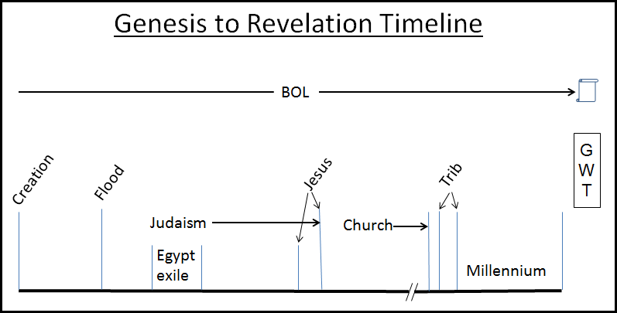
______________________________________________________________________________________________________________

9 If anyone has an ear, let him hear.
10 If anyone is destined for captivity, to captivity he goes; if anyone kills with the sword, with the sword he must be killed. Here is the perseverance and the faith of the saints. NASU
______________________________________________________________________________________________________________

Revelation 13:11-18
11 Then I saw another beast coming up out of the earth; and he had two horns like a lamb and he spoke as a dragon.

This beast is typically referred to as the ____________________.
______________________________________________________________________________________________________________

12 He exercises all the authority of the first beast in his presence. And he makes the earth and those who dwell in it to worship the first beast, whose fatal wound was healed.
13 He performs great signs, so that he even makes fire come down out of heaven to the earth in the presence of men.
_____________________________________________________________________________________________________________________________________________________________________
14 And he deceives those who dwell on the earth because of the signs which it was given him to perform in the presence of the beast, telling those who dwell on the earth to make an image to the beast who had the wound of the sword and has come to life.
______________________________________________________________________________________________________________

15 And it was given to him to give breath to the image of the beast, so that the image of the beast would even speak and cause as many as do not worship the image of the beast to be killed.
______________________________________________________________________________________________________________

16 And he causes all, the small and the great, and the rich and the poor, and the free men and the slaves, to be given a mark on their right hand or on their forehead,
17 and he provides that no one will be able to buy or to sell, except the one who has the mark, either the name of the beast or the number of his name.
______________________________________________________________________________________________________________

18 Here is wisdom. Let him who has understanding calculate the number of the beast, for the number is that of a man; and his number is six hundred and sixty-six. NASU
______________________________________________________________________________________________________________

SEQUENCE OF EVENTS -
TODAY TO THE ANTICHRIST

- Earth – April 29, 2025 @ 8:30 PM.

- The prophecies for the end of the church era happen and the beginning of the tribulation events begin to happen (Lk 21:28)

POSSIBILE EVENTS -
- Technology advancement
- NWO advancement
- Israel non-stop wars
- World populace easily deceived (Covid 19) Lawlessness (at all levels, especially the top)
- Expansion of antisemitism

3.The full number of the gentiles comes in. (Rom 11:25)

4. The departure (rapture) occurs. Restrainer removed. (1Cor 15:1-4, 1Thess 4:13-18)

A. A shout heard world-wide
B. A Trumpet heard world-wide
C. The physically dead believers are resurrected
D. The living believers receive glorified bodies
E. The living believers depart

5. We arrive at the throne room in heaven. (Rev 4)

6. The Lamb takes the scroll from the Father (Rev 5)

7. The greatest celebration in the Bible (Rev 5)

8. The Lamb breaks the first seal – rider on a white horse (Rev 6:1-2)

9. The anti-Christ is revealed and establishes authority.(Rev 13:1-10)

10. The anti-Christ enforces an Israeli peace covenant (Dan 9:27)
and the tribulation period (70th week of Daniel) is initiated.

PERSPECTIVE FOR REVELATION 13 – 4/29/2025

- Why has it not been possible for Bill Clinton, George Bush, Donald Trump or anyone else to bring peace to Israel?

Ans – Because –
- The ____________ hadn’t occurred and the ___________ was still present on earth holding back all efforts to bring Israel even temporary peace.
- This is a function reserved for the _____________________.

Remember, real peace is not coming to Israel because; Luke 19:42 "If you had known in this day, even you, the things which make for peace! But now they have been hidden from your eyes”. NASU
Just one of the significant items based on the Triumphal Entry of 10 Nisan, 32AD.

file: 250429 - Rev–chap-13 HB rev f.doc

