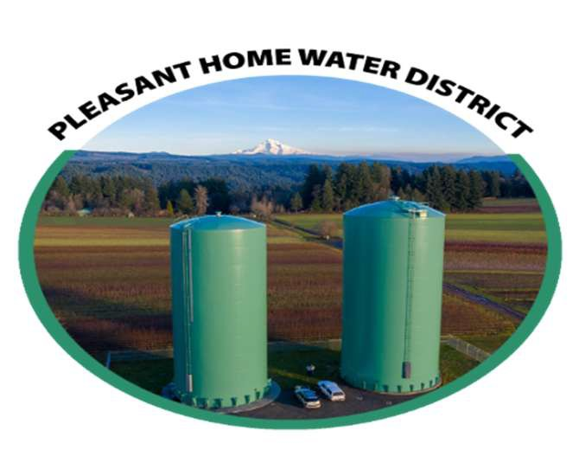

INSTRUCTIONS
- Print in ink or type.
- Fill out application completely. Incomplete applications will not be processed.
- Sign and date the application.
- E-mail (preferred) the application to customerservice@pleasanthomewater.com. Or mail to address is PO BOX 870 Gresham, OR 97030.
- This Position will be open until filled.
- All applicants will be notified of their status.

APPLICANT INFORMATION
Last Name |  |  |  |  | First |  |  |  |  |  | Middle |  |  |  |  |  | Date
Address |  |  |  |  |  |  |  |  |  |  |  |  |  | Apartment/Unit#
City |  |  |  |  | State |  |  |  |  |  |  |  |  | Zip Code
Phone |  |  |  |  | E-Mail
Position Applied For |  |  |  |  |  |  | Date Available to Start |  |  |  |  |  |  |  | Desired Salary
Are you a United States Citizen? |  |  |  | Yes | No |  | [f no, are you authorized to work in the United States? |  |  |  |  |  |  |  | Yes |  |  |  | No
Have you ever worked for the District? |  |  |  |  | Yes |  | No |  | If so, when?
EDUCATION
High School |  |  |  |  |  |  | Address
From |  |  | To |  | Did you graduate? |  |  | Yes |  | No |  |  | Degree
College |  |  |  |  |  |  | Address |  |  |  | □
From |  |  | To |  | Did you graduate? |  |  | Yes |  | No |  |  | Degree
Other |  |  |  |  |  |  | Address
From |  |  | To |  | Did you graduate? |  |  | Yes |  | No□ |  |  | Degree

MEMBERSHIPS, CERTIFICATES AND SPECIAL SKILLS
Professional Memberships and Associations |  | Computer Technical Skills
Trade Licenses/Certifications |  | Equipment Operations
REFERENCES
Please list three professional references.
Full Name |  | Relationship
Company |  | Phone
Address
Full Name |  | Relationship
Company |  | Phone
Address
Full Name |  | Relationship
Company |  | Phone
Address

EMPLOYMENT HISTORY
Beginning with your present or more current job, describe your work experience, paid or unpaid. Describe each job separately, emphasizing tasks related to customer service, admin wok, or other responsibilities. If you need more space, additional sheets may be added. Explain all gaps in employment.
Current or Last Employer
Company |  |  |  | Phone
Address |  |  |  | City, State and Zip Code
Job Title |  |  |  | Supervisor
Responsibilities and Job Duties
What did you like the most? |  |  |  | What did you like the least?
Reasons for leaving |  |  | I. |  |  | 2.
May we contact supervisor? |  |  | Yes No | Full-time, part-time or volunteer?
Previous Employment
Company |  |  |  | Phone
Address |  |  |  | City, State and Zip  rn.-1-,
Job Title |  |  |  | Supervisor
Responsibilities and Job Duties
What did you like the most? |  |  |  | What did you like the least?
Reasons for leaving |  |  | I. |  |  |  | 2.
May we contact your previous supervisor for a reference? |  |  | Yes No |  | Full-time, part-time or volunteer?

Previous Employment
Company |  |  | Phone
Address |  |  | City, State and Zip Code
Job Title |  |  | Supervisor
Responsibilities and Job Duties
What did you like the most? |  |  | What did you like the least?
Reasons for leaving |  | I. |  |  | 2.
May we contact your previous supervisor for a reference? |  | Yes  No | Full-time, part-time or volunteer?
Previous Employment
Company |  |  | Phone
Address |  |  | City, State and Zip Code
Job Title |  |  | Supervisor
Responsibilities and Job Duties
What did you like the most? |  |  | What did you like the least?
Reasons for leaving |  | I. |  |  | 2.
May we contact your previous supervisor for a reference? |  | Yes □N0 |  | Full-time, part-time or volunteer?

SUPPLEMENTAL INFORMATION

Why are you interested in this position?


RELEASE FOR CRIMINAL HISTORY RECORDS CHECK
I hereby release the Pleasant Home Water District (PHWD), the Law Enforcement Data System ("LEDS") AND THE Department of Motor Vehicles ("DMV"), their agents and assigns, from any liability for access to my criminal history and motor vehicle records, including, but not limited to any arrests, warrants, convictions and disposition of charges. I understand that these matters are confidential, and I give my full release and agreement to PHWD to use LEDS and DMV information to determine my eligibility for volunteer employment and/or membership in PHWD. The background check is only to be run if I am considered for employment.

DATE APPLICANTS SIGNATURE

