Ph**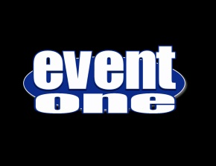 PHOTOBOOTH SERVICES** booth

**EventOne does photo booth the right way.  There are many photo booth providers but compare and you'll see that very few offer the guest experience and the value that EventOne can!**

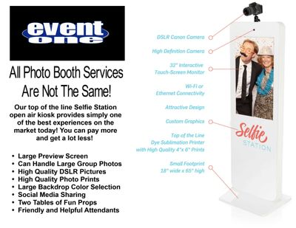

**- Perfect for weddings, birthdays, school dances, holiday parties, corporate events, anniversaries, fundraising events, reunions, Bar Mitzvah/Bat Mitzvah, Quinceanera**

**- Selfie Station Open Air Kiosk with Large 32" Preview Screen**

**- Quality DSLR Photos with Flash (NEVER A WEBCAM)**

**- Quality Unlimited Subliminal Dye Prints**

**- Two Large Tables of Custom Fun Props (You can decide what types of props)**

**- Large Selection of Backdrop colors including Green Screen or Custom Vinyl Banners**

**- Social Media Sharing Is Always Included (We bring our own Wi-fi)**

**- Custom Photo Templates 2x6 Photo Strips or 4x6 Prints (We design what you want!)**

**- Kiosk Can Be Branded With Your Logo**

**- Print GIF and Video Options**

**- Friendly And Helpful Attendants**

**- Photo And Guestbook Options**

**- All Photos Made Available For Viewing Or Download From The Cloud**

**407-793-2551**

**855-550-DJ4U**

**EventOneFl.com**

**Facebook.com/EventOneFl**