Ph 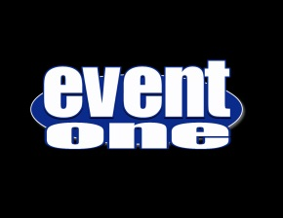 KARAOKEbooth
EventOne makes you and your guests the stars! Our Karaoke events can include stage like settings and backdrops, multiple wireless microphones, large easy to read screens for lyrics, Nearly a limitless song selection, fun props, and much much more!

Karaoke Features Like No Other!

Stage Lighting And Shimmering Backdrops Put You In the Spotlight
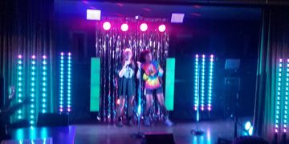
EventOne can bring that on stage look to your special event. With our stage lighting in your choice of colors and our shimmering foil stage backdrops: You will look as good on stage as you sound!

Amazing Selection Of Karaoke Songs To Choose From
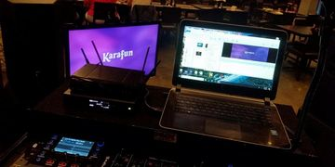
With over 29,000 songs and growing, EventOne is sure to have one of your favorites. We also feature a Top 1000 song book and helpful attendant to assist you in your song selection.

Quality Sound System Will Make You Sound Your Very Best
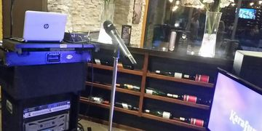
With crystal clear speakers, powered floor monitors, state of the art dual wireless microphone system, and our experienced KJ monitoring everything: You're sure to sound your very best at all times!

Large Easy To Read Lyrics
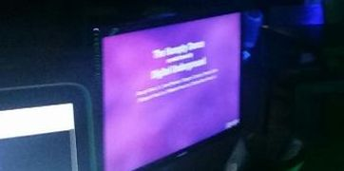
Never miss a word to your favorite song with our large monitors. Our 40" HD monitors can be adjusted to your desired height, angle, and location.

Fun Contests
Feeling competitive? EventOne can organize all kinds of fun karaoke competitions. From idol style singing competitions, to karaoke roulette.

Fun Extras
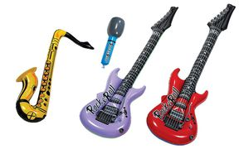
Add to your karaoke fun with a tambourine, an inflatable guitar, saxophone or even an inflatable microphone for your shy singers.

407-793-2551
855-550-DJ4U
EventOneFl.com
Facebook.com/EventOneFl

