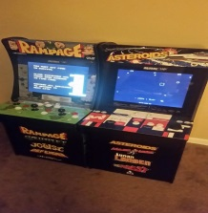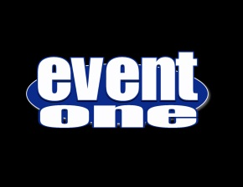 VINTAGE VIDEO GAMES

booth

-EventOne Brings Classic Arcade Fun To Your Party!
No matter what the age, everyone loves the classic arcade games! EventOne has you covered. We feature both cocktail table and upright console game machines.

-Modern And Flexible
The games are classic, the machines are not. EventOne features modern reliable multicade machines playing all of your classic arcade favorites.

-Authentic Look, Feel, And Gameplay
Our machines look, feel , sound, and play just how you remember. Authentic cabinet graphics, controls, emulated sounds and gameplay bring the true arcade experience to your party.

-Leave Your Quarters At Home
All EventOne's game cabinets are set to free play. So your guests can keep coming back for that high score!

-So Many Options
EventOne's game cabinets are more compact, lightweight, and energy efficient then their classic counterparts. Our upright cabinets are 2/3 scale size and can be played sitting down. EventOne can also add risers to the cabinets bringing them up to classic arcade stand up height. The choice is yours!

-Any Event Is The Right Event.
Whether you're throwing a retro themed event, a birthday, corporate event, or team builder, games are always a great addition. Can anyone say tournament?

407-793-2551
855-550-DJ4U
EventOneFl.com
Facebook.com/EventOneFl

