Ph 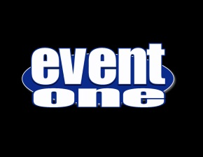 **FACE PAINTING**booth

# FACE PAINTING

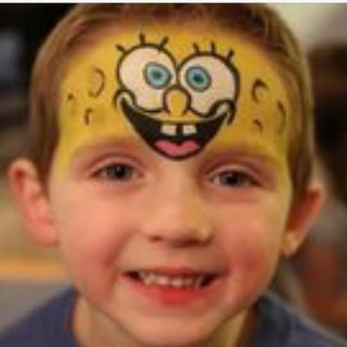

**EventOne's resident face painter Kyli can really bring your party to life!  Her face painting services will bring smile to the faces of both the young and young at heart!**

**Kyli took both high school & college courses at the same time at the age of 15!  She has a degree in simple arts as well as graphics through the Art Institute in Minneapolis, Minnesota! Not only is she a people person but she's great with kids,  As a mother of two, Kyli really understands what it takes. Kyli is also very experienced working with children with special needs.**

#### Safety Is Our Priority Pimage86

**Rest assured all paints used are Hypo-Allergenic, Paraben Free, Lead Free, and Non Toxic.  Paints are water soluble and easily removed when needed.  All painting materials are painstakingly sanitized before use.**

#### Limited Only By Your Imagination

#### There's a world of choices out there.  There's really know limit to what Kyli can do. Just show her/tell her what you want or let Kyli come up with something fun for you.  Either way you and your guests are sure to be thrilled with the results!

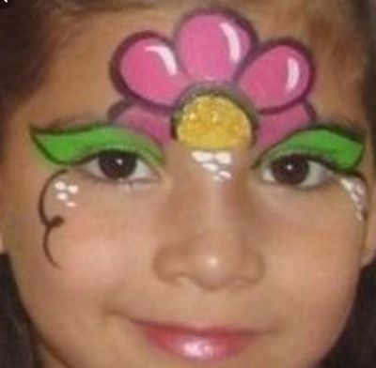

**407-793-2551**

**855-550-DJ4U**

**EventOneFl.com**

**Facebook.com/EventOneFl**