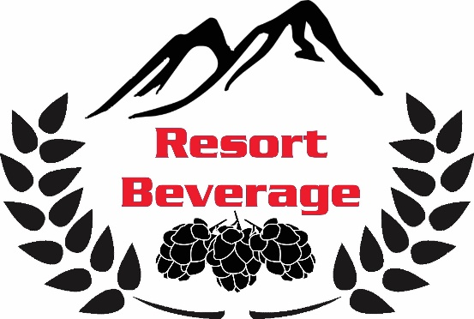
Resort Beverage Company, Inc.
2903 Route 611
Tannersville, PA 18372
www.ResortBeverage.com
Christina.williams@resortbeverage.com
570-629-1686

Keg Request and Tap Deposit Form

If you want to make a reservation in advance, please email us at the address above and let us know what you
would like to order, then bring this form with you when you pick up your keg.

Customer Information
Name: __________________________________________ Phone Number: ______________________
Address: ____________________________________________________________________________
Email: __________________________________________
Reservation Date: _____________________
- Kegs come in a variety of sizes:
  - 1/6 barrel, sixtel (~55 – 12 oz beers) Great for a party with a few friends
  - 1/4 barrel, quarter keg (~83 – 12 oz beers) Great for a party of 15-25 people
  - 1/2 barrel, half keg (~160 – 12 oz beers) Great for a large party
- Prices vary and are subject to change.
- There is a $30/keg deposit to be paid upon pick-up, and a $40 deposit for each tap pump.
- A minimum of 2 weeks’ notice is required on all keg rentals.

Brand(s) Requested: ______________________________________________ Keg Size: _____

*IF YOU ARE RENTING TAP PUMPS FROM US YOU MUST SIGN AND AGREE TO AND FILL OUT THE BOTTOM PORTION OF THIS FORM*
--------------------------------------------------------------------------------------------------------------------------------------------------
By renting this equipment, I agree to return it in same or better condition (where condition is determined by RESORT BEVERAGE COMPANY). I agree that I am 21 years of age or older (valid ID is required), and that I remove RESORT BEVERAGE COMPANY, along with any and all shareholders, employees, and associates, from all responsibly of any liabilities that may arise due to the use, or illegal misuse of this/these keg(s)/equipment and its/their contents.
Rental Fees: I agree to a deposit of $40 per tap pump to be charged to myself. After 14 days the equipment is considered to be late. I understand that not returning the equipment on time prevents other happy patrons from enjoying our products. I agree that any equipment not returned after one month (1) of rental date will forfeit my entire deposit on said equipment.

Signature: ___________________________________________________ Date: _________________________
Printed Name: _____________________________________ Employee Initials: _________________________
**Bottom to be returned with rental upon drop off-Resort Beverage to fill out upon pick-up**
--------------------------------------------------------------------------------------------------------------------------------------------------

Name of Customer:______________________________________ Date of Rental: _______________________
Keg(s) Rented: ____________________________________________________ # of Pumps Rented: _________
Date of Return: _____________________ Condition?: ______________________________________________
Total Deposits Given Back to Customer: __________________________ Employee Initials: ______________

