Redhawks U14 Boys Skills & Drills

(Coach RJ and Coach Bill’s Favorites)
Updated for Coaches –
February 24th, 2022

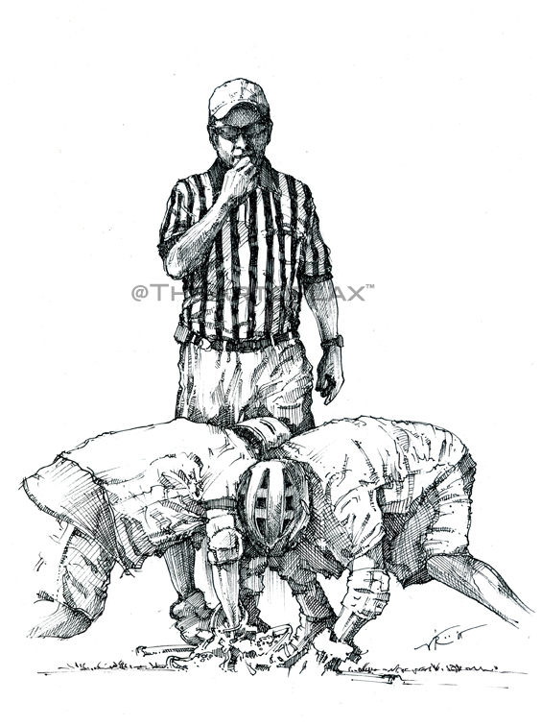
Ground balls are key…and that starts with the faceoff. Remember you are not allowed to rake the ball unless you are a goalie or in a faceoff scrum. Remember to scoop through…this guide can also be used by parents in the back yard.

Ground Ball Drill #1
Set up two lines with the kids facing each other. The goal is to teach each kid the importance of picking up balls on the fly—scooping not raking. There are numerous variations on the drill.

Ground Ball Drill #2 (stationary)
Give each kid a ball. Have them toss the ball down and quickly scoop up quickly. They should each repeat this activity 50-60 times to get comfortable with the basic movement.

Man Ball Drill
This is a great drill because it simulates a scrum and the kids get to have a little contact—which is a great simulation of actual play. Line the kids up in three lines. The centerline can be long polls and the adjacent lines can represent the offensive players. The object is for the defensive player to make an effort to get the ball away from the offensive players, and force a turnover. The player closest to the balls yells out “ball,” while the second player attempts to screen out the one attacker on defense. Once the ball is secured, the kid with the ball has to scream out “release.” For U-12 players it’s great to run just prior to a game to get the boys accustomed to contact. It’s an important drill in that success at ground balls will determine most game outcomes at the youth level. It also helps with our transition game, where we tend to score a good number of our goals. Ground balls + control of the clock = victory. Coaches—you can also have two defenders in the adjacent line and one offensive player (shorty) scrumming for the ball.

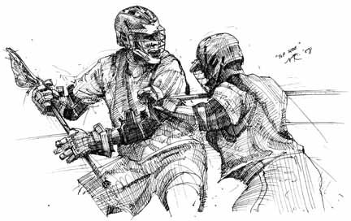
Passing #1 (triangles)
From an offensive as well as a defensive perspective, triangles are an integral part of the game. This is a great drill to implement, as the kids can greatly improve passing and catching on the run—along with field position. The goal is to get the kids to pass the ball around the triangle, while shifting positions. This is kind of like musical chairs. We should have middies working together, as well as attack players. They simply need to pass and change positions. We set up four flat cones so players are constantly moving to the empty spot. It encourages “off-ball” play.
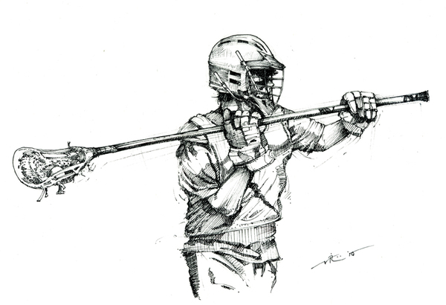
Passing Soft Hands #2 (stationary)
This is a very basic drill. Have the players pair up and then pass the ball back and forth without cradling. This drill is designed to help players develop “soft hands,” and to develop the ability to catch any ball. For the kids that are “brand new” to the game, have them do ground balls as well. That way they will not lose confidence because all of them can handle a basic ground ball. After a while they will all graduate to handling regular passes. As the kids advance we should continue to make them throw and catch on the left side. This is mandatory at the U14 and high school level. By the end of the season, all of our advanced players should have a solid ability on the left (right handed kids). The opposite is true for the left-handed kids.

Passing #3 (running)
We need to do that running drill with a focus on passing and catching. Line the boys up in two lines in front of the goal. Have them pass back and forth—a minimum of three passes—then let the kid on the right side take the shot. We can run this one on the left side as well.

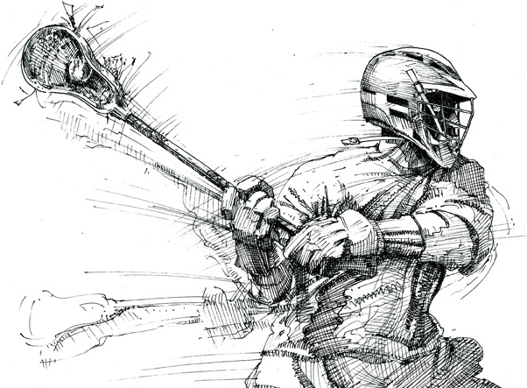

Quick stick #1 (shooting)
Set up two lines in front of the cage. Have the X player provide feeds to the advancing players. Give the X attack plenty of balls. Have the kids charge the goal. Move the line from center (top of the hole) to the left and then right side. Players should be able to “quick stick” and score on a reasonably good goalie. This type of shooting should be done with the minimum of cradling. No more then a half turn to stabilize the ball in the cross. Getting the shot off quickly/accurately is what this drill is all about. Shot speed is not critical to score with this sort of shot. The attacker should shoot the ball accurately to maximize success. Our 3-2-1 (Open) offense is built around quick stick feeds to the crease; so is our high posted 1-2-1 Brooklyn formation. Remind the boys that bounce shots rule!

General shooting drill
This can be a fun thing for the kids. It’s something that they all love to do. With a goalie in cage, line them up at top center, right and left (three lines). Place the goal in a place where there’s a fence or backstop, or you’ll be shagging balls all over the field. Let the kids fire away in sequence. Make it a competition and see who actually puts in the most. Encourage them to shoot on the ground, as most goalies at the youth level have difficulty with ground ball shots.

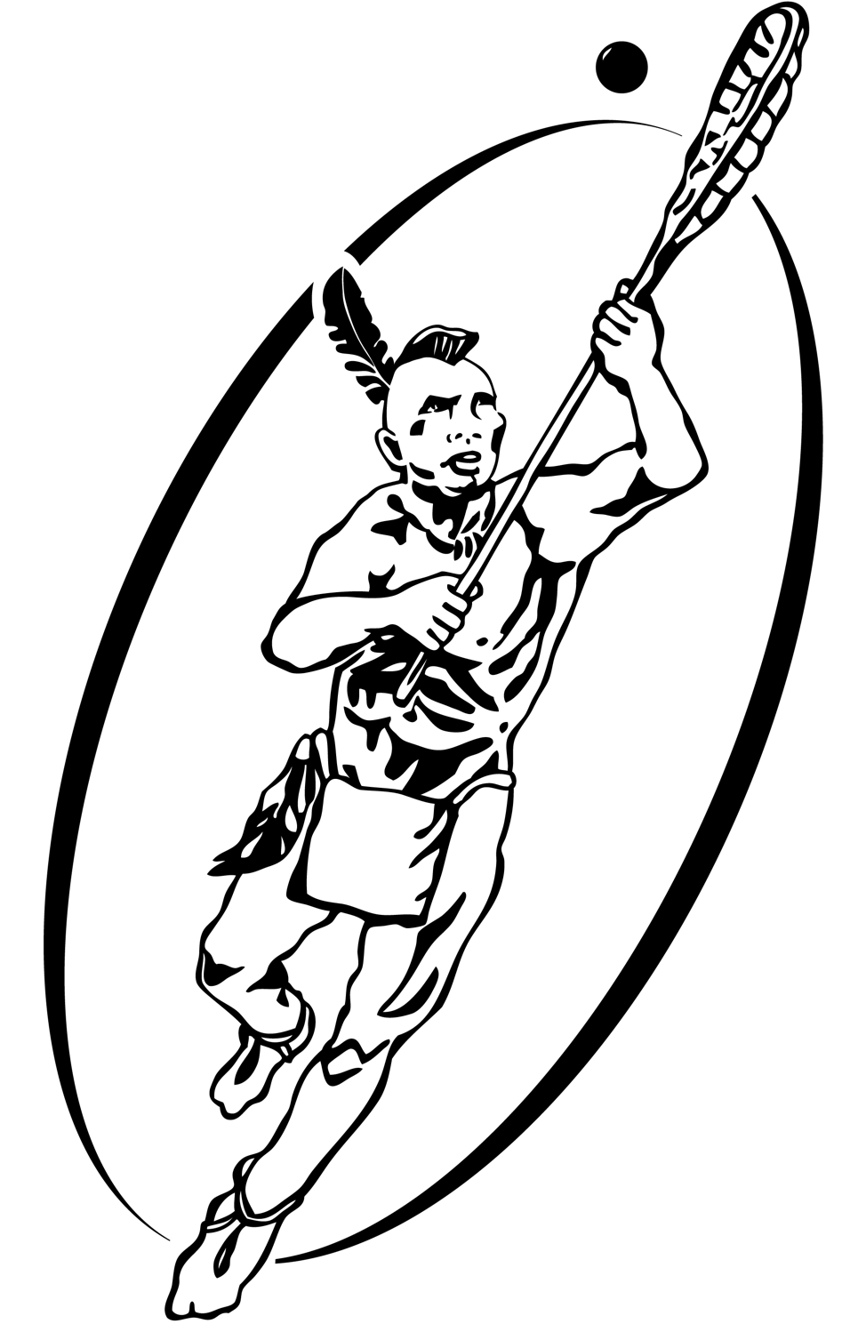

Quick stick #2 (shooting)
Put an attack player at X. Set up two lines, to simulate midfield players in a game in a 2-3-1 formation (Long Island Offense) in front of the goal. Have the two boys crisscross in front of the cage. The attacker at X can then dish off to either of the players (left or right side of the goal above the crease). This is a great drill for middies as it simulates the cutting action that will be part of our regular 3-2-1 formation. In Open the opportunity to score comes from cuts to the crease (quick stick release), and basic split dodges as you spread the opposition’s defense and open up lanes.

Fast Break #1 (3-v-2)
We do this drill with all of our players quite often. On the offensive side the three players (middies) should move toward the goal on a fast break. The key is to get them to pass the ball, and fake out the two defenders. Spontaneity is the key here. We want to teach the kids how to get in position. If done properly, one offensive player will be open and in position to shoot and score. On the defensive side you should set-up the two boys in an “I” formation. As the boys “break” and attempt to draw out the two defenders, the D players should “slide” to break up the impromptu play. This is a great drill. When done spontaneously we also refer to this as our “Duke Drill.”

Fast Break #2 (4-v-3)
This is another version of the drill, which includes two additional players. There are other versions of the fast break drill that are more instructive and do a better job of simulating transition play (boys shifting from offense to defense). We need a full field to do that one. We refer to it as our West Genny (Genesee High School) drill. Right now all of our offensive players can’t handle that level of complexity. If we move along too quickly, we could frustrate some of the new players. The best way to instruct is to have our most advanced players demonstrate the drill. So I’d go along with the same offensive and defensive players when demonstrating the 4-on-3 fast break. The important thing here is to have the fourth offensive player ready to move to X. We want him there to be close to the out-of-bounds to maintain possession after the shot. In this situation we need to get our three defensemen in a tight triangle in front of the goal. They should not over-commit or be caught out of position.
We use cones if necessary as part of the training exercise. Also, offensive players should be encouraged to stay “spread out,” in and effort to draw out the defenders. The rule here: Defenders tight in the triangle formation (literally a zone and ready to slide). Offensive players want to spread wide, in order to draw off defenders and get one kid open for the shot.
Defensively during this drill, we need to stress good footwork, good slides and proper checking (poke and slap checks are an important skill for all long poll and defensive middies to master.

Fast Break (game situation)
We’ve scored many of our assisted goals in unsettled play over the years. We want to simulate this in a practice setting. A great drill—especially when we have the numbers—is to have our attacking team in transition all pull to the goalie right and draw out all the defenders. Once out of position, have the X attack sneak around and finish on the right side crease. It works on either side of the field. It’s in theory similar to Coach Logan’s ASU play where he shifts all the action to one side of the field, leaving the other side vulnerable.

Fun Simulation (Fast break prep)
A fun way to engage the kids—a take on “monkey in the middle”—is to have three offensive player set-up in a wide triangle. Then have two defensive players attempt to take the ball away. The offensive players can move in and out (what we call V cuts) in an attempt to avoid the defenders and maintain possession. You can run multiple drills simultaneously and engage all the kids. It’s fun, and almost a game in itself. This is a take-off on our regular triangle drill—but more fun! This can also be extended to Coach RJ’s “Crab Simulation.”

ISO Simulation (Isolation play)
Part of our standard offense will include a few ISO moves. One is when the center midfielder starts at the top and dodges 2 or 3 defenders to take the shot. To simulate, set-up 3 cones and line up the boys about 20 yards from the crease. Next have each player dodge and navigate around the obstacles to take the shot. It’s a good drill in that each player gets to do several dodges and finishes up with a shot on goal. Encourage good cradling (right to left) given that in a game, defenders would be actively trying to dislodge the ball to force a turnover. Note: A more advanced version of the drill entails the replacing of cones with defensive players. Iroquois Indian players would do this drill in a way that almost looked like the Indian version of running the gamut. It’s a blast to watch as it discourages ball hogs! Note: When doing an ISO the middies get to create some real separation from their respective defenders. If they draw them out far enough and execute a good dodge, they can draw a second defender and find a lane in front of the crease to take the shot—and hopefully finish. There’s always the “draw and dump” option. We need to encourage both middie lines to do ISO moves.

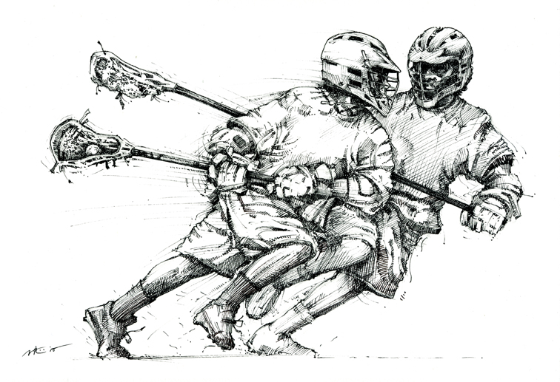

Dodge drill #1 (face dodge)
This is the most basic dodge. Line the boys up and take them through the ISO simulation, including the cones. The face dodge is when the player literally moves the stick quickly from right to left across the face (very tight). Ideally, the player should switch the stick from the right to left hand—and then back again.
You can also do this drill where you pair off the boys and have them dodge against each other. The defender should actively attempt to dislodge the ball to force the turnover. In a face dodge the stick does

Dodge drill #2 (roll dodge)
In this dodge the offensive player bumps up against the defender and literally rolls off of the opposing player’s body with a quick switch of direction. Once again, you can pair off the players in 2’s, or have them practice this drill as part of the ISO simulation. Match them up by size for best effect. At the U-14 level, this can still be a very effective dodge. It’s tougher to execute as the boys become more advanced defensively. This is not a good move at the college level—and even high school defenders often have the skill to take out any attacker brazen enough to make this move—and like the ‘swim dodge” the young players think this really looks pretty cool.
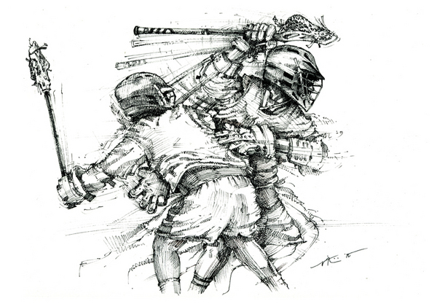

Dodge drill #3 (split dodge)
We like this dodge and believe that it can be very effective at all age levels— right up and including college ball. All of the boys will improve dodging over the season, and the split dodge is the most effective one—in that you can completely fake out the defender and goalie. In this drill we want to start with a right-side cradle and then quickly shift to a left-side cradle in a position to shoot (left-handed). Encourage the boys to take a leftie bounce shot. The percentages are very high with this type of shot, given that the goalie (especially at the youth level) is not anticipating a weak-side shot. Also run the drill by having the boys starting out with a left-side cradle; then proceeding to a right side finish. Set up cones that signal a change of hands to help build the necessary dexterity and stick work. To make things interesting (more advanced) add two defenders to the drill.
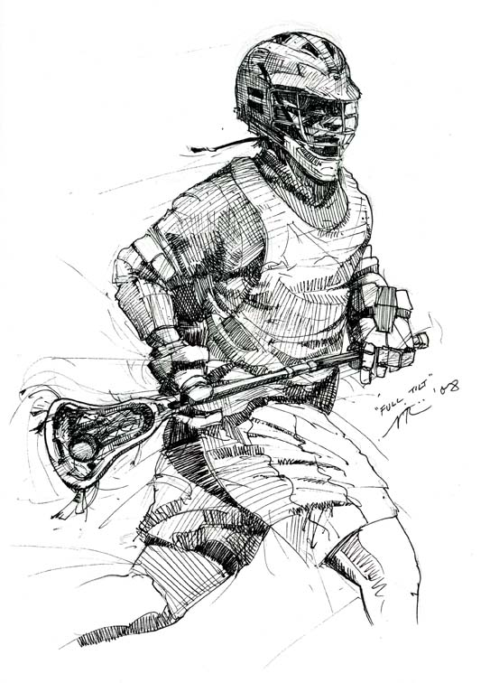
Basic cradle drill (running)
There was some discussion that teaching the boys to cradle is not necessarily the best use of time. With young players, the more time that they have a stick in their hands the better. We should combine our dodging drill (cones and defenders)— encouraging the boys to work on their basic cradle skills. Also, we should encourage players (during down time or 6-on-6 drills) to hit the bounce-back, and practice basic stick handling, including cradling.

Checking drills (poke & lift; slap)
This drill is important for all players. Obviously, it’s critical for defensemen and midfielders, but it’s also critical for the attack players to learn for the ride. We can start out by breaking the boys up into pairs. The defender needs to practice the poke check, along with that basic lifting movement that we always demonstrate early in the year. Poke checks are extremely effective, as this sort of check is annoying and disruptive to any attackers. Another key check is the slap check. This is especially effective when the attacker has both hands on the stick. A good hard slap check can often dislodge the ball if executed properly. Things to avoid: Tell the boys to avoid one hand checking as it sometimes gets way out of control and leads to a penalty call (slash). Also, remind them that when an attacker moves to a one-handed cradle, his free hand can no longer be checked. Finally, a cross-check violation occurs when a player has the shaft of his stick fully exposed with hands wide apart, and hits the attacker with the open shaft.
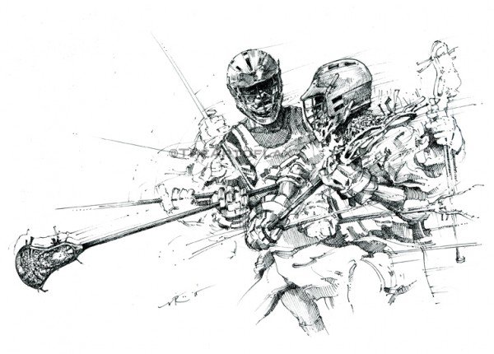
There are some defensive players that U12 and U14 players need to avoid…

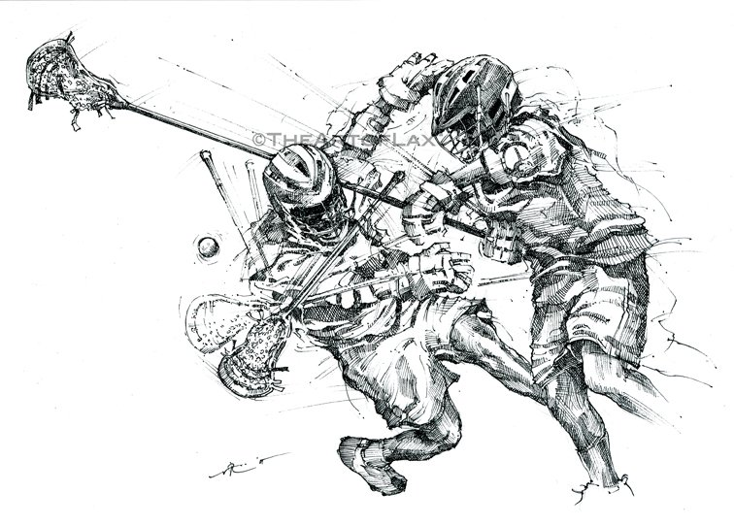
Face-off drill
There are multiple ways to do this drill. Here’s a good way to start. Pair the boys up according to size, weight and general ability. Blow the whistle and let them face-off multiple times. Take the top 6 kids (based on your observation) and have them dual it out to see who’s the “king of the mountain” so to speak. This is a great drill for a number of reasons. Like the man-ball drill, the kids get physical contact. Our best face-off guys are often our strongest and most competitive players. We need to work on this drill a bit because like ground balls, winning face-offs can often determine the outcome of a game. It certainly impacts possession time and that all-important transition play.
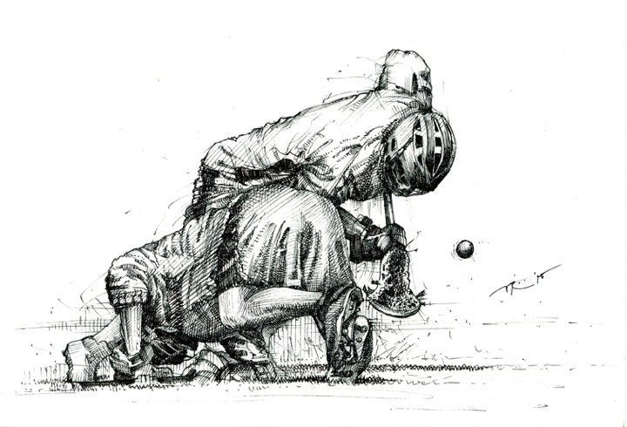
Clear Drill (Ride Drill for offense)
First off, setup a 6-on-6 situation on the field (half field). Simulate a shot and have the goalie go to the back of the crease and yell out CLEAR. Coach him to dish off to and adjacent poll (right or left side). Focus on clearing to the sidelines.
The goalie should be encouraged to slowly walk down the center of the field if all of the clearing team is covered. Patience is key. We should also give the ball to a fast player who is also a good stick handler. We should encourage the kids to make 2-3 passes down the field to make a clear. We also can move quickly into our fast break set play—this is when the middies move to field left or right and our X player comes to the right side of the crease—the job of the left-side middie is to pull his defender wide. The right side middie is set up on the center-left crease—also in a position to score. Clears throughout our season will often depend on the unique skills of players on our team. If you have an incredibly fast long pole who protects the ball well—often he will become your “go to” guy. If your goalie is a quick and shifty ball handler encourage him to bring the ball out—as many teams will not press (ride) the goalie at the youth level. The key in special teams’ play is leveraging our team’s core strengths (players) and adapting to each situation.

Note: Players should avoid the Gellman unless there is an imminent turnover threat and the goalie is out of the crease. The Gellman is when the goalie or a defender simply hurl the ball down the field.

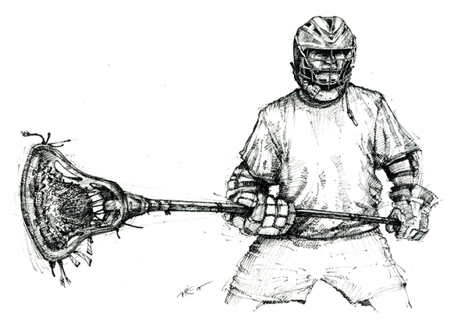

Half Field Scrimmage (6-on-6)

Most often we’re going to do a 30-minute scrimmage at each practice, given our field constraints. Here’s where we get to bring it all together. Even though we lack field space, a half field scrimmage is really good for coaches to focus on putting it all together. All of our best coaches at the Redhawks and Chauncey Boys favor this practice approach. We can practice man-down situations (man-up for the offense), clears, rides and even set plays. The defensive middies are also key, so we need to work both lines defensively at practice. Our offense should practice the 3-2-1 set. That would include both of our middy lines.

Basic Formations:

- Long Island — This is one of our standard formations. It’s a
2-3-1 with two middies up top; a middy in the center crease; two adjacent attackers and one attacker at X. The crease-based middy should be encouraged to move “high and low” as ultimately he’s looking to shake his defenders for the open shot (quick stick) on the crease. Also, you can foster incredibly confusing off-ball movement by having the kids “find and replace” various positions all over the field. This happens when the coach generally yells out something like “CAOS!”

- Brooklyn (Mambo) — This is our 1-4-1 formation with heavy offensive strength on the crease. We have developed one play called “Bridge,” which is an option feed to either the left or right side crease. As the top middy in ISO mode dodges to the hole in this formation, he has the option to pass to the left or right outside attackers on the periphery. The two inside players can set picks simultaneously.

- 100, 200 or 300 — We move the ball around at a quick pace to draw a two or three (defender) and set up for an option play—ISO and middy attacking the crease; quick stick in the crease; give & go from X or up top (initiated by a middy). This is a standard 6-on-6 approach—encourage the players to draw 2’s and 3’s; thus creating a temporary “man-up” situation.

- Canada — This is our basic invert formation: First the X man and Top Center Middy move counter clockwise and replace each other—and to add deception, left and right attackers/middies set picks as the X attack and top center middy invert. Next, the attackers invert with the middies to add to the confusion. If executed properly, the X man (now top middy) can cut to the crease for a feed from X (now the center middy). If executed properly, this is a very simple yet effective formation. To change back to a standard 3-2-1 the top middy needs to simply yell out “Reset.”

- Open —spreading wide on the field in a 3-2-1 formation. This is a very effective way to open up lanes and create opportunities for cuts to the crease and quick dodges by your fastest middies. In “Open” or Big Sky the players just spread wide—attempt to draw defenders—so that they can execute an alley dodge or “pick and roll.” What’s also great is that you can also run “motion triangles” at the attack and create exciting and offensively powerful off-ball movement. Give and go action is easily executed at the attack with the right or left side attackers often drawing two defenders at X—leaving the X man (now in front of the net) open for an easy layup.

Brooklyn Formation or classic 1-4-1

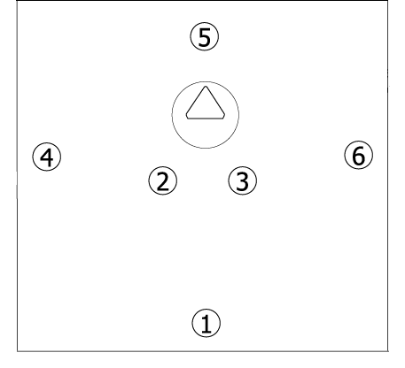

Long Island 2-3-1

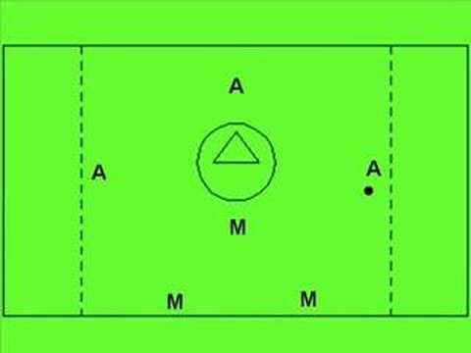

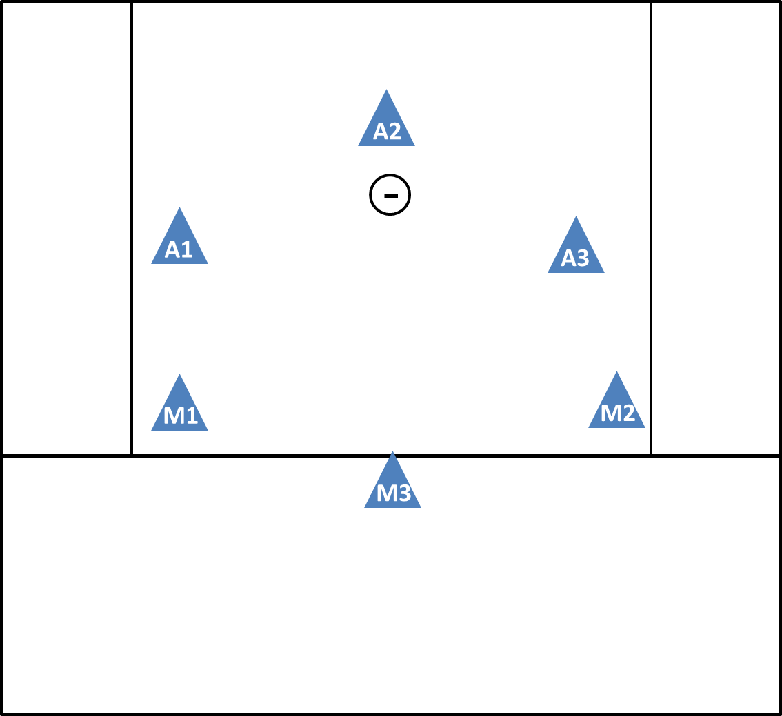

Classic 3-2-1 — Spread for
“Open” is our standard formation. We encourage lots of off-ball movement; middy shifts; ally dodges and feeds from X. This is the preferred formation used by Coach Bill’s U14 and U12 teams over the past 18 seasons.

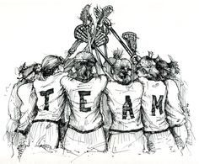

Tips for every U12 player:

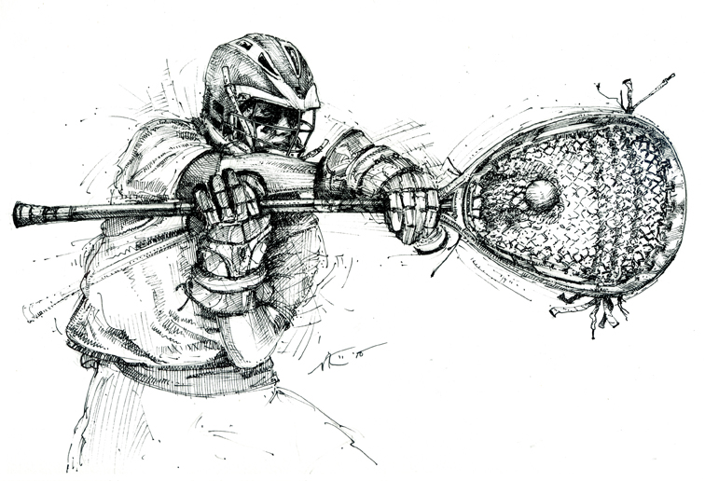

—Goalies have 5 seconds to exit the crease after stopping a shot

—Polls need to always remember key checks like poke & lift and slap checking

—Our two basic defenses are Navy (hot slide from crease); Army (Adjacent slides). Both are “man defense.” Air Force will be the zone that RJ introduces.

—In Fast Breaks our basic defensive formations include the I formation (2 players); triangle (3 players) and box (4 players).

—Wing play is key to winning at the faceoff X and we always run an LSM to win possession.

—Our ride is called “Raider.” In this zone ride we push the opposing players toward the center to affect a turnover or failure to advance.

—We clear to our adjacent polls (sidelines) who look for the cutting middy; who in turn looks for an open attack player with a possible look on crease

—Quick Starts require defensive players to “back off” or face a :30 technical penalty

—Never talk back to a referee

—Mouth guards are mandatory and a violation is always penalized

—Illegal sticks are a serious non-releasable 2-minute infraction

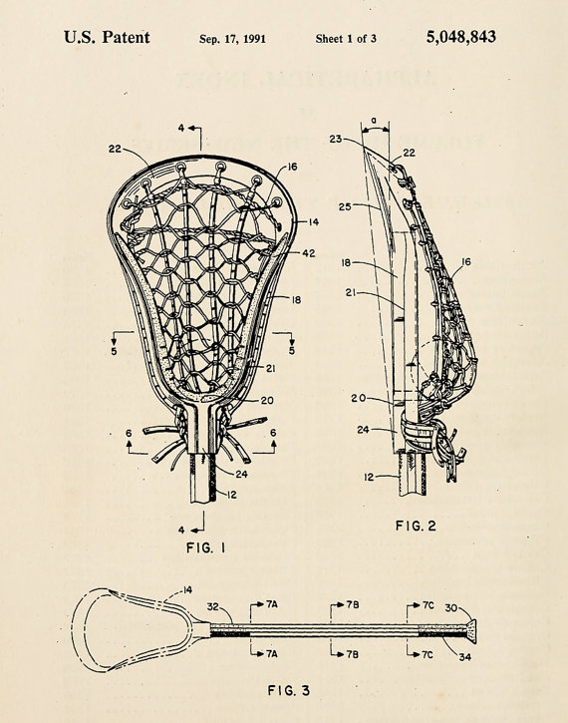

—Listen for coaches always

—Off-ball movement is very confusing to the opposing “D”

—Formations work best with lots of off-ball movement and shifts

—Always go for the ground ball shot at U12 level

—Remember to remain stationary when setting picks

—Always stay hydrated

—Passing and team play wins’ games!

—Time of possession impacts the outcome of a game

—Watching your favorite college team will increase your “Lax IQ.’

—You will never stop learning new things, and that’s one of the fun parts of the game!

—Play safe!!!

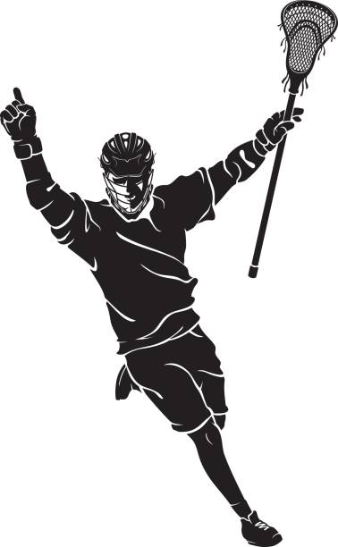

Redhawks U14B Skills and Drills

March 1, 2023

Coach Ryan “RJ” Johnston
& Coach Bill Cleary



