

Good day,
Thank you for your interest in becoming an Independent Courier Driver with FLED!
This is a 1099 contract position, meaning you'll use your own vehicle and be responsible for maintenance, fuel, insurance, and taxes at the end of the year.
Insurance Requirements:
- Cargo Vans or larger: 30/50/100 or a Commercial Policy
- Pick-up Trucks, Mini Vans, SUVs, or Cars: Combined insurance coverage of $100,000 Proper insurance is required for any vehicle used for deliveries.
Payment Structure:
We compensate drivers based on vehicle type:
- SUVs/Mini Vans: 68% of the delivery rate per job
- Pick-up Trucks/Mini Cargo Vans (City Vans): 70% of the delivery rate
- Cargo Vans (Mid/High Roof): 73% of the delivery rate
- Box Trucks: 75% of the delivery rate
Payments are issued via direct deposit every two weeks, so a bank account is required. Drivers currently earn between $800.00 - $1,800 per pay period, with increased income potential based on availability.
Work Schedule & Delivery Rates:
- Monday-Friday: 7:30 AM - 5:30 PM
- Saturday: 7:30 AM - 3:00 PM
- Delivery rates are determined by product type, customer distance, time, and fuel costs.
Requirements:
- Ability to lift 50 lbs.
- Willingness to haul tires (this comprises a significant portion of deliveries but is not the only service provided)
- Smartphone required for dispatching (there is a $15 app fee per pay period)
Hiring Process:
- Complete the attached IC Application and W9
- Submit copies of your Driver’s License, Insurance proof, and a picture of your vehicle
- Once received, we will conduct a phone interview and answer any questions
- Email all insurance, driver’s license and vehicle pictures to:
onboarding@fledelivery.com
About Us:
We have been serving the Jacksonville area for 11 years and are rapidly expanding.
To begin working with us, you must provide proof of insurance and a completed IC Agreement.
If you have any questions, feel free to reach out via email. We look forward to working with you!

Kristen Scarborough
Fast Lane Express Delivery
www.fledelivery.com
(904) 646-7556 Direct Line
(904) 646-7150 Dispatch/ Office Line
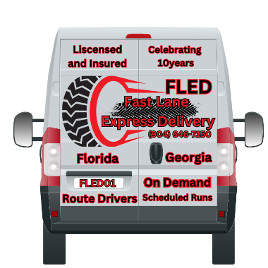

OUR Business is Handling YOUR Business with Professionalism & Care.

