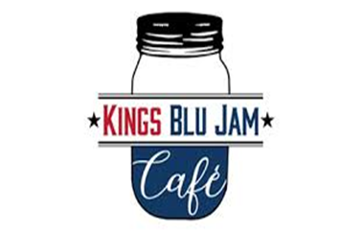
Kings Blu Jam Café
Keto Breakfast Menu
4711 Louetta Rd. STE 101
Spring Tx, 77388
(713)-389-5555
Breakfast
Keto Pancakes (2) – House made mix, served with your choice of meat $7.75
Keto Waffle – House made mix, served with your choice of meat $9.75
Keto Chaffle Breakfast Sandwich- your choice of meat, cheese & one egg any style served on a chaffle bun $8.50
Keto Chorizo Omelet – Spinach, white onions, cheddar cheese topped with sour cream avocado and bacon $11.50
Keto Grits- Pureed cauliflower “grits” mixed with cheddar $3.25
Keto Breakfast Sandwich- two sausage patties, one egg, cream cheese, sharp cheddar, avocado & siracha $7.50
Keto Kolache- Fathead dough wrapped sausage topped with sesame seeds $5.45
Keto Classic Benedict- 2 poached eggs over a chaffle & Canadian bacon, topped with house made hollandaise sauce $10.50
Keto Biscuits & Sausage Gravy – 2 almond flour biscuits topped with our rich house made sausage gravy $9.95
Keto Crab Cake Benedict (weekend only)- 2 poached eggs over a chaffle & crab cake (jumbo lump crab, trio peppers, celery, shallots & pork rinds) topped with house made hollandaise sauce $14.25
MEAT: Bacon, ham, Blu jam pork or Turkey sausage
CHEESE: Swiss, Pepper Jack, Cheddar, or American cheese

