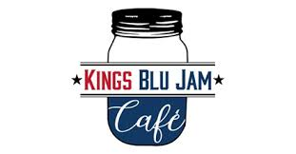
Kings Blu Jam Café
Keto Lunch & Dessert Menu
4711 Louetta Rd. STE 101
Spring Tx, 77388
(713)-389-5555

Lunch
Keto Shrimp & Grits – Cheddar & romano cheese cauliflower puree “grits” topped with shrimp, roasted tomatoes, sautéed mustard greens and crumbled bacon $14.95
Keto Hamburger- Angus beef, bibb lettuce, tomato, pickles, red onion, mustard and mayo served on a chaffle bun with a side salad $13.25
Keto Cauliflower Mac- Grilled chicken, cheddar and muenster cheese, Dijon mustard, spinach and fresh garlic $10.50
Keto Avocado Blt & Egg- Bacon, avocado, hard boiled eggs, green onions atop spinach with fresh lemon juice $10.75
Keto Blu Jam Club- Roasted Turkey, smoked ham, bacon, cheddar cheese, lettuce, tomato and herb aioli on a chaffle bun served with a side salad $11.00
Keto Chicken & Waffles- Jalapeno bacon-cheddar waffle & fried chicken (pork rind breading) served w/ sugar-free syrup $12.75
Chaffles can be used for regular menu sandwiches for an additional $2.00

Dessert
Keto Cookie (weekly flavors) $2.50
Keto Coffee Cake $3.75
Keto Cheesecake Brownie $3.75
Please ask your server for daily Keto desserts!

