**Little Socks Gymnastics – summer term newsletter**

Wow, what a term it has been! We have a fantastic amount of entries into the logo competition and what a difficult job we had at getting it down to 6 finalists. Congratulations to Raven, LilaRose, Freya, Decca, Yulika & Ava for making the final 6. The gymnasts’ then voted for their favourite and choose Freya’s design as the winner. I have already started working on our new logo and we are very excited and proud of it.

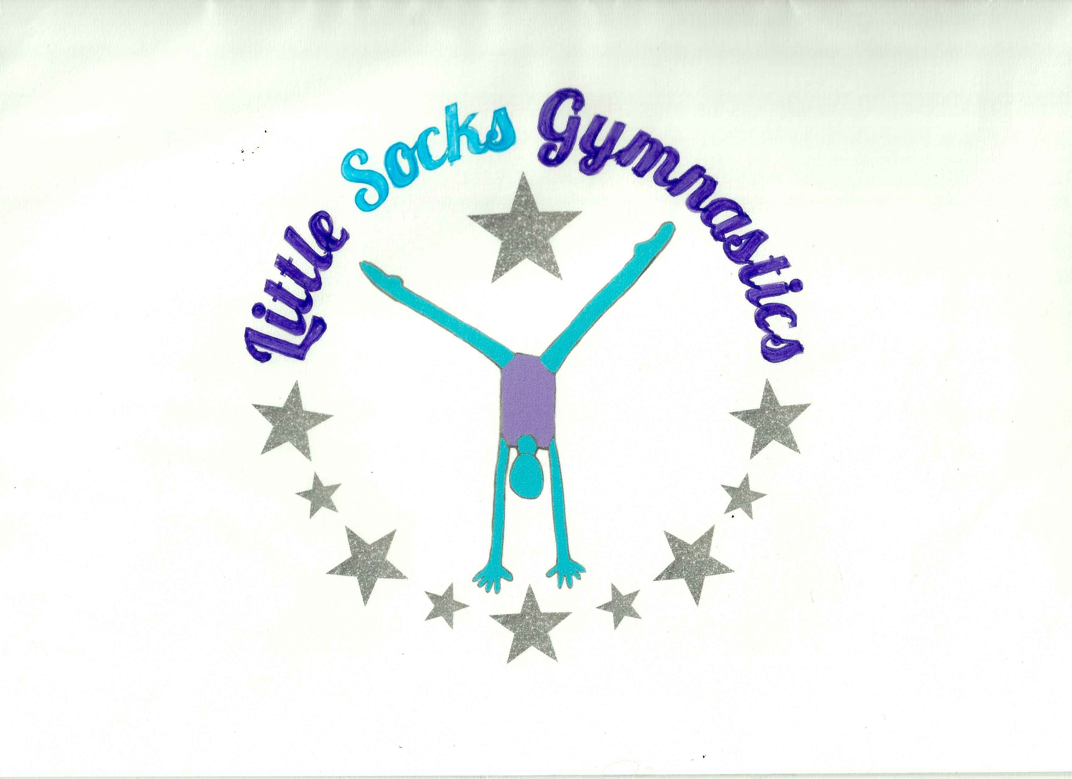

Congratulations to all gymnasts who entered the club competition on 24th March. Medals and ribbons were competed for and everyone made us proud. It is nerve wracking performing in front of your fellow gymnasts and parents and have the added pressure of being judged! We have selected gymnast’s from the club competition to represent Little Socks at the London Regional competition in June. We were very lucky to have Noah Williams - Commonwealth & GB diver along come and present medals and ribbons. He began his sporting life as a recreational gymnast! A massive thank you to all our young volunteers judges and coaches, who along with the fantastic gymnastics made the event a huge success.

The summer term will be upon us soon and hopefully bring sunshine! The summer term focus will be on class displays and regional competition practice. All children will be part of a class display which we will be performing to parents, friends and family at the end of term, we therefore ask that you don’t stay and watch the children this term so that the displays are a surprise. Try to remember to bring a water bottle for your child & please put their name on it.

We are looking to enter a group into the London Festival of Gymnastics in October. This is an annual event, which we have entered several times in the past. It is a non-competitive event which showcases gymnastic displays, it involves costumes, team work, fun and hard work – we will be sending out further details soon. If you do wish to take part in this fantastic event then you will need to be able to commit to attending all practices.

Congratulations to Autumn who is expecting her 2nd child in July – Julia will cover her Saturday classes for the summer term. She will continue on Thursdays and be supported with her group’s by Izzy.

**Please confirm that your child/ren is returning to gymnastics for the summer term as we would like to be able to offer any available spaces out to our waiting list as soon as possible.**

**Summer term 2019 - Dates**

**Thursday -** 11 week term

1 hour class = £66

April 25th

May 2nd, 9th, 16th & 23rd

June 6th, 13th, 20th, 27th

July 4th & 11th

**Saturday -** 10 week term

1 hour class = £60

1.5 hour class = £75

2 hour class = £90

April 27th

May 4th, 11th, 18th & 25th

June 8th, 15th & 29th

July 6th & 13th

NO CLASSES ON SATURDAY 22ND JUNE – LAURISTON SUMMER FAIR

Class fees are payable termly in advance and should be paid in full by the 2nd week of term.

Thank you for all your support.

Julia, Autumn, Tracey, Natasha, Renee.