**Castle Resturant**

Q-24 , Labim Mall

Hattiban east,Lalitpur

457812345

…………………………………………………………………………………………………………….

Date:12/4/2077

Bill no.:39234278

………………………………………………………………………………………………………………

**Particulars Q.T.Y Amount**

**……………………………………………………………………………………………………………**

Chicken Mo:Mo 2 120.00

Chicken Sasuage 3 50.00

………………………………………………………………………………………………………………

Sub Total 390.00

Tax (10%) 45.00

**Total 435.00**

**……………………………………………………………………………………………………………**

GSTIN 27bt0restrojkl0898llop

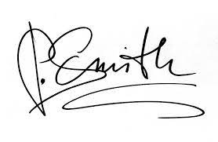 Signature

----------------------

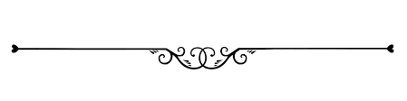

**Thank You. Visit Us Again!**