Tax Invoice
Real Food Cafe
Hattiban, Lalitpur
Ph: ……………. Bill no: ……
Date: …...........
Name: Khagendra Joshi
Address:Hattiban, Lalitpur
s.No | Particular | Qty | Rate | Amount
1)  2) | Chicken MO:MO  Chicken Sasuage | 2  3 | 120  50 | 240  150
 |  |  | Total | 390
 |  |  | Discount | N/A
In words: Four Hundred and Twenty Nine Only. |  |  | Taxable Value | 390
 |  |  | SC (10%) | 39
 |  |  | Grand Total | 429
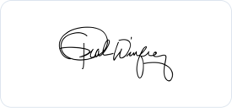
Signature

E.& O.E.

