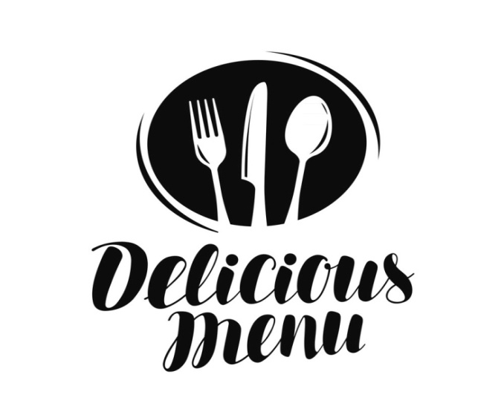

**XYZ Resturant**

**"Healthy Food for goodlife"**

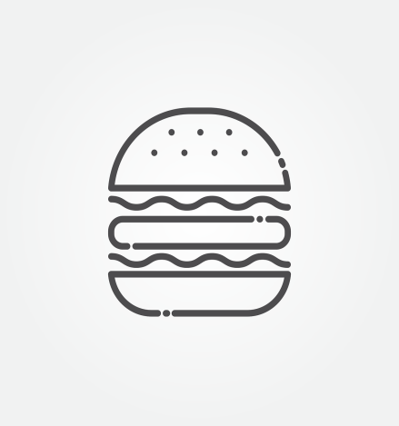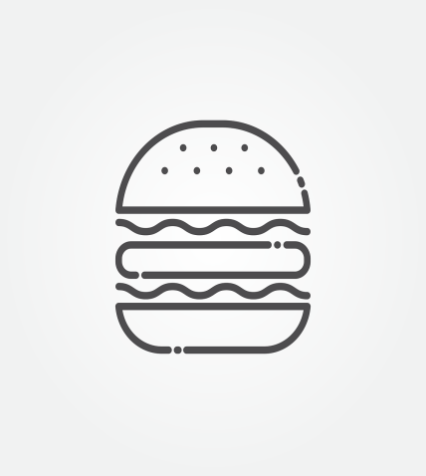 **MENU**

**Dine-In/Take Out**

For Food Delivery

**Just contact us for orders**

**+9770089546210 loc.352**

[www.XYZ.com](http://www.XYZ.com)



Main Dishes

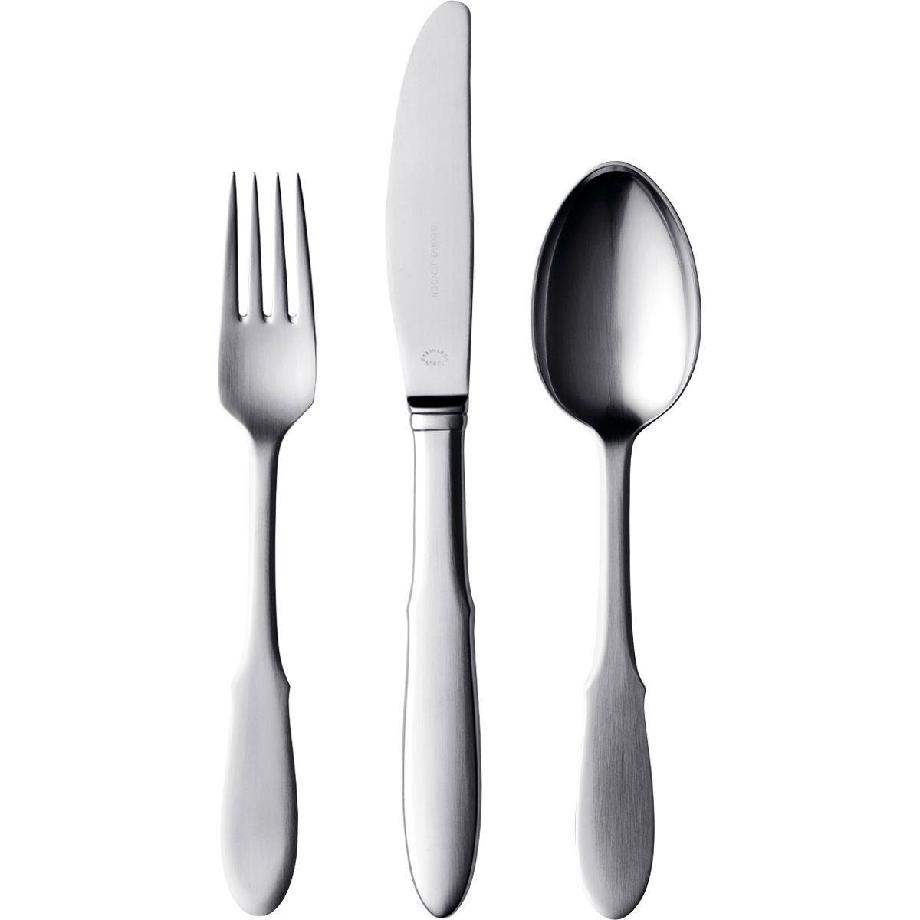

X-mas Chicken Roast …………………………………………………………………………… $ 70.00

Chicken curry , biriyani , Veg Mo ; mo e.t.c ..

Chicken Dishes and veg dishes..

Grilled Chicken X-mas …………………………………………………………………………… $ 70.00

Sasuages , Pork Fry , Pizzas E.T.C

Xmas Special Dishes and drinks

Fried Chicken ………………………………………………………………………………………… $ 70.00

Chicken Choila , Chicken Sadheko e.t.c

Fried KFC style chicken and other fried chicken reciepes

Appetizers

Holiday Cake …………………………………………………………………………………………… $ 60.00

Chocolate flavoured , Strawberry Flavoured , Vannila Flavour e.t.c

Cupcakes and dough nuts with cherries

X-Mas salted Egg …………………………………………………………………………………….. $ 75.00

Egg fry , egg boiled , omlet , e.t.c

Salted fried egg , besan fried egg , non - salted egg (normal )…

Mixed Salad …………………………………………………………………………………………… $ 70.00

Tomatoes and cheese salad , toppings with mayonese salad..

Special X-mas salad

Beverages

X-Mas Cocktail ………………………………………………………………………………………… $ 80.00

Lemonade , Hot Lemon e.t.c

Summer coolers and juices ., Wines and coffees

Special Winter Wine ………………………………………………………………………………… $70.00

Hot coffes and teas..

Hot lemon with honey , and summer wine..