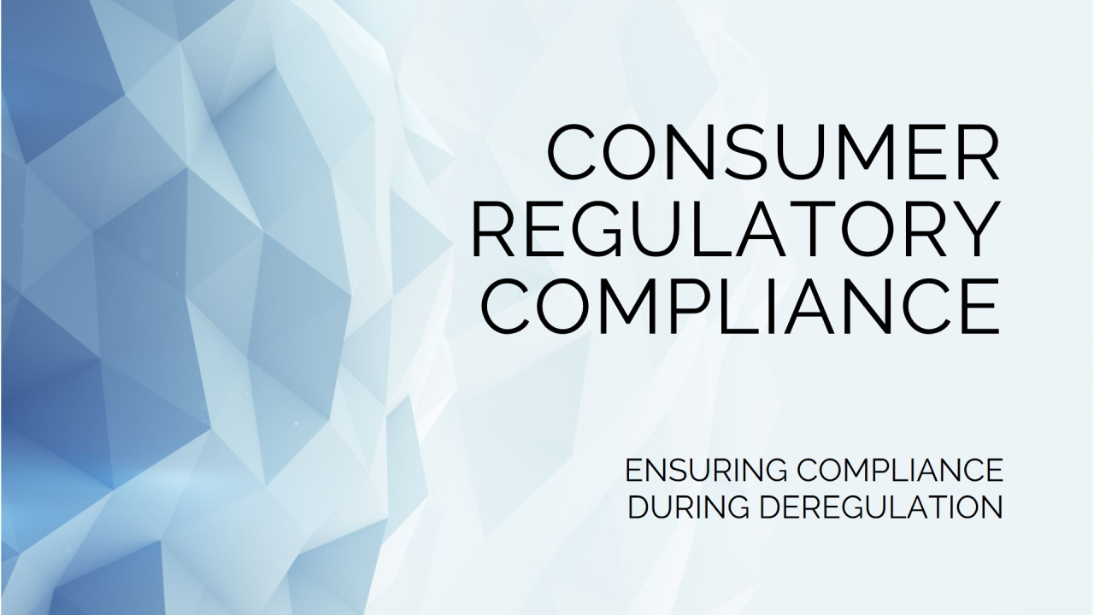
Ensuring Consumer Regulatory Compliance During a Period of Deregulation
by Miles Daniel
January 17, 2025

Consumer regulatory compliance evolves in response to many different factors, including changes in political environments. If the past is any indicator, this political cycle will be no different. With anticipated shifts in policy objectives centered on deregulation to spur economic growth and reduce compliance costs, an institution's ability to balance the benefits of regulatory and compliance practices that foster consumer trust and stable operations will be a key financial and operational differentiator. This article explores how to maximize the benefits of both during a period of deregulation.

Understanding Deregulation and Its Impact
Deregulation refers to the reduction, simplification, or elimination of government rules and oversight, typically aimed at fostering innovation, reducing costs, and enhancing competitiveness. However, even in periods of deregulation, compliance remains a critical component of organizational strategy. This is primarily because deregulation does not mean a complete absence of rules; rather, it shifts responsibility back onto businesses to self-regulate and adopt best practices that adhere to effective solutions.

A responsibility that requires:
- Effective Risk Management solutions that incorporate a Compliance framework to help businesses identify, assess, and mitigate risks, regardless of the regulatory landscape. Risks such as fraud, data breaches, and discriminatory lending practices can have severe financial and reputational consequences, making proactive compliance essential.
- Operational Integrity through consistent Compliance frameworks also help organizations standardize operations, reduce errors, and maintain transparency. These benefits are particularly important in industries like finance, healthcare, and technology, where missteps can have far-reaching consequences.
- Consumer Trust and Brand Reputation is another key factor in our highly competitive industry. Frankly speaking, deregulation does not reduce consumer expectations for fairness, transparency, and ethical behavior. Far from it! Therefore, strong compliance programs demonstrate a commitment to these values, building trust and fostering long-term loyalty and competitive advantage over less or non-compliant peers.
- Investor and Stakeholder Confidence through the adherence of Environmental, Social, and Governance (ESG) standards, even when regulations are lax. Compliance with voluntary or industry standards can attract investment and enhance credibility in competitive markets. Maintaining robust compliance programs demonstrates accountability and builds trust among stakeholders.
- Global Operations and Cross-Border Compliance remained non-negotiable. Where businesses frequently operate across jurisdictions with varying regulatory standards, robust compliance ensures adherence to international rules from anti-money laundering (AML) and counter-terrorism financing (CTF) laws to GDPR for data privacy even when domestic regulations are less stringent.
- Preparedness for Regulatory Shifts. The reality is that Deregulation is often cyclical, and a change in administration or public sentiment can result in the reinstatement of stricter rules. Not to mention many states maintain or even strengthen their consumer protection laws during periods of federal deregulation, necessitating vigilance on the part of businesses operating across jurisdictions. Organizations with strong compliance foundations can adapt more quickly to such shifts with thoughtful strategic planning, avoiding costly penalties and disruptions if, and when, they are reintroduced.

A recent example of this occurred during the previous Trump administration whose emphasis on deregulation aimed to reduce perceived regulatory overreach that, according to proponents, stifled innovation and economic growth. As a result, agencies such as the Consumer Financial Protection Bureau (CFPB), initially established during the Obama administration to protect consumers from unfair practices in financial services, experienced significant changes in their enforcement focus and leadership. Notably, under the leadership of Mick Mulvaney and later Kathy Kraninger, the CFPB shifted toward a philosophy of ensuring regulatory certainty and balancing consumer protection with the economic impact on businesses. This translated into billions of dollars in reduced penalties and consumer relief for non-compliance, fewer enforcement actions, to accommodate a more business-friendly regulatory environment. However, for those who remained non-compliant, the costs of compliance tripled those prior to deregulation once the Biden administration took office (“CFPB Enforcement by the Numbers” www.consumerfinance.gov/enforcement/enforcement-by-the-numbers/).

So, while deregulation may result in less compliance burden, it also introduces new complexities. Among them are Regulatory Uncertainty, to which deregulation often leads from a patchwork of state, federal, and international rules, requiring businesses to adapt their compliance frameworks to diverse requirements. Additionally, unanticipated shifts in Market Dynamics can occur through reduced oversight can lead to increased scrutiny from consumers, investors, and advocacy groups demanding ethical practices and transparency. Last is the inevitable Risk Amplification through deregulation, which often creates gaps in oversight, increasing the potential for fraud, money laundering, discrimination, and/or data privacy and security, which businesses must proactively mitigate. As such, organizations must navigate evolving legal, ethical, financial, and reputational landscapes to maintain trust, protect stakeholders, and ensure sustainable operations to and through periods of deregulation.

The Balance Between Deregulation and Compliance
For Financial Institutions, the challenge lies in balancing the opportunities of deregulation with the responsibilities of compliance. Strategies include Proactive, Risk-based Self-Regulation that entail establishing internal codes of conduct and risk sensitive best practices that go beyond legal requirements. By prioritizing compliance efforts based on areas of highest risk to the business and stakeholders, your institution ensures efficient allocation of resources while addressing critical vulnerabilities. Proactive Stakeholder Engagement, which includes engaging with consumers, investors, and regulators to align business practices with societal expectations. Continuous Monitoring will remain paramount to enable real-time monitoring, automated reporting, and risk assessment. These solutions enhance Compliance efficiency and accuracy, even as regulations fluctuate. All these reinforced with Training and Education ensure Board, Management, and staff understand compliance policies and ethical considerations, fostering a culture of accountability.

The Benefit of Technology During Periods Deregulation
Advancements in technology have made compliance more efficient, even in deregulated settings. Key innovations include Regulatory Technology (RegTech) Solutions such as Compliance Risk Governance (“CRG”) to simplify, standardize, and automate enterprise-wide compliance monitoring, real-time reporting, risk assessments, and regulatory change management ensuring adherence to evolving regulations. These solutions, along with complimentary AI and Machine Learning capabilities, analyze vast datasets to identify risks, detect fraud, promote fair lending practices and ensure ethical practices. Blockchain plays the supporting role of providing transparent and immutable records for auditing and regulatory reporting. While Data Privacy Tools help manage consumer consent, secure sensitive information, and comply with global data privacy laws. By leveraging advanced compliance tools and maintaining robust frameworks, many institutions successfully navigated the challenges of deregulation while safeguarding their reputations and minimizing cost and risks.

Conclusion
Whether bracing for, or embracing, the prospects of deregulation, financial institutions still face significant compliance challenges. As previous periods of deregulation highlight, there is a delicate balance required to reduce regulatory burdens while maintaining consumer confidence and protection. In periods where businesses are increasingly expected to self-regulate, robust compliance programs are not merely a regulatory necessity - they are a strategic imperative that protects organizations from legal, financial, and reputational risks while fostering trust and sustainability by embracing compliance as a core value. Investing in robust compliance programs and systems and fostering a culture of accountability with which organizations can navigate deregulated landscapes with confidence and integrity can support long-term success in a rapidly evolving world.

