Newsletter:

The Voice of BAC

Happy July!!!!!!!! Summer is in full swing, and the BAC crew is loving it!!!!

We had a fantastic month of June which kicked of with our annual visit from Gee Funny Farms. They always do such a wonderful job of combining learning and fun as well as a unique hands-on experience with our animal friends. This year we were up close and personal with an adorable bunny, a prickly porcupine, a non-stinky skunk, a super soft chinchilla, and a scaley bearded dragon.

We celebrated all of the awesome dads out there with donuts, bingo, and handmade gifts. Thank you to all of dads who stopped by for a treat and a visit!!!!

Everyone enjoyed a variety of activities such as making homemade ice cream in a bag, creating little creatures out of pool noodles, karaoke, bingo, a movie and margaritas, lots of fresh air and walking, crafting, and breaking in our new bowling set.

**Coming Up:**

Tuesdays- Music Therapy

July 3rd- BAC Cookout

July 4th – BAC Closed for holiday

July 18th -Kona Ice

**June Birthdays:**

**BAC would like to wish these amazing individuals a Happy Birthday!!!!**

**Kaitlin- 7/1**

**Erin- 7/9**

**Emerlean- 7/13**

**Jenny S.- 7/22**

**July 2025**



Gee Funny Farm!!!

Karaoke Duets

**Contact Us**

**Brookfield Adult Center**

**20711 Watertown Rd.**

**Ste. V**

**Brookfield, WI. 53186**

**Phone:**

**262-599-8083**

**Hours:**

**8am-3pm**

**Email**

[**brookfieldadultcenter@gmail.com**](mailto:brookfieldadultcenter@gmail.com)

**Website**

**Brookfieldadultcenter.com**

**Reminders:**

* ***Please be reminded that our program opens at 8am and runs till 3pm. Members are advised to be picked up no later than the 3pm closing time. Late fees will be charged for every 5 minutes after the closing time.***
* ***If your member will not be attending program, please do well to communicate this with the center for us to plan accordingly. (262-599-8083)***
* ***We are accepting donations of wipes and any art and craft supplies.***
* ***Are you looking for volunteer opportunities? If you or someone you know would be interested volunteering in subcontracted activities such as art therapy, pet therapy, aromatherapy, magic, music and any form of entertainment please reach out to the office at 262-599-8083.***

***Thank you for your usual cooperation!!***

**Brookfield Adult Center**

 **20711 Watertown**

Guys Trivia

Bowling

Bonanza

**262-599-8083**

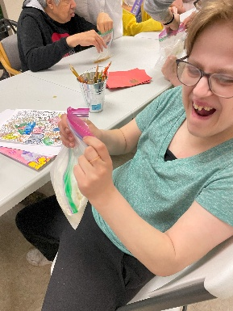 **8am-3pm**

Email

**brookfieldadultcenter@gmail.com**

Website

**Brookfieldadultcenter.com**

I scream….

You scream….

We all scream for Ice cream!!

**Brookfield Adult Center**

**20711 Watertown Rd.**

**Ste. V**

**Brookfield, WI. 53186**

**262-599-8083**

 **8am-3pm**

Website

Donuts

With

Dad!!!!

