Monday | Tuesday |  |  | Wednesday |  | Thursday |  | Friday
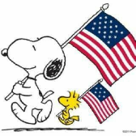 | 1  Morning Group  BAC Fitness  True or False  Red-White-Blue Star Craft  Table/Card Games  HBD Kailin!!!! |  |  | 2  Morning Group  BAC Fitness  Summer Fun Door Decorating Competition |  | 3  Morning Group  BAC Fitness  4th of July Cookout  Bingo  Afternoon Movie and Popcorn |  | 4  BAC will  be closed.  Happy 4th!!!!!
7  Morning Group  BAC Fitness  Balloon Tennis  Mosaic Art with Beans Part 1  Table/Card Games | 8  Morning Group  BAC Fitness  Sensory Dough  Mosaic Art with Beans Part 2  Table/Card Games |  |  | 9  Morning Group  BAC Fitness  Dish Soap Silly Putty  Crazy Bowling    Table/Card Games  HBD Erin!!! |  | 10  Morning Group  BAC Fitness  Name that Tune  Rock Painting  Table/Card Games |  | 11  Morning Group  BAC Fitness  Bingo  Karaoke    Movie  HBD Emerlean!!  (6/13)
14  Morning Group  BAC Fitness  Name that Tune  Beading Group  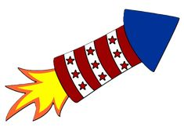  Table/Card Games | 15  Morning Group  BAC Fitness  Bowling  ABC Game  Table/Card Games |  |  | 16  Morning Group  BAC Fitness  Squirt Gun Watercolor Painting  Cup Cake Wars  Table/Card Games |  | 17  Morning Group  BAC Fitness  Balloon Volleyball  Watercolor Painting  Table/Card Games |  | 18  Morning Group  BAC Fitness  Bingo  Karaoke  Kona Ice
21  Morning Group  BAC Fitness  Group Trivia  Crazy Bowling  Table/Card Games | 22  Morning Group  BAC Fitness  Sink or Float  Giant Memory  Table/Card Games  HBD Jenny S.!!!! |  |  | 23  Morning Group  BAC Fitness  Yahtzee  Beach Ball Frenzy    Table/Card Games |  | 24  Morning Group  BAC Fitness  A-Z Game  Beading Group  Table/Card Games |  | 25  Morning Group  BAC Fitness  Bingo  Karaoke  Movie
28  Morning Group  BAC Fitness  Odds or Evens  Coloring and Conversation  Table/Card Games |  | 29  Morning Group  BAC Fitness  3 Word Game  Making Moon Sand  Table/Card Games | 30  Morning Group  BAC Fitness  Design Your Own Sunglasses  Sunglasses Fashion Show  Table/Card Games |  | 31  Morning Group  BAC Fitness  Beach Roll and Race  Karaoke  Table/Card Games |  | 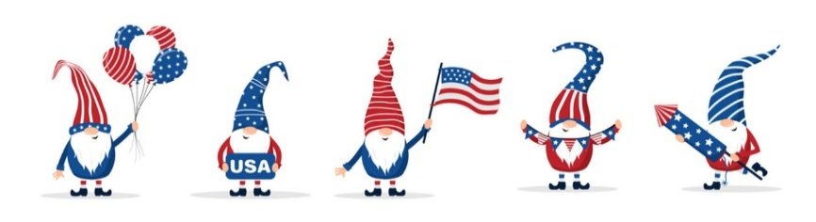


July Birthdays:
Kailin – 1st Erin- 9th

Emerlean- 13th Jenny S- 22nd


