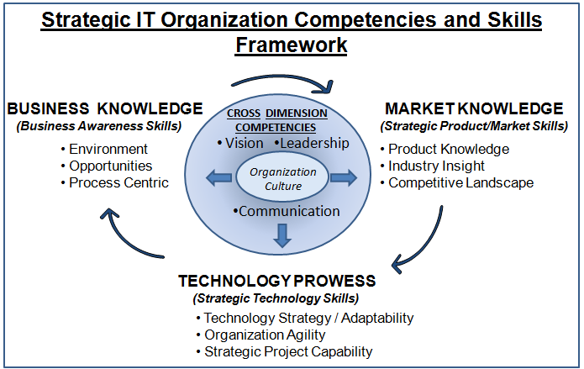
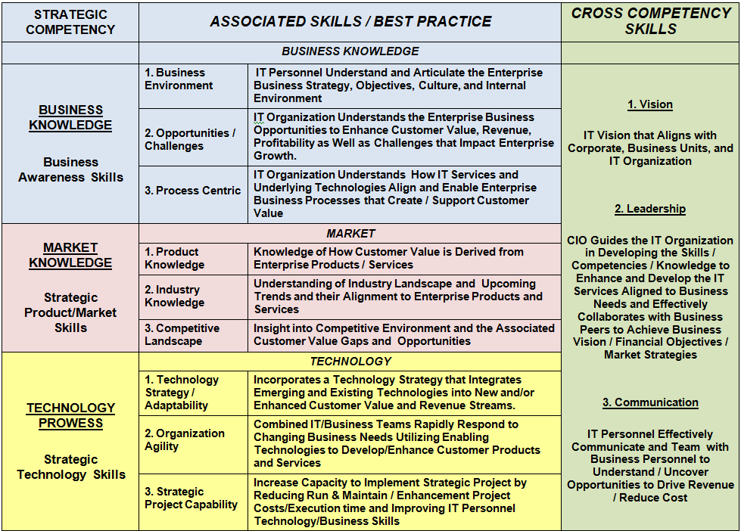

Strategic IT Competencies and Skills Assessment
COMPETENCIES AND ASSOCIATED SKILLS
BUSINESS KNOWLEDGE
SKILL | BEST PRACTICE |  | Score ( 1 = Low / 8 = High)
 |  |  | Skill Knowledge(a) | Applying Skill (b)
Business Environment |  | Understanding and Ability to Articulate the Enterprise Business Strategy, Objectives, Culture and Internal Environment
Opportunities/Challenges |  | Understanding and Ability to Articulate the Enterprise Business Opportunities that Can Enhance Customer Experience/Value, Enterprise Revenue/ Profitability/ROI, and the Challenges that Impact Enterprise Growth
Process Centric |  | Understanding and Ability to Articulate How IT Services Align and Support Enterprise Process and Innovate New Processes as Needed.
Rounding Adjustment |  |  | 1.0 | 1.0
SUB TOTAL BUSINESS KNOWLEDGE
MAXIMUM SCORE |  |  | 25.0 | 25.0
MATURITY % (sub-total / maximum score)

COMPETENCIES AND ASSOCIATED SKILLS
MARKET KNOWLEDGE
SKILL | BEST PRACTICE | Score ( 1 = Low / 8 = High)
 |  | Skill Knowledge(a) | Applying Skill (b)
Product Knowledge | Knowledge of How Customer Value is Derived from Enterprise Products and Services
Industry Knowledge | Knowledge of Industry Landscape and Upcoming Trends and their Alignment to Enterprise Products and Services
Competitive Landscape | Awareness of Competitive Environment and the Existing Customer Value Gaps and Associated Opportunities to Provide Customers Additional Value in the Form of New/Enhanced Products and Services
Rounding Adjustment |  | 1.0 | 1.0
SUB TOTAL MARKET KNOWLEDGE
MAXIMUM SCORE |  | 25.0 | 25.0
MATURITY % (sub-total / maximum score)

COMPETENCIES AND ASSOCIATED SKILLS
TECHNOLOGY PROWESS
SKILL | BEST PRACTICE | Score ( 1 = Low / 8 = High)
 |  | Skill Knowledge(a) | Applying Skill (b)
Technology Strategy / Adaptability | Incorporates Emerging and Existing Technologies into New and/or Enhanced Products/Services that Provide Customer Value that will Drive Additional Revenue, Reduce Costs, and/or Increase ROI
Organizational Agility | Teams of IT/Business Personnel Rapidly Form Based Upon Changing Business Needs Leveraging Enabling Technologies to Develop/Enhance Customer Products and Services
Strategic Project Capability | Capability to Implement Strategic Projects by Reducing Costs of Run & Maintain Activities and Enhancement Projects as well as Improving IT Personnel Technology/ Business Skills to Improve Efficiencies
Rounding Adjustment |  | 1.0 | 1.0
SUB TOTAL TECHNOLOGY PROWESS
MAXIMUM SCORE |  | 25.0 | 25.0
MATURITY % (sub-total / maximum score)

COMPETENCIES AND ASSOCIATED SKILLS
CROSS COMPETENCY SKILLS
SKILL | BEST PRACTICE | Score ( 1 = Low / 8 = High)
 |  | Skill Knowledge(a) | Applying Skill (b)
Vision | IT Vision that Aligns with Corporate and all Business Units (including IT)
Leadership | CIO and Key IT Personnel guide the IT Organization in Developing the Skills/Competencies/Knowledge to Enhance and Develop the IT Services Aligned to Business Needs, Development and Enhancement of Products and Services as well as Effectively Collaborates with Business Peers to Achieve Business Vision / Market Strategies/ Financial Objectives
Communication | IT Personnel Effectively Communicate, Collaborate, and Team with Business Personnel to Understand/Uncover Opportunities to Drive Revenue, Reduce Costs and Improve ROI
Rounding Adjustment |  | 1.0 | 1.0
SUB TOTAL CROSS COMPETENCY SKILLS
MAXIMUM SCORE |  | 25.0 | 25.0
MATURITY % (sub-total / maximum score)

COMPETENCIES AND ASSOCIATED SKILLS
SUMMARY
SKILL | BEST PRACTICE
 |  | Skill Knowledge | Applying Skill
SUB TOTAL BUSINESS KNOWLEDGE
SUB TOTAL MARKET KNOWLEDGE
SUB TOTAL TECHNOLOGY PROWESS
SUB TOTAL CROSS DIMENSION
TOTAL SCORE
AVERAGE MATURITY
MAXIMUM SCORE |  | 100 | 100
MATURITY % (TOTAL SCORE / MAXIMUM SCORE)

