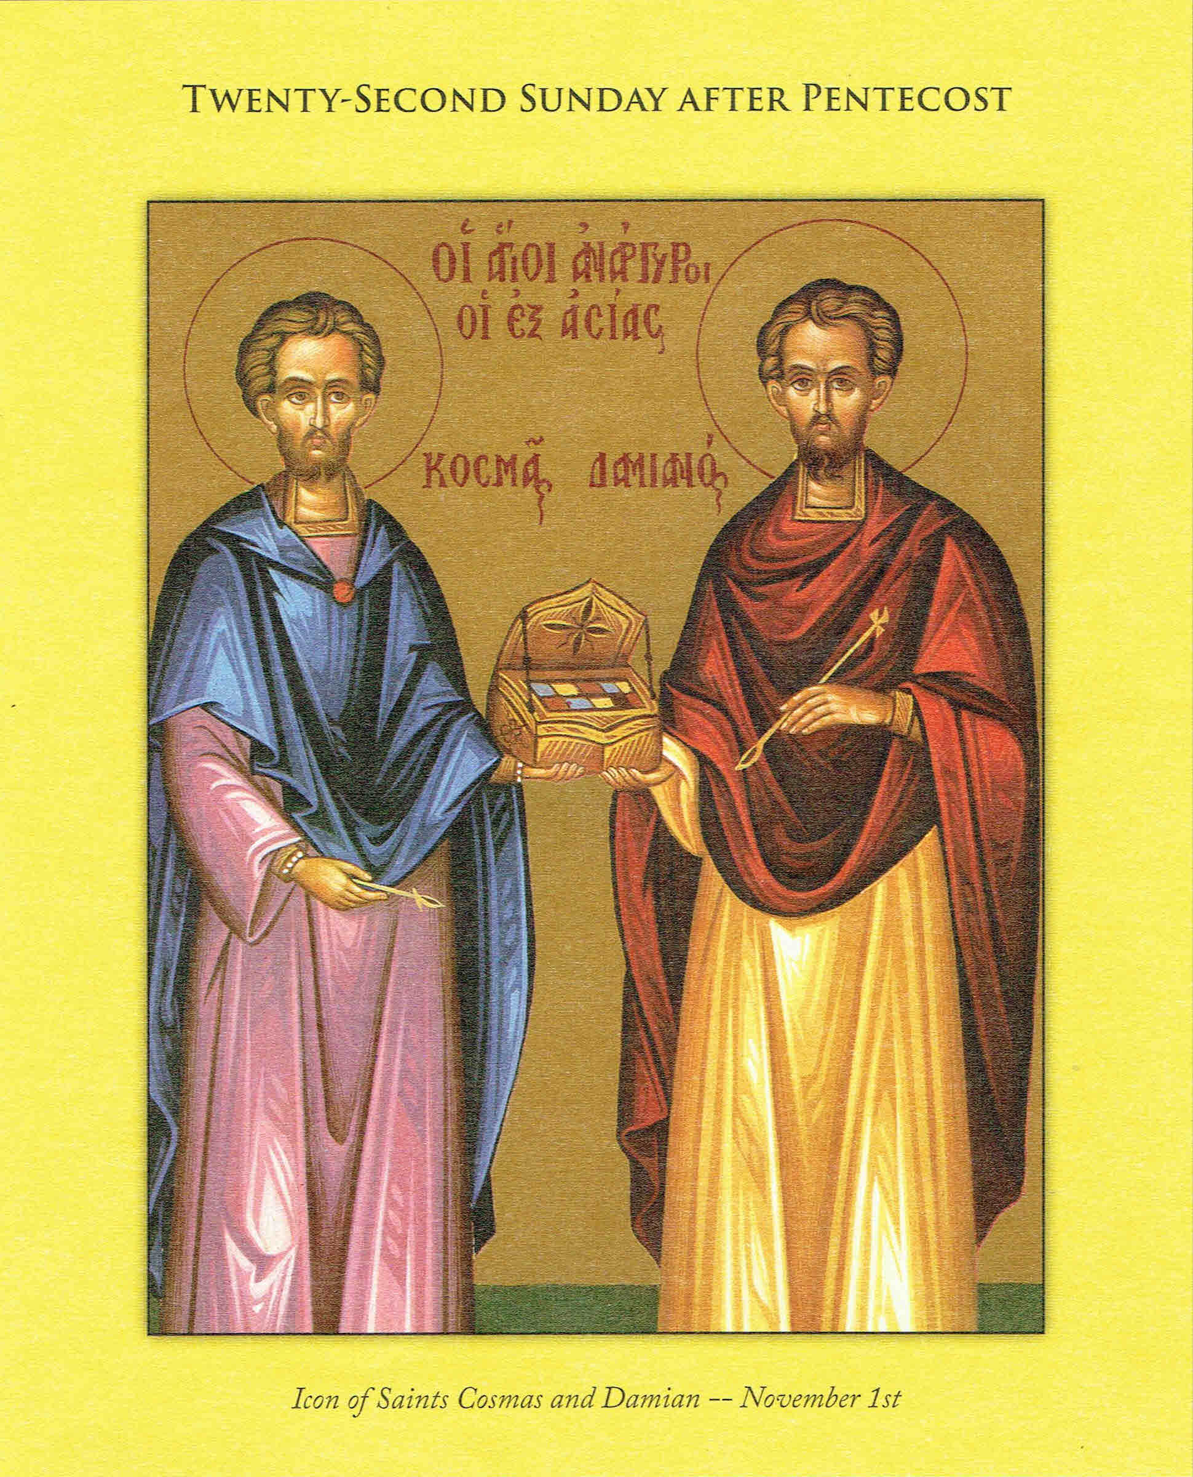
St. Mary Byzantine Catholic Church

(Under the Holy Protection of the Mother of God)

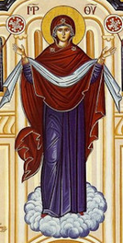
2115 Listravia Ave., Morgantown, WV 26505
Office: (304) 296-2455
Website: HolyProtectionWV.com

Facebook: St. Marys Holy Protection Byzantine Catholic Church

E-mail: holyprotectionwv@gmail.com
Rev. Father James Fraser
Residence (cell): (304) 918-3297

Holy Mystery of Reconciliation: ¹/₂ hour before Liturgy or by appointment
Holy Mystery of Anointing: prior to surgery or whenever requested
Holy Mysteries of Baptism and Chrismation: Arrange with Father Jim
New Parishioners: Welcome! Please see Father for registration



DIVINE LITURGY SCHEDULE FOR OCT 28th to NOV 5th, 2023
Saturday  Oct. 28th  6:00 p.m. | 22nd Sunday After Pentecost - p 146  Readings: Gal 6:11-18; Lk 8:26-39  Intention: For the people of St Mary's Parish
Wednesday  Nov 1st  7:00 p.m. | Divine Liturgy - p 146  Readings: 1 Thess 2:1-8; Lk 11:42-46  Intention: For Lucian, Req. by Sam Mazza.
Sunday  Nov. 5th  10:30 a.m. | 21st Sunday After Pentecost - p 152  Readings: Eph 2:4-10; Lk 8:41-56  Intention: For the people of St Mary's Parish

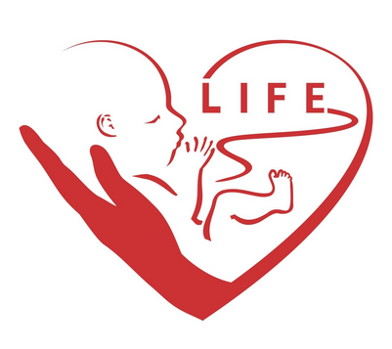
CHOOSE LIFE! That the people of this nation may come to fully understand that abortion means the violent death for an unborn child, we pray to the Lord.


Cabbage Roll Sale

St. Mary's will be selling our delicious cabbage rolls (halupki) for $20 per dozen, cooked or uncooked. Orders are due by Monday, November 13 & can be picked up on Friday, November 17 at the parish. Proceeds will benefit the parish building & maintenance fund. Questions? Call Ellen at 304-282-0431.

Iconography Workshop

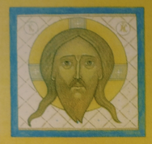
Peter Pearson will be conducting an Icon workshop, at St. John the Baptist Byzantine Catholic Church in Uniontown, PA, that will include the completion of the Holy Face icon, aka Veronica's Veil. You will learn a little about the history, spirituality and aesthetics of byzantine iconography. The Workshop is Nov. 16-19 with the cost being $275 with a deposit of $125 due by Nov. 1st. Send payment to St. John the Baptist Byzantine Catholic Church, 185 E. Main Street, Uniontown, PA 15401. For more info call marko (401)852-2249 or ikon71355@gmail.com

Byzantine Assembly 2023

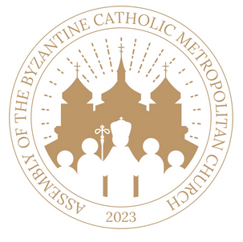
Metropolitan Archbishop William C. Skurla and the Council of Hierarchs of the Byzantine Catholic Metropolitan Church of Pittsburgh will be hosting the 3rd assembly of our Church on Thursday, November 2 to Sunday, November, 5 2023, at St. Mary's Byzantine Catholic Church, Hillsborough, NJ.

The Assembly's theme is Living Our Faith: Moving Forward, Appreciating Our Past.
For more information, contact the Assembly coordinators, Fr. Ed Cimbala, at 212- 677-0516 or Fr. Yury Oros at 609-394-5004.

The assembly website is byzantineassembly2023.org,
and the email is byzantineassembly2023@gmail.com.
Individuals between ages of 18-35 will have fees paid by Maria Theresa Foundation.

41ST ANNUAL CARPATHO-RUSYN FESTIVAL
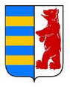
St. John the Baptist Byzantine Catholic Church in Uniontown, PA, located at 201 E. Main Street, is celebrating its annual ethnic festival, the 41st Annual Carpatho-Rusyn Celebration on Sunday, Oct. 29 in the Parish Social Hall. The event will take place from 12 noon to 5:00 p.m. Divine Liturgy for the day will be 10:30 a.m. with some parts in Church Slavonic.

There will be ethnic foods such as holubki, pirohi, halushki, kolbasi and sauerkraut, soup, pagach, baked goods (long rolls, a variety of pastries, cakes, kolachi, breads, and much more). This annual event will feature performances of Rusyn Folk music by “Rusynsky Betjare” starting at 12:30PM and continuing throughout the afternoon. The day will include a display of artifacts, authentic costumes, models of Rusyn wooden churches, photographs, and documents.


Pray for the Sick, Recovering, and Shut-Ins:

Lord Jesus Christ Son of God, Thank You for Your Mercy

May we keep all our ailing and healing parishioners in our prayers every day.

Please let Father Jim know to include any family and parish members who are ill, hospitalized, or need a visit for blessing, anointing, confession, or request of prayers. Kindly call Father Jim at (304) 918-3297 Thank You.



HAPPY BIRTHDAY WISHES go to:


Don Waycaster on Oct. 30th,

Debra Olexa on Oct. 31st and

Linda Waycaster on Nov. 1st

May God bless you with Peace, Health, and Happiness!

For many happy and blessed years!

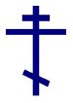

O Holy Spirit,

I have my own expectations about what I should and should not do.

I surrender to You my ideas, my limitations, my preferences, and my goals.

Fill me, Holy Spirit, with Your supernatural gifts!

Empower me to accept and grow in the supernatural life as much as the early disciples.

I want to be useful to You. I want to go where You lead me.

Holy Spirit, send me forth gifted and empowered to make a difference spreading the

Good News of God’s forgiving love.

Offertory Collection for Oct. 15th, 2023

Envelope  Offerings | Loose  Offerings | Candles | Mem. John McCabe | Building Fund | Total
$85 | $209 | $15 | $150 | $20 | $479

Church Attendance for Sunday was: 25

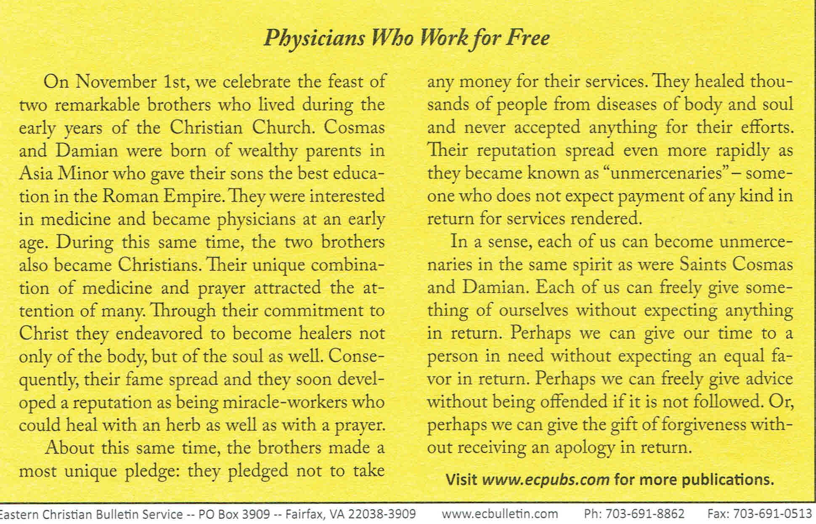
Please note that Saturday's Oct. 28th Liturgy is the Vesperal Liturgy for Sunday Oct. 29th. There will not be a Liturgy on Sunday the 29th. Fr. Jim will be celebrating the Liturgy at 10:30 a.m. at St John the Baptist In Uniontown. He encourages us all to attend Liturgy in Uniontown and then stay for St John's Carpatho-Rusyn Festival.



Bishop Theodore Romzha - Oct. 31st

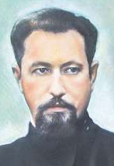
The Servant of God Bishop Theodore Romzha was born on 14 April 1911, in the village of Veliky Bychkiv, Transcarpathia. From 1930-1933, he studied philosophy in Rome and completed his theological education also in Rome from 1933-1937, culminating in a Licentiate. Shortly thereafter, he became an administrator of the parish in Berezovo. Beginning in 1939, he was a professor of philosophy at the seminary in Uzhorod. On 24 September 1944, he was ordained to the episcopacy for the Mukachevo eparchy. During the Red Army presence in the Carpathian region of Ukraine, he was tireless in his defence of the rights of the Catholic Church there. On 27 October 1947, the Soviets attempted to kill Bishop Romzha. Heavily wounded, he was taken to the hospital in Mukachiv, where he was subsequently poisoned and died on 1 November 1947.



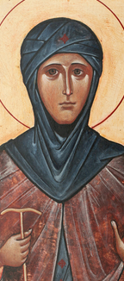
St. Winefride - Nov. 3rd
St. Winefride was a maiden of noble birth who lived in North Wales in the seventh century. The niece and spiritual daughter of St. Beuno, she entered the Monastery of Gwytherin after his death, where she lived under the spiritual direction of St. Eleril.
The son of a neighboring chieftan, Caradoc, demanded that Winefride submit herself to him. When she refused, he pursued her and struck off her head with a sword. The spot where her head fell became known as Holywell, because of the appearance of a healing spring for those who would take its waters with faith. Holywell remains a great place of pilgrimage in Britain to this day.
By permission of Abba Moses (www.abbamoses.com)

