“Oh beautiful for spacious skies, For amber waves of grain, For purple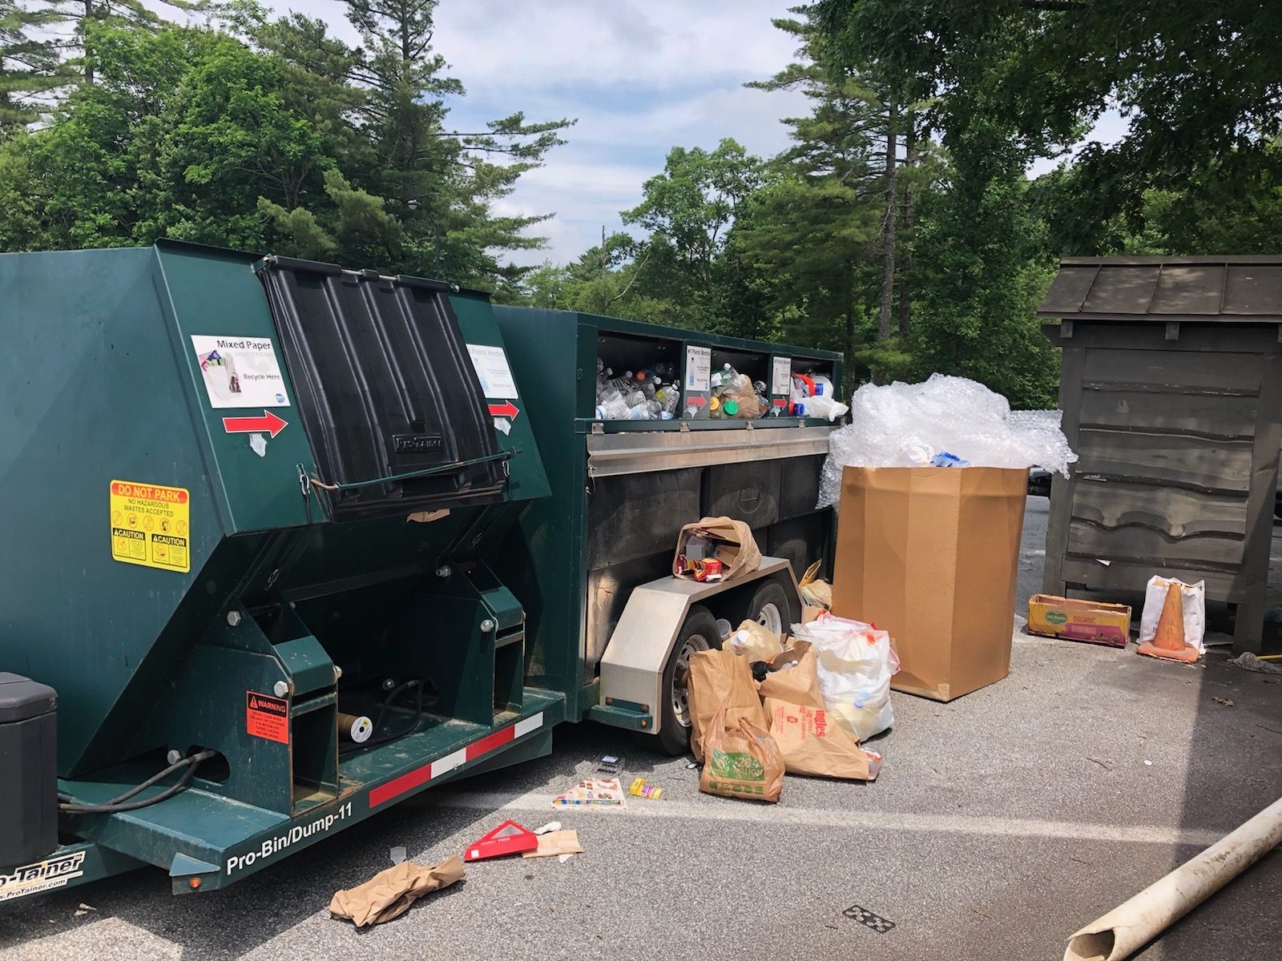 mountains majesties, Above the fruited plain.”

If our small convenience center at the recreation center is full, please take your recycling and household garbage to the sites listed below. Also, Highlands has public cardboard recycling bins throughout the business district.

|  |
| --- |
| **Highlands Transfer Station: 1080 Rich Gap Road, Highlands, NC**  Monday through Friday: 7:30am - 4:30pm; Saturday: 8:00am - 2:00pm.  **Buck Creek Center: 10333 Buck Creek Road, Highlands, NC**  (828) 526-0393 Monday through Saturday: 7:00am - 7:00pm; Sunday: 9:00am - 5:00pm |

“America, America! God shed his grace on thee, And crown thy good with brotherhood, From sea to shining sea.”

I still have hope our nation will continue to embrace the ideals expressed in America the Beautiful. Let’s start by keeping Highlands beautiful and embracing the spirit of brother and sisterhood.

Happy 4th of July!

