It Only Takes One To Ruin It

March 16. 2022

I was ready to write about the Town Retreat, and then about Thursday’s Board Meeting. But then I drove to Founders Park on Monday to begin a road-running workout. I came upon a depressing site. The photo below shows a trash bag stuffed in the top of a BearWIse, bear resistant street can.

Realizing that someone had carelessly attempted to place their household trash bag in the street BearWise can was distressing. What the photograph does not show is a half-eaten lunch plate that was left on top of the can. What are some people thinking? Are they unthinking slobs that simply do not care about this beautiful community? As the mayor I was crushed to know such reckless behavior is still afoot in Highlands.

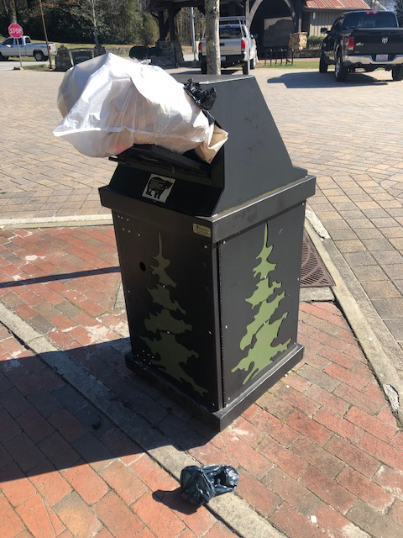

I rationalized why someone would do such a dastardly deed. I thought maybe the trash crews didn’t empty the cans after weekend activities. Even if they hadn’t, there’s no excuse for such behavior. So, I went around the park and checked the other street cans. They were not full, and all had been emptied that day.

The painful truth is that someone decided to dispose of their household garbage by just stuffing the bag in a street can that is designed to handle only small amounts of garbage, fast food trash or coffee and ice cream cups. Several years ago, when we first deployed the street cans, I caught a woman trying to put her household trash bags in a street can near Reeves. I confronted her and she stopped. I wish I had seen the person stuffing this BearWise receptacle.

Since implementing the BearWise program, we have removed those ugly shared dumpsters that used to be on public streets. These dumpsters that were rented by businesses became magnets for people depositing their household garbage and overfilling the dumpsters. The new roll cart system has greatly reduced that problem.

If you see someone stuffing a BearWise receptacle, take a photo and send it to Askmayorpat.com. We will investigate, and I will at least photo-shame the offender. I know some may think their mayor is over reacting, but I not going to let these kinds of trashy behaviors become the norm in Highlands.

Also, a citizen recently sent me a photo of a bear resistant roll cart in a neighborhood that had been overfilled to where the lid could not be closed. There were additional bags of garbage on the side of the cart. I urged the person to contact the police at 526-9341. Our code enforcement officer will investigate those violations. In addition, our sanitation crews have been directed to report these violations to the code enforcement officer.

As for the offending neighborhood residence, those folks may need to acquire an additional bear resistant trash can, especially if they are operating an STR.

We do have a town board meeting Thursday night with a full agenda. It starts at 7 pm at the Highlands Conference Center. The board had a productive retreat last Thursday. More information to come.

Pat Taylor