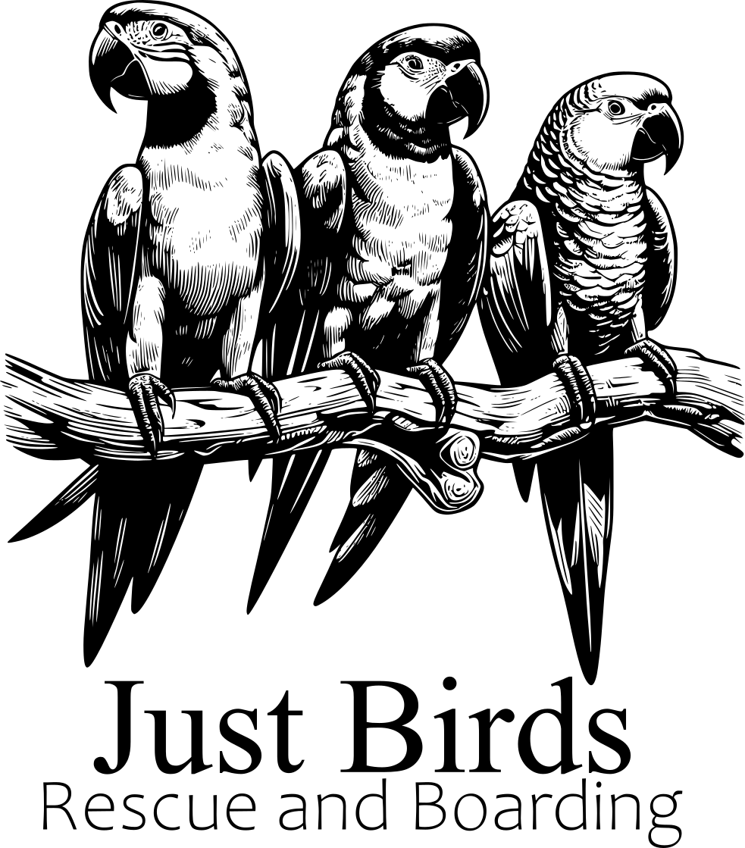

**Boarding Form**

**Date:**

**Name:**

**Address:**

**Phone:**

**Email:**

**Bird details**(Please include as much information as possible )

**Vet details for in case of emergencies  
Name: Number:**

**Address:**

**Checking in date: Checking Out date:**

(10% deposit to be paid on arrival, and final payment to be received on check out, cost is:  
£3 per day for a small cage  
£4 per day for a medium cage  
£5 per day for a large cage

Discounts available for multiple birds, and long term boarding).

**Terms and Conditions:**

If the birds are not retrieved within **three months** of the scheduled date, or if full payment is not received, they will be deemed as surrendered into Karen Hanlon’s care, unless alternative arrangements for collection have been mutually agreed upon.

Owners are to supply Just Birds with documentation that the parrot is free of disease and mites and the right to contact the appointed vet if required.

Owners are to supply an appropriate holiday cage unless otherwise discussed, and the bird's food for the duration of the stay unless otherwise discussed. If food is to run out before the check out day, a daily charge of £1.00 will be applied.

By signing this document you affirm that the bird has not had any contact with wild birds, this is for the welfare of other birds.

|  | __________________________  [**Sign**] | __________________________  [**Date**] |
| --- | --- | --- |