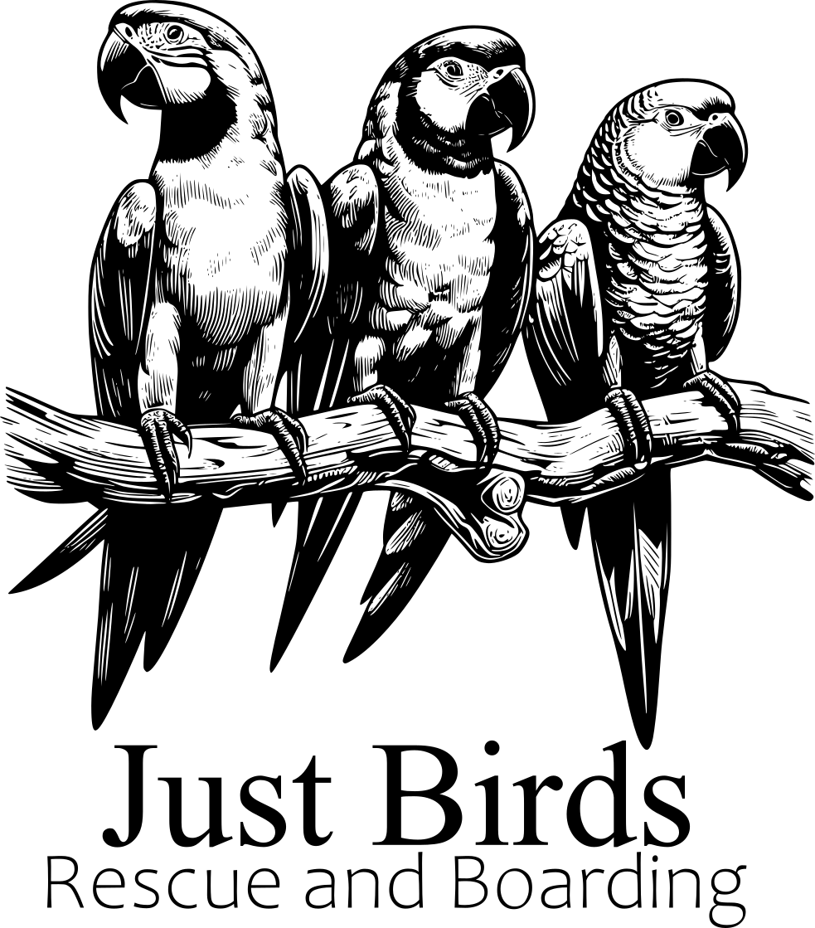

**Surrender Form**

**Date:**

**Name:**

**Address:**

**Phone:**

**Email:**

**Bird details**(Please include as much information as possible )

**Terms and Conditions:**

I, the individual identified above, confirm ownership of these birds and assert my legal authority to surrender them. I acknowledge that upon surrender, I forfeit any legal claims to them, and Karen Hanlon of Just Birds Rescue and Boarding reserves the right to responsibly rehome them in a manner deemed suitable and in the best interests of the birds.

|  | __________________________  [**Sign**] | __________________________  [**Date**] |
| --- | --- | --- |