North Dorset Scout District Newsletter

Issue 3 Number 3 May 2018

FROM OUR DISTRICT COMMISSIONER’S DESK

Simon Young. DC simon.young@wates.co.uk
All,
Well it’s been a short while since my last significant update, but we are coming to the busy season (as if it has not been already!), as I am sure you are aware the census was completed at the end of January / middle of February and I am pleased to announce that the total membership for North Dorset has risen to 809 in total made up of 617 young people and 192 adults. Naturally we have seen some ups and downs on these numbers but it is the 5th year in a row we have seen either stability or growth within the district. Thank you to you all for maintaining your membership of scouting no matter what you role, we cannot deliver scouting to the young people without you, and a big thank you to all the young people who attend, we hope you enjoy your scouting and continue to do so for many years to come.
What the census has shown us is we are in the need for new leaders across the sections, whilst this is not news as we juggle our lives to fit around scouting and not always succeeding, the census figures submitted show that we have a waiting list of 114 young people across Beavers, Cubs and Scouts and a large majority of these across just three groups. I will of course be working hard with the groups to try and reduce the waiting lists and get more young people into scouting that want to be involved.
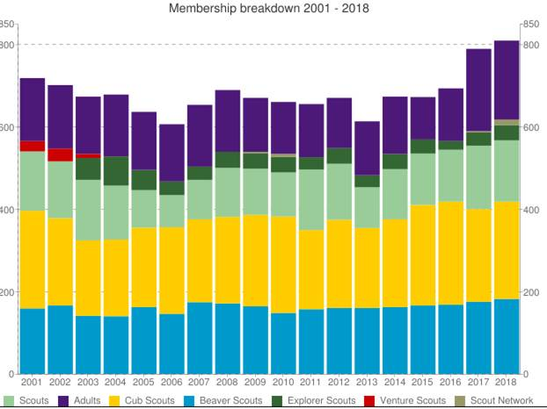

Sunday 22nd April saw the annual St George’s Day celebrations and whilst I have said my thanks for those who participated, support and help organise it would not be right if I did not mention it in some way. This year was the first time in Dorset that two Districts have combined to celebrate this day and as such 600 persons were checked into the days celebrations following the parade through Sherborne.

Awards were presented to both the young people and adults alike and approximately 70 awards were presented on the day in total, well done to you all and well done to those who achieved their chief scouts awards and in particular to Graham Airey for his Silver Acorn award and Jenny Merefield for her Bar to the Silver Acorn.
It’s that time of year again when the AGM’s are due to take place and I urge you all to attend your groups and the district AGM, I’m sure you will hear of the details but if not please do contact your GSL or one of the district team.
As you know our ADC’s are there to support you in programme planning and recently we have seen a few isolated areas of limited support in the local meetings on some sections, can I ask that you support these meetings and join in with the section meetings and activities that are arranged, these people are there as support to all sections and deserve all groups to support and not just the usual one’s. Yes I am well aware that we all have family and work and it’s another night out, but if you can share the load among the sections its will make it easier and help support your scouting. Many Thanks.
Lastly with the camping season just round the corner, can I urge the permit holder to ensure that applications for nights away are submitted directly to me on the appropriate NAN form and ideally 14 days before the camp at the very least. This is not just me being a stickler for the rules but it’s required by the Scout Association and our insurance as well as me being able to protect you if needed. Our young people deserve to spend a night away with their fellow scouters and I want to do my upmost to support you in delivering this to them.
As you may have heard the new strategy and brand is now available and here is the new brand, a move from the 2008 logo when it was last reformed, in addition the new strategy is also out there and the scouts association plans to 2023, please take a look and see what it may involve.
In addition to this the front page of the national website has also had an update and has a new look, see it here -http://scouts.org.uk/home/ the content behind is still the same for members, so you don’t have to worry about looking for new pages

Happy summer and hope to catch up with you all soon
Yours In Scouting,
Simon

DISTRICT ANNUAL GENERAL MEETING

The North Dorset District Annual General Meeting will be held on Wednesday 4th July 2018 starting at 7.30pm at Motcombe Village Hall. Amongst all the excitement there will be an informed talk on Online Scout Manager (OSM)

A WORD FROM OUR DISTRICT TREASURER
Geoff Spencer. D Tr geoffanddeanna@tiscali.co.uk

SUMMER IS COMING

Just a few gentle reminders when planning your camps.

NIGHTS AWAY NOTIFICATION (Form NAN)
This form provides the information a Commissioner requires to APPROVE an event to take place (i.e. POR 9.1b/9.1c). The Permit holder is responsible for ensuring that the appropriate Commissioner is informed about each Colony, Pack, Troop, or Unit attending a night’s away event (even a District or County event). This can also be done online in the event function of Compass.
For all Nights Away experiences your Form NAN should be with your District Commissioner (or appointee) SEVEN days before the event (in normal circumstances). How the information is passed on will depend on local arrangements (this may be for example by telephone call, e-mail or fax).
PURPLE CARD
The purple card provides support for safe Scouting and guidance in the procedures for dealing with an emergency.

MINI BUS PERMITS
ALL Scout Groups, Districts and Counties who operate (own, borrow or hire), a minibus require a Standard Bus Permit so that voluntary groups can charge or accept a form of remuneration for providing transport for their own members, without having to comply with the full PSV operator licensing or PCV driver licensing requirements.
Under the Section 19 permit scheme, non-profit making organisations can make a charge to passengers for providing transport to the people whom the organisation serves without the need to obtain a PSV Operators License and, in most cases, without having to comply with PCV driver licensing requirements.

BEAVER CHEW

Jacquie Harris. ADC Beavers. adc.ndbeaverscouts@btinternet.com

DISTRICT LONGLEAT OUTING

Despite it being during one of the coldest spells we’d had all winter @ 100 intrepid Beaver Scouts, along with Leaders and Helpers, enjoyed a fabulous day at Longleat on 24th March. As well as spotting the larger animals on the journey around the Safari they were all able to get close-up to some of the smaller creatures.

AROUND THE COLONIES

Blandford’s’ Deer Park and Riversdale Colonies, along with Winterborne Whitechurch, took part in a sleepover with ‘Dippy’ at Dorset County Museum, Dorchester on 28th April. Finding out all about dinosaurs and playing dinosaur games before settling down to sleep.
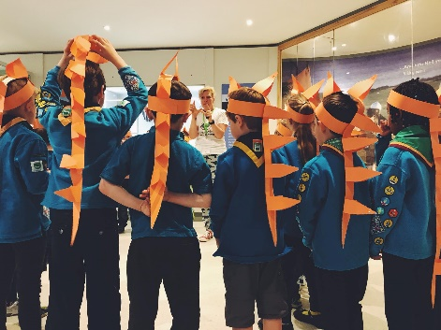

More recently Blandford’s’ Beavers have been exploring the Living Classroom at Bonsley Wood, Durweston – making pizza calzones and learning campfire songs amongst the bluebells.
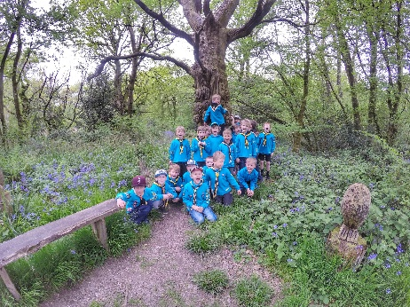
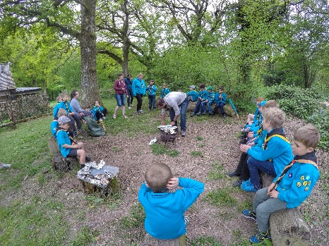

Charlton Marshall have also been exploring Bluebell Woods, these at Pamphill.

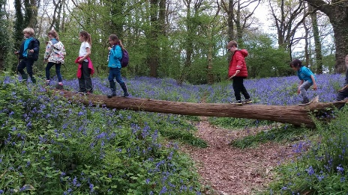
Meanwhile, Gillingham’s Sioux Beavers have been working hard on Wateraid which they have chosen for this years’ Million Hands project. Through visits by Wessex Water and the Rotary Club, the Beavers have found out about the difficulties in getting clean drinking water in some parts of Africa and learned about the Wateraid boxes which are sent out to help the villages. The Beavers then took part in a sponsored walk, working as teams to carry water carriers along the water sources of Gillingham. Their efforts raised £170 for Wateraid and £220 towards their new Scout building.

Well done Beavers.

LOOKING FORWARD
BeaJam 18 takes place at Buddens Farm on 16th/17th June. Organised by Dorset County Scouts it gives attending Beavers the chance to meet other Colonies from around the County.

District Beaver Scouts also have the opportunity to visit Jurassic Jamboree for the day on 12th August – more information is available from your Colony Leaders.

CUB HOWL

Clive Biggs, ADC Cubs. Clive72biggs@aol.com

SCOUT SHOUT
Suzi Bullen. ADC Scouts. suzibullen@hotmail.co.uk

It’s been a bit of a slow start to the year for Scouts for one reason and another, however I am pleased to say the our first district event has occurred with Trig Tower Tor being completed on the weekend of 12th & 13th May, the tor took in the site of Sturminster and its surrounding areas of Shillingstone, Fiddleford and Hinton St Mary among others.
We had eight teams enter in total from various troops, four on the Junior and four on the Seniors, following various map plotting and compass works as well as the usual several kilometres of hiking the winners of the Junior turned out to be Blandford (see photo attached) with the small team of three and the winners of the Senior were Stalbridge (again photo attached), my congratulations to all teams that took part and in particular to those who walked away with the trophies.
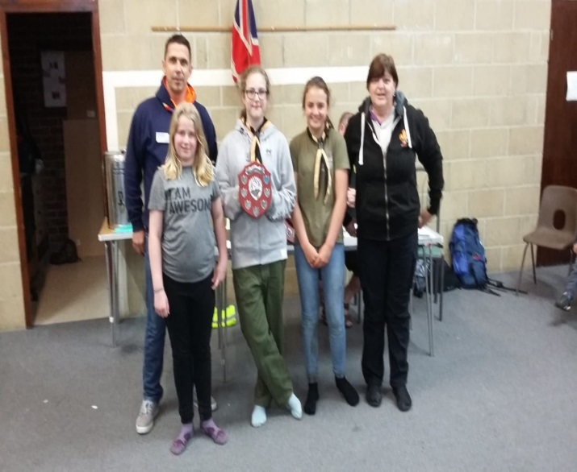
Sturminster Newton leaders did themselves proud and showed us all how to be fantastic hosts, my thanks to them all and in particular to Dom and Leigh for all the hard work in sorting the trig points over the days, weeks and months before the event, none of it would have been possible without their help, but also thanks to all those who attended and helped in some form.
Our next event is RAE awards at Shaftesbury very soon, so let’s have some great teams entered for this forthcoming camping competition ,not only to participate but also to earn several badges in just taking part in the weekend.
Yours In Scouting,
Suzi

EXPLORERS AND NETWORK REVIEW
Lionel Boyle. DESC. Lionel.explorers@gmail.com

AROUND THE DISTRICT

Beavers from Winterborne Whitechurch and Blandford had an amazing sleepover with Dippy at the county museum. They took part in four activities in the evening, followed by a film and hot drink before bed.

Blandford Scout group have been doing lots of fundraising recently. We enjoyed our annual bingo event at the royal British Legion. Damory vets kindly sponsored the event, donating £150 plus some prizes. We also had a large stall at this years Georgian Fayre which raised a further £310 and we had some volunteers up at the Teddy Rocks site helping to clear up after the event.

We had 48 Young people from all sections of Blandford Scout group attend this years St George’s Day parade, with three bronze and two silver chief scout awards given to some of our dedicated scouters. We were really pleased that Sandra our Scout Leader was also given a special recognition award for all her hard work.

We are looking forward to our AGM in June!

Sam Elliott

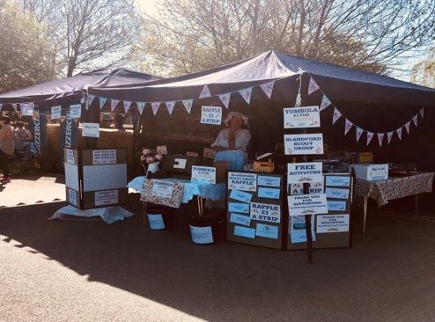

ADULT APPOINTMENTS AND DBS

John Kerley. Chair AAC. john.kerley@yahoo.co.uk Helen Graeser. DAS. northdorsetscouts@gmail.com

A very successful AAC, with Janet and Debbie making up the committee, was held on the 8th May 2018 at Sturminster Newton HQ. We saw and approved the following;

AESL Shaftesbury, ABSL Charlton Marshall, Youth Commissioner, AESL Blandford

ACTIVITIES

Rob Young. ADC Activities. youngrob@aol.com

NORTH DORSET DESPERATLEY NEEDS YOU!

Do you climb, do you abseil, do you go caving/potholing, paddle a kayak or canoe, go rafting or any other adventurous activity? If so have you thought about being assessed so that you can provide these activities for our young people?

If you are interest in gaining an adventurous activity permit please contact Rob Young in the first instance.

AIR ACTIVITIES

John Kerley DA Air Activities. scoutaviation@yahoo.co.uk

Blue skies are ordered and the sun will shine. Groups attending the 18th to 20th May Aviation Camp at Henstridge Airfield are coming from 2nd Wimborne, Winterborne Whitechurch, 1st South Brent Devon, 2nd Templecombe, Evercreech Explorers, Camelot Explorers and Blandford. Our visitors from Devon have promised to bring Devonshire Scones for our enjoyment.

If you would like to see first hand what we get up to then please call in on the Saturday.

ADDITIONAL NEEDS

Sheila Kerley. ANA. kerleysheila@yahoo.co.uk

Stoma

What is a stoma?
A stoma is an opening made on the abdominal wall used to divert waste products from the normal passages out into a bag. These can be required for various reasons on a temporary or permanent basis.
- A colostomy passes formed motions from the colon
- An ileostomy intercepts the bowel higher up and passes liquid motion
- A urostomy carriers urine from the 'water works' system
Individuals may have one such opening or both a colostomy and urostomy. Young people with a stoma may have other disabilities eg. spina bifida or an underlying illness eg. bowel disease.
Living with a stoma
Facilities must be available for changing the stoma bag, washing the stoma and skin area with warm water, and disposal. Colostomies usually need changing once a day. Ilestomies and urostomies need to be drained two or three time during the day. The frequency will depend upon the intake of fluids. Most young people are able to manage their own draining and changing very proficiently unless other disabilities prevent this. Most young people will have contact with specialist stoma care nurses through hospital.
Practical tips
- Given proper care a stoma in itself should not prevent anyone taking part in all Scouting activities
- Occasionally a bag may need to be drained or changed in a meeting; appropriate facilities must be available
- A reminder may be needed that a bag change is due
- During camps and over nights appropriate toilet facilities must be available, which will provide warm water and a means of disposing of stoma bags
- Careful disposal of bags is essential; this is normally done by emptying the bag into the toilet and disposal of the plastic bag
- When travelling, opportunities must be provided for bag emptying at regular intervals
- Check there are plenty of bags of the right type available before any long journey or over night
What else do you need to know?
- How independent is the individual?
- How much help will they need and who will give it?
- Are the bag supplies and facilities for changing adequate?
- Is an emergency kit available for journeys?
- Is there a stoma care nurse in the area? (check with the local health centre or general practitioner)
Discuss with the individual and/ or parents/ carer the extent to which help is needed and learn any practical tips they might have to offer.

OUR DISTRICT CHAIR’S CHUNTERINGS

Liz Greenway liz.littlewolford@btinternet.com

Editor John Kerley at john.kerley@yahoo.co.uk All copy for the July 2018 edition to be submitted by the 29th June 2018 please.

