NORTH AMERICAN SOCIETY OF
OCEANIC HISTORY

NATCHEZ, MISSISSIPPI
MAY 14TH -MAY 17TH

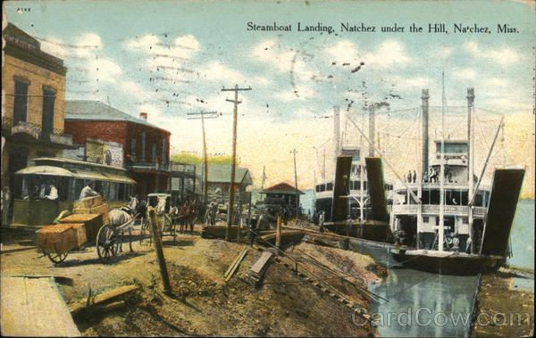

CONFERENCE SCHEDULE

WEDNESDAY
4:00-7:00, Registration

7:00-9:00, Board Meeting, Conference Room A

THURSDAY
9:00-4:00, Registration

9:30-9:45 Opening Remarks (Rooms A, B, and C)

9:45-11:00 MORNGING SESSIONS
Session 1: Atlantic Natchez (Room A)
Chair: Susan Stearns, University of Mississippi

9:45-10:05 Gateway to the Atlantic World: Natchez and the Trade of the Ohio
River Valley, 1795-1810. Susan Stearns, University of Mississippi

10:10-10:30 Natchez’s Colonial Spanish Slave Trade: From the Caribbean and
Beyond 1763 – 1798. Christian Pinnan, Mississippi College

10:35-10:55 “Grievously Oppressed”: The Burden of Transiency, Illness, and
Medical Relief in Maritime Frontier Natchez. John Jensen, University of
West Florida

11:00-11:30 Q&A

Session 2: Brits, Black Ships, and the African Squadron: Matthew Perry (Room B)
Chair: Larry Bartlett, Independent Scholar

9:45-10:05 “Worthy of all Praise”: Matthew Calbraith Perry and US Policy in West
Africa. Roger Bailey, The Citadel

10:10-10:30 Spoils of the ‘Black Ships’: Anglo-Japanese Relations, 1840s-1850s.
Sabrina Cervantez, Louisiana State University

10:35-10:55 Cartographic Conflict: The US North Pacific Exploring Expedition,
Intercultural Violence, and Imperial Mapmaking in Japan, 1853-1856.
Michael Verney, Drury University

11:00-11:30 Q&A
Session 3: Ports, Rivers and Fleets of South Carolina (Room C)
Chair: Jason Raupp, East Carolina University

9:45-10:05 Cosmopolitan Georgetown: Slavery, Rice, Indigo, and the World. J.P.
Wilson, University of South Carolina

10:10-10:30 The Pon Pon Road as the King’s Highway: Linking Colonial South
Carolina to Georgia 1732-1776. Timothy Reed, Texas Christian University

10:35-10:55 The Port City’s Fleet: Charles Town Society and the South Carolina
State Navy, c. 1775-1780. Benjamin Schaffer, University South Carolina

11:00-11:30 Q&A

11:30-1:00 Lunch (Banquet Room)

1:00-2:30 AFTERNOON 1 SESSIONS
Session 4: Preservation, Tourism and Partnerships (Room A)
Chair: Kevin Grubbs, Tarrant County College

1:00-1:20 “Gunning, Fishing, and A Good Time:” Gulf Coast Tourism in the
Gilded Age. Kevin Grubbs, Tarrant County College

1:25-1:45 The Trouble with Wild Rivers: River Restoration in the Northeast.
Zachary Bennett, Norwich University

1:50-2:10 Pull Together: The National Partnership We All Need. Cathy Green,
National Maritime Historical Society

2:10-2:30 Q&A

Roundtable 1: Teaching Naval History in Diverse Venues (Room B)
Facilitator: Evan Wilson, U.S. Naval War College

1:00-2:30 Participants: Ryan Mewett, United States Naval Academy; Cori
Convertito, Key West Art & Historical Society; Lewis Patterson, United
States Naval Academy; Jason Smith, Southern Connecticut State
University
Session 5: Landscapes and Waterways (Room C)
Chair: Jillian Schuler, Virginia Department of Historical Resources

1:00-1:20 A Rare Case of ‘Control’ In Archaeology: Riverbank Exploration and
Comparative Analysis on the Blackwater River. Arik Scapellato,
University of West Florida

1:25-1:45 “The Tomb of a Dream:” Documenting the Western Portal of the
Marshall Tunnel Complex. Jillian Schuler, Virginia Department of
Historic Resources

1:50-2:10 Wrecked Borders: Shipwrecks as Maritime Cultural Landscapes in
Northern Michigan's Manitou Passage. Catherine Schellhammer, East
Grand Rapids High School

2:10-2:30 Q&A

2:30-2:45 Break

2:45-4:15 AFTERNOON 2 SESSIONS
Session 6: Naval and Maritime Responses (Room A)
Chair: Kurt Knoerl, Georgia Southern University

2:45-3:05 New England and the Nottingham Galley: Provincial Responses to
Shipwreck During Queen Anne’s War. Neal Dugre, University of
Houston-Clear Lake

3:10-3:30 Cultural and Geological Influences on Historical Inland Watercraft of
Louisiana. Allison Belcher, ELOS Environmental, LLC.

3:35-3:55 War on the Water: Maritime Engagements between Native Americans
and the British During Pontiac’s Uprising. Kurt Knoerl, Georgia Southern
University

3:55-4:15 Q&A
Session 7: Shipping (Room B)
Chair: Michael Verney, Drury University

2:45-3:05 The Greek Princess of King Cotton. Alexander Billinis, Clemson
University

3:10-3:30 Tale of Two Ports: History, Archaeology, and Impacts on Preservation of
the Colonial Brunswick Town Waterfront, North Carolina. Jeremy
Borrelli, Jason Raupp and Jennifer McKinnon, East Carolina
University

3:35-3:55 Philadelphia Merchants in the Riverine West: Laying the Foundations of
Empire, 1750-1803. Kim Gruenwald, Kent State University

3:55-4:15 Q&A

Session 8: Voices from the Deck: Shipboard Experiences on Early North American Steamboats (Room C)
Chair: Carolyn Kennedy, Texas A&M University

2:45-3:00 Living and Working on Phoenix II: Artifact Distribution and Spatial
Organization on an Early 19th-Century Lake Champlain Steamboat.
Carolyn Kennedy, Texas A&M University

3:05-3:20 “A World in Miniature”: The Experience of Western River Travel on the
Steamboat Heroine (1832-1838). Kevin Crisman, Texas A&M
University

3:25-3:40 Life Aboard the steamboat Yellowstone During the Texas Revolution
(1835-6): A Journey of Firsts. Kristen Crouse, Texas A&M University

3:45-4:00 Life Aboard a Nineteenth-Century Naval Steam Frigate: Accounts from
the USS Missouri and USS Mississippi. Hunter Johnson, Texas A&M
University

4:00-4:15 Q&A

5:00-7:00 Reception (Banquet Room)
Hor d’ oeuvres and Cash Bar

FRIDAY
9:00-4:00, Registration

9:30-9:40 Opening Remarks (Rooms A,B,C)

9:40-11:30 MORNING SESSIONS
Session 9: Science and Technology (Room A)
Chair: Penelope Hardy, University Wisconsin-La Crosse

9:40-10:00 Trolley Boats and Battery-Electric Self-Propelled Barges – Electric
Propulsion Systems for Inland Waterway Navigation (1830 – 1920). Ingo
Heidbrink, Old Dominion University

10:05-10:25 The Roots of Divergence in American Fisheries Science in an Imperial
Context. Jennifer Hubbard, Ryerson/Toronto Metropolitan University

10:30-10:50 The Little Fish Hook That Could: Oldest European Hook in Florida
Fished From Pensacola Luna Settlement, Archaeological Site (8ES1). Nic
Reagan, John Bratten, and Pax Johnson, University of West Florida

10:50-11:30 Q&A

Session 10: Navies at Home and Abroad (Room B)
Chair: Paul Fontenoy

9:40-10:00 Roll Up to Roll Out: Submerged Battlescape Heritage of Roi-Namur
Island. Jason Raupp, Dominic Bush, Shawn Arnold, ECU/University College
of Cork, Ships of Discovery

10:05-10:25 The American Civil War in the Indian Ocean: Global Dimensions of a
National Conflict. Kerry Ward, Rice University

10:30-10:50 Storms, Shipwrecks, and Sickness: The Royal Navy in the Caribbean
during the American Civil War, 1860-64. John Beeler, University of
Alabama

10:55-11:30 Q&A

Session 11: The French Connection (Room C)
Chair: Michael Tuttle, Gray and Pape

9:40-10:00 “For the Needs of War”: African Participation in the French-Chickasaw
Wars. Olivia Barnard, Johns Hopkins University

10:05-10:25 John Hoxse and the Quasi War with France. Peter Hames, SUNY
Maritime College

10:30-10:50 The U.S. Navy and the Making of an American New Orleans, 1806-
1815. Tony Peebler, Texas Christian University

10:50-11:30 Q&A

11:30-1:00 Lunch (Banquet Room)

1:00-2:30 AFTERNOON 1 SESSIONS
Session 12: Archaeological and Historical analysis of Vessel types (Room A)
Chair: Cathy Green, National Maritime Historical Society

1:00-1:20 A Ship for Every Season: A Reconstruction and Analysis of the Double-
Ended Steamer Waccamaw (1861 – present). Thomas Fosdick, East Carolina University

1:25-1:45 A Bugeye of Mallows Bay: The Possible Remains of Bessie Lafayette.
Patrick Boyle, Texas A&M University

1:50-2:10 Alaska’s “Forgotten Battlefield”: Exploring the Submerged Remains
of the Battle of Attu. Dominic Bush and Jason Raupp, University of College Cork and East Carolina University

2:10-2:30 Q&A

Roundtable 2: Naval Life-Writing Challenges and Opportunities (Room B)
Facilitator: Evan Wilson, U.S. Naval War College

Participants: Samantha Cavell, Southeastern Louisiana University; Abby Mullen, U.S. Naval Academy; Ryan Wadle, U.S. Naval War College

Session 13: Remembering and Reevaluating Famous Shipwrecks (Room C)
Chair: Christina Bolte, UWF

1:00-1:20 Remembering the Maine: Public Memory and the Making of American
Navalism. Jason Smith, Southern Connecticut State University

1:25-1:45 Orchids on Titanic. Paul Johnston, Smithsonian Museum of American
History

1:50-2:10 The Sultana Disaster and Confederate Boat Burners. Michael Walborn,
Kansas State University

2:10-2:30 Q&A

2:30-3:00 Break

3:00-4:00 A Roundtable Remembrance of James C. Bradford (Conference Room C)
Facilitator: Ryan Wadle, U.S. Naval War College

Panelists: Ian Abbey, Prairie View A&M; Jonathan Chavanne, Ret. US Navy; Craig Felker, Ret. US Navy

4:30-6:30 Student and Early Career Reception, Natchez Brewing Company, 207 High St. Pizza/snacks provided

SATURDAY
9:00-10:30, Business meeting (Room C)

Free Day, Hop-on-Hop-off bus tour (Will pick up out front of hotel)

5:00-6:00 Cocktail hour (Banquet Room)
Cash Bar, 2 free drink tickets

6:00-8:00 Banquet and Awards. Keynote: Craig Symonds, “Annapolis Goes to War”

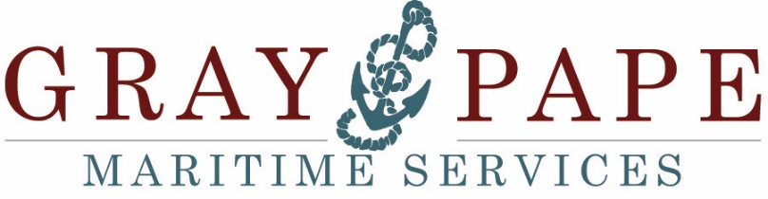
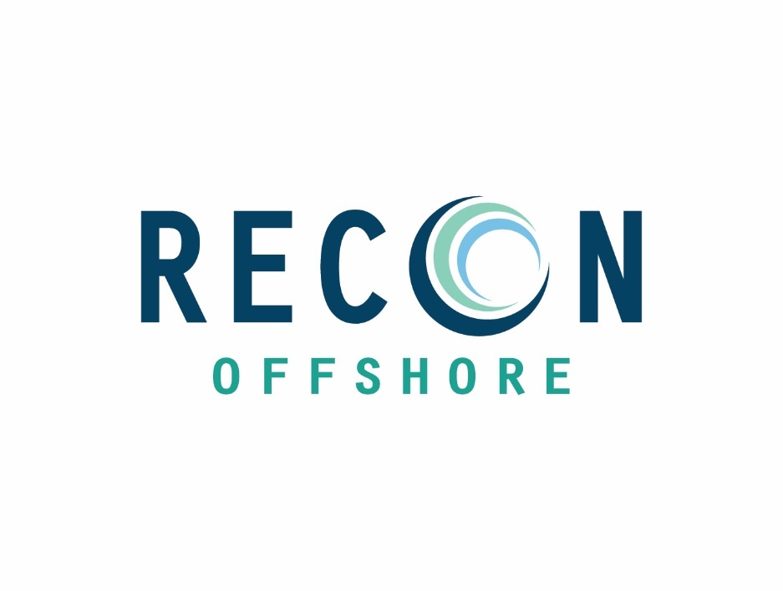
Thank you to our sponsors!
