Resources for Making Remote Work Work for You

Book Suggestion: Success with Less: Releasing Obligations and Discovering Joy by Karen Mangia. www.successwithless.net, PDF Career Companion http://successwithless.net/wp-content/uploads/2019/07/success-with-less-career-companion.pdf
Working from Home: Making the New Normal Work for You by Karen Mangia
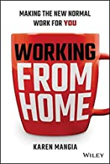

Applications:
Helps you build communication and math skills. Elevate - https://elevateapp.com/about
Best apps for reducing anxiety (2020 article): https://www.healthline.com/health/anxiety/top-iphone-android-apps#calm
Apps to help with schooling: https://www.educationalappstore.com/app-lists/best-apps-for-schools
Podcasts
Working from Home: https://beta.prx.org/stories/355092
How pandemic impacted jobs and lives: https://ibjpodcast.podbean.com/e/three-women-explain-how-the-pandemic-impacted-their-jobs-and-their-lives/

