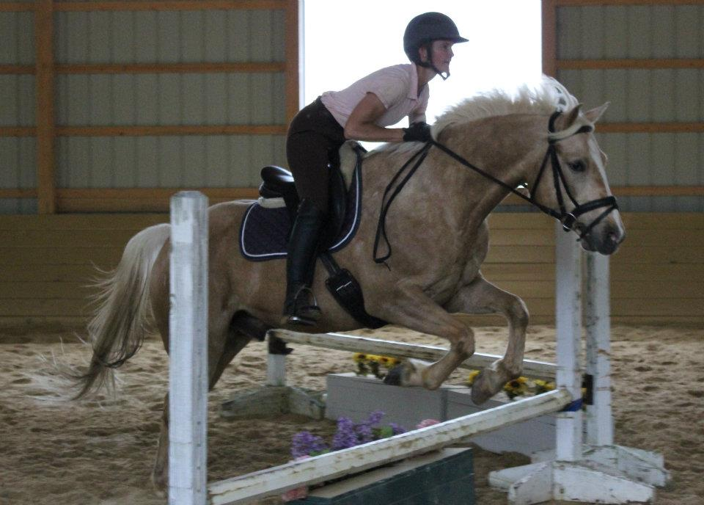

Please be advised

Even though we all love our wonderful horses, horses are very large animals which can accidently hurt someone. We expect all of our youngsters to be respectful and safe at all times on the farm. If a youngster disregards our rules and is not manageable we will ask the parents to pick up their young one(s). There will be no refund for losing their spot. We reserve the right to turn away any youngster that is not capable of following our rules, has learning, age, or physical challenges which do not allow them to handle horses safely. It is our priority to keep all youngsters, horses, and staff SAFE! We want this to be a fun atmosphere where children progress in their riding ability and learn proper horsemanship. At Breezy Meadow Equestrian Centre, your future equestrian will learn solid foundational riding principles!

bREEZY MEADOW EQUESTRIAN CENTRE

49 Driftway Road

Howell, NJ 07731

856-252-7075

Our goals

At Breezy Meadow Equestrian Centre’s Riding Program, we teach how to ride safely with proper horsemanship, starting from the first time you’ve ever touched a horse to competing at local horseshows. Our horses have the innate ability to connect with people, and are loving and gentle. They will make your time with them very memorable.

When all youngsters arrive at the barn, the horsemanship director considers their skill, confidence, age and size in assigning appropriate mounts, riding groups, and instructors. The overall priorities of Breezy Meadow Equestrian Centre’s horsemanship program are: safety, fun, and skill advancement.

Besides learning how to ride with us, we take time to teach horse behavior and emphasize the responsibility of owning or leasing your very own horse, starting with grooming, feeding, exercising, cleaning, vet care, nutrition and more. We want our students to be prepared the very best they can be!

If your youngster thoroughly enjoys the horsemanship program, they are welcome to add additional weeks! Riders may also join our lesson program and continue to further their skills on their journey with horses! Please ask Regina to add another week for you or you may make arrangements for a regular riding lesson schedule.

And don’t forget we offer riding year-round for equestrians of all ages. Weekly Lessons are open to age 5 – 95!

Western, Hunter, and Jumper lessons from beginner to advanced. Super reasonable rates! $40 per hour/rider

In addition to spring and summer horsemanship programs, we offer all year riding for children and adult lessons/trail rides. Please call to schedule a lesson or trail ride with Regina in advance of your visit.

Riding Camp/Horsemanship Program For Girls and Boys!

Bring this to barn!

* Boots with a small heel (cowboy or paddock boots)

**NO flip flops or open-toed shoes for riding. Sneakers are NOT appropriate for riding.**

* Riding breeches, leggings, or jeans. Also bring a change of clothes/shoes for hot weather.
* Summer Only - Swim Suit for water sports (one-pieces only for girls) and Beach Towel
* Flip-flops/water shoes
* Change of clothes/sneakers
* Sunscreen/(insect repellent optional)
* Lunch, snack, and plenty of drinks
* Again, we say ***PLENTY*** of drinks/water
* No electronics or valuables
* Your own riding helmet if you have one, although we provide if you need **one**
* **Signed Registration and Release Form!**

“

**DELETE BOX IF NOT IN USE.”**

**Please contact (text or call)**

**Regina Ennis at 856-252-7075**

Sample Schedule of Events

***9:00*** **am**

**Youngsters arrive**

Feeding and Watering

***10:00***

Groom and saddle your horse

***10:15***

Instructional Riding Lesson

***11:15***

Untack your horse and give them lunch/water

***11:30***

Paddock Maintenance

***12:00***

Lunch

***12:30***

Demonstration: *Roping, Farrier, Bathing, Braiding etc.*

***1:30***

Groom and saddle your horse

***1:30***

2nd Ride/Possible Trail ride

***2:45***

Untack and put your horse away

***\*3:00pm***

**Barn cleanup/pick up time** \***Parents, we ask for your courtesy on adhering to these pickup times as we also have regularly scheduled activities after day horsemanship programs.)**

* + - * $210 per week, $65 per day
      * Non refundable deposit $100 to secure reservation. Balance paid before first day of Camp. No rescheduling. Paypal.com (856-252-7075) or Venmo (Regina-Ennis)
* Please let us know if you need extended hours which will be $20 per day per camper. ☺

bREEZY MEADOW EQUESTRIAN CENTRE

**49 DRIFTWAY ROAD**

**HOWELL, NEW JERSEY 07731**

_________

Like us on Facebook!

Some of the games we play

With horses

Barrel Racing

Barrel Dash

Pole Bending

Keyhole

Musical Horses

Obstacle courses

Chase Me Charlie

Without horses

Capture the flag

Kickball

Scavenger Hunt

Some of the other activities our campers participate in

Nature Hikes

Horse Painting

Demonstrations

Watersports

Lasso Rope Practice

Trail Rides

We can’t wait to meet your youngster! It will be one fantastic horsemanship season! Please feel free to call if you have any questions or concerns.

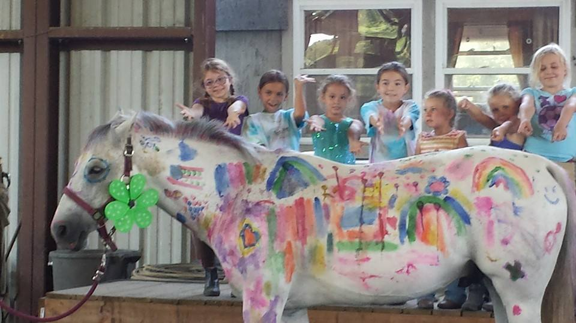

**Regina Ennis, Horsemanship Coordinator 856-252-7075**

**Breezy Meadow Equestrian Centre**