CENTRAL KENAI
PENINSULA POINTS ON PREVENTION
PRIMARY PREVENTION PLAN
TOGETHERWE CAN PREVENT
POWER-BASED VIOLENCE

VISION
To ensure education and resources are readily available fostering a safe, supportive, and healthy community.
Revised 12/2019

Thank you to Central Kenai Peninsula’s, Peninsula Points on Prevention Coalition (PPOP), the current primary prevention coalition promoting a safe and healthy community who developed, reviewed, and finalized this plan:
Ashley Blatchford, Serena Borofsky, Shari Connor, Audrey Cuculla, Leslie Felts, Elizabeth Hammer, Audrey Gifford,
This plan was compiled by: Renee Lipps, Prevention Coordinator with The LeeShore Center.

A special thank you to Barbara Waters and Shauna Lipps for the use of images throughout this plan.

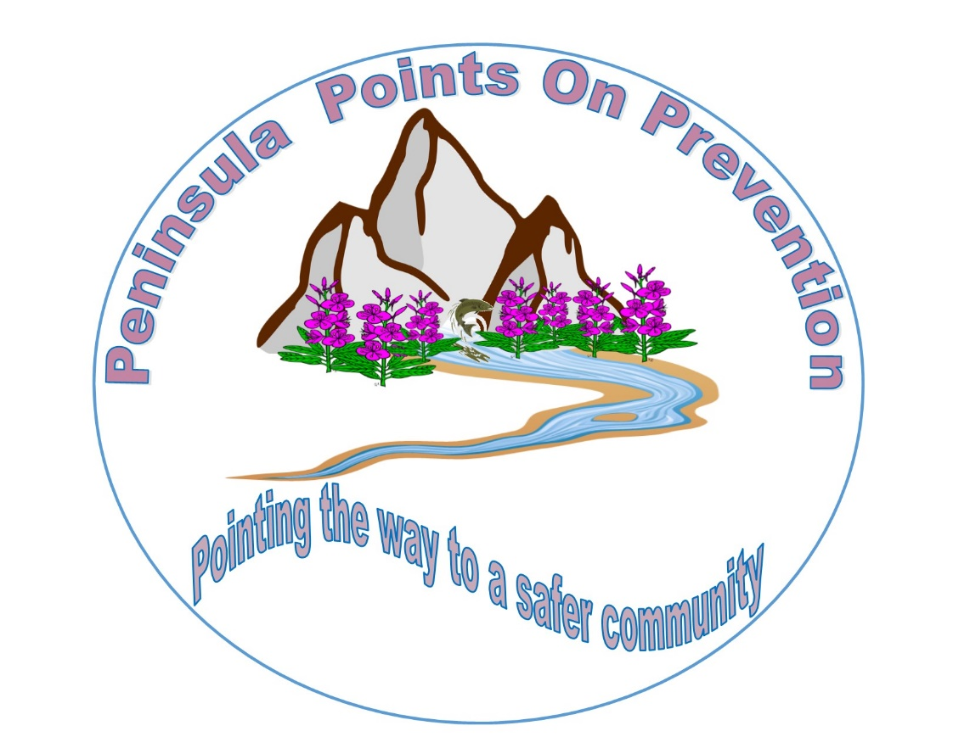

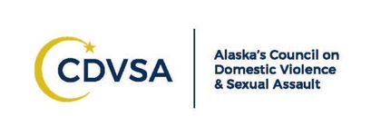

This publication was funded through the State of Alaska, Council on Domestic Violence and Sexual Assault

Table of Contents
Community Overview………………………………………………………………….. 1

Did you Know…………………………………………………………………………… 2

Is our Community Ready for Prevention…………………………………………… 5

Community Goals………………………………………………………………………. 7

Goal One…………………………………………………………………………………. 8

Goal Two……………………………………………………………………….………… 9

Goal Three……………………………………………………………………………… 10

Strategies……………………………………………………….……………………… 11

References…………………………………………………..…………………………. 14

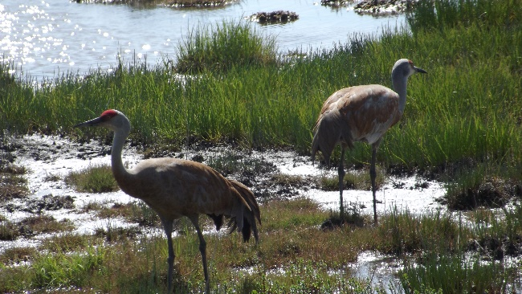
Overview of Community
The Kenai Peninsula is a large peninsula jutting from the coast of Southcentral Alaska, it covers approximately 620 square miles, with a population of approximately 55,400. The Dena’ina people lived in the region long before the first Russian explorers arrived in Alaska in 1741. While they do not measure their history in years, the Dena’ina consider they have lived in the area since time immemorial, a period that is beyond the reach of memory or record. The name Kenai is derived from the word "Kenaitze" or "Kenaitze Indian Tribe", the name of the Native Athabascan Alaskan tribe, the Kahtnuht’ana Dena’ina, that historically inhabited the area. The Kenai Peninsula is known as “Alaska’s Playground”.
The Central Kenai Peninsula is made up of many small communities such as Sterling, Nikiski, Cooper Landing, Kasilof and the two most populous communities of Kenai and Soldotna.

The main industries on the peninsula are oil, fishing, tourism, and healthcare but economic factors are greatly impacted by the boom/bust cycle of those industries. In the last 10 years, two major operating plants have closed and the fishing industry has continued to fall. In addition, at least five businesses closed in Kenai in the last two years.
The Central Kenai Peninsula is a magnificent place to live with breathtaking scenery, true wilderness, fishing opportunities, and plenty of wildlife to view. In a region of rich cultural and bio diversity and beauty, we also see geographical isolation, lack of accountability for offenders, and the stigma and fear associated with victims of intimate partner violence (IPV), sexual assault (SA), and teen dating violence (TDV). However, the community continues to work to reduce these challenging issues by holding various events and activities throughout the year to support education/awareness, prevention and community connectedness such as:
- Choose Respect March
- Community Awareness Workshop on Domestic Violence and Sexual Assault
- Annual Women’s Run
- Kenaitze Candlelight Vigil
- Green Dot Overview Chats and Bystander Intervention Trainings
- School Presentations to youth about healthy relationships
- Soldotna Creek Park hosts many events to support community connectedness, Wednesday Market, Music, and Family Movie Night

1
Intimate partner violence refers to the actual or threatened physical, emotional or sexual abuse by a current or former partner or spouse
Did you know?
Alaska has had the unfortunate distinction of ranking among the top five states for rates of intimate partner violence and is number one for sexual violence with numbers reaching epidemic proportions. The effect of this violence has long term implications for generations to come, including child abuse, suicide, substance misuse, psychological and mental health issues, and brain development issues for children exposed to violence. Like much of the state the Central Kenai Peninsula suffers from high rates of power-based violence (IPV, SA, TDV, and child/elderly abuse). In a 2013 Victimization Survey conducted on the Kenai Peninsula it was found that 43 out of 100 women have experienced intimate partner violence; 30 out of 100 had experienced sexual violence; and 52 out of 100 had experience IPV, SA or both. The most recent domestic violence and sexual assault arrest data for 2017 by the Alaska State Troopers, E Detachment (which incorporates all arrests for the Kenai Peninsula Borough including the communities of Homer and Seward) showed 459 incidents of domestic violence and sexual assault; 30% of those incidents included alcohol and drugs with an arrest rate of 53%. Kenai and Soldotna police responded to 97 domestic violence and sexual assault incidents. Further data from Kenai showed that 89% of perpetrators were arrested; and that children were present in 50% of the incidents.
Comparatively, roughly 35 percent of women and 28 percent of men in the general population of the U.S. have experienced rape, physical violence, and/or stalking by an intimate partner in their lifetime.

One specific population at a significant higher risk for domestic and sexual violence than others is American Indians and Alaska Native women. According to a study from the National Institute of Justice, 84% of American Indian and Alaska Native women have experienced violence in their lifetime, and more than half have endured this violence at the hands of an intimate partner, and more than two-thirds of the women, or 66%, say they have been the victims of psychological aggression by a partner.

It is also critical to recognize the underserved populations in our community. Some of the most underserved or under recognized populations that also experience comparable rates of IPV/SA is our elderly, individuals with disabilities, and the lesbian, gay, transgender, queer (LBGTQ) community.
2
There is very limited information/data for these populations in our state. There is a tremendous amount of work to be done to truly understand how these population are impacted by IPV, SA, and TDV.

Unhealthy relationships can start early and last a lifetime. These are learned behaviors which can also be unlearned. Stopping this epidemic will require many people working together to create a community that promotes respect, non-violence, and connectedness. In a recent national survey, nearly 10% of high school students reported physical violence and 11% reported that they experienced sexual violence from a dating partner in the 12 months before the survey. Teens who are victims are at higher risk for victimization during college and throughout their lifetimes. Victims of teen dating violence are more likely to experience symptoms of depression and anxiety. They might also engage in unhealthy behaviors, such as using tobacco, drugs, and alcohol. (Centers for Disease Control).

Although we do not have local data on teen dating violence, based on data provided by local law enforcement it was determine that 50% of the time children were present during domestic violence incidents, it is a fair assessment that these behaviors will be carried on into young adulthood.
Here’s what we do know:
Alaska conducted a statewide Youth Risk Behavior Survey in 2017 (this survey is conducted bi-annually). The survey found physical dating violence among adolescents (high school students in grades 9-12) was 7.3% for all Alaska adolescents and 8.2% were physically forced to have sexual intercourse (when they did not want to).
FAST FACT:
The majority of parents of teen victims are unaware of the abuse.
Teen Dating Violence

Unless change is introduced, these patterns of violence are passed from one generation to the next and reinforced by communities that have become accustomed to this type of violence as a norm.
3
We need to truly understand what social norms we are setting in our community. They are often based on what people believe to be normal, typical, or appropriate. Social norms can function as unspoken rules or guidelines for how people behave, and for how people are expected to behave. To solve the puzzle of violence in our community we must work together and recognize the power we have to be the change we wish to see in our community.

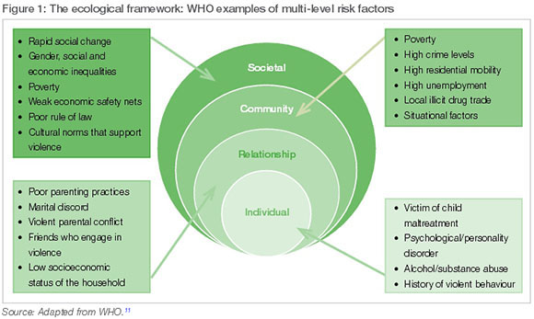
Identifying the root causes of power-based violence in a community is the first step in prevention. The CDC and the World Health Organization created a list of factors that put an individual at risk for perpetration and victimization. These traits are called risk factors and include low self-esteem, an acceptance of traditional gender roles, and relationships among others.

People generally follow social norms because they want to fit in with the people around them. Social norms can result in positive or negative outcomes.
Nationally, there is a growing movement to work towards preventing violence before it ever occurs– this is called primary prevention. Primary prevention efforts work to modify and/or entirely eliminate the events, conditions, situations, or exposure to influences (risk factors) that result in the initiation of IPV, SA, and TDV and associated injuries, disabilities, and deaths. Additionally, IPV, SA, and TDV prevention efforts address perpetration, victimization, and bystander attitudes and behaviors, and seek to identify and enhance protective factors that impede the initiation of power-based violence in at risk populations and in the community. It is a community-oriented approach that takes the onus from victims and advocates and encourages the entire community (women, men, and youth) to prevent power-based violence. (Sexual Violence Prevention: Beginning the Dialogue/CDC)
4
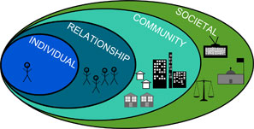
Sometimes social norms help people behave in ways that keep themselves - and others - safe and healthy.
Effective prevention approaches recognize the complexities associated with a major problem. In order to eliminate a major issue, a social change is necessary. The social ecology model is a comprehensive model that focuses on the individual, relationship, community and societal level influences that promote behavioral change. Addressing each level of influence simultaneously contributes to a higher likelihood of successful change.
Individual
- Learning attitudes and behaviors that support equality and respect.
Relationship
- Implementing bystander intervention training
- Mentoring and skill-based programs for pre-school, school age children and young adults
- Positive social relationships with peers, colleagues, partner and family members
Community
- Implementing social marketing campaigns addressing violence norms

Community

- Identifying and addressing community risks factors that may contribute to power-based violence in a community
Societal
- Promoting norms, policies and laws supporting bystander skill-building, healthy relationships, and a safe community.
Community Climate
In the spring of 2018, The LeeShore Center in Kenai Alaska conducted a Community Readiness Assessment to assess key factors influencing the community’s preparedness to address Intimate Partner Violence, Sexual Assault, and Teen Dating Violence. The LeeShore staff interviewed eight members of the Kenai community. These interviewees represented a range of professional, organizational and social entities including: Law Enforcement, Faith-based community, Education, Health, business, and Government (tribal). The interview responses were scored by two independent scorers utilizing a standardized scoring criteria.
5
The community reflected a higher score in the area of Community Knowledge of the issue, indicating that at least some community members have heard of IPV, SA, and TDV. Among some community members, there are some misconceptions about IPV, SA, and TDV. Additionally, some members of the community are at least somewhat aware that these issues are occurring locally.
Did You Know?
During 2017,
The LeeShore Center

- provided safe shelter to 165 women and children (a total of 6262 bed nights)
- Of the adult women served, 78% were fleeing domestic violence
- 15% had experienced sexual assault, and 7% were victims of stalking.
- 55% of the violent crimes were not reported to law enforcement.
- Advocates answered 876 crisis calls
- provided advocacy and crisis intervention support to 352 walk-in clients
- Provided 10,401 safety check calls per victim request.

Although, the assessment provided an overall score of 2.6 (denial/resistance), it only represented the sectors listed above. This would be an indicator that more work needs to be done with specific sectors.
In order to gain a better perspective of how the community at large views IPV and SA, the LeeShore Center distributes a community wide survey every three years; the most recent surveys were completed in March of 2017. Of the 171 surveys completed and returned 43 were male and 125 were women (three surveys did not provide gender information). Survey results showed that 96% believed domestic violence to be a problem and 95% believed sexual assault to be a problem in our community. With 92% indicating that that services provided by LeeShore to be needed and essential to the community.
The survey also asked respondents about their knowledge of prevention efforts occurring in the community; 64% were aware of the annual “Choose Respect March” and 55% were aware of the Green Dot Bystander Intervention strategy. Both of these strategies are a great start to prevention efforts in our community because they offer a proactive means of improving responsiveness, creating visions for change, and moving from meeting the immediate needs of survivors to an integrated, approach that combines bystander intervention, support services and social change. Successful prevention efforts reflect a social change model that promotes a thriving culture where all relationships are built on respect, equality, and peace.
6
Goals:

The Peninsula Points on Prevention coalition has developed three goals for the Central Kenai Peninsula to build capacity that helps to strengthen various protective factors within the community. These three goals focus on building capacity to support prevention efforts, awareness of prevalence of IPV, TDV, and SA in our community, and to increase level of awareness around the intersects with many of the other challenges faced by our community such as, child abuse, suicide, substance misuse, and behavioral health issues.
GOAL THREE
Community that takes an active bystander role, promoting a safe and healthy community.

_________________________
The aim of this goal is to provide community members with support, education, and tools to take an active role in keeping community members safe.

GOAL TWO
Youth recognize their individual power to choose the nature of their relationships and identify the components that make up healthy relationships.
____________________
The purpose of this goal is to provide education to school age children about healthy and unhealthy relationships, resources available if needed, and how to identify safe adults in their life, thus empowering them to be a positive role model in their schools.

GOAL ONE

Informed and educated community that supports safe and healthy relationships.
_____________________
This goal aims to assist community members in gaining knowledge surrounding the amount of individuals that are impacted by this violence locally, fostering support of a social change that promotes safety for all.

7

- By August 2019 10% of the community will have been exposed to the “Did You Know” (DYK) information.
- By December 2020 15% of community members can define, and recognize ACEs, IPV, TDV, And SA.
- By June 2024 25% of community members will have attended annual education and awareness events.
____________________________________________________________________
Strageties:
“Did You Know?” campaign
Choose Respect
Community outreach events

GOAL ONE

Informed and educated community that supports safe and healthy relationships

DID YOU KNOW?
While it has been long understood that violence has implications for emotional and physical injury, it is only relatively recently that we are beginning to recognize the longer-term effects that reap an extensive toll on the broader health status of individuals, families and communities.
8
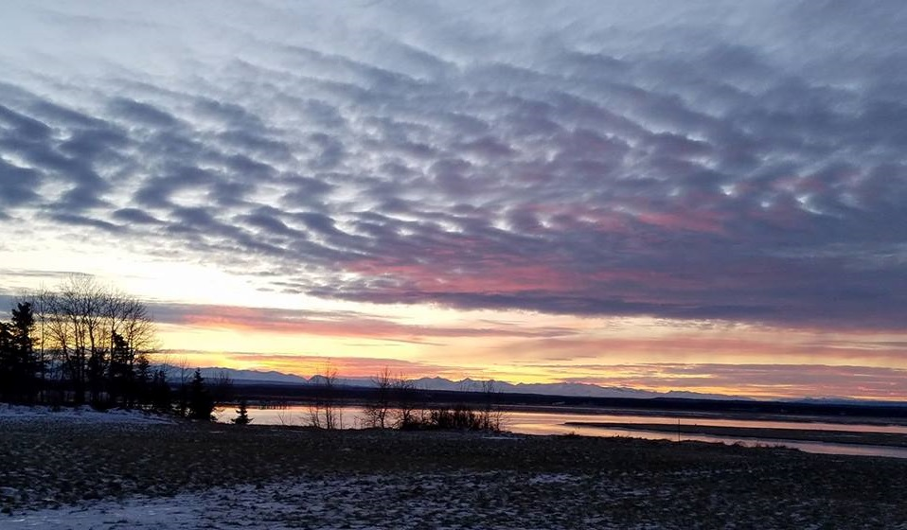
9
DID YOU KNOW?
Consent, by definition, means permission for something to happen or agreement to do something. Consent is more than yes or no. It is a dialogue about desires, needs, and level of comfort with different sexual interactions. Healthy sexual interactions are rooted in consent and respect.

- By June 2021 25% of Central Kenai Peninsula middle/high school youth have participated in a class and/or event that exposed them to educational information about healthy relationships.
- By June 2021 25% of Central Kenai Peninsula middle/high school students will have been exposed to information about supportive resources available in the community.
- By June 2024 10% of Central Kenai Peninsula middle/high school students will have access to leadership opportunities.
- By June 2021 15% of Central Kenai Peninsula pre k/elementary school students have been exposed to one or all presentations about friendship skills, conflict resolution, anti-bullying, and empathy building.
________________________________________________________________
Strageties:
“Did You Know?” campaign
The 4th R
Ophelia Project
Community outreach events

GOAL TWO

Youth recognize their individual power to choose the nature of their relationships and identify the components that make up healthy relationships.

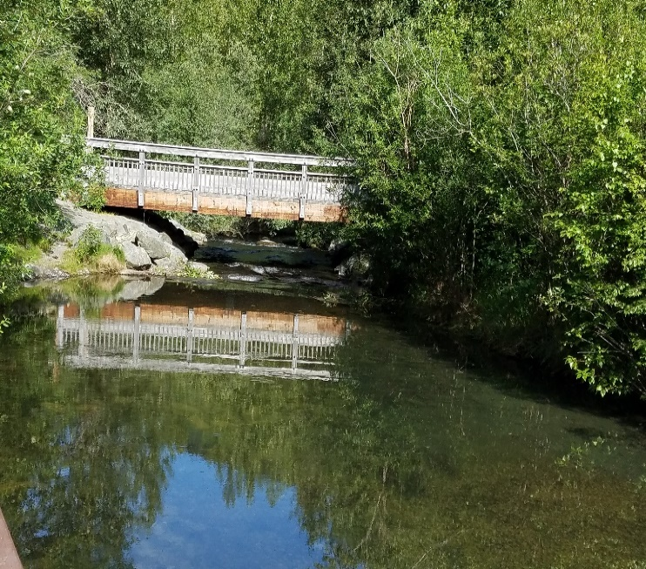

- By January 2021 increase community’s bystander intervention training team by four additional certified community trainers
- By January 2022 15% of community members have an increased understanding of the impacts IPV, TDV, and SA in our community
- By December 2023 75% of community members have access to education and resources about bystander intervention.
- By January 2024 20% of community members are taking a proactive bystander role in the community
_________________________________________________________________
Strategies:
“Did You Know?” campaign
Green Dot
Community outreach events

GOAL THREE

Community that takes an active bystander role, promoting a safe and healthy community.

10
Did You Know?
60% of the time there are people positioned to intervene when power-based violence occurs but only 15% of time are they able to do something.
Strategies

Choose Respect
In 2008, through a partnership between the Council and the Alaska Network on Domestic Violence & Sexual Assault, the "Real Alaska Men Choose Respect" campaign was born in an effort to engage men in the work of ending domestic violence and sexual assault. As part of that campaign, former Governor Sean Parnell was asked to film a public service announcement (PSA), along with other Alaskans, to help raise awareness.
In December of 2009, Gov. Parnell pledged that Alaska would take every step necessary to stop the epidemic of domestic violence, sexual assault, and child sexual abuse in Alaska, and began his statewide "Choose Respect Initiative."
Since then, we have witnessed more and more Alaskans finding the courage to speak, and the strength to act. Alaska started with 18 partner communities. By March of 2014, more than 170 Alaska communities participated in Choose Respect marches, rallies, and community events

The Fourth R
The Fourth R emphasizes the five basic competencies of social and emotional learning: self-awareness, self-management, social awareness, relationship skills and responsible decision-making. The Fourth R provides lessons that meet the skills for Health Life Content Standards developed by the State of Alaska, Department of Education & Early Development and also aligns with the performance indicators of all eight of the U.S. National Health Education Standards for grades 9-12. The Fourth R is a comprehensive curriculum that seeks to reduce violence and promote related protective factors to prevent perpetration and victimization. It is one of the few curriculums that has been proven to reduce violence and improve decision-making and communication skills among students.

Ophelia Project
Creating a Safe School is a multifaceted change process that brings together a community of caring adults (administrators, teachers, staff, parents) with students to work together to change the social culture in a school or school district. Its primary goal is to positively impact the social norms in a school community by recognizing and addressing the hurtful, covert behaviors of peer aggression and identifying, teaching and modeling a more positive set of normative behaviors for educators, students and parents.

11
Strategies
GREEN DOT
Green Dot is a comprehensive approach to violence prevention that uses peer and cultural influences and social change theory to engage bystanders with proactive behaviors and interventions. The Green Dot curriculum is informed by concepts and lessons learned from bodies of research and theory across disciplines including: violence against women, diffusion of innovation, public health, social networking, psychology, communications, bystander dynamics, perpetration, and marketing/ advertising. Green Dot is built on the premise that in order to measurably reduce the perpetration of power-based personal violence, a cultural shift is necessary. In order to create a cultural shift, a critical mass of people will need to engage in a new behavior or set of behaviors that will make violence less sustainable within any given community. The “new behavior” is a Green Dot.

Did You Know?
This is a community wide campaign to bring a greater level of awareness to community members. The campaign aims to help them understand some of the warning signs associated with IPV, SA, and TDV, potential long-term consequences, the prevalence within our state and community (when data was available), the intersects with many other challenging issues in our community, and identify protective factors associated with reducing the chances of this violence occurring in the first place. This will be done by physically distributing hard copy information around our community in posters, fliers, placemats, and coffee sleeves. This information will be presented at various venues in the community such as, groups, organizations, business, faith-based community, and community wide events.

12

Who can get involved?
If you are interested in learning more about how you can be a part of making the community a safe and healthy place to live, please contact Renee Lipps, @ (907) 283-9478 or rlipps@leeshoreak.org You can also visit our website @ peninsulaprevention.org
- Youth Group and Community Leaders
- Health Workers and Service Providers
- Faith Leaders
- Law Enforcement Officers
- Policy Makers
- Community Members
- Parents
- Educators
- Men
- Women
- Youth
- Elders

13
References
Center for Disease Control
https://www.cdc.gov/

National on Domestic Violence, Trauma and Mental Health
http://www.nationalcenterdvtraumamh.org/research-and-policy/

The World Health Organization (WHO)
https://www.who.int/

National Institute of Justice
https://www.nij.gov/Pages/welcome.aspx

National organization for Women
https://now.org/resource/violence-against-women-in-the-united-states-statistic/
Kenai Peninsula Borough
https://www.kpb.us/
Kenai Peninsula Borough School District
http://www.kpbsd.k12.ak.us/

Kenai Peninsula 2013 Victimization Survey
http://uaajusticecenter.blogspot.com/2013/10/alaska-victimization-survey-results_10.htmlation Survey/

Alaska Council on Domestic Violence and Sexual Assault
https://dps.alaska.gov/CDVSA/Home

Alaska Network on Domestic Violence and Sexual Assault
https://www.andvsa.org/

2017 Alaska Youth Risk Behavior Survey
http://dhss.alaska.gov/dph/Chronic/Pages/yrbs/yrbsresults.aspx

Additional reference information for this plan provided by:
The LeeShore Center Alaska State Troopers
Ketchikan IPV Prevention Plan Soldotna Police Department
Pathways to a Safer Sitka Kenai Police Department

Never believe that a few caring people can’t change the world. For, indeed that’s all who ever have. Margaret Mead
14
14

