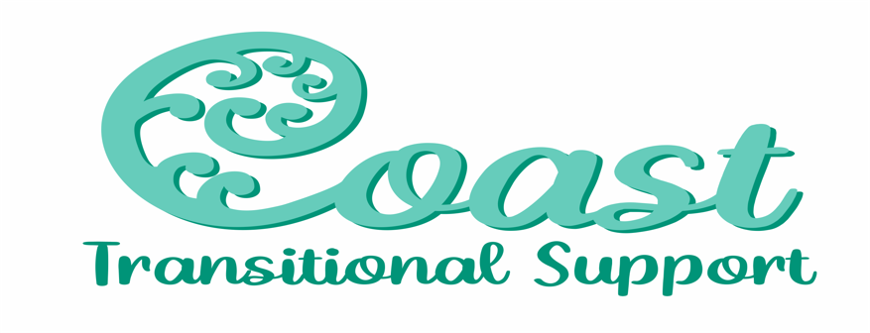

**Coast Transitional Support – Referral Form**

Referral Form for NDIS Participants

Please send completed form to [Anna.Keating@coasttransitionalsupport.com](mailto:Anna.Keating@coasttransitionalsupport.com)

Please attach a copy of the NDIS plan to this document

**Participant Details:**

|  |  |
| --- | --- |
| **First Name:** | **Last Name:** |
| **Date of Birth:** | **Gender:** |
| **Address:** | **Emergency Contact:**  **Name:**  **Address:**  **Contacts:**  **Relationship to participant:** |
| **Telephone:** | **Email:** |
| **Consent given for referral:** | **Date of Referral:** |
| **Details of person making referral:** | **Other Details: (ie Guardian)** |

**Living Arrangements:**

|  |  |
| --- | --- |
| **Alone:** | **Family/Partner:** |
| **Supported Accommodation:** | **Other (please specify)** |

**NDIS Plan Details:**

|  |  |
| --- | --- |
| **NDIS Number:** | **Plan Start Date:** |
| **Plan End Date:** | **How is Plan Managed:** |
| **Plan Manager Details:** | **Any Other Information:** |

**Participant’s Diagnosis:**

|  |  |
| --- | --- |
| **Primary Diagnosis:** | **Secondary Diagnosis:** |
| **Health Issues:** | **Other:** |

**Services Required:**

|  |
| --- |
|  |

**Any Other Details:**

|  |
| --- |
|  |

**Safety Issues:**

|  |  |
| --- | --- |
| **Any risk of self-harm identified?** | **Any harm from others identified?** |
| **Any harm to others identified?** | **Are there any pets on the property?** |
| **Are there any firearms stored on property?** | **Any history or current substance abuse:** |
| **Any health issues of anyone living at property?** | **Any other risks that support staff need to know?** |

|  |
| --- |
| **Does the participant display any challenging behaviours?** *(please specify below)* |

**Level of Support Required:**

|  |  |  |  |  |  |
| --- | --- | --- | --- | --- | --- |
| **Domain** | **Dependant** | **Needs some assistance** | **Independent with use of aids/equipment** | **Independent** | **N/A** |
| **Mobility** |  |  |  |  |  |
| **Self-Care** |  |  |  |  |  |
| **Mealtime Assistance** |  |  |  |  |  |
| **Food Preparation** |  |  |  |  |  |
| **Domestic Tasks** |  |  |  |  |  |
| **Community Access** |  |  |  |  |  |
| **Communication** |  |  |  |  |  |

**Existing Support Services:**

|  |
| --- |
|  |

**Mainstream supports:**

*(Education, health, community etc)*

|  |
| --- |
|  |

**Daily Routine Information:**

|  |
| --- |
|  |

**Likes and Dislikes:**

|  |
| --- |
|  |

**Any Other Important Information:**

|  |
| --- |
|  |

**Signatures:**

|  |  |
| --- | --- |
| **Participants Signature:** |  |
| **Name of Participant:** |  |
| **Advocate or Guardian Signature:** |  |
| **Name of advocate or Guardian:** |  |
| **Organisation:** |  |
| **Date:** |  |