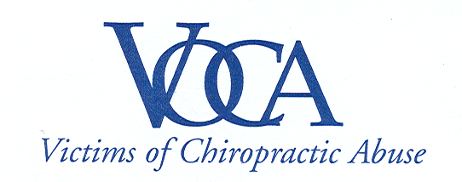

For Immediate Release

ILLEGAL CHIROPRACTIC ANTI-TRUST ACTIONS
NO SURPRISE TO VICTIMS

Westville, CT | March 5, 2008 – Victims of Chiropractic Abuse, Inc (VOCA) regrets to say it is not surprised that Connecticut’s two major chiropractic industry groups have been caught orchestrating an illegal coordinated effort to boycott an insurance company in violation of anti-trust laws.

Settlements were announced today stemming from a joint investigation by Connecticut’s Attorney General’s Office and the Federal Trade Commission that impose stiff civil penalties on the Connecticut Chiropractic Council (CCC), the Connecticut Chiropractic Association (CCA) and the association’s general counsel.

“These are the same tactics the chiropractic groups have used to try and thwart our public awareness campaign,” said Janet Levy, President of Victims of Chiropractic Abuse (VOCA). “We believe the CCA and CCC have orchestrated an illegal campaign of harassment by telephone and email to intimidate victims and destroy our efforts.”

For example, on Friday February 29th New Haven chiropractor Steve Piserchia was served with an arrest warrant for making harassing phone calls to a chiropractic stroke victim - making fun of her permanent disabilities - from his offices at New Haven Medical, Sports & Occupational Health, PC at 1213 Chapel Street in New Haven. He will appear in New Haven Superior Court at 9:30 a.m. March 13th.

In addition, both chiropractic groups, according to their own statements posted on the Internet, have actively schemed to violate the first amendment rights of VOCA and the Chiropractic Stroke Awareness Group (CSAG).

The following was posted July 30, 2005 on the CCA’s chiroweb.com Website regarding a billboard advertisement in New Haven designed to raise awareness of the potentially severe health risks of chiropractic neck manipulation.

“Almost immediately after the billboard appeared, the Connecticut Chiropractic Association mobilized in an effort to have it removed. A coalition of the profession's leaders, headed by Robert Hirtle, the association's general counsel, contacted NextMedia, the owner of the billboard, and persuaded the company to remove it less than two weeks later.”

VOCA would like to congratulate state and federal authorities for investing the time and resources to uncover illegal activities by the chiropractic industry, most specifically the industry’s unwillingness to deal fairly with anyone unless it is on their terms.

For more information call 203-982-4575 or email voca93@gmail.com or chirostroke@gmail.com.

About Victims of Chiropractic Abuse, Inc:
Victims of Chiropractic Abuse, Inc. (VOCA) was incorporated in May of 2005 to promote awareness of chiropractic risks through advocacy and legislation. VOCA seeks to require chiropractors to obtain informed consent from patients prior to treatment and believes malpractice claims against chiropractic physicians should be made public, just as they are for medical physicians.

203-982-4575 | www.vocact.com
PO Box 3278 | Westville, CT | 06515

