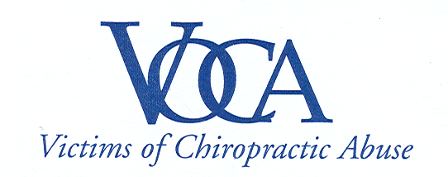

For Immediate Release

CONNECTICUT GOVERNOR SIGNS LAW
ADDING CHIROPRACTORS TO ONLINE PROFILE

Westville, CT | June 16, 2008 – On Monday June 16th Governor M. Jodi Rell formally signed into law SB-471 (Public Act No. 08-109) which will - for the first time in Connecticut – assist the public in making informed decisions about whether to visit a chiropractor. The signing follows overwhelming approvals by both houses of the Connecticut General Assembly.

“This is a historic event for patients’ rights here in Connecticut," said Janet Levy, President of Victims of Chiropractic Abuse which sought the legislation. “The public will now be able to easily access important information to make fully informed health care choices.”

The new law will extend the state’s Physician Profile to include chiropractors. The profiles – to be posted on the Internet - will have such information as a chiropractor’s training, disciplinary actions, criminal convictions and malpractice court judgments.

The law will go into effect January 1, 2010.

Ms. Levy suffered a stroke after chiropractic manipulation of her neck six-years ago.
Like most other people she believed chiropractic to be a “safe” and “natural” alternative - as advertised - and was totally unaware that it involved any serious risks at all.

“After feeling stroke-like symptoms following the manipulation the chiropractor assured me he was a doctor and that there was nothing to worry about.” Levy said. “I never realized he didn’t have the same training as a medical doctor. He nearly cost me my life.”

Levy founded VOCA after discovering there are hundreds of others who have also been severely injured by chiropractic treatment.

For more information call 203-982-4575 or email voca93@gmail.com or chirostroke@gmail.com.

About Victims of Chiropractic Abuse, Inc:
Victims of Chiropractic Abuse, Inc. (VOCA) was incorporated in May of 2005 to promote awareness of chiropractic risks through advocacy and legislation. VOCA seeks to require chiropractors to obtain informed consent from patients prior to treatment and believes malpractice claims against chiropractic physicians should be made public, just as they are for medical physicians.
203-982-4575 | www.vocact.com
PO Box 3278 | Westville, CT | 06515

