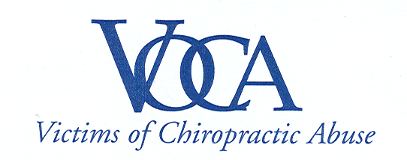

For Immediate Release

NO EVIDENCE OF BENEFITS – EVIDENCE OF HIGH RISK
HEALTH INSURER EXCLUDES NECK MANIPULATIONS

Westville, CT | August 26, 2010 – Victims of Chiropractic Abuse, Inc. (VOCA) is encouraged by the news that Kaiser Permanente Mid Atlantic States and Mid-Atlantic Permanente Medical Group have revised their chiropractic manipulation coverage policies to exclude cervical adjustments (neck manipulations).

In its announcement, Kaiser stated, “Given the paucity of data related to beneficial effects of chiropractic manipulation of the cervical spine and the real potential for catastrophic adverse events, it was decided to exclude chiropractic manipulation of the cervical spine from coverage.” (see attached document)

“This is a significant development,” said Janet Levy, President of VOCA. “A leading health insurance company has reviewed the evidence and supports what our organization has been saying for years – the risk of stroke and death from neck manipulation is a real and unacceptable risk to the public health.”

The decision by Kaiser Permanente Mid Atlantic States and Mid-Atlantic Permanente Medical Group impacts coverage in Maryland, Virginia, Washington, DC, as well as Federal and Medicare enrolled members.

According to Kaiser, “Chiropractic manipulation of the cervical spine is associated with vertebral artery dissection and stroke. The incidence is estimated at 1.3-5 events per 100,000 manipulations.”

“We believe this is just the beginning of the healthcare establishment recognizing the real danger posed by chiropractic neck adjustments, as well as its human and financial costs to our society,” Levy said.

For more information contact Jon Crane at 203-982-4575.

