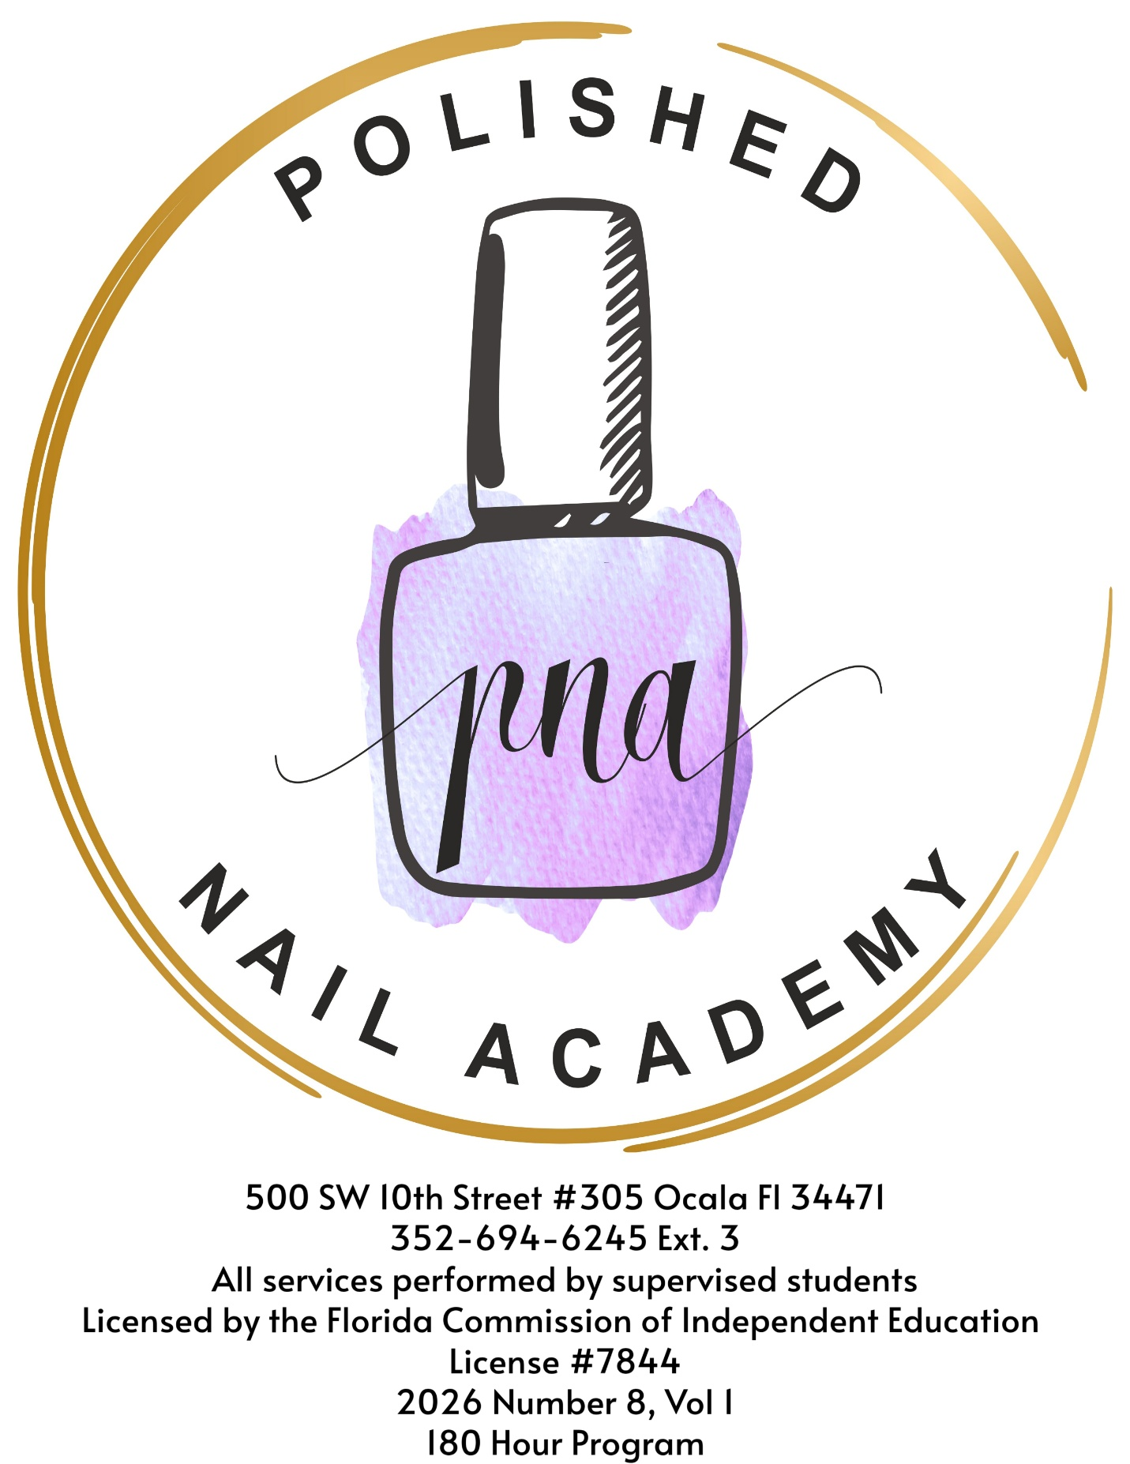

Welcome!
Welcome to the exciting world of nail technology! The field you’ve chosen to explore is a place where skilled technicians can make a living independently or working for someone else.
Why choose Polished Nail Academy?
At Polished Nail Academy, we teach Nail Technology exclusively. We are not a small department housed in a larger cosmetology school. All instruction is both live and personal: 1 on 1 or small groups. Small classes offer personal attention. Our Director, Melissa Goodson, a 30-year industry veteran, is committed to educating nail techs.
Call us at 352-236-2099 and make an appointment to check us out. Read this catalog carefully and we’ll answer any questions that you may have. We look forward to meeting you and showing you how Polished Nail Academy can help you prepare for a career as a nail tech.
Mission Statement:
Our mission at Polished Nail Academy is to provide students with a comprehensive education in nail technology through a well-planned curriculum delivered by experienced instructors. Upon graduation, Polished Nail Academy graduates will be prepared for the state licensing exam and entry into the professional beauty industry.

Table of Contents:
Mission Statement Page 2
Polished Nail Academy Pages 3-5
-Contact Information
-Licensing
-Program Administration
Admissions Page 5
Requirements for Graduation Page 6
Requirements for Nail Technology Licensing Page 7
Tuition Pages 6-8
Student Cancellation and Refund Policy Pages 8-9
Academic Calendar and Class Schedule Pages 9-10
Educational Program and Curriculum for Nail Technology Pages 10-14
Satisfactory Academic Progress Pages 14-16
Advanced Education Page 16
Description of Physical Facilities Pages 16-17
COVID-19 Precautions and Policy, pages 16-17
Student Services Page 18
Student Policies Pages 18-22
Appeal Policy
Grievance Policy
Student Rights
Student Conduct
Polished Nail Academy:
Contact:
Polished Nail Academy
500 SW 10th Street, Suite #305, Ocala, FL 34471
Telephone Number: 352-236-2099
Website: www.polishednailacademy.com
Polished Nail Academy, LLC, is 100% owned by Melissa Goodson and is registered with the Department of State, Division of Corporations.
Institutional Licensing:
Polished Nail Academy, ID Number 7844, is licensed by the Florida Commission for Independent Education. Additional information regarding this institution may be obtained by contacting the Commission at 325 West Gaines Street, Suite 1414, Tallahassee, FL 32399-0400, toll-free telephone number (888)224-6684.
Program Administration:
Director and Principal Instructor: Melissa Goodson
Licenses: Nail Tech since 1990, diploma awarded by Sunstate Academy, Fort
Myers, FL
Salon License in Ocala 2008 to present
Barbicide licensed in 2020 (since licensing began)
Most recent additional certifications:
Young Nails, 2010 “Use Your Imagination”
Young Nails, 2011 “Mani-Q Color”
Master Painter Course, 2012
Extreme Shapes in Acrylic, One Stroke Nail Art, 2016
Wildflowers Nail Academy, 2017 “Gel Stamping”
Wildflowers Nail Academy, 2019 “E-file Class”
PF Backstage, Nail Camp East 2019, “Educate Like A Boss”
Nail the Future, Nail Camp East 2019
Crystal Beauty Academy, 2019 “Swarovski Create Your Style, Certified
Nail Artist”
Executive Assistant: Christen Mejias
Administrative Assistant: Donna Clore
Instructors: Tara Forgette (licensed Nail Tech)
Juliann Marie Bernier (licensed Nail Tech)
Addison Goodson (licensed Nail Tech)
Kaitlynn Marie Kirby (licensed Nail Tech)
Jessica Masker (licensed Nail Tech)
See Organization Chart:
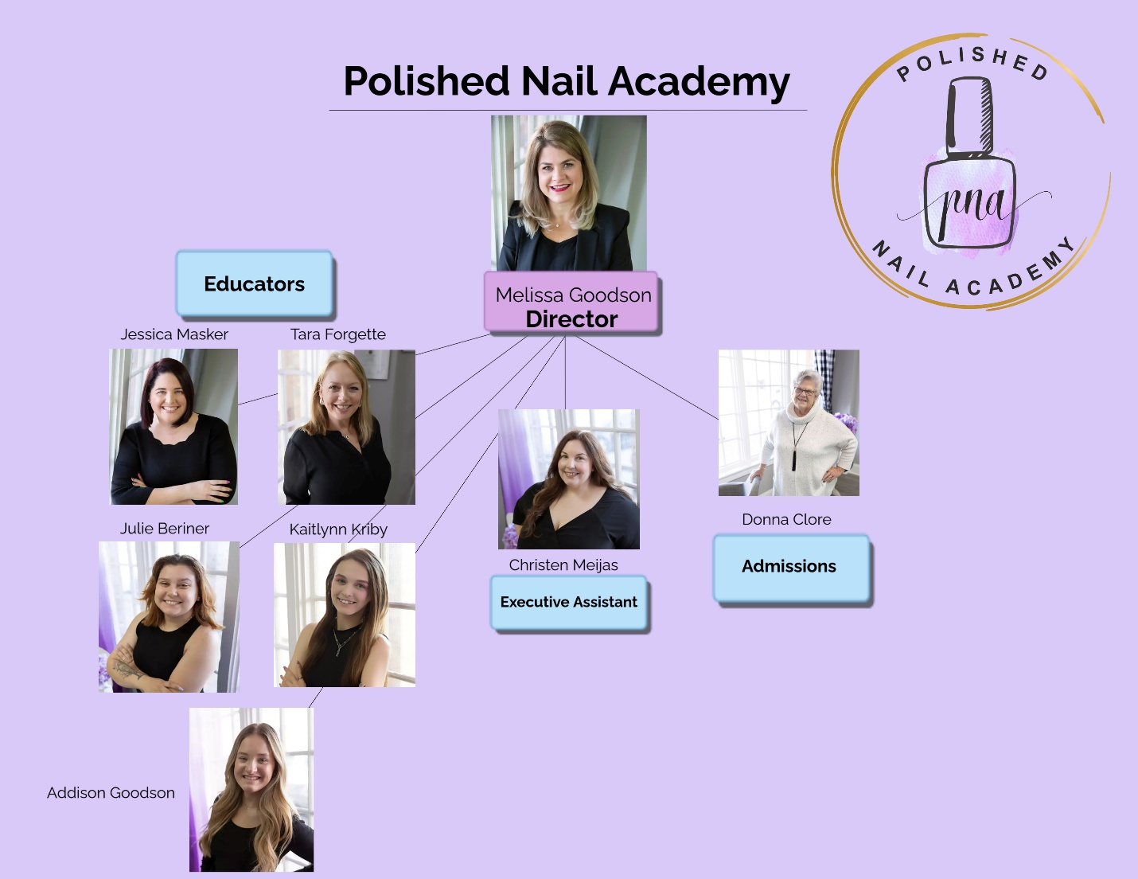

Admissions:
Non-Discrimination Statement:

Polished Nail Academy is an equal opportunity institution and employer. The school does not discriminate, exclude participation in programs or activities, or limit employment or application opportunities based on race, color, national origin, religion, sex, gender identity or sexual orientation, disability, military or veteran status, or age.

Requirements:
- Legal minors, those under the age of 18, must have parent or guardian approval to apply.

- Completed Application and Interview with School Director.
Interested applicants may review the catalogue online at www.polishedocala.com at any time.
Requirements for Graduation:
Before enrolling, potential students with certain felony convictions should contact the Florida Board of Cosmetology, Department of Professional and Business Regulations to determine their eligibility to obtain licensure prior to enrollment at Polished Nail Academy. The Board may be reached at: Division of Professions, Board of Cosmetology,2601 Blair Stone Road, Tallahassee, FL 32399-0793, Phone: (850) 487-1395.
- Completion of 180 hours of topic (120 hours) and service (60 hours).
- Pass a final practical and written examination with 70%, Letter Grade of C or better.
- Meeting all financial obligations with the school.
Diploma
Diploma is awarded upon satisfactory completion of all requirements for graduation.
Requirements for Nail Technology Licensing:
The graduate will submit a completed application, certified by the school, to the DBPR. The completed application includes:
- Application Form (completed and signed)
- Students are responsible for paying to complete a board-approved HIV/AIDS course.
- School official completion of the Certificate of Eligibility portion of the application.
- If applicable, previous course credit evaluation documentation per Section IV of the application.
After having satisfactorily taken the Nail Registration, the graduate will receive a Nail Specialist License issued by the Department of Business and Professional Regulations.
Polished Nail Academy does not make or imply any guarantee of employment to any student. See Student Services, page 18 to learn about the school’s student placement services.
Tuition:
Total cost of eight week (day) or fifteen week (night) program:
$3,000
Breakdown of total cost:
$1,500 Deposit breakdown:
Book rental $150.00
Kit $550.00
Tuition $500.00
Insurance $150.00
Registration: $150.00
Total: $1,500.00
$1,500 Balance breakdown:
Tuition $1,500.00
Total: $1,500.00
Payments are due as follows:
$1,500 Due 3 weeks prior to the first day of the course
$750 Due the first day of the beginning of the third week
$750 Final payment due the first day of the beginning of the sixth week.
Please note: there will be a credit card swipe fee of 2.86% per swipe.
Terms of payment:
Polished Nail Academy will accept the following forms of payment:
1. Credit card. there will be a credit card swipe fee of 2.86% per swipe
2. Debit card: there will be a debit card swipe fee of 2.86% per swipe
3. Cash
Student Cancellation and Refund Policy:
Total cost of 8 week (day) or 15 week (night) program:
$3,000
Breakdown of total cost:
$1,500 Deposit breakdown:
Book rental $150.00
Kit $550.00
Tuition $500.00
Insurance $150.00
Registration: $150.00
Total: $1,500.00
$1,500 Balance breakdown:
Tuition $1,500.00
Total: $1,500.00
Should a student’s enrollment be terminated or cancelled for any reason, all refunds will be made according to the following refund schedule. This schedule is applicable to all students whether they pay in full before classes start or by installments during the course of study.
- Cancellation can be made in person, by electronic mail, by Certified Mail or by termination.
- If the school does not accept the applicant or if the student cancels within three (3) business days after signing the Application or Enrollment Agreement, the student’s funds will refunded.
- Cancellation after the third (3rd) Business Day, but before the first class, results in a refund of all monies paid, with the exception of the following fees*:
-Registration fee (not to exceed $150)
-Books fee ($150)
-Kit Fee ($550)
*Please see RULE 6E-1.0032(6)(i): The refund policy shall provide for cancellation of any obligation, other than a book and supply assessment for supplies, materials and kits which are not returnable because of use, within 3 working days from the student’s signing an enrollment agreement or contract.
- Cancellation after attendance has begun, through 40% of the program, will result in a Pro Rata refund computed on the number of hours completed to the total program hours.
- Cancellation after completing more than 40% of the program will result in no refund.
- Termination Date: In calculating the refund due to a student, the last date of actual attendance by the student is used in the calculation unless earlier written notice is received.
- All refunds will be made within 30 days.
Academic Calendar and Class Schedule:
Class Calendar for the Academic Year 2026
Students attend either daytime classes, Monday through Thursday, 9:00am to 3:00pm, or nighttime classes, Monday through Thursday, 5:30pm to 8:30pm.
Holidays:
Holidays:
2026
Thursday, January 1, 2026 – New Year's Day
April 8-9, 13-14, 2026 - School Closure
Monday, May 25, 2026 – Memorial Day
Monday, September 7, 2026 – Labor Day
Wednesday, November 25, 2026 – Thanksgiving Eve
Thursday, November 26, 2026 - Thanksgiving
Thursday, December 24, 2026 – Christmas Eve
Thursday, December 31, 2026 – New Year’s Eve
Daytime Calendar: 2026
Monday, January 5, 2026 Thursday, February 26, 2026
*Monday, March 2, 2026 Thursday, April 30, 2026
*4/6-4/9 School Closed
Monday, May 4, 2026 Thursday, June 25, 2026
Monday, June 29, 2026 Thursday, August 20, 2026
Monday, August 24, 2026 Thursday, October 15, 2026
*Monday, October 19, 2026 Thursday, December 17, 2026
*11/23 – 11/26 School Closed
Nighttime Calendar: 2026
Start Date: Completion Date:
Monday, January 26, 2026 Thursday, May 14, 2026
*4/6-4/9 School Closed
Monday, May 18, 2026 Thursday, August 27, 2026
Monday, August 31, 2026 Thursday, December 27, 2026
*11/23 – 11/26 School Closed

In case of school closure due to weather event, lockdown, etc.:
Polished Nail Academy will follow the guidelines of the Marion County Public Schools for closure in of an emergency or weather event such as a hurricane. During the summer months, we will follow the guidelines provided by the City of Ocala, Marion County Emergency Services and the State of Florida.
In all cases, should the school be closed, students can count on rapid and detailed communication from the school director:
- Updating the website within 24 hours of the emergency including the condition of the school, its projected reopening and a make-up schedule. This information will be updated on a regular basis should a continuing emergency such as a lockdown occurs. Otherwise, in the case of weather, the school will reopen as soon as the emergency has been officially declared over. All students will be expected to follow the online posted make-up schedule to ensure that no learning time is lost to the emergency.

- Sending of emails and texts to students with detailed instructions about school expectations of them in terms of online study until we can get back into the building.

Polished Nail Academy’s Educational Program
for Nail Technology:
Total Hours: 180 divided into 120 Topic Hours and 60 Service Hours
Course: Topic Hours: Service Hours
NT – 01 Orientation and
Florida Cosmetology laws and rules 4
NT – 02 Sanitation 8
NT – 03 Ethics 4
NT – 04 Nails and Nail Disorders 3
NT – 05 Manicuring 20 8
NT – 06 Pedicuring 10 6
NT – 07 Overlay 15 8
NT – 08 Sculpting/Tips 20 10
NT – 09 Nail Fill-In’s 10 5
NT – 10 Artificial Nail Removal 5 3
NT – 11 Polishing and Nail Art 6 10
NT – 12 Gel Nails 5 10
NT – 13 Employment Skills 5
NT – 14 The Business of Nail Technology 5
Topic Hours: 120 Service Hours: 60
Course Descriptions:
Since Polished Nail Academy only offers one program, Nail Technology, all classes listed below are identified first as NT. The numbers following NT indicate the order in which the courses are taken. The purpose of the program is to prepare the student for the state licensing exam so all courses are at the beginning level.
NT-01 Orientation and Florida Cosmetology Laws and Rules
The students will be exposed to classroom procedures and rules. The instructor will review the text and review books to demonstrate the most effective ways of mastering the materials. Next the students will define and demonstrate understanding of Florida State Laws and Regulations for Cosmetology by restating their meaning and application in their own words.
NT-02 Sanitation
The students will define sanitation and disinfection as well as identifying safety precautions. They will demonstrate understanding of contamination control through the identification of common salon contaminants. Through correct application of disinfectants, the students will display understanding how to sanitize and disinfect implements and hard surfaces effectively. The culminating activity will demonstrate comprehension by each student of Sanitation as they model the use of safety precautions while manicuring, pedicuring and extending nails. They will be able to perform all sanitation procedures required by Florida law. In addition, students must complete the Barbicide Certification online program. There is no charge for this mandatory certification.
NT-03 Ethics
The students will provide definitions of salon conduct and professional ethics. Next, they will demonstrate their understanding by providing examples of appropriate conduct in a business setting with an emphasis on behavior towards clients and co-workers. They also will describe examples of professional ethics in dealing with clients and co-workers. Each student will be able to provide a detailed description of a professional nail technician’s appearance and behavior towards clients, colleagues and salon owners.
NT-04 Nails and Nail Disorders
The students will gain knowledge of normal nail anatomy. They will be able to describe nail structures. Building on this foundation, the students will learn about nail irregularities, disorders and diseases, both common and unusual. They will then be able to define and identify nail irregularities, disorders, and diseases, demonstrating an understanding of the origin of each problem and its effect on the decision to provide nail technology services.
NT-05 Manicuring
The students will learn procedures for basic table set-up including identification and use of nail technology supplies. They will learn the steps to perform a plain manicure including proper selection of a nail shape and how to handle blood during a manicure. This learning includes how to perform a man’s manicure and how to manicure using an electric file. They will also gain knowledge and experience in providing the following specific treatments: paraffin wax treatments, hand and arm massage, and reconditioning hot oil manicure. They will be able to distinguish between plain and spa manicures as well as French and American manicures.
NT-06 Pedicuring
The students will be able to both identify and employ pedicure supplies and instruments. They will learn the procedures for performing a pedicure such as exfoliating the skin, cutting toenails and providing a massage to the feet. They will then be able to distinguish between and provide both a pedicure and a full-service pedicure.
NT-07 Overlays
The students will identify all the supplies required for nail tips and explain their use. They will point out and distinguish between types of nail tips. They will demonstrate the proper procedure and precautions to employ during the application of nail tips. They will explain the proper maintenance of nail tips and demonstrate the correct method of their removal.
NT-08 Sculpting/Tips
The students will identify all the supplies required for acrylic nail applications. They will explain the chemistry of acrylic nails. Next, they will demonstrate the proper procedures and precautions for: 1. Application of primer; 2. Application of acrylic nails over tips. The students will also demonstrate two basic types of maintenance for acrylic nails.
NT-09 Nail Fill-ins
The students will be introduced to the basics of nail fill-ins. They will be instructed in the use and maintenance of the following products: nail dehydrator, nail primer, monomer liquid, polymer powder, application brushes, dappen dishes and abrasives. Students will be guided in the use of these products to provide seamless fill-ins through extensive practice. During class NT-14, The Business of Nail Technology, students will be introduced to the concept of nail fill-ins as the “bread and butter” of their business. Proficiency in this skill has immediate and lasting effect on the nail tech’s bottom line.

NT-10 Artificial Nail Removal
The students will begin with a review of the construction and placement of artificial nails. Next, they will examine and learn about the use of the following implements and materials for UV and LED Gel Removal, Hard Gel, Soft Gel or Gel Polishes: polish remover, nail buffer, abrasive, buffer, UV or LED gel remover. Demonstrating a thorough grasp of the purpose and use of these materials through written and verbal communication, students will practice artificial nail removal.
NT-11 Polishing and Nail Art
Students will be exposed to and encouraged to try multiple examples of creative touches, both ideas (holiday-themed decorations) and materials (i.e., Swarovski crystals). Through hands-on exposure, they will be introduced to core nail art principles such as the “look” determining not only the materials but also the number of layers required to achieve the design. The students will then learn to evaluate the complexities underlying the realization of a design. This experience will lead students to appreciate the profit maximization potential of nail art.
NT-12 Gel Nails
The students will look over and examine closely the following implements and materials: nail forms, UV or LED gel, UV or LED gel primer or bonding gel, brush, UV or LED gel lamp, a cleansing solution, lint-free cleansing wipes and nail cleanser or primer. Each of these items will be reviewed to confirm student understanding of both their nature and purpose. Next the students will watch and then later try on forms the 14-step procedure for creating gel nails. All students will have the opportunity to observe licensed nail technicians providing gel nails in real time in Polished Nail Salon.
NT- 13 Employment Skills
The student will demonstrate understanding of the interviewer’s role by describing the ideal employee and what kinds of questions they will ask to find that person. They will generate their own list of questions about the salon to use in making an informed employment decision. Then the students will list effective interviewing and questioning strategies. They will practice the interviewing process through role-playing as both interviewer and potential employee. The course concludes with students analyzing the information gained from an interview to make a decision about which salon is the right fit.
NT-14 The Business of Nail Technology
The students will learn the advantages and disadvantages of booth rental versus salon ownership. In analyzing the two business models, they will consider a variety of factors such as working environment, types of compensation and decision-making as an owner versus a renter. They will be required to demonstrate the skills of keeping good personal records and understanding of salon records. They will also demonstrate competence in the basics of the nail technology business: advertising, booking appointments and collecting payment for services. They will be introduced to principal techniques for selling nail products and services.
Satisfactory Academic Progress Policy:
Purpose: SAP uses quantitative (attendance) and qualitative measures (grade point average) to determine whether or not a student is making SAP in his/her Nail Technology program of study. Both are measured in every class. Each student must maintain SAP in order to continue enrollment.
SAP allows the director to observe student progress closely on a daily basis. As soon as SAP evidence of a possible problem emerges, the director will consult with the student to forestall any damage to the student’s prospects for graduation.
All student SAP information is maintained in student files.

Quantitative measure is a product of the program calendar.
Standard: 180 clock hours completed in 8 weeks, day class.
180 clock hours completed in 15 weeks, night class.

Definition of Clock Hour: Clock Hour means a period of 60 minutes with a minimum of 50 minutes of instruction in the presence of an instructor.

Quantitative Measure means attendance. In order to complete the program in three months, students are required to attend 95% of all classes and services. Attendance will be taken daily to ensure that students are on track to finish on time. All absences will be reviewed by the Director.

Excused absence refers to:

- An absence in the case of a medical emergency or circumstances clearly beyond the student’s control such as a hurricane.
- An absence with prior notice and approval by the Director.

Unexcused absence refers to:
- An absence not in the case of a medical emergency or circumstances clearly beyond the student’s control such as a hurricane.
- An absence without advance notice and permission from the Director.

Qualitative Measure means cumulative grade point average. The standard is established by the school’s director in consultation with the educational advisor.

Standard: A minimum cumulative grade point average of 70%, at least 2.0 I, must be maintained after the completion of each of the sixteen classes. This average applies equally to theory and practical work.
This average will be measured for each student at the end of each course. Students in danger of falling below the required minimum will receive immediate counseling with the Director. The Director and student will devise a plan for remediation.

Evaluation Period:

Standard: Students will be evaluated for attendance on a daily basis and cumulative grade point average at the end of each of the sixteen classes that comprise the twelve-week Nail Technology program.

Grading System:

This system applies to every student in the Nail Technology program. The scale below is used for both theory and practical work.

A – 90 – 100 (4.00)
B – 80 – 89 (3.00)
C – 70 – 79 (2.00)
F – < 70
The principal instructor monitors each student’s progress on a regular basis. If the student continues to fail to achieve SAP after meeting with the director and devising a plan to correct any deficiencies, the student may be subject to dismissal. Before the director’s final decision about enrollment termination, the student has the option to appeal it in writing and by offering supporting documents for any unusual circumstances not under his/her control that call for special considerations.
Advanced Education:
Specialty Workshops: While attending Polished Nail Academy, students are allowed to attend ANY specialty workshops offered to currently licensed nail techs for an additional fee depending on the specialty class.
Description of Physical Facilities:
Polished Nail Academy is located at 500 SW 10th Street, Suite 305, Ocala, FL 34471 in the Old Bridge Station Plaza. It offers plenty of parking spaces with overhead lights. The buildings and parking lot are ADA-compliant.
The school occupies Suite 305 with 1,255 square feet dedicated to the Learning Area. The school houses:
-The school library
-A student lunchroom with a refrigerator and microwave
-Locking storage cabinets for all school paperwork
-Lockers for students
-One ADA-compliant bathroom. Polished Nail Salon, next door in Suite 303 has two more ADA compliant bathrooms and the school laundry.
The corporate office and supply store are located in Suite 309.
Learning Area: an integrated, flexible space to maximize student learning
- Classroom:

-12 desks and 12 chairs
-2 teacher’s desks and 2 chairs
-Fixed 52-inch TV screen on the wall facing the parking lot
-Portable whiteboard

- Clinical Practice Area:

-12 manicuring tables (47” L X 18” W X 30” H) and 12 chairs as well as 12
12 client chairs.
-12 credenzas with five drawers, divided as needed.
-Lighting is provided both by directional LED lights and clip-on LED lights at each workstation
-One pedicure chair (Two more chairs are available in the nail salon.)
-Reception desk with petty cash and Square Computer to receive
payments.
- Storage:

-2 tall, mirrored cabinets with a product display functioning as visual storage between them.
Corporate Office:
- Office area:

-3 locking desks, chairs, computers with printers

-Locking filing cabinets for all school paperwork
-1 ADA-compliant Bathrooms

Polished Nail Salon is next door to the school in Suite 303. The school laundry, two additional bathrooms and lunchroom including a refrigerator and microwave are situated within the salon’s walls.
COVID-19 Precautions and Policy:
The school has been fitted with individual air scrubbing systems. Each manicuring table has its own separate duct. This duct runs from the top of the table to the ceiling where it enters ductwork leading to the air scrubber. It pulls the air including dust and odors resulting from nail services away from the client and nail tech. The air is run through a scrubber which cleans it thoroughly before discharging it outside. Similarly, there is a separate system of ductwork which pulls fresh air in, runs it through the scrubber before venting it inside the school and salon.
Additional precautions include the placement of all desks and manicuring tables at recommended social distancing. There is no waiting room in the school. We will conduct all client services by appointment only with arrivals confirmed by phone calls and texts. Our door will be locked with both entry and exit carefully monitored.
Student Services:
Hours: 9am-8:30pm, Monday through Thursday
Friday, by appointment
- Academic Services: The principal instructor monitors each student’s progress on a regular basis. Attendance is taken daily. If a student starts to fall behind or his/her grades drop below SAP, the Director will meet with the student. Additionally, students may decide to meet with the Director for help when they realize that they need assistance. In both cases, the director and the student together will analyze the problem(s) and plan remediation. The school will provide tutoring for improved comprehension and testing performance as well as coaching for improving service production.

- Financial Services: While Polished Nail Academy does not make financial loans to students, the Director is available to review student financial questions, concerns and issues. We provide complete information about the cost and payment methods at the time enrollment is being discussed. We encourage students to review their finances carefully before signing up at Polished Nail Academy. Equally, if a student finds him/herself facing an unexpected financial problem, the director will be available for consultation.

- Student Placement: Polished Nail Academy will make every effort to help students with employment placement. The school will provide an extensive contact list of potential employers for students to access while looking for job placement. The school director will be available for counseling and guidance. Additionally, the school, through class, NT-15 Employment Skills, will provide the guidelines students are expected to use regarding proper attire, a winning attitude and the organization of interview appointments to ensure positive results. While it is the student’s responsibility to make contact with potential employers and to follow through with interviews, the school director will be on hand to critique, coach and support all students in their job search process.

- Student Counseling: Polished Nail Academy offers admissions and career counseling to all students. In addition, the director will provide referrals to area mental health counselors in the case of a student requiring personal counseling.
Student Policies:
All students are expected to follow the policies and procedures of Polished Nail Academy. As a condition of acceptance, students agree to accept the responsibility to be aware of and follow codes of conduct, behavior standards and all program specific rules, policies, and procedures.

Appeal Policy:

Before the director’s final decision about probationary status or enrollment termination, the student has the option to appeal it in writing and by offering supporting documents for any unusual circumstances not under his/her control that call for special consideration. The Director will make a decision about the student’s appeal in five (5) business days. The Director’s decision will be final.
Grievance Policy:

In the event that any student has a grievance or complaint about Polished Nail Academy’s educational program, faculty or other issue, the student may write a letter to the Director to express his/her dissatisfaction. This letter must include all the details of the grievance. The Director will make a decision about the student’s complaint in five (5) business days.
If this complaint remains unresolved, students may refer their grievance to: Commission for Independent Education, 325 West Gaines Street, Suite 1414, Tallahassee, FL 32399-0400, toll-free telephone number (888)224-6684.
Student rights:
All Polished Nail Academy students have the right to know:
- Polished Nail Academy is a non-smoking, non-vaping institution. No illegal drugs or alcohol are permitted at any time.
- All facilities at Polished Nail Academy are ADA-compliant.
- Information about Polished Nail Academy’s nail technology program, faculty and facilities.
- Detailed explanation of how much it costs to attend the school as well as the school policy on refunds for students who drop out.
- The method by which the school determines Satisfactory Academic Progress (SAP) as well as the consequences for unsatisfactory performance.
- The name and address of Commission for Independent Education which licenses Polished Nail Academy if the student has a complaint that goes unresolved.
Student Conduct:
- Attendance and Tardiness:

The school expects regular attendance. Attendance will be taken daily. All absences will be reviewed by the Director. See SAP, page 13.
Tardiness:
All classes will start on time. The school expects students to arrive fifteen minutes early to be prepared for the beginning of class. If a student arrives 15 minutes or more after class has started, he/she will need the Director’s permission to attend the class. Such permission will only be given to students who demonstrate a valid reason for their tardiness. Frequent and excessive tardiness may be grounds for probation or dismissal.
- Leave of Absence:
In order to complete either the day or night program, students are required to attend 95% of all classes and practicing of services. For a day student completing the program in three months, this requirement provides up to a two day leave of absence. For a night student completing the program in five months, this requirement provides up to a four day leave of absence should the student need to deal with a personal emergency, etc.

- All leaves of absence must be cleared with the school director before they take effect.

- It can last no longer than 2 days for day or night students.

- It will be granted only once during the twelve-week program in which the requesting student is enrolled.

- Should the student need more time off, he or she will be required to enroll in the next available session and start the program over.
- Any work missed including practicing services during the leave of absence must be made up within two days of the student’s return to the school.

- Dress Code:
-Black scrubs (Cherokee brand on Amazon has a wide variety of sizes), black or white sneakers (closed toe, no sandals).

- Classroom Rules:
-Arrive fifteen minutes early, prepared to work.
-No food, no drinks, no gum during class. Breaks will be organized by the teacher.
-All phones, silenced, will be collected at the beginning of class. Students will have access during breaks.
-No engagement in behaviors which interferes with the teaching and learning environment.
- Conduct:

Proper conduct and a professional work attitude are expected of all students at all times. A student who violates the rules and regulations of the school will be given one warning and counseling with the Director for the first offense*. If the student continues to violate the school’s rules and regulations, the student will be subject to dismissal. The Director reserves the right to dismiss any student whose personal conduct is judged unsatisfactory.

Any of the following behaviors may result in a student’s probation or dismissal after the Director’s review:

-Unexcused or excessive absences
-Leaving school without permission of the Director
-Use of obscene or foul language
-Lewd behavior
-Sexual harassment
-Behavioral problems including insubordination to instructors and lack of participation in class
-Failure to follow school rules and regulations
-Refusal to provide a service to a customer

*In the case of alcohol and illegal drugs, see Section G. Grounds for Immediate Dismissal below.

- Grounds for Immediate Dismissal:
There is no tolerance for illegal drugs or alcohol at Polished Nail Academy.
Any student involved in any of the following illegal drug and/or alcohol activities is guilty of misconduct and is subject to immediate dismissal for the first offense with no refund:
- Bringing and/or possessing any form of illegal drug or alcohol onto the school’s premises or property including the parking lot during scheduled class time or while on school business.

- Using, consuming, transferring, selling or attempting to sell or transfer illegal drugs or alcohol.
The records of any dismissed student will remain on file indefinitely.
- Probation:
During the program’s twelve weeks for the day program or twenty weeks for the night program, students will only be eligible for one probationary program not to exceed one week or as determined by the Director. Students will be advised by the Director and then placed on probation if minimum standards of attendance, measured daily, and Satisfactory Academic Performance, measured at the end of each class, are not met.
While on probation, students must meet the minimum standards in the area(s) that is/are below, or their enrollment will be terminated. Minimum standards are defined:
-95% attendance is the minimum
-Cumulative grade point average of 70%, at least 2.0, is the minimum.

