Any% Glitchless Double Mage Route
Pixel Remastered

Organized By: CaptoftheDorks
Source Material: IceBlue, Leonis
Observations from Watching: Thunderclaude

Astos
HP: 420
Attack Sleep Dark Slow Fira Thundara Haste Slowra Death 11.1% chance
4% Chance to drop Mythril Sword

Cornelia

Item Shop
Sell
- Mythril Knife
- Mythril Hammer
- Old Equipment
- Cottage

Buy
- 20 Ethers (3k)
- 35x Potions (1400)
- 5x Antidotes (300)
- 2x Golden Needle (1k)
- 2x Phoenix Down (1k)
(6700)

Melmond
Rest at Inn
Melmond
Weapon Shop
- Sell Mythril Mail and Wyrmkiller
- Silver Armlet x1 (Equip on weaker BM)
Black Magic
- 2x Firaga (8k)

Earth Cave
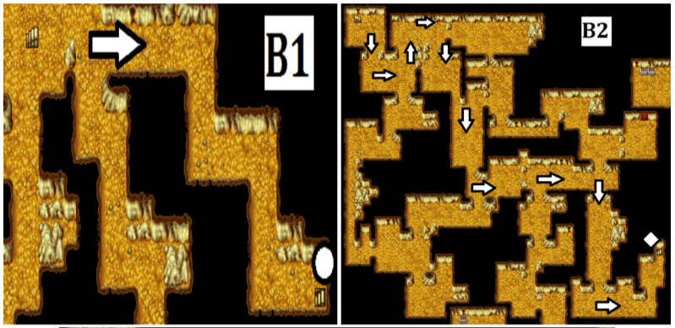
1
2
Head straight to B2. On B2, (1)grab Coral Sword, Tent, and 330 Gil.
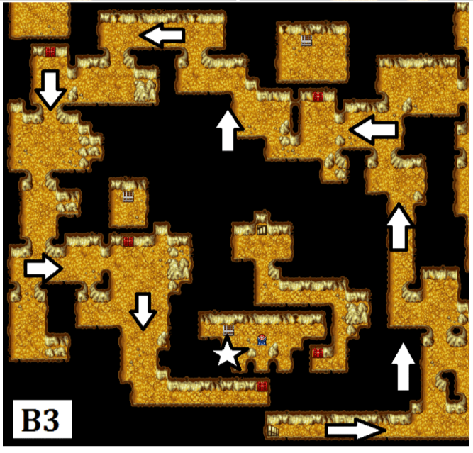
4
3
Head North, (3)grab 3400 Gil chest, then (4)head South to Vampire.

Vampire -
HP: 280
Attack 64.1% \ Gaze (paralysis) 32.05% \ Flee 3.85%
Cottage up before re-entering Earth Cave and prepare for the 2nd dive.

Pick up Ruby.
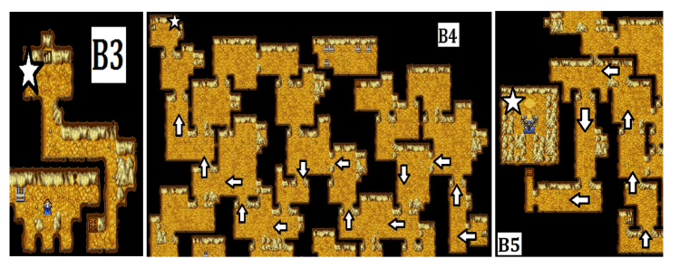
Lich 1 -
HP: 1200
Attack 23.81% \ Hold Slow 14.29% \ Sleep Fira Blizzara Thundara 9.52% \
Haste Sleepra 4.76%

Melmond
Armor Shop
- 1x Silver Armlets (Equip on remaining BM)

Crescent Lake -
Rest at Inn
Item Shop
Sell
- Unused Armor
Buy
- 40x Hi-Potions (6k)
- 25x Ethers (3750)
- 5x Antidotes (300)
- 2x Phoenix Downs (1k)
(11500) (37.5k)

Black Magic
- 2x Thundaga (26k)

Head to Circle of Sages and grab your Canoe.
Tent up before entering Ice Cave.
Ice Cave -

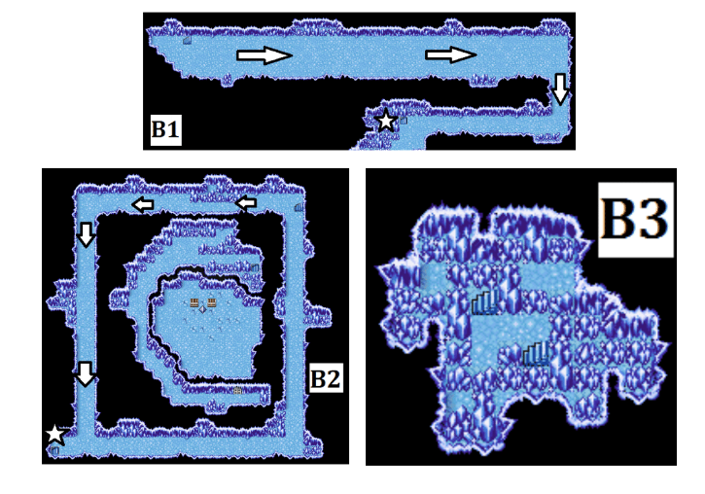

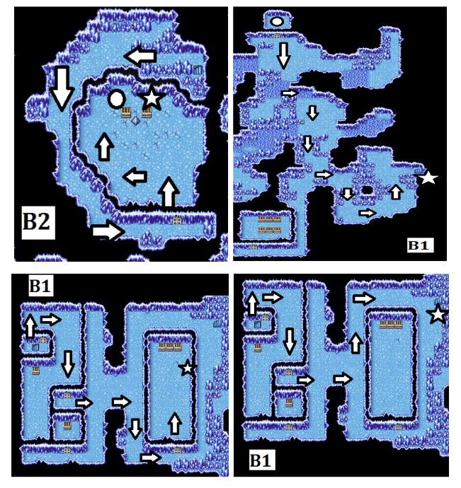
Evil Eye -
HP: 162
Attack 40% \ Silence Slow Thundara 8% \ Sleep 6% \ Hold Flee 5% \ Death Break Kill Gaze 2%

Once you get the Airship, make your way to Pravoka & Elfheim to get Status Boost Spells.

Pravoka
Black Magic
- Temper BM

Elfheim
Black Magic (Northwest)
- Haste BM

Waterfall
Cottage/tent up before canoeing up.

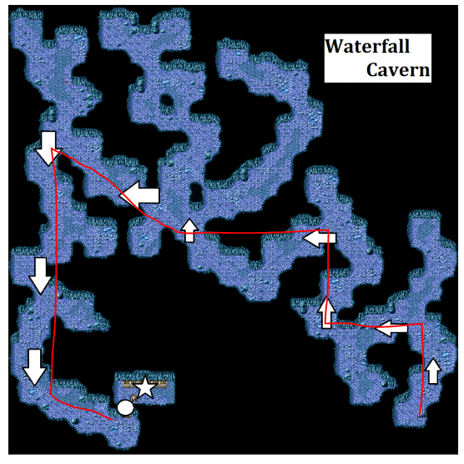
1
Caravan -

Purchase the Bottled Faerie then re-enter buy menu.

Sell
- Unused Armor
Buy
- 3 Giant Tonics
- 3 Speed Tonics

Gaia
Black Magic
- Blizzaga (60k)
Armor Shop
Sell
- Defender Sword
- Wizard Staff
- Unused Equipment
Buy
- 1-2 Protect Rings (16k each)

Item Shop
Buy
- Reup items if needed

Sea Shrine -
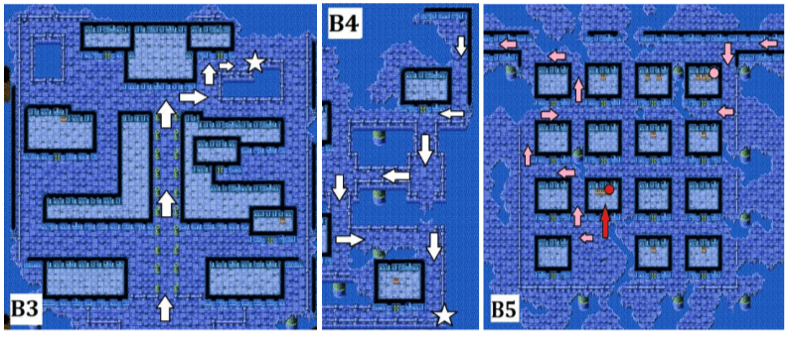
Slab
Armlet
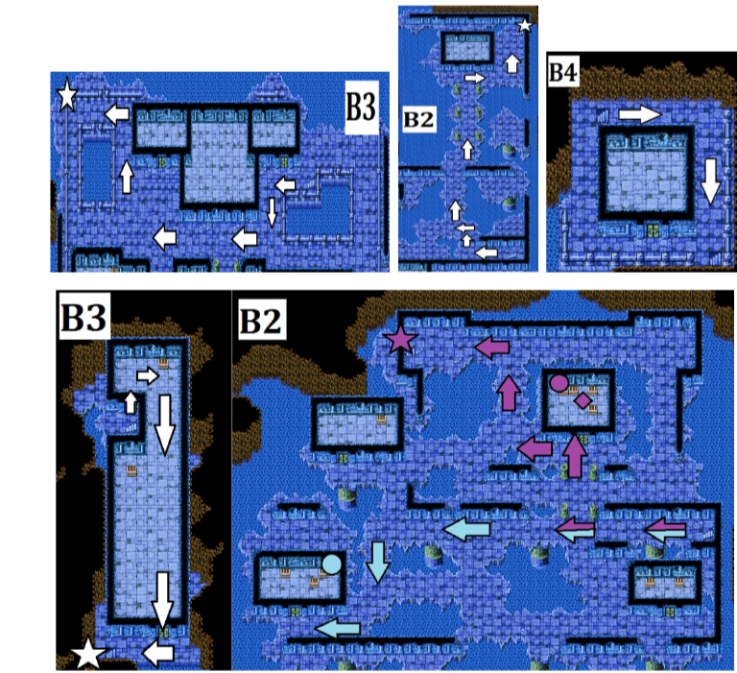
Only grab Giant’s Glove and Ribbon Optimize the Ribbon to the other BM.
Make your way to Kraken’s floor.
Ribbon
Glove

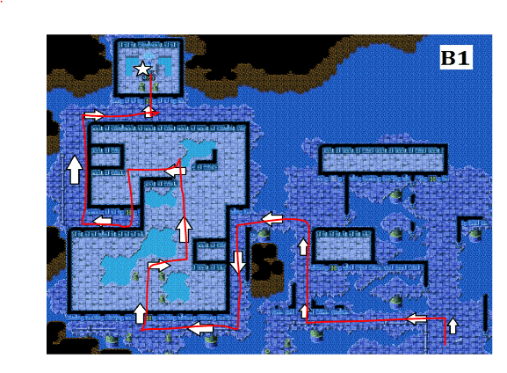
Kraken 1 -
HP: 1800
Attack 50% \ Ink 50%

Melmond/Lufenia
Mirage Tower / Flying Fortress
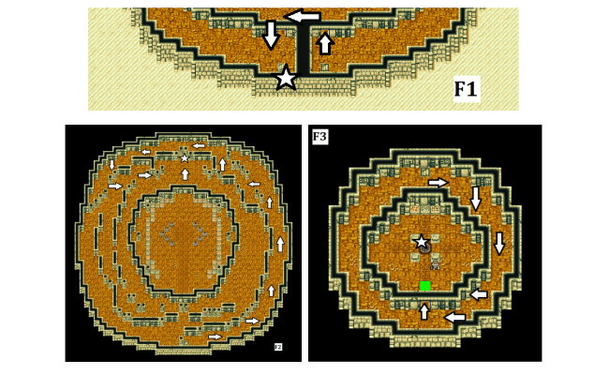
Blue Dragon -
HP: 454
Attack 65% \ Thunderbolt 30% \ Flee 5%

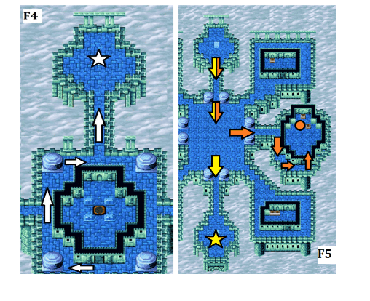
Ribbon
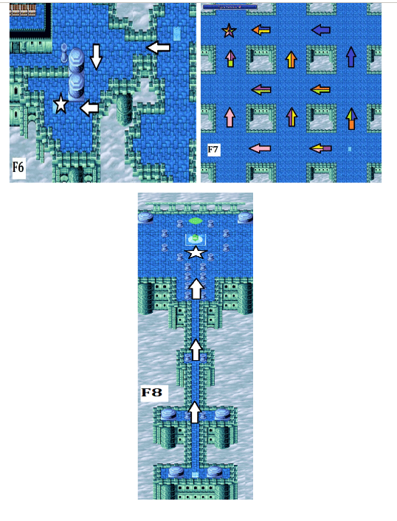
Tiamat 1 -
HP: 2400
Attack 42.86% \ Icestorm Blaze Poison Gas Thunderbolt 14.29%

Strats
- 1st Turn – M: Giant Glove | BM: Haste and Temper.
- 2nd Turn – M: Attack | BM: Temper
- 3rd Turn – M: Attack | BM: Defend
Mount Gulug
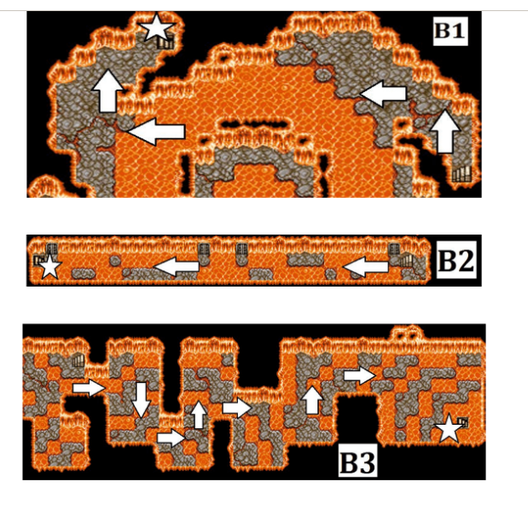
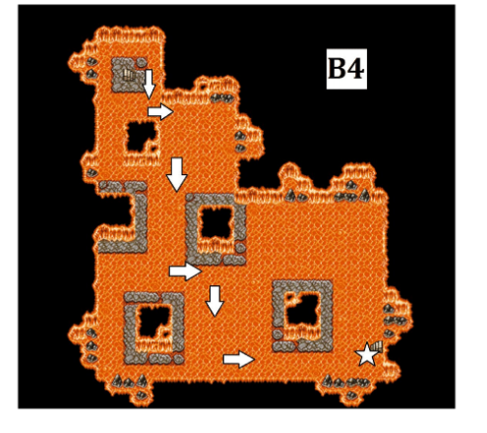
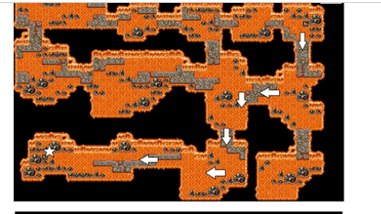

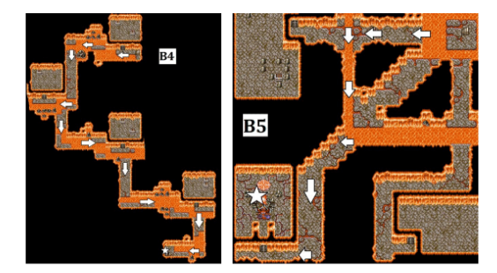
Marilith 1 -
HP: 1440
Attack 42.86% \ Fira 28.57% \ Hold Dark 14.29%
Strats
- Blizzaga or Monk Strat

Chaos Shrine Past (The Casino) –

20 PD
50 Hi
40 Ethers
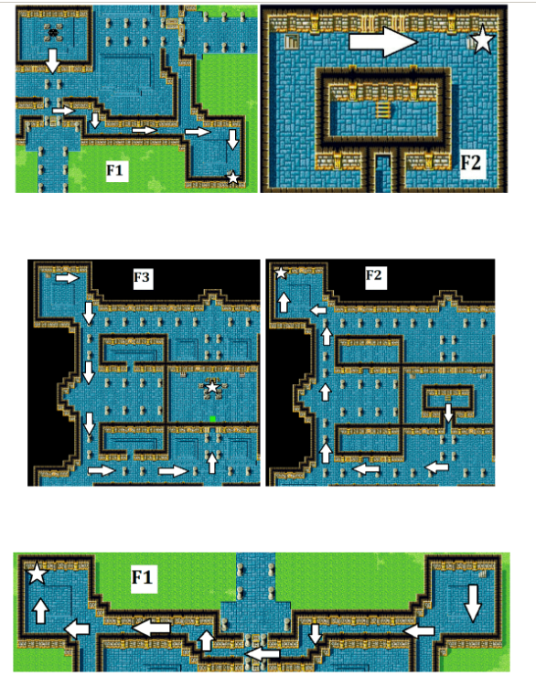

Death Eye -
HP: 360
Attack 40% \ Silence Slow 10% \ Dispel 9% \ Hold Stop 6% \ Flee 5% \ Gaze (Instant Death) Break Death 4% \ Warp (Full party kill) 2%

BM: Firaga
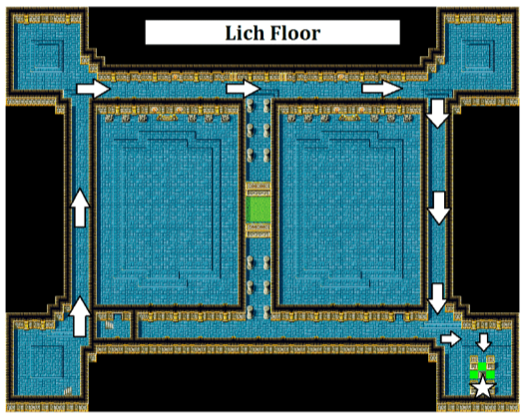
Switch Monk into the 3rd or 4th position as they are targeted less often.

Lich 2
HP: 2800
Attack 44.44% \ Flare 16.67% \ Kill Stop 13.89% \ Warp 11.11%

Strats
- 1st Turn – M: Giant Gloves | BM: Haste & Temper
- 2nd Turn – M: Attack | BM: Temper
- 3rd Turn – M: Attack | BM: Temper
- 4th Turn - M: Attack | BM: Defend

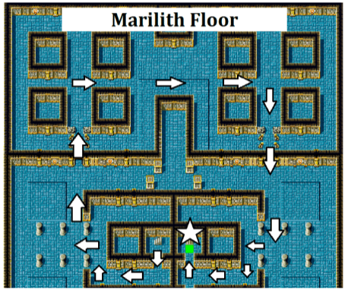

Marilith 2 -
HP: 3200
Attack 42.42% \ Firaga 30.3% \ Stun 15.15% \ Death 12.12%

Strats
- 1st Turn – M: Giant Gloves | BM: Haste & Temper
- 2nd Turn – M: Attack | BM: Temper
- 3rd Turn – M: Attack | BM: Temper
- 4th Turn - M: Attack | BM: Defend

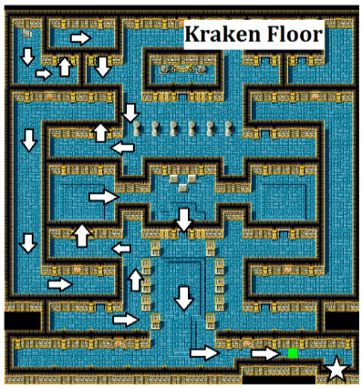
Kraken 2 -
HP: 3600
Attack Thundara Ink 33.33%

Strats
- 1st Turn – M: Giant Gloves | BM: Haste & Temper
- 2nd Turn – M: Giant Gloves | BM: Temper
- 3rd Turn – M: Attack | BM: Temper
- 4th Turn - M: Attack | BM: Defend

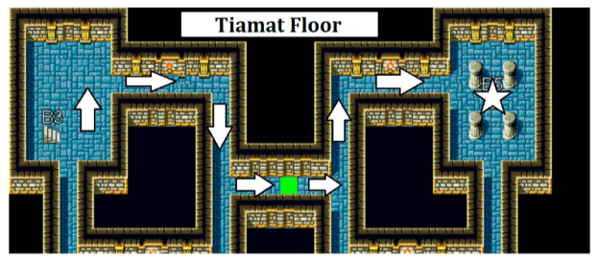
Tiamat 2 -
HP: 5500
Attack 25.51% | Fira Thundara Blizzara 14.29% | Icestorm Blaze Poison Gas Thunder Bolt 7.14% | Scourge 3.06%

Strats
- 1st Turn – M: Giant Gloves | BM: Haste & Temper
- 2nd Turn – M: Giant Gloves | BM: Temper
- 3rd Turn – M: Attack | BM: Temper
- 4th Turn - M: Attack | BM: Defend

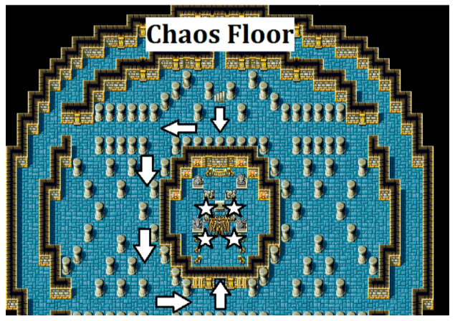
Chaos -
HP: 20,000
Attack 40% | Blizzara 10%| Tsunami Cyclone Blaze Blizzaga Thundaga Firaga Slowra Flare 5% | Earthquake Curaja 2%

Chaos is pure RNG until you get a good rotation. Goal is to keep monk alive as if he dies and is revived, he will need new buffs.
The more turns you can buff, the faster the Monk can kill.

Fight notes
- If Chaos casts Haste turn 1, reset.
- If Chaos casts turn 1 flare, reset.
3000-5000 HP is the ideal attack of the Monk. Heal with Hi-Pot or use Elixir if Monk gets low again.
Strats
- 1st Turn –Giant’s Tonic
- 2nd Turn – M: Giant Gloves | BM: X-pot/Haste
- 3-5 Turn – M: Giant Gloves | BM: Speed Drink/Temper x3
- 6-10 Turn - M: Attack | BM: Hi-Pot

