***Any% Dragoon Jump Route****FF3 Pixel Remaster*

**Organized By: CaptoftheDorks**

**Source Material:** [**KaguyaNicky**](https://www.twitch.tv/kaguyanicky)

**Observations from Watching:** [**KaguyaNicky**](https://www.twitch.tv/kaguyanicky)

**Run Timing**: Timing starts on character confirmation. Splits are usually done on the start of the death animation of the boss. Final split is on the death animation of Cloud of Darkness.

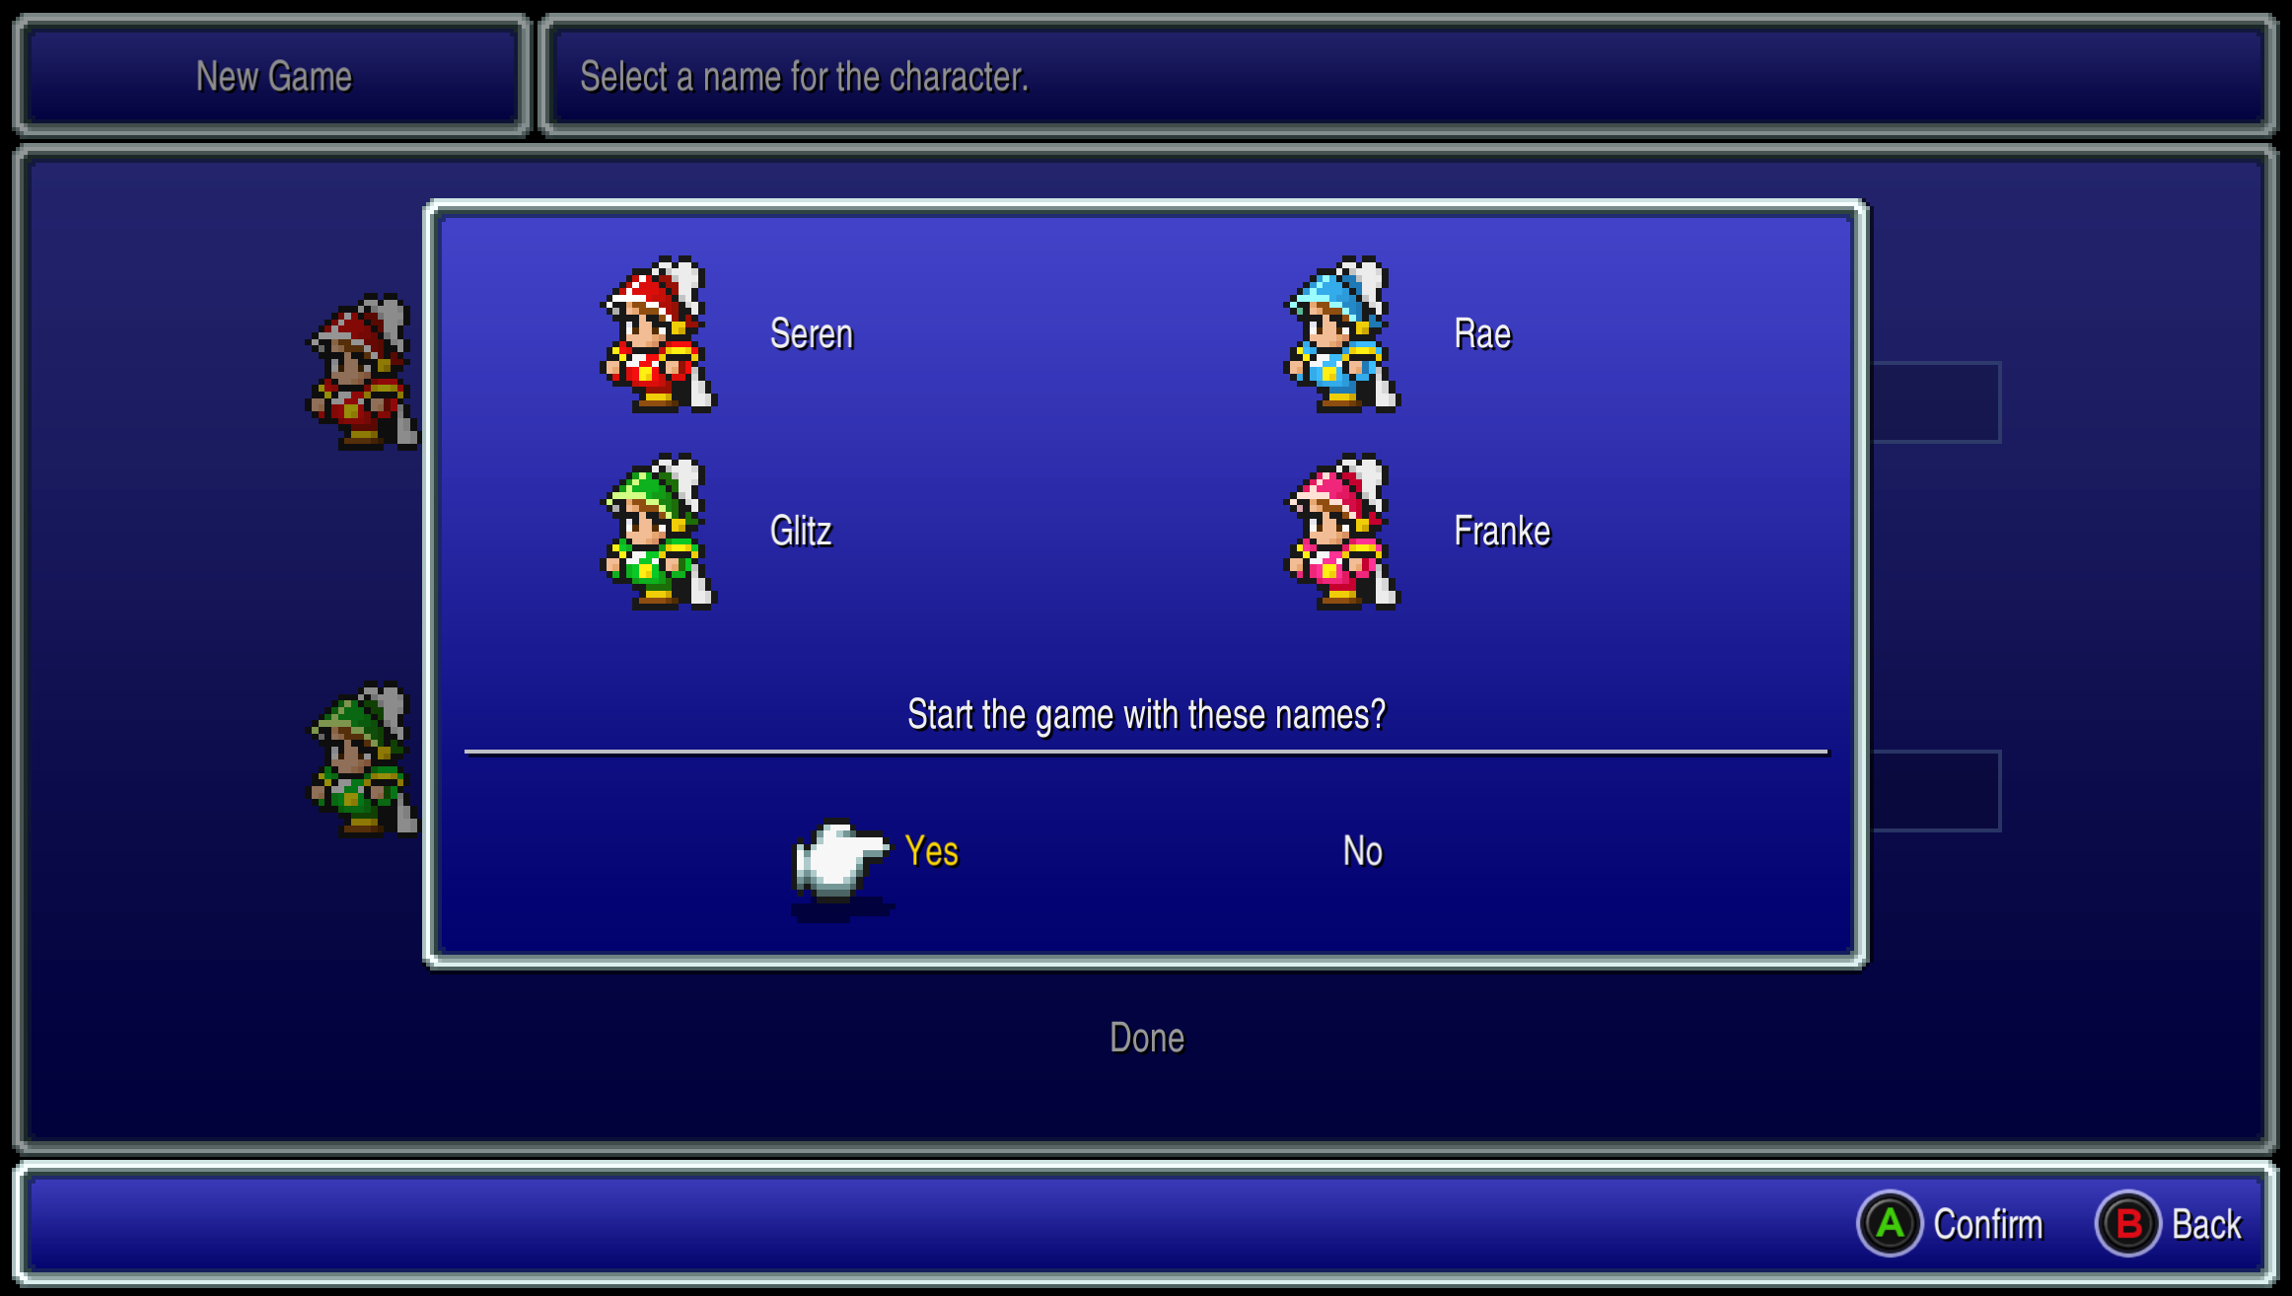

**Risk**: Something

**Encounters**: Taking encounters to level up the Dragoon is crucial to surviving Cloud of Darkness at the end.

**Leveling Objectives:**

1. There are some yes

**Step Count**: Steps count will determine how many fights you get. Encounters can be skipped if you get through areas with the least amount of steps, so be wary of not taking a direct route when necessary.

**Movement:** Make sure you are running instead of walking for most of the game.

Table of Contents

***Any% Dragoon Jump Route*** 1

***Altar Cave*** 4

***Ur*** 4

***Kazus*** 4

***Desert*** 5

***Cave of the Seal*** 5

***Sasune Castle*** 5

***Kazus*** 6

***Dragon’s Peak*** 6

***Tozus*** 7

***Vikings Cove*** 7

***Nepto Temple*** 7

***Tokkul*** 8

***Village of the Ancients*** 8

***Gulgan Gulch*** 9

***Tower of Owen*** 9

***\*Bonus Town*** 10

***Dwarven Hollows*** 10

***Molten Cave*** 11

***Dwarven Hollows*** 11

***Hyne Castle*** 12

***Castle Argus*** 12

***Caanan*** 13

***Shipwreck*** 13

***Water Temple*** 13

***Water Cave*** 13

***Amur*** 13

***Sewers*** 13

***Goldor Manor*** 13

***Saronia*** 14

***Doga Mansion*** 14

***Temple of Time*** 14

***Ancient Ruins*** 14

***Sunken Cave*** 14

***Bahamut’s Lair*** 14

***Cave of Darkness*** 14

***Doga Underground*** 14

***Ancient Maze*** 14

***Dark Tower*** 15

***Game Start***

Start Credits: 1:25

The game opens on with you in Altar Cave and attacked by a pack of 4 Goblins.

## ***Altar Cave***

Autobattle: Attack Goblins

Head to the rock to the north, interact to open passage to the 2nd floor to the northeast

Flee: All Random Encounters

2F: Pickup Antarctic Wind (left).

Head to the top stairs to fight the first boss.

**Land Turtle**

HP: 111

Attack until Dead

Talk to Crystal, exit.

Return up into cave.

Collect chests on hidden path bottom right for 2000 Gil.

Exit head south to Ur.

## ***Ur***

Item Shop:

* 4 Eye Drops
* 5 Antidotes
* All Potions

Exit south to Kazus.

## ***Kazus***

Talk with ghost Cid at Inn (top middle).

Grab item(Zeus’s Wrath) top left hidden path

Exit to Desert (west).

## ***Desert***

Get airship in middle of desert.

Config:

* Autobattle On
* Optimal of Job Change

Job Change:

* All to Monk

Backrow top 3

Sort items,

potion top 3 monks.

(Intention is to let 4th slot die.)

## ***Cave of the Seal***

Kill encounters with potions/monk hits. (Cant auto potions)

Lv.5: Frontrow

Grind to Lv.7

Chest:

* 1st: Cure
* 2nd: 600 gil
* 3rd: Antarctic Wind

**Djinn**

HP: 550

Attack

## ***Sasune Castle***

Speak with King.

Hidden path bottom to chest

Chest:

* 2x 1k Gil

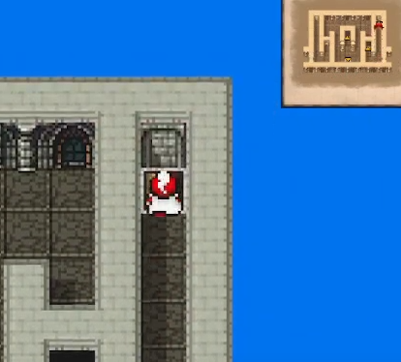Exit to Airship.

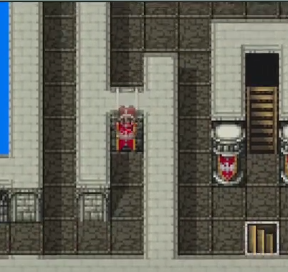

## ***Kazus***

Magic Shop:

* 2 Fires
* 4 Blizzards

Weapon Shop:

* 6 Mythril Rods

Armor Shop:

* 3 Mythril Bracers

Job Change:

* 4 to Black Mages

Backrow Black Mages

(Intend to let 3rd Monk die)

Learn:

* 1 – Fire, Blizzard
* 2 – Fire, Blizzard

Heal at Inn

Speak with NPC (upmost building)

Get Airship, crash into rock.

**Canaan**

Total:

7 antidotes

3 Eye drops

5 echo grass

4 gold needles

Take World Map encounters with Blizzard ALL.

If Monk isnt dead, single target suicide with Blizzard.

## ***Dragon’s Peak***

Blizzard encounters until level 8.

**Bahamut**

HP: ???

Flee

Force encounter to kill last 2 slots.

Job Change:

* Top Black Mage into White Mage

Learn:

* 1 – Mini

Cast Mini ALL

## ***Tozus***

Grab Fire Staff/Cura in library.

Give Antidote to NPC.

Job Change:

* Top White Mage into Black Mage

Grind:

* Kill ALL with Blizzard to Lv12

## ***Vikings Cove***

Heal at Inn

Sell Cura, Fire Rod, Buy 3 Thunders

Reup items and dump to potions

Chest: (Right of stairs)

* Fira
* Blizzara
* Thundara

Learn:

* 1 – Blizzara (WM)
* 2 – Fira, Thundara

## ***Nepto Temple***

Kill encounters with Blizzard ALL

**Giant Rat**

HP: 1050

Fira, Blizzara, AoE Fire

Chest:

* Serpent Sword

Autobattle Blizzard on way out

UnMini

## ***Gulgan Gulch***

Sea Encounters: Thunder

Land Encounters: Fire/Blizzard

Chest:

* Ice Rod
* Fire Rod
* Mage Robe

Speak with Elder to get Toad cast.

**Castle Argus**

Chests in throne room right

Head down, heal with water

Head back up to torch right for secret room

## ***Tower of Owen***

Sort Items

Heal

Blizzard/Fire Kills

Learn:

* 1 –Toad (WM)
* 2 – Blizzara

Cast Toad ALL

Go thru Toad water

Un Toad

Job Change:

* White Mage into Black Mage

**Medusa**

HP: 2000

Blizzara & Fira x2

Blizzard & Fire

Equip:

* Fire Rod > Mythril Rod
* Optimize Blm2

Chest:

* 7F: Bomb Fragment (left)
* 9F: All chests (Flame Mail, Zeus Wrath)

## ***Dwarven Hollows***

Sea Encounters: Fire & Thunder

Land Encounters: Flee

Armor Shop(Sell 3rd mage items)

* 2 Ice Armor
* 3 Ice Helms
* 4 Ice Shields
* 2 Mage Robes

Item Shop , Heal

Sell

Buy  
 3 pd, 2 mallet, 2 kisses, rest hi pots

Job Change:

* Black Mage into White Mage

Cast Toad ALL

Go thru Toad

Un Toad

Job Change:

* White Mage into Black Mage

Chest:

* 2nd/3rd: Zeus’ Wrath

**Gutsco**

HP: 2800

Red Mages

Blizzara & Fira

Fight out

Heal at Inn

Deliver Horn

## ***Molten Cave***

Kill ALL with Blizzard

Chest:

* 1F: Antarctic Wind (right)

Job Change:

* Switch to Red Mages

Potion.

**Salamander**

HP: 4000

Red Mages

Blizzara, Blizzard

Hi-Potions as neccessary

## ***Dwarven Hollows***

Chest:

* Collect except 3rd row, last bottom

Speak with dwarf bottom right

* 2 – Thief

Flee to Tokkul, ship by forest

Land ship northwest of desert.

Get kidnapped.

## ***Hyne Castle***

Take from pot.

Mini ALL

Move & unMini

2 Thiefs

Chest:

* 3F

Job Change:

* Both Scholars

**Hein**

HP: 3500

Turn ½

* BM: Blizzard

Turn 3

* Scholar: Study for element weakness
* BM: Defend or Hi-Pot

Turn 4/5

* Scholar: Element effective item
* BM: Element Black Magic

Job Change:

* 2 – Scholar > Thief

## ***Castle Argus***

Flee with Scram

Speak with King & Exit

## ***Caanan***

Top Left Building

Cid: 4th Item

Get new airship

Collect shuriken in Gyshal

Fly out, southwest

## ***Shipwreck***

Chest:

* Zeus Rash
* Blood Sword

Give Girl Potion

Land in Sea below

## ***Water Temple***

Heal upper right

Head to shard

## ***Water Cave***

Flee with Scram

After Crescent room >

Job Change:

* 2 – Thief > Scholar

**Kraken**

HP: 5000

* Scholar: Zeus’ Wrath
* BM: Thundara

## ***Amur***

Equip:

* Remove All

Item Shop:

PD, fill, max hipot

Sell Except

* Ice Helm, Ice Armor, Ice Shield
* Flame Mail, Heroic Shield, Guantlets

Armor Shop:

* 2, 2, 3, 0, 2, 3, 0,

Go to right building then water top left

Job Change:

* 2 BB, 2 Viking
* Kick Kill

Back row

## ***Sewers***

Chest:

* 1 onscreen
* 2 adjecent rooms hidden

Forced Goblins, Kick

Chest:

* Cat Claws
* Main Gauche
* Thorian Hammer
* Orichalcum
* Power Bracers (equip)

Go to Goldor Manor

## ***Goldor Manor***

* Kick

Thief to get into room, BB unequip claws

**Goldor**

HP: 6000

* Top BB heals, rest boost then attack

Frontrow All at boss

After battle, heal, Ottershroom, Get Chocobo

Backrow, top viking with shields

## ***Saronia***

Southwest Town

Forced Battle: Kick, Defend

Northeast Town

Get Elixir in upper right tree

Equip:

* BB: Remove All

Weapon Shop:

Sell:

* Knives
* Chakra bands
* Black belt gi
* Thorian hammer

Buy:

* 1 Thunder Spear
* 8 Wind Spears

Item Shop

* 2 Ottershrooms

**Garuda**

HP: 7500

* Jump
* pd

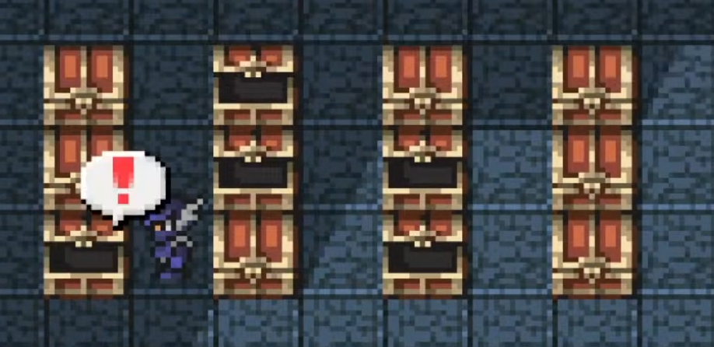

Job Change:

* Dragoon Time!

Collect Chests

Backrow All

Red mage/thiefs

Head outside, right building, nautilus

Fly northeast

## ***Doga Mansion***

Pot for heal

Flee with Scram

Mini All

UnMini once outside

Job Change:

* RM > Thief

Fly northwest

Go underwater at circle

## ***Temple of Time***

Flee with Scram

Chest:

* 1f right room
* B2 – Defender

B3: upper right room

Go down to Lute

Chest:

* B4: Protect Rings x2, Lamia Harp (hidden)

Viking top

Exit with Ottershroom

Fly around and use Lute on Unei.

Talk to Unei again.

Fly to Ancient Ruins

## ***Ancient Ruins***

Flee with Scram

Chest:

* Room1: Reflective Mail give to viking top

Go up to middle door

Weapon Shop:

Sell:

* Main Guache
* Lamia Harp
* Defender
* Wind Spears
* Rune Bow

Buy:

* 2 Blood Lance

Go up to stair, unlock Invincible

Switch to Nautilus

Fly northwest to island in bottom right

Dive!

## ***Sunken Cave***

Viking, 2 Black belts for help on first fight

Grind on 2nd room.

Viking uses Thorian Hammer for Thundara to Level 22-23

Top viking to be dragoon, frontrow

Chest:

* 3F: Air knife & diamond helm

Optimize Dragoon

Use Viking for HP, dragoon for levels

Dragoon 26/ HP 2k

Secret passage (top 2 chests, bottom left

Exlir on dead dragon after 3 defends

Red 3def, jump

Switch to Invincible,

Refresh on hipot, eyes, anti, pd, 2 otters

## ***Cave of Darkness***

* Jump get levels

**Hecatoncheir**

HP: 9800

* Jump

Ottershroom Out

Get Nautilus, Go to Doga Mansion

## ***Doga Underground***

Flee with Scram

Job Change:

* Thief > Dragoon
* Thief > WM

**Unei**

HP: 11800

* Jump

**Doga**

HP: 12800

* Jump

Revive WM, Ottershroom Out

White Robes x2

Get Invincible, fly left to upper right, exit in front of statues

Head to Maze

## ***Ancient Maze***

Flee with Scram

Chests:

* Crystal Mail
* Crystal Helm
* Holy Lance on left

Grind Dragoon to skill lv.71  
End with RM petrify

## ***Crystal Tower***

**Xande**

HP: 38000

* Jump

Dragoon buff to 84

## ***Dark Tower***

Flee with Scram

Thief > Dragoon before fights

NE run to middle

**2Head Dragon**

HP: 65000

* Jump

Chest: Ribbon

**Cerberus**

HP: 60000

* Jump

**Xande Clone**

HP: ?

* Jump

**Cloud of Darkness**

HP: 12000

* Jump

**Ahriman**

HP: 75000

* Jump

**Echidna**

HP: 70000

* Jump