***Any% Route****FF6 Pixel Remaster*

**Organized By: CaptoftheDorks**

**Source Material:**

**Observations from Watching:**

**Run Timing**: Timing starts on New Game. Splits are usually done on the start of the death animation of the boss. Final split is on the death rattle of Kefka.

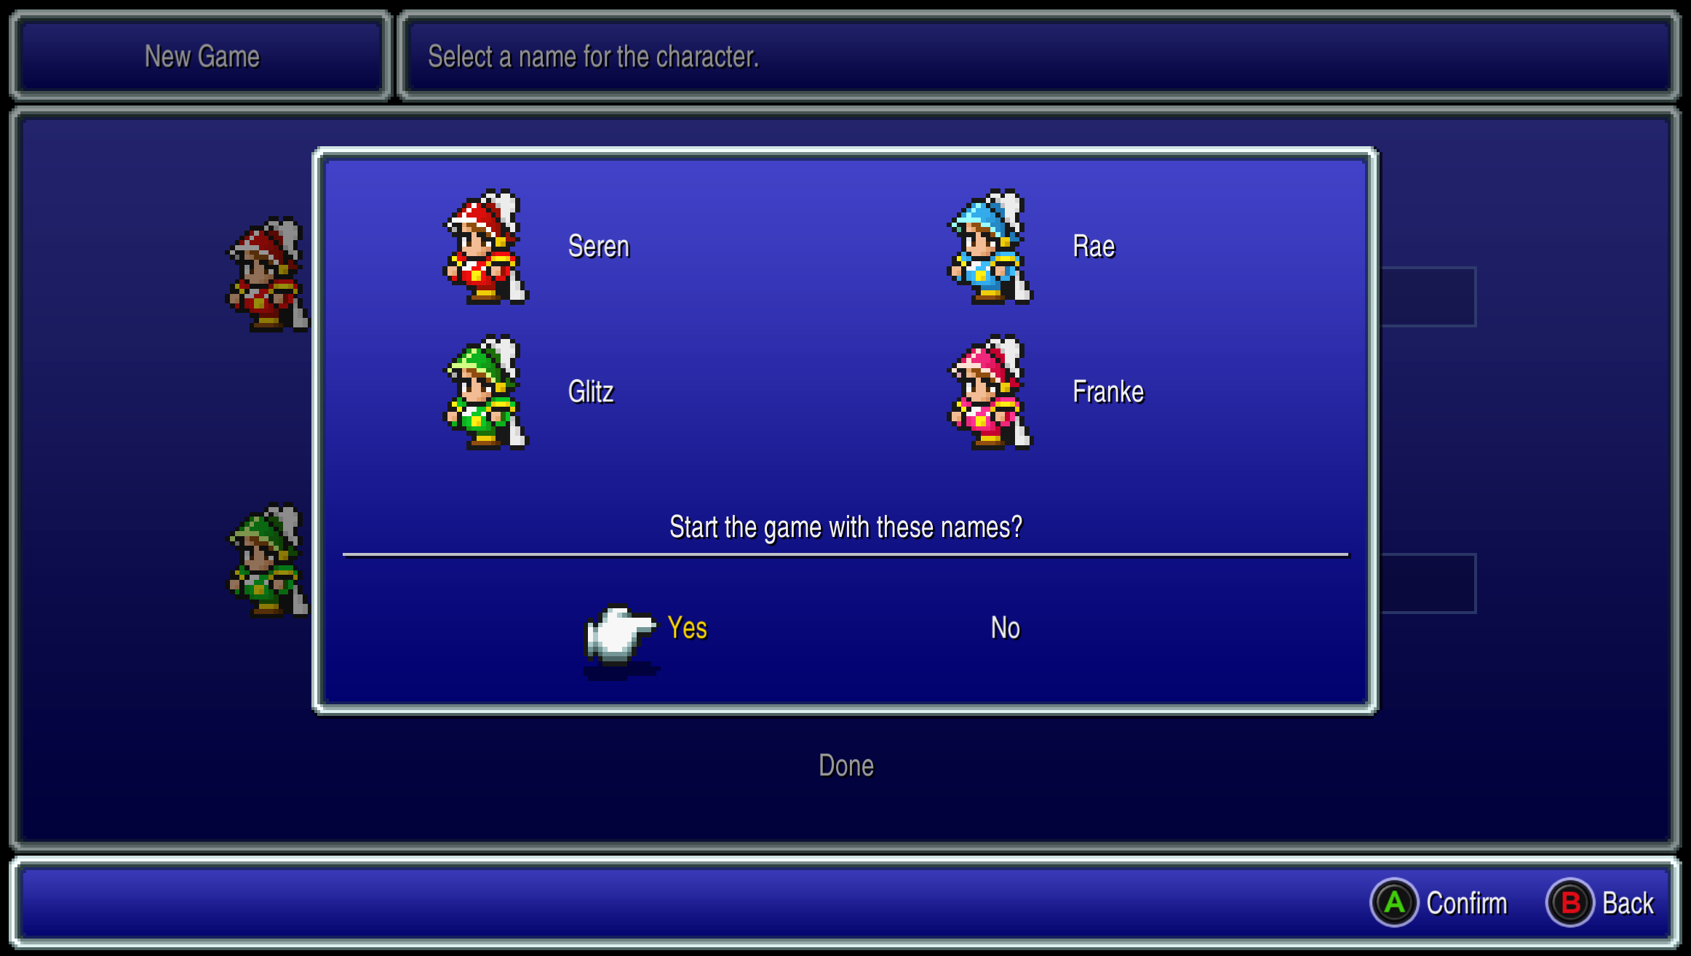

**Risk**: Something

**Encounters**: Take only Mt. Ordeals encounters for Paladin Cecil to Lv.18 & Trapdoors for Kain before Demon Wall. Else run.

**Leveling Objectives:**

1. There are some yes

**Step Count**: Steps count will determine how many fights you get. Encounters can be skipped if you get through areas with the least amount of steps, so be wary of not taking a direct route when necessary.

**Movement:** Make sure you are running instead of walking for most of the game.

Table of Contents

***Narshe*** 4

***Figaro Castle*** 4

***Figaro Cave*** 4

***South Figaro*** 5

***Mt. Koltz*** 5

***Returners Hideout*** 6

***Lete River*** 6

***Sabin Scenario*** 6

***Phantom Forest*** 6

***Phantom Train*** 7

***Narshe Cave*** 9

***Locke’s Scenario*** 9

***South Figaro Cave*** 10

***Kefka at Narshe*** 10

***Narshe*** 10

***Figaro Castle*** 10

***Zozo*** 10

***Opera House*** 10

***Vector*** 10

***#24*** 10

***Esper World*** 10

***Airship*** 10

***Sealed Cave*** 11

***Vector 2*** 11

***Thamasa*** 11

***Esper Hideout*** 11

***Thamasa*** 11

***Floating Continent*** 11

***Nikeah*** 11

***Figaro Return*** 11

***Kohlingen*** 11

***Maranda Forest*** 11

***Narshe*** 12

***Gogo’s Cave*** 12

***Kefka’s Tower*** 12

***Game Start***

Start Credits:

## ***Narshe***

**Ymir**

HP: **1600**

Terra: Magitek Missle

Biggs/Wedge: Defend

Get all EXP to Terra, run with rest.

1st Battle: Fire Beam

Skip movement

2nd Battle: Bio Blast

3rd Battle: Bio Blast

**Guard Leader**

HP: **420**

Mog: Unequip Pike/Shield, Cast Dance

Else: Attack Silver Lobos

Fire All until Terra Lv.6

Grab **Sleeping Bag**

Switch to Mog Party.

Avoid and rush Guard Leader.

Walk **South** to Figaro Castle

## ***Figaro Castle***

Speak to Edgar.

Go to left tower to Matron.

Return to Edgar.

**M-Tek Armor**

HP: **210**

Edgar: Crossbow

Locke: Steal

Terra: Fire

Talk to guards (left, right), then Kefka

Follow Locke, trigger cutscene.

Ignore Kefka & leave.

“Z” to lock screen.

Head south to Figaro.

## ***Figaro Cave***

R1: Heal at Spring, Right to Door.

R2: 1st Right, Down, Staircase to left.

R3: Left room.

R4: Bottom to exit.

Walk South to Figaro

## ***South Figaro***

Buy: 4500 gp

Sprint Shoes (x3)

Menu:

* + Backrow All

Terra: Sprint Shoes

Locke: Mythril Shield

Exit, head northeast to Mt. Kotlz

Take any fight. (Crossbow & Fire)

## ***Mt. Koltz***

Goal:

Edgar: Lv.10

Locke: Lv.9

Terra: Lv.8

R1: Up straight.

R2: Right

R3: Down, **Main Gauche**, return, right, **Gigas Glove**

Menu:

Edgar: Gigas Glove

Locke: Main Gauche

R3: Exit top Left

R4: Left, Up, Right

R5: Right

R6: Right, Up, Cross Bridge

R7: Right

R8: Follow Path

**Heal!**

Menu:

* + Frontrow Locke

**Vargas**

HP: **720**

Edgar: Crossbow

Locke: Attack

Terra: Fire

Sabin: Aura Cannon, Raging Fists

Menu:

Locke: Remove All

Exit, Head up.

Run for rest of game unless stated.

## ***Returners Hideout***

Follow guy to Banon.

Talk to Locke, get **Phoenix Down**, leave.

Top Left Room, **get all chests & pot**, exit down right & get **White Cape**.

Talk to Sabin, then head to shop

Sell:

Ethers (x2)

Buy:

Eye Drops (x2)

Sprint Shoes (x2)

Head north, get **Green Cherry** & **Antidote**, head north to Edgar.

Leave, talk to soldier on bottom.

Say Yes to Banon for **Gauntlet**.

Head North.

Menu:

* + Backrow All

## ***Lete River***

Take all fights.

Pteradon, Exocite x2: Crossbow

Pteradon x2: Crossbow & Fire

Exocite, Nautiloid: Crossbow & Fire

Goal:

Edgar: Lv.11

Left, Heal

Menu:

* + Frontrow Edgar

Edgar: Gigas Glove, Gauntlet, Optimal

Sabin: Sprint Shoes, Optimal

**Ultros 1**

HP: **-**

Edgar: Fight

Sabin: Aura Cannon

Terra: Defend

Bannon: Pray

## ***Sabin Scenario***

Walk SE along mountains to Imperial Camp.

Menu:

Cyan: Sprint Shoes, White Cape

Walk South to Captain.

**Captain**

HP: **456**

Cyan: Bushido - Sky

Walk south to Kefka & follow with 1 hit fights

Before 3rd enc:

Menu:

* + Backrow Sabin

Heal

**Solidiers & Templar**

HP: **-**

Sabin: Raging Fists

Cyan (M): up, down stairs, down, cutscene in throne, down and right to room.

Sabin (M): Talk to Cyan, Sabin fight, autobattle 2 fights, heal when needed.

**Solidiers & Officer**

HP: **-**

Sabin: Aura Cannon

Cyan: Sky

**Mech Fights**

HP: **-**

Fire Beam

Leave Base

Left across bridge, down & right across bridge, south into forest.

## ***Phantom Forest***

ATB clear queue, then run.

R1: Top right

R2: Touch Spring, bottom right

R3: Closest Up

R4: Top right

## ***Phantom Train***

ATB clear queue, then run.

R1: Enter Train, check door, left

R2: Go thru next car

R3: Enter car, talk to ghost at door you came in, jump train

R4: Enter, switch twice, exit left

R5: Dining Car or ladder 2 cars

R6: Left & Right switch, talk to train

**Phantom Train**

HP: **-**

Suplex, PD

Talk to Cyan

Head down, right, up to falls.

***Barron Falls***

Menu:

* + Backrow All

Item Arrange

Sabin: Earrings over Shoes

Jump

Rhipozas

HP: **775**

Kill 1, hold for 30, Aura & Fang

***Veldt***

Down to exit, right around mountain up to Mobliz

Item Shop

Buy:

Dried Meat

Leave

Left Down to Mountains, kill enc for Gau.

***Serpent Trench***

Right options

Xpotion, Green Beret

***Nikeah***

Sell:

Sleeping Bag, Antidote, Eye Drops, Tents, Crossbow, Black Belt

Buy:

Magus Hat (x1)

Smoke Bombs (Rest)

Head to docks to Capt

***Terra’s Scenario***

Additional raft encs.

Head up into Narshe.

Use secret entrance on left to get into cave.

## ***Narshe Cave***

R1-3: Up

R4:

R5: Up, right, door down

R6: Up

R7: left, tunnel, down, rune blade chest, right

R6: Down & left

Menu:

* + Edgar Remove All

R8: Bridge home, down and talk to Arvis.

## ***Locke’s Scenario***

Menu:

* + Locke: Sprint Shoes/Gauntlet, Main Gauche

Head to Item shop, talk to merchant to steal.

After battle head down to first house, head downstairs.

Head to café, downstairs, steal from other merchant.

Return to house, talk to old man upstairs, return downstairs to kid, “Courage”

Head into secret area, grab Elixir, go upstairs.

Bottom barrel, Phoenix Down, head inside, upstairs, first room, behind bookcase to left.

Remove Locke’s outfit. Down to chests, Hyper Wrist & Hermes Sandals.

Back up to first door and Celes. Steal key from guard.

Menu:

* + Backrow Celes

Go to last door grab chests 500gp, 1k gp, 1.5k gp, upright clock thru door.

Right, Down, Right, Down, Left to Earrings, right to exit to Figaro.

Walk up right to cave.

## ***South Figaro Cave***

R1: Up

R2: Left

R3: down stairs, left, up, right to stairs, up

R4: right to chest Thunder Rod, back

R5: right & up

R6: left to text box, menu, then down

Menu:

* + Locke: Air Knife, Gigas Gloves/Gauntlet

Tunnel Armor

HP: **1300**

Locke: Attack

Celes: Runic

## ***Kefka at Narshe***



Menu:

* + Backrow all but Locke
  + Sabin: Earrings x2
  + Celes: Dagger on Shield



Hell Rider

HP: **-**

Locke: Attack

Sabin: Aura

Cyan: Fang

Celes: Attack

Kefka

HP: **-**

Locke: Attack

Sabin: Aura

Cyan: Fang

Celes: Runic

**BREAK**

## ***Narshe***



Grab Elixir from clock, head down to treasure house for chest and then leave Narshe for Figaro Castle.

## ***Figaro Castle***

Head to Weapons shop on right before throne room.

Sell:

Mythril Spear, Rune Blade, Hyper Wrist x1, Hairband, Peace Ring

Buy:

Drill, Flash

Head over to Item shop on left.

Buy:

20x Hi Pots

11x Phoenix Downs

32x Holy Water

Head down, down 2 stairs, move to Kohlingen, up and leave to WM.

Menu:

* + Backrow all Sabin: Earrings x2
  + Locke: Main Guache, Hermes Sandals/Thief Bracer
  + Edgar: Reflect Ring/Earring, Optimal

Head north to top of continent village, grab Hero Ring from pot in house.

Head to Choco stable in forest. South hook around to Zozo.

## ***Zozo***

R1: Bottom left of town to door

R2: Stairs

R3: Door

R4: Left, Up stairs

R5: Up stairs, jump building, door

R6: Up stairs, Grab Ether, down

R7: Up stairs

R8: Up 3 flights, door

R9: Up 2 flights, door, Fire Knuckle, menu, boss

Menu:

* + Locke: Hermes Sandals/Sprint Shoes
  + Edgar: Earring/Hero’s Ring
  + Cyan: Remove Buckler

Heal

Dadaluma

HP: **3270**

Edgar: Drill

Sabin: Aura

Cyan: Fang

Locke: Defend

After 2 Drills, Edgar Flash

Head up to Terra. Cutscene.

Collect Materia (3) Ramuh, Cait Sith, Siren

Collect left/right chests, Hermes Sandals, X-Pot



Leave Zozo to right, travel to Jidoor.

Buy: Armor

White Dress

Head to Mansion, talk to panicky man, check letter.

Name Setzer, head to Choco shop.

Take Chocobo south to Opera House.

## ***Opera House***

Talk to Impersarrio, auto move to seat.

## ***Vector***

Exit, Head up.

## ***#24***

Exit, Head up.

## ***Esper World***

Exit, Head up.

## ***Airship***

Exit, Head up.

## ***Sealed Cave***

Exit, Head up.

## ***Vector 2***

Exit, Head up.

## ***Thamasa***

Exit, Head up.

## ***Esper Hideout***

Exit, Head up.

## ***Thamasa***

Exit, Head up.

## ***Floating Continent***

Exit, Head up.

## ***Nikeah***

Exit, Head up.

## ***Figaro Return***

Exit, Head up.

## ***Kohlingen***

Exit, Head up.

## ***Maranda Forest***

Exit, Head up.

## ***Narshe***

Exit, Head up.

## ***Gogo’s Cave***

Exit, Head up.

## ***Kefka’s Tower***

Exit, Head up.