PAGE 1 of 3 –Grilled Cheese Challenge– EQUPMENT RENTAL FORM

**GRILLED CHEESE CHALLENGE**

**Lakeshore Village BIA** **Saturday June 9th, 2018**

**EQUIPMENT RENTAL FORM:**

Contact Name: Business: Address:

City: Province: Postal Code:

Bus Phone: Cell Phone:

Email Address:

***Vendors and Exhibitors must report to vendor check-in and sign for their rental order. At that time vendors may take their rental items or request delivery.***

|  |  |  |  |  |  |
| --- | --- | --- | --- | --- | --- |
| **ITEM** | **DESCRIPTION** | **VISUAL** | **RATE** | **QUANTITY** | **TOTAL** |
| Bistro Chair | White plastic arm chair | Cayman Chair (002) | $5.00 |  |  |
| Chair | Burgundy folding chair |  | $3.00 |  |  |
| Patio Table | 39” - Round white plastic | 39 inch Round Patio Table (002) | $25.00 |  |  |
| Table | Straight Folding Table Length: 6’  Width: 30”  Height: 29” |  | $20.00 |  |  |
| **ITEM** | **DESCRIPTION** | **VISUAL** | **RATE** | **QUANTITY** | **TOTAL** |

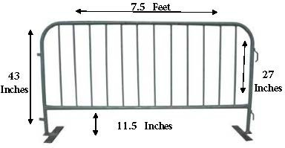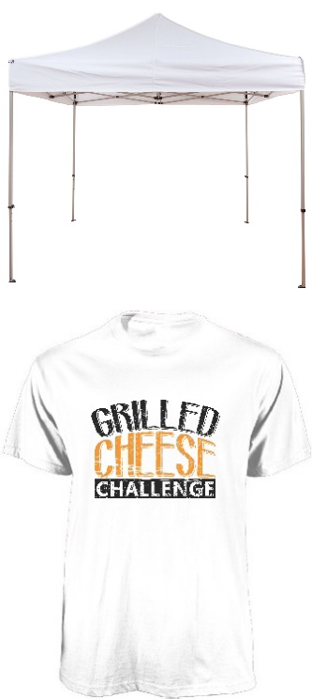

|  |  |  |  |  |  |
| --- | --- | --- | --- | --- | --- |
| Barricade | Sidan Type C Barricade |  | $18.50 |  |  |
| Tent | 10’x10’ White Pop Up Tent (Walls & Weights Included) |  | $200.00 |  |  |
|  |  |  |  | S: |  |
| T-Shirt | Unisex  White Grilled Cheese Challenge T-Shirt (Sizes: S,M,L,XL) | $20.00 | M:  L: |
|  |  |  | XL: |
| Power | One 15-Amp Power |  | Call for Quote |  |  |
|  | | | | SUBTOTAL |  |
| HST |  |
| TOTAL |  |

Card Type: Visa

Address: *_ _ _* City: Province: *_* Postal Code: *_ _* Country: Phone #:

Cardholder’s Authorized Signature:*_ _ _* Date: *_/ / _*

**Total Amount:** *_*

*_*

Last Name:

First Name:

**Billing Address:** *Your billing information must match what your financial institution has on file or your order will not be processed.*

CVV or CID (Security Code):

Expiration Date: */ _*

Card Number:

AMEX

MasterCard

**EQUIPMENT RENTAL TERMS AND CONDITIONS:**

1. All payments must be made in full before delivery date
2. All payments must be made using a credit card
3. Customer assumes full responsibility for all rented items, including their safe and proper use, operation, maintenance, and return to Hypitch Marketing.
4. This rental contract forms the sole agreement between the customer and Hypitch Marketing. The customer agrees to indemnify and hold Hypitch Marketing harmless for any claims from customer’s use or misuse, including any third parties for loss, injury, and damage to persons or property arising out of the customer's negligence or operation including legal costs incurred in defense of such claims.
5. Operators should read any/all warnings and instructions (safety instructions) that may be provided.
6. Retaking of equipment: if customer fails to return all rented items upon agreed time, customer agrees to pay for all additional charges. If customer refuses to return rented items, the customer agrees that Hypitch Marketing and its agents may take all reasonable actions necessary to recover rented items without prior notice or legal process.
7. Customer acknowledges the possibility of injury and will provide adult supervision at all times according to the laws appropriate to the province of Ontario.
8. Attorney fees: customer agrees to pay all reasonable attorney fees and court costs incurred by Hypitch Marketing. In enforcing these terms and conditions.
9. Hypitch Marketing makes no warranties of merchantability or fitness for particular purpose, or any warranties, expressed or implied.

***CVV or CID (Security Code):*** *Visa and MasterCard: 3 Digit number located on the back of your card. American Express: 4 Digit number located on the front of your card.*

Sign and complete this form to authorize Hypitch Marketing to make a onetime debit to your credit card listed above. By signing this form you give Hypitch Marketing permission to debit your account for the amount indicated on or after the indicated date. This is permission for a single transaction only, and does not provide authorization for any additional unrelated debits or credits to your account. We rely on the information you provide on this form, including payment information (credit card numbers and expiration dates), and transactions-related information, which must be true, accurate, current and complete. You will be solely responsible and liable for any and all loss, damage, and additional costs that you, we or any other person may incur as a result of your submission of any false, incorrect or incomplete information.

If you have any questions about the information collected on this form, please contact Hypitch Marketing at 416-388-2704 or [info@hypitchmarketing.com.](mailto:info@hypitchmarketing.com) Under provincial legislation, a false statement from the applicant may result in a penalty.