SCHEDULE OF INSURED COVERAGE AND OTHER NON-INSURED SERVICES
TRIP CANCELLATION ** TRIP COST *
Cancellation for Work Reasons
Coverage for cancellation due to work-related reasons in addition to job loss
---------------------------------------------------------------------------------------------------------------------------------
Trip Interruption:………………………………………………………………….. 150% of Trip cost *
Trip delay – 6 Hours………………………………………………………………. $ 750.00 ($150/day)
Missed Connection – 3 hours……………………………………………………… $ 500.00
Baggage/Personal Effects………………………………………………………….. $ 1.500.00
Baggage delay – 24 hours…………………………………………………………. $ 400.00
Accident & Sickness Medical Expense…………………………………………… $ 50,000.00
Emergency Evacuation & Repatriation…………………………………………… $250,000.00
Non-Insurance Worldwide Emergency Assistance Services……………………… Included
Cancel for Any Reason (CFAR)…………………………………………………… Optional
* Up to the lesser of the Trip Cost paid or the limit of Coverage for which benefits are requested and the appropriate plan cost has been paid. Maximum limit of $20,000.
** For $0. Trip Cost, there is no Trip Cancellation and Trip Interruption is limited to $500 return air only
*** CFAR coverage is 75% of the nonrefundable trip cost. CFAR is optional and available for individuals or for the entire group. Trip cancellation must be 48 hours or more prior to scheduled departure. CFAR must be purchased at the time of plan purchase and within 14 days of your initial trip deposit. This benefit is not available to residents of New York State.
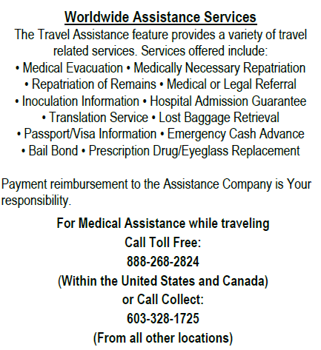
Cost of Trip | Rates | With CFAR | Cost of Trip | Rates | With CFAR
$0 | $21 | $31.50 | $4,501-$5,000 | $319 | $478.50
$1-$300 | $33 | $49.50 | $5,001-$5,500 | $353 | $529.50
$301-$500 | $39 | $58.50 | $5,501-$6,600 | $388 | $582.00
$501-$1,000 | $58 | $87.00 | $6,001-$6,500 | $422 | $633.00
$1,001-$1,500 | $ 93 | $139.50 | $6,501-$7,000 | $485 | $727.50
$1,501-$2,000 | $115 | $172.50 | $7,001-$7,500 | $519 | $778.50
$2,001-$2,500 | $145 | $217.50 | $7,501-$8,000 | $537 | $805.50
$2,501-$3,000 | $172 | $258.00 | $8,001-$8,500 | $561 | $841.50
$3,001-$3,500 | $194 | $291.00 | $8,501-$9,000 | $595 | $892.50
$3,501-$4,000 | $242 | $363.00 | $9,001-$9,500 | $623 | $934.50
$4,001-$4,500 | $276 | $414.00 | $9,501-$10,000 | $665 | $997.50

To purchase the Group Deluxe Insurance, please click on the following link:

https://www.travelinsured.com/group.signup?group=104505&guid=a96fb4ff8bb44cfbab976f3729476fa9

To purchase the Cancel for Any Reason (CFAR) Insurance, please click on the following link:

https://www.travelinsured.com/group.signup?group=104506&guid=d0be17d0d3594c24b57691cf941e464d

Please note that the premium amount will change as you put in the tour cost. If you wish to only pay the $21.00 coverage, please leave the tour cost at $0.

*********************************************
