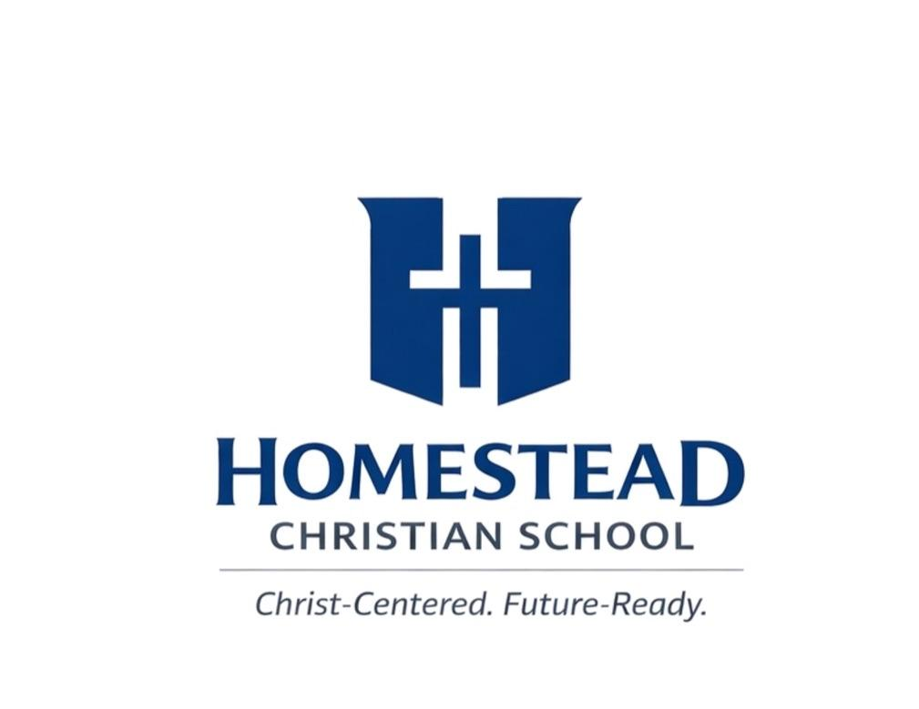
HCS Elementary School Supply List

Kindergarten 2nd Grade
Backpack Backpack
Change of clothes (labeled) Lunchbox
Lunchbox Water bottle (Labeled with name)
Water bottle (Labeled with name) Oversized Shirt for Art
Oversized shirt for Art KJV Bible
KJV Bible #2 Pencils
Jumbo Crayons Crayons/Colored Pencils
Washable Markers Scissors
Glue Sticks 3 Notebooks
Child-safe scissors 2-3 Folders
#2 Pencils Erasers for pencils
Pencil box Pencil Pouch/box
2 Notebooks Glue sticks
Writing Tablet Writing Tablet

Shared Supplies:
Shared Supplies: Tissue Box
Tissue boxes Lysol Wipes
Lysol Wipes Hand Sanitizer
Hand Sanitizer
3rd/4th Grade
1st Grade Backpack
Backpack Lunchbox
Lunchbox Water bottle (labeled with name)
Water bottle (Labeled with name) Oversized Shirt for Art
Oversized shirt for Art KJV Bible
KJV Bible #2 Pencils
Pencil Box Crayons/Colored pencils
#2 Pencils Glue sticks
Crayons (24 Count, 2 boxes) Scissors
Colored pencils 4 Notebooks
Glue sticks 3 folders
Child-safe scissors Pencil Pouch/box
2 composition notebooks Erasers
Writing Tablet Writing Tablet

Shared Supplies: Shared Supplies:
Tissue boxes Tissue Boxes
Lysol Wipes Lysol Wipes
Hand Sanitizer Hand Sanitizer
HCS Middle School Supply List

5th-8th Grade
Backpack
Lunchbox
Water bottle (Labeled with name)
KJV Bible
Planner
#2 Pencils
Pens (black/blue/red)
Highlighters
Colored pencils
Markers
5 Notebooks
2’’ Binder
½’’ binder for Spanish
Dividers
Index Cards
Wide Rule/College Rule paper
Ruler
Calculator
Compass
Protractor

Optional: Laptop or tablet

Shared supplies:
Tissue Boxes
Lysol Wipes
Hand Sanitizer

HCS High School Supply List

9th-12th Grade
Backpack
Lunchbox
Water bottle (Label with name)
Planner for assignments
Budget planner
#2 Pencils
Pens (black/blue/red)
Highlighters
Colored pencils
Markers
5 Notebooks
2’’ Binder
½’’ binder for Spanish
Dividers
Index Cards
Wide Rule/College Rule paper
Ruler
Graphing Calculator
Compass
Protractor

Optional: Laptop or Tablet

Shared supplies:
Tissue Boxes
Lysol Wipes
Hand Sanitizer

