SPECIFICATIONS OF GREENDISPO MIDI , SANITARY NAPKIN INCINERATOR

Sanitary Napkin Incinerator Jointly developed and Patented by, CSIR- NEERI Nagpur & DST - ARCI - Hyderabad , and the industrial partner M/s Sowbal Aerothermics to control emissions and improve energy efficiency .

Joint IP Appl No: 201821021430

These incinerators are “ ECO - FRIENDLY “ adhering to emission norms laid out by CPCB

- Peak ignition temperature of 800°C Is achieved during burning

- 50 mg ash as residue per pad

- Connected heater load is 1250 Watts of power with Auto cutoff

- Improved insulation methods for minimum outer body temperature

- Triple Walled Construction to improve energy efficiency and assist in secondary combustion

- Unique design to include secondary Combustion operation to minimize Dioxins and Furans

- CSIR -NEERI & DST ARCI with Industrial Partner Sowbal Aerothermic’s Contribution to improve the
livesof Women and Girls in the country.

- NEERI TESTED and also NIIST tested for Dioxins and Furans

- 304 Stainless Steel inner body and powder coated external MS body

10 Compact , and beautifully painted for convenience and Aesthetics
11 Multiple and Repeated tests done at CSIR –NEERI to confirm the emission values

System Specifications

Green DispoMidi :
Advanced engineered product to incinerate used sanitary pads. GreenDispo midi incinerates3 used pads for every 5 min . The outer body temperature is ambient + 15 degrees .A safe electrical heating unit with time controlled operation. A 10 feet flexible aluminium pipe for fume escape is provided.

Specifications | Green Dispo Midi | 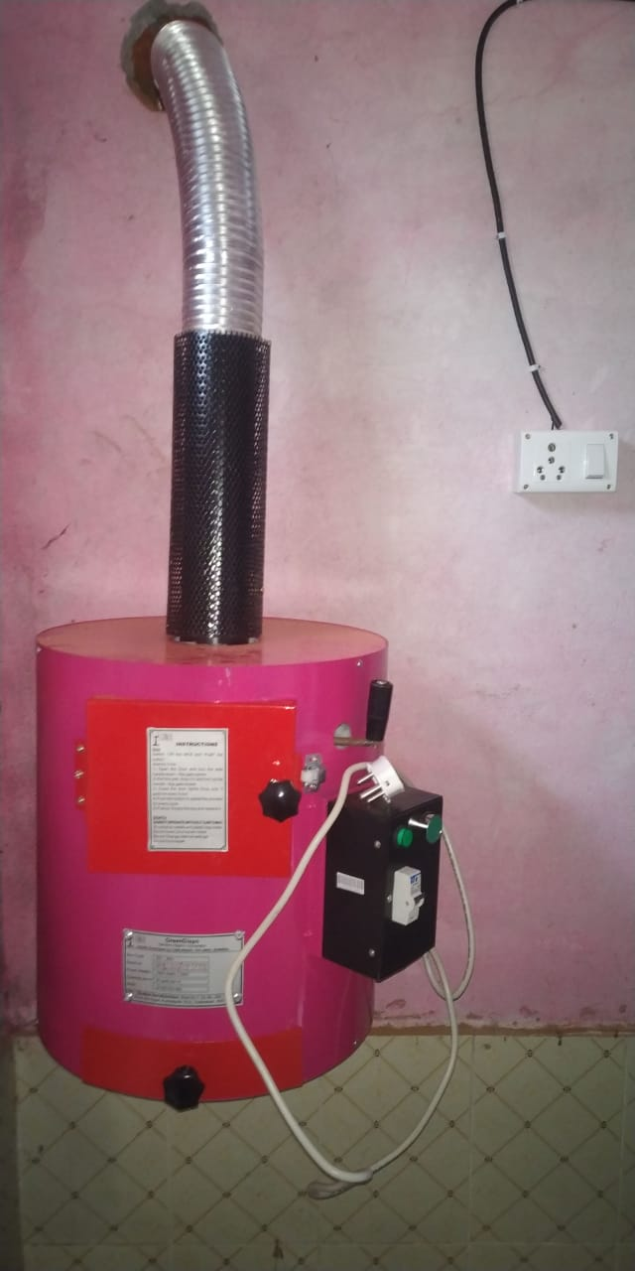
Incineration Time | 3 pads for every 5 min
Per hr count | 30 -36 pads per hour
Operational Method | 15 min operation
Ash per pad | 50 mg
Dimensions | Round Model  360 mm Diameter  450 mm Height
Weight | 13 Kgs
Design of construction | Triple walled
Outer Shell | MS 1 mm thick duly powder quoted
Inner combustion chamber | SS 304 , 1mm thickness
Central wall | SS 304 , 0.5 mm thickness
Insulation | 25mm high temperature ceramic fiber blanket - for sides  50 mm on the top surface
Exhaust | 1 ft long MS pipe with safety cover and 10 ft aluminium flexible extendable exhaust pipe
Electricity consumption | 1250 ( 1.25 KW ) Watts per hr
Peak Burning Temperature | 800°C +
Installation location | Wash room - Wall Mountable
Secondary Combustion | Inbuilt provision – As per patent Application
Heater Control | TIMER – Auto Cutoff
Safety | Electrical Safety - MCB
Thermal Safety | Safety Cover for Exhaust Pipe for user safety
Emission Test done by | 1) CSIR –NEERI- Nagpur  2) CSIT – NIIST - Thiruvananthapuram

