- 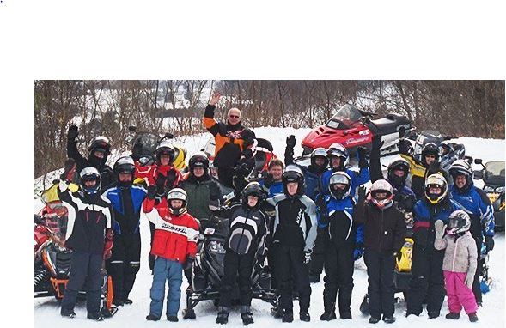  2022 LWRC Club RideS  For families of LWRC members and their guests. Not a member? Join today!  Dates (weather permitting):  - Saturday, January 15, 2022  - Wednesday, February 9, 2022 (Ladies’ Ride!)  - Saturday, March 5, 2022  Meet time: 9 a.m. at the Fish Lake Snow Park  Lunch: Provided by the LWRC at our booth at the Snow Park (hot dogs, chips, beverages)  Questions? Contact the LWRC at lakewenatcheerecclub@gmail.com or call Michelle at (509) 860-3220.  Event & Membership info: lakewenatcheerecclub.org.  Volunteer Opportunity! If you don’t ride but would like to join in the fun, please contact the LWRC about helping us out with this event. | Ride Safe  Don’t ride alone  - Ensure your equipment is in good condition  Wear proper attire and helmet  Do not carry more than 1 passenger  Never ride impaired by drugs and/or alcohol  Follow other riders at a reasonable distance  Come to a complete stop before crossing roads  Inform others about your travel plans  Check the weather forecast  Lake Wenatchee Rec Club  14400 Chiwawa Loop Rd (Lake Wenatchee airstrip)  Leavenworth WA 98826  509-763-3858

